Table S3-1. Heritabilities of seven carcass traits¹ in Pietrain × Landrace crossbred pigs from 7 single-trait models.
Traits | Heritability
BF_PL | 0.50 ± 0.03
MD_PL | 0.12 ± 0.02
MP_PL | 0.47 ± 0.03
BF_AB | 0.40 ± 0.03
MP_AB | 0.40 ± 0.03
CF_AB | 0.41 ± 0.03
CW_AB | 0.30 ± 0.02
¹: BF_PL: Backfat thickness measured using Piglog at the station; MD_PL: Muscle depth measured using Piglog at the station; MP_PL: Meat percentage measured using Piglog at the station; BF_AB: Backfat thickness measured using AutoFOM at the abattoir; MP_AB: Meat percentage measured using AutoFOM at the abattoir; CF_AB: Conformation score measured using AutoFOM at the abattoir; CW_AB: Carcass weight measured using AutoFOM at the abattoir.

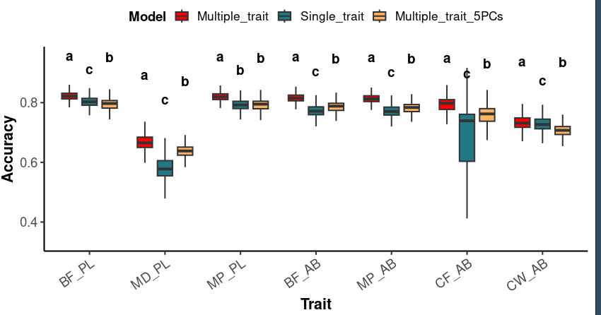
Fig. S3-1. Accuracy of genomic estimated breeding values for seven carcass traits in Pietrain x Landrace crossbred pigs from multiply-trait, 7 single-trait, and multiply-trait model including the first five principal components models. BF_PL: Backfat thickness measured using Piglog at the station; MD_PL: Muscle depth measured using Piglog at the station; MP_PL: Meat percentage measured using Piglog at the station; BF_AB: Backfat thickness measured using AutoFOM at the abattoir; MP_AB: Meat percentage measured using AutoFOM at the abattoir; CF_AB: Conformation score measured using AutoFOM at the abattoir; CW_AB: Carcass weight measured using AutoFOM at the abattoir. Boxes that do not share a common lowercase letter are significantly different from each other for the same trait (P < 0.05, Dunn test with FDR correction). Models that share the same letter do not differ significantly).

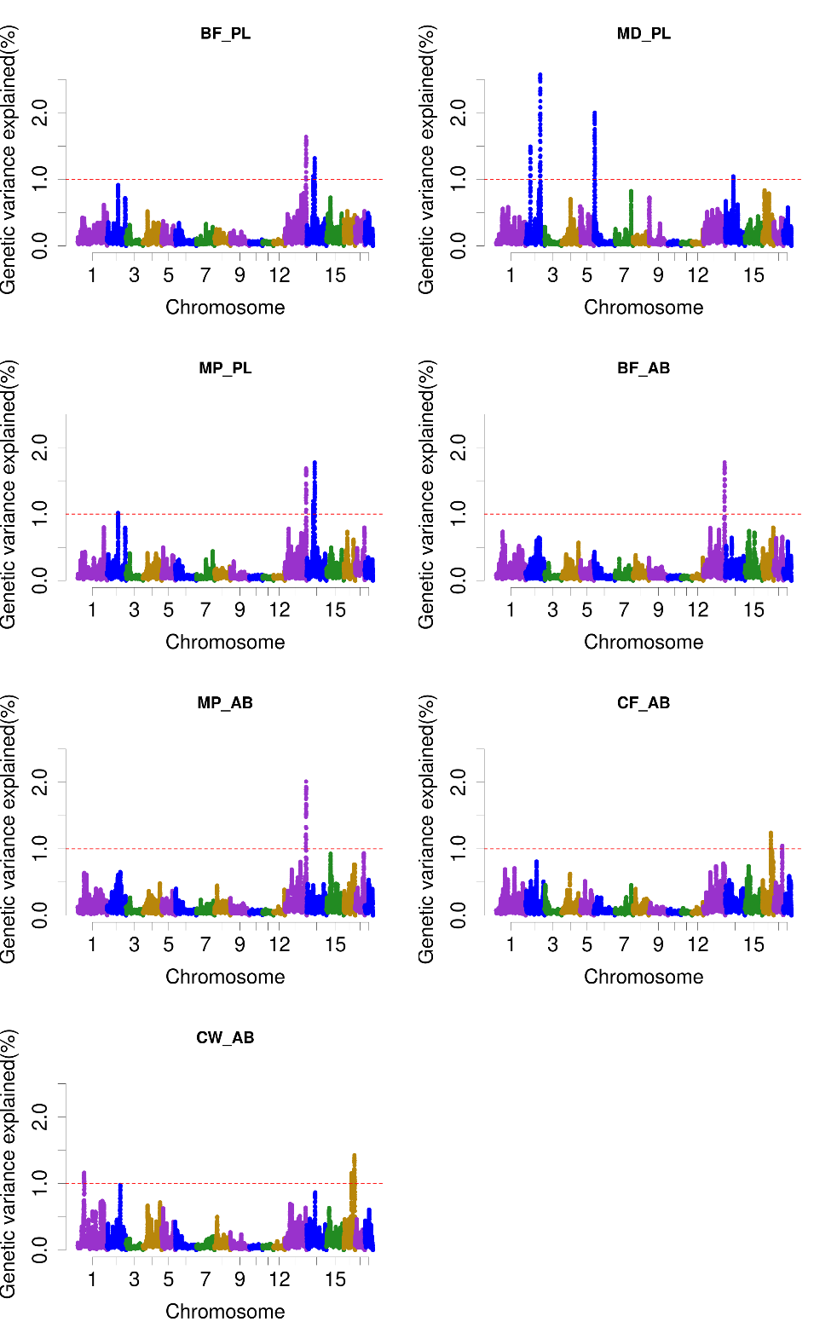
Fig. S3-2. Total additive genetic variance is explained by genomic windows across (combines 50 consecutive SNPs) for seven carcass traits in Pietrain x Landrace crossbred pigs from 7 single-trait models. BF_PL: Backfat thickness measured using Piglog at the station; MD_PL: Muscle depth measured using Piglog at the station; MP_PL: Meat percentage measured using Piglog at the station; BF_AB: Backfat thickness measured using AutoFOM at the abattoir; MP_AB: Meat percentage measured using AutoFOM at the abattoir; CF_AB: Conformation score measured using AutoFOM at the abattoir; CW_AB: Carcass weight measured using AutoFOM at the abattoir.

