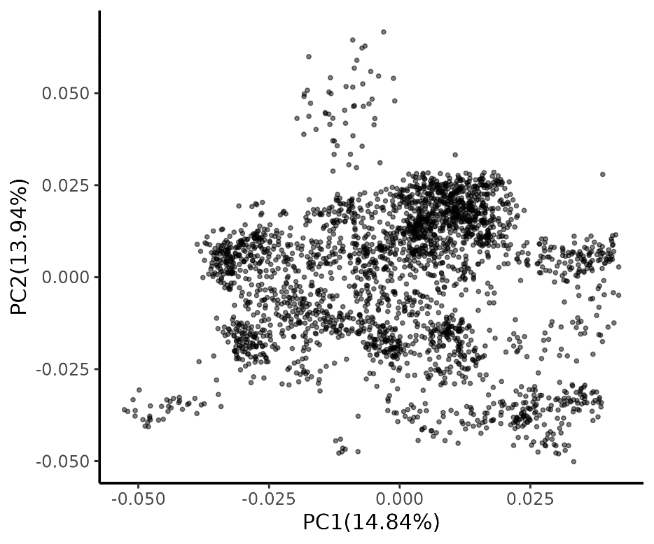
Fig. S2-1. Principal component analysis (PCA) of Belgian Pietrain x Landrace crossbred pigs used in the ssGWAS. The percentages shown on the x- and y-axes represent the proportion of total variation explained by PC1 and PC2, respectively.

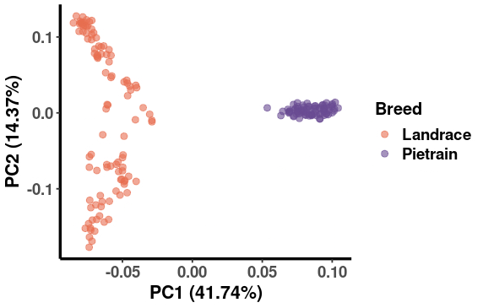
Fig. S2-2. Principal component analysis (PCA) of Belgain Pietrain and Landrace. The percentages shown on the x- and y-axes represent the proportion of total variation explained by PC1 and PC2, respectively.

