Table S4-1. Heritabilities of seven carcass traits¹ in Pietrain × Landrace crossbred pigs estimated using a seven-trait model including the first five principal components as fixed effects.
Traits | Heritability
BF_PL | 0.49 ± 0.03
MD_PL | 0.12 ± 0.02
MP_PL | 0.46 ± 0.03
BF_AB | 0.39 ± 0.02
MP_AB | 0.38 ± 0.02
CF_AB | 0.43 ± 0.03
CW_AB | 0.30 ± 0.03
¹: BF_PL: Backfat thickness measured using Piglog at the station; MD_PL: Muscle depth measured using Piglog at the station; MP_PL: Meat percentage measured using Piglog at the station; BF_AB: Backfat thickness measured using AutoFOM at the abattoir; MP_AB: Meat percentage measured using AutoFOM at the abattoir; CF_AB: Conformation score measured using AutoFOM at the abattoir; CW_AB: Carcass weight measured using AutoFOM at the abattoir
Table S4-2. Genomic regions explaining more than 1.0 % of the total genetic variance for seven carcass traits in Pietrain × Landrace crossbred pigs using a seven-trait model including the first five principal components as fixed effects.
¹Trait | Chr | Position(bp) | Var(%)
BF_PL | 13 | 204890159—207054612 | 1.83
BF_PL | 14 | 42654224—45211762 | 1.03
MD_PL | 13 | 204890159—207054612 | 1.05
MD_PL | 14 | 55471082—58008984 | 1.18
MD_PL | ²16 | 64648193—66439144 | 1.03
MP_PL | 13 | 204890159—207054612 | 1.88
MP_PL | 14 | 42654224—45211762 | 1.08
BF_AB | 13 | 204890159—207054612 | 1.80
MP_AB | 13 | 204890159—207054612 | 1.92
CF_AB | 13 | 204890159—207054612 | 1.31
CF_AB | 16 | 64648193—66439144 | 1.13
CW_AB | 1 | 31740851—34609595 | 1.08
CW_AB | 16 | 57565582—60236416 | 1.25
CW_AB | 16 | 74907982—76704560 | 1.62
¹: BF_PL: Backfat thickness measured using Piglog at the station; MD_PL: Muscle depth measured using Piglog at the station; MP_PL: Meat percentage measured using Piglog at the station; BF_AB: Backfat thickness measured using AutoFOM at the abattoir; MP_AB: Meat percentage measured using AutoFOM at the abattoir; CF_AB: Conformation score measured using AutoFOM at the abattoir; CW_AB: Carcass weight measured using AutoFOM at the abattoir; Chr: Chromosome; Position(bp): Starting and ending coordinates of the genomic window; Var (%): percentage of total genetic variance explained by the genomic window.
²: Genomic regions in bold were identified using the seven-trait model including the first five principal components as fixed effects; all other regions were identical to those detected using the original seven-trait model.

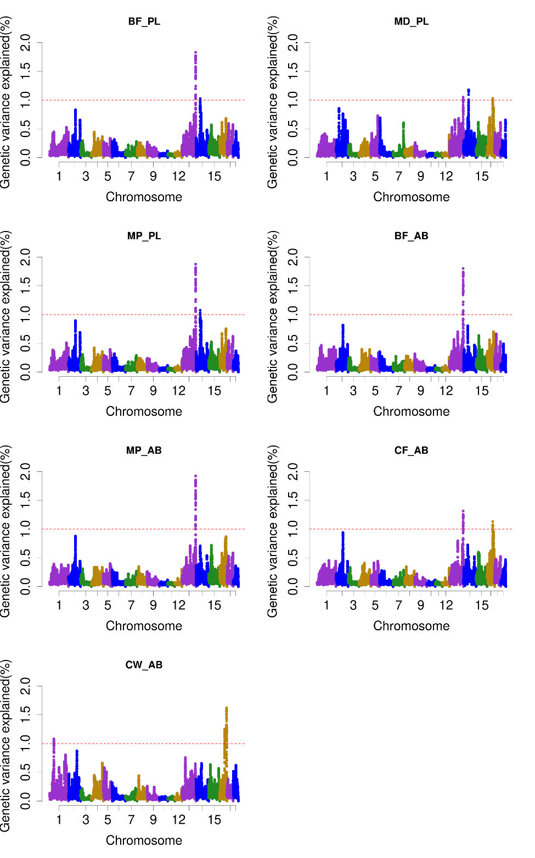
Fig. S4-1. Total additive genetic variance explained by genomic windows (each combining 50 consecutive SNPs) for seven carcass traits in Pietrain × Landrace crossbred pigs, estimated using a seven-trait model including the first five principal components. BF_PL: Backfat thickness measured using Piglog at the station; MD_PL: Muscle depth measured using Piglog at the station; MP_PL: Meat percentage measured using Piglog at the station; BF_AB: Backfat thickness measured using AutoFOM at the abattoir; MP_AB: Meat percentage measured using AutoFOM at the abattoir; CF_AB: Conformation score measured using AutoFOM at the abattoir; CW_AB: Carcass weight measured using AutoFOM at the abattoir.

