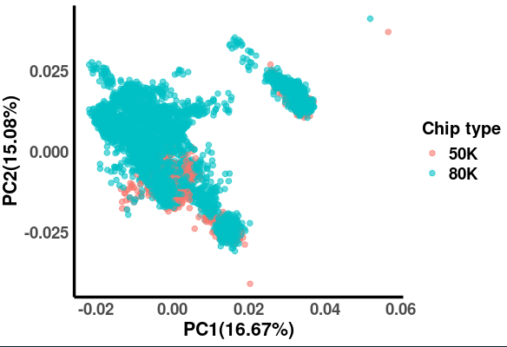
Fig. S1-1. Principal component analysis illustrating the genetic relationship between pigs genotyped with the 80K reference chip and pigs imputed from the 50K chip. The percentages on the axes represent the variance explained by PC1 and PC2.

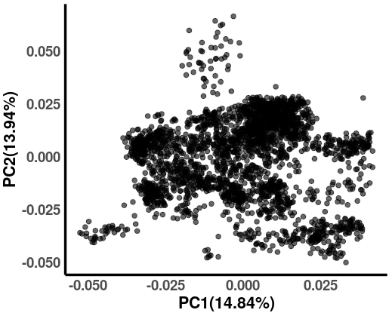
Fig. S1-2. Principal component analysis (PCA) of Belgian Pietrain x Landrace crossbred pigs used in the ssGWAS. The percentages shown on the x- and y-axes represent the proportion of total variation explained by PC1 and PC2, respectively.

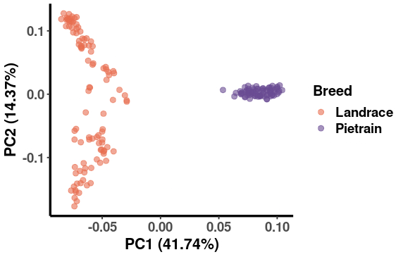
Fig. S1-3. Principal component analysis (PCA) of Belgian Pietrain and Landrace. The percentages shown on the x- and y-axes represent the proportion of total variation explained by PC1 and PC2, respectively.

