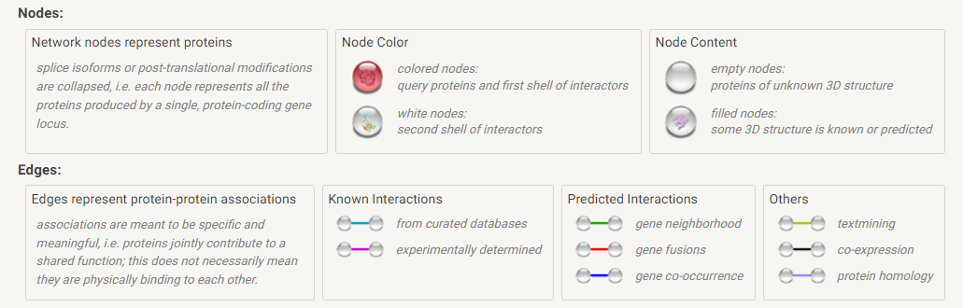

Legend for all Figures

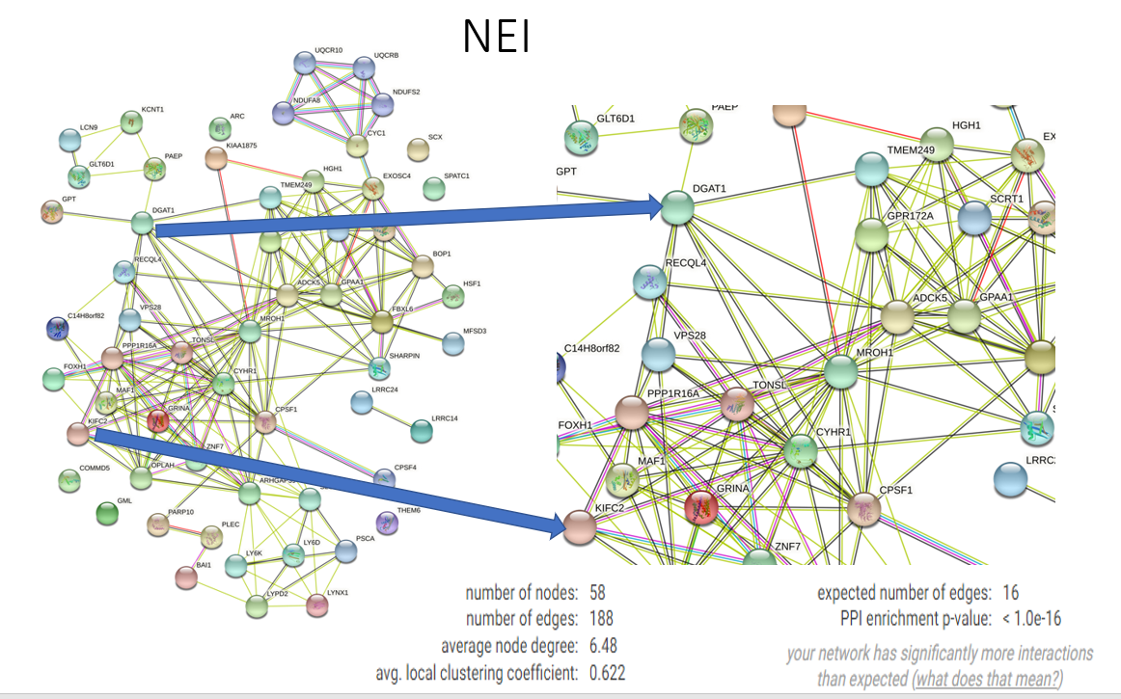

**Supplemental Figure S1** Gene Network of protein-protein interaction (PPI) for nitrogen efficiency index (NEI). Inside the red circle is top-1 hub genes in this candidate gene sets

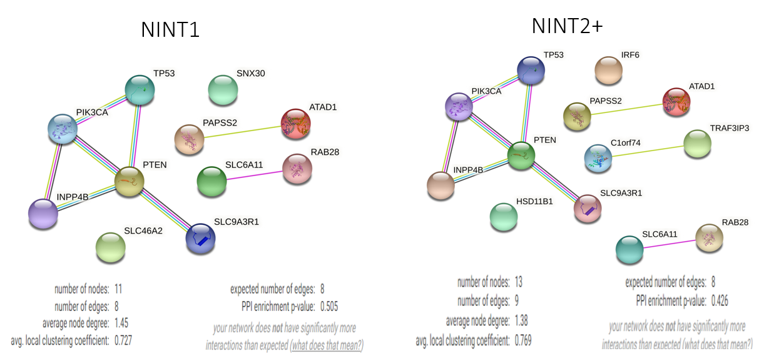

**Supplemental Figure S2** Network diagram of protein-protein interaction (PPI) for N intake in primiparous cows (NINT1) and N intake in multiparous cows (NINT2+). Inside the red circle is top-1 hub genes in this candidate gene sets

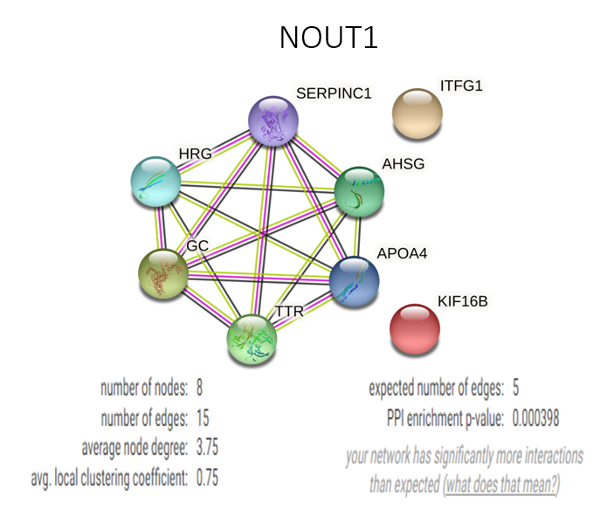

MTPN1

**Supplemental Figure S3** Network diagram of protein-protein interaction (PPI) for milk true protein N in primiparous cows (MTPN1). Inside the red circle is top-1 hub genes in this candidate gene sets

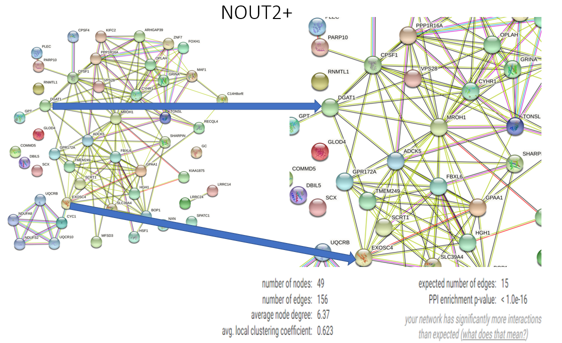

MTPN2+

**Supplemental Figure S4** Network diagram of protein-protein interaction (PPI) for milk true protein N in multiparous cows (MTPN2+). Inside the red circle is top-1 hub genes in this candidate gene sets

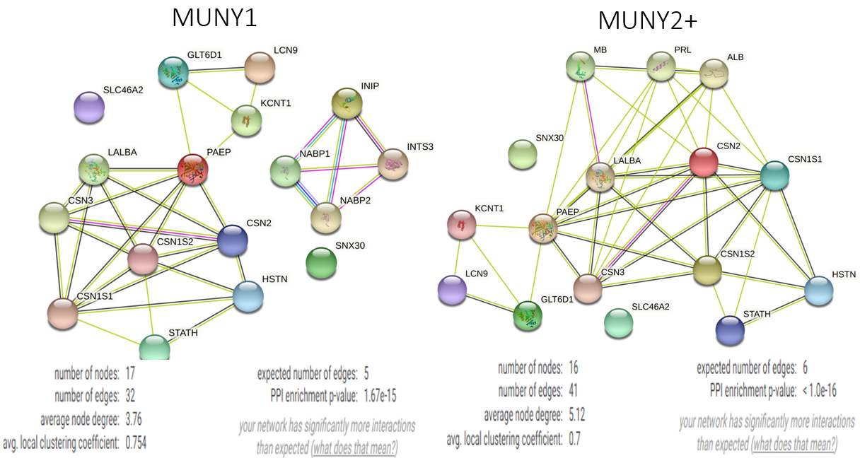

**Supplemental Figure S5** Network diagram of protein-protein interaction (PPI) for milk urea N yield in primiparous cows (MUNY1) and milk urea N yield in multiparous cows (MUNY2+). Inside the red circle is top-1 hub genes in this candidate gene sets