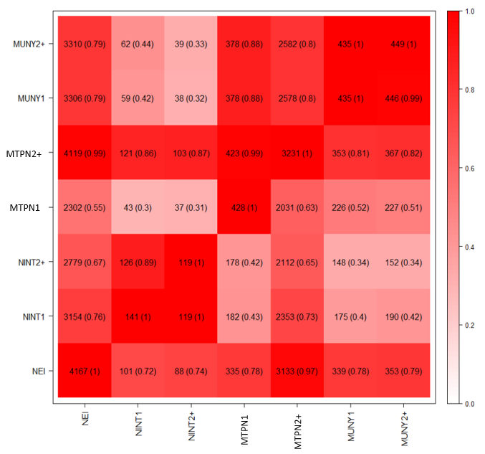

**Supplemental Figure S6:** The number (percentage) of share QTLs among N efficiency index (NEI), N intake in primiparous cows (NINT1), N intake in multiparous cows (NINT2+), milk true protein N in primiparous cows (MTPN1), milk true protein N in multiparous cows (MTPN2+), milk urea N yield in primiparous cows (MUNY1), and milk urea N yield in multiparous cows (MUNY2+). The upper left triangle is the number of candidate genes for NEI as the denominator and the lower right triangle is the number of candidate genes for traits as the denominator

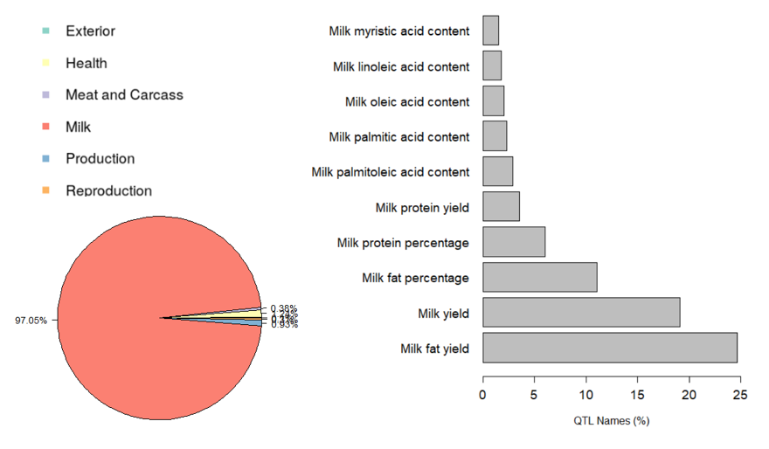

**Supplemental Figure S7:** The percentage of QTLs class for QTL of the top-3 genomic regions selected in the N efficiency index (**NEI**) (pie chart, left) and top-10 QTLs in the major QTLs class (Milk) (bar plot, right)

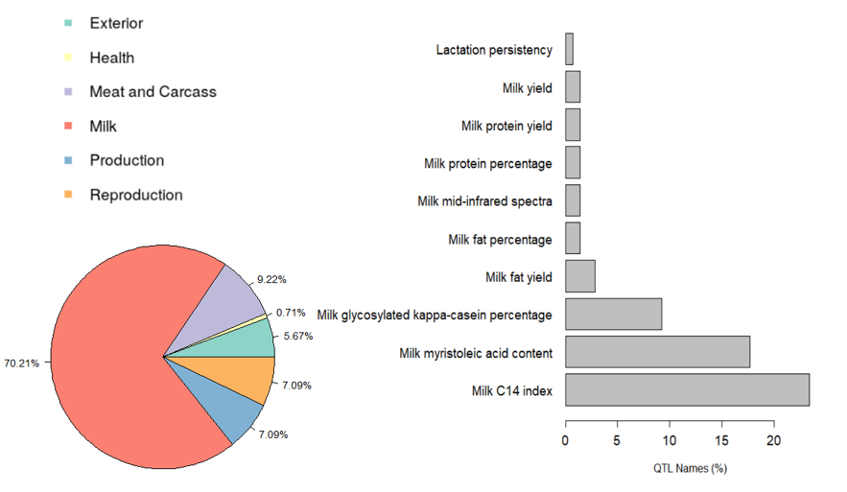

**Supplemental Figure S8:** The percentage of QTLs class for QTL of the top-3 genomic regions selected in the N intake in primiparous cows (**NINT1**) (pie chart, left) and top-10 QTLs in the major QTLs class (Milk) (bar plot, right)

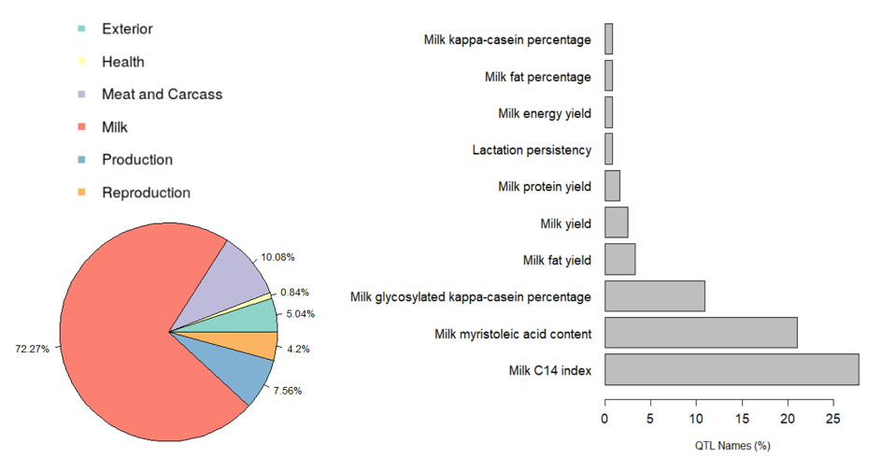

**Supplemental Figure S9:** The percentage of QTLs class for QTL of the top-3 genomic regions selected in the N intake in multiparous cows (**NINT2+**) (pie chart, left) and top-10 QTLs in the major QTLs class (Milk) (bar plot, right)

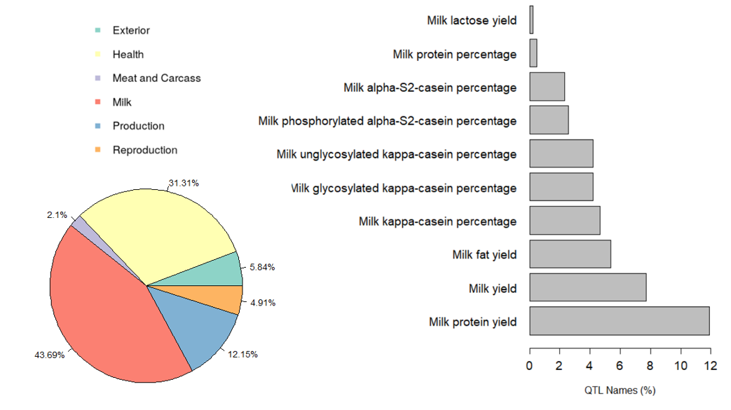

**Supplemental Figure S10:** The percentage of QTLs class for QTL of the top-3 genomic regions selected in the milk true protein N in primiparous cows (**MTPN1**) (pie chart, left) and top-10 QTLs in the major QTLs class (Milk) (bar plot, right)

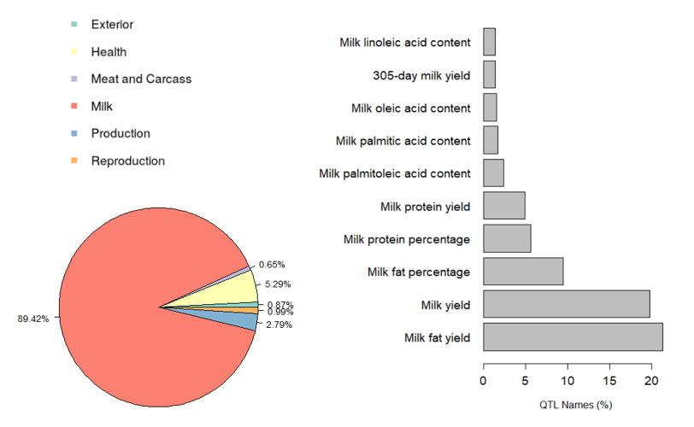

**Supplemental Figure S11:** The percentage of QTLs class for QTL of the top-3 genomic regions selected in the milk true protein N in multiparous cows (**MTPN2+**) (pie chart, left) and top-10 QTLs in the major QTLs class (Milk) (bar plot, right)

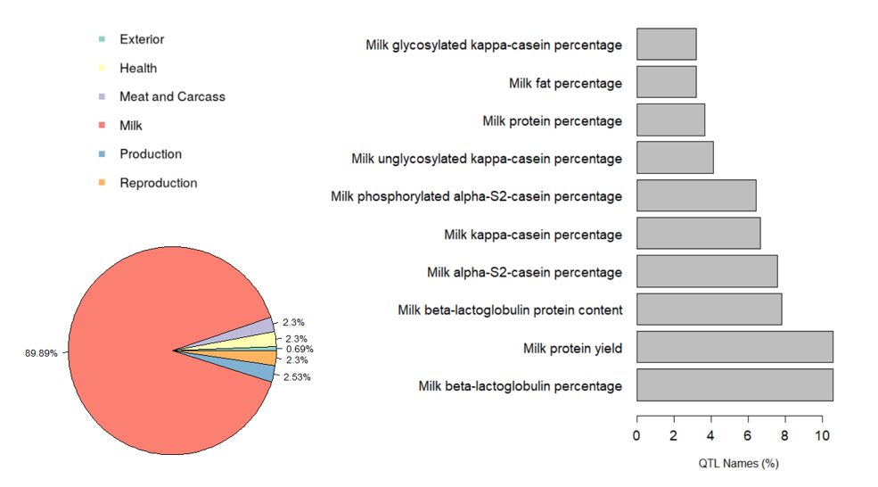

**Supplemental Figure S12:** The percentage of QTLs class for QTL of the top-3 genomic regions selected in milk urea N yield in primiparous cows (**MUNY1**) (pie chart, left) and top-10 QTLs in the major QTLs class (Milk) (bar plot, right)

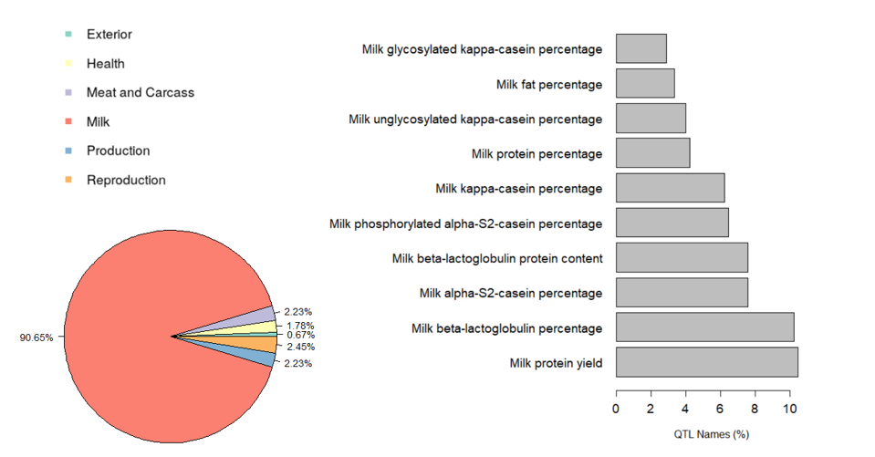

**Supplemental Figure S13:** The percentage of QTLs class for QTL of the top-3 genomic regions selected in milk urea N yield in multiparous cows (**MUNY2+**) (pie chart, left) and top-10 QTLs in the major QTLs class (Milk) (bar plot, right)