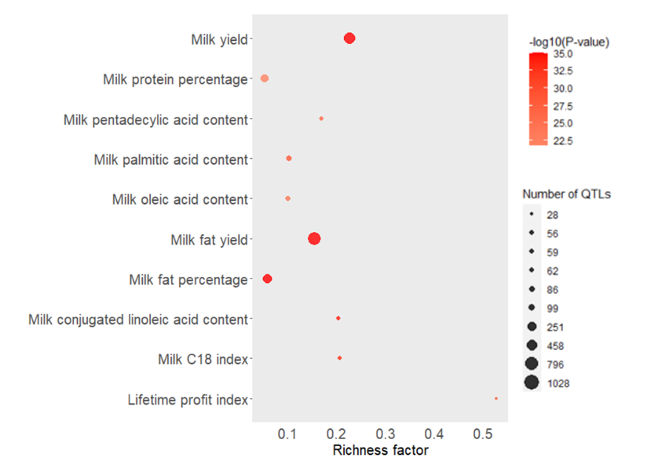

**Supplemental Figure S14:** The top-10 of enrichment QTLs among N efficiency index (**NEI**)

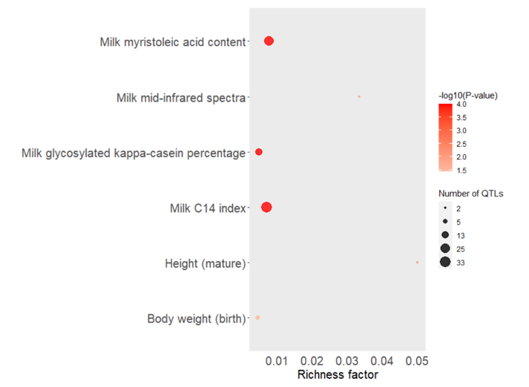

**Supplemental Figure S15:** The top-10 of enrichment QTLs among N intake in primiparous cows (**NINT1**)

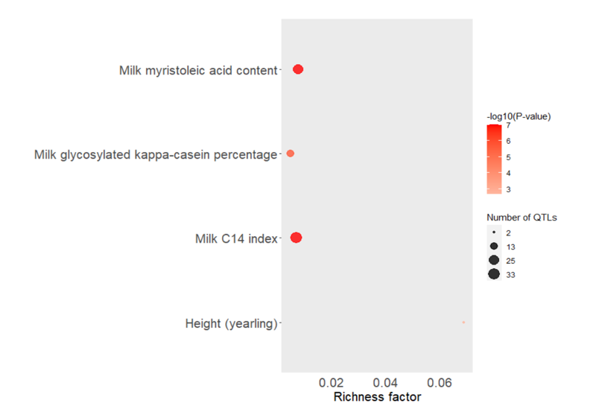

**Supplemental Figure S16:** The top-10 of enrichment QTLs among N intake in multiparous cows (**NINT2+**)

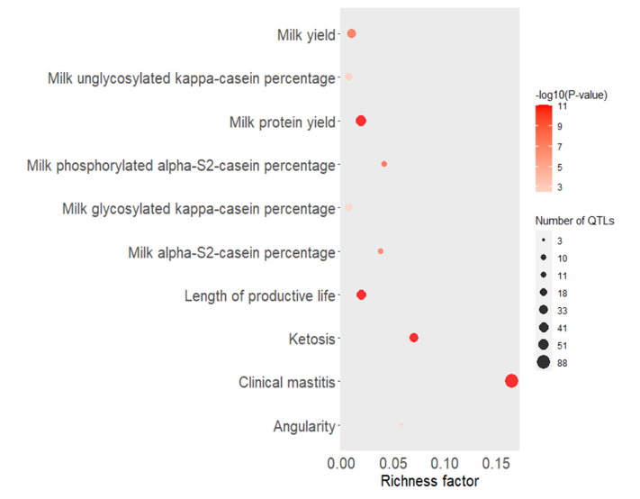

**Supplemental Figure S17:** The top-10 of enrichment QTLs among milk true protein N in primiparous cows (**MTPN1**)

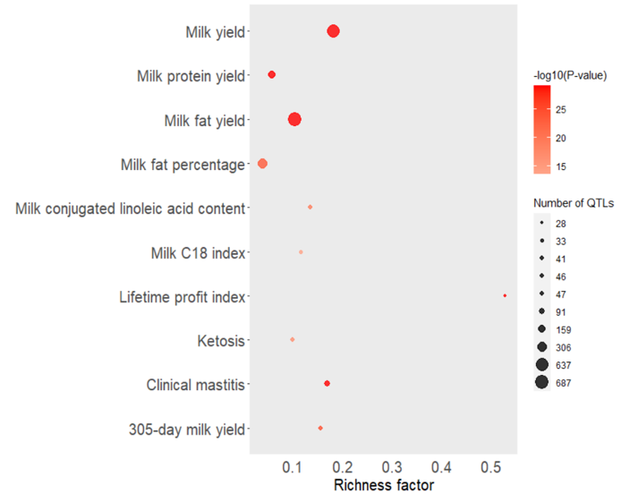

**Supplemental Figure S18:** The top-10 of enrichment QTLs among milk true protein N in multiparous cows (**MTPN2+**)

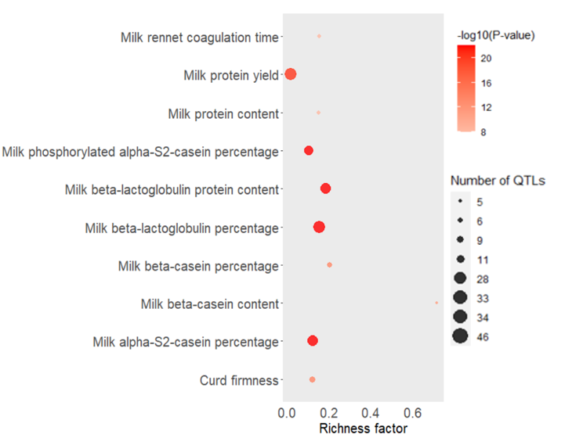

**Supplemental Figure S19:** The top-10 of enrichment QTLs milk urea N yield in primiparous cows (**MUNY1**)

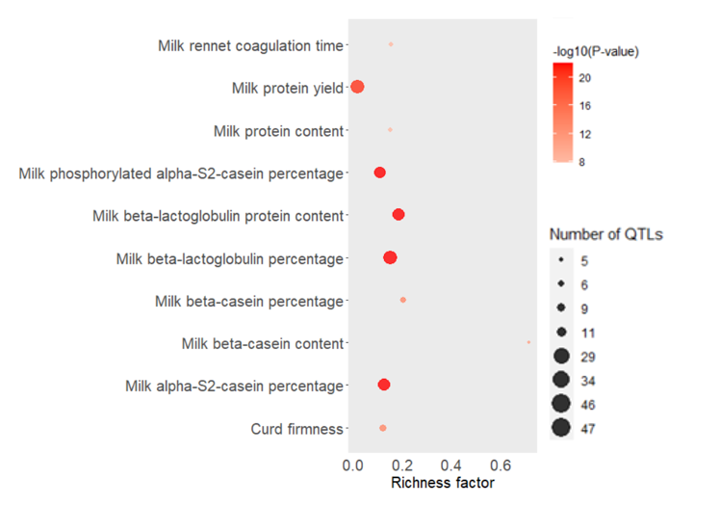

**Supplemental Figure S20:** The top-10 of enrichment QTLs among milk urea N yield in multiparous cows (**MUNY2+**)