Supplemental work 1: unsupervised learning
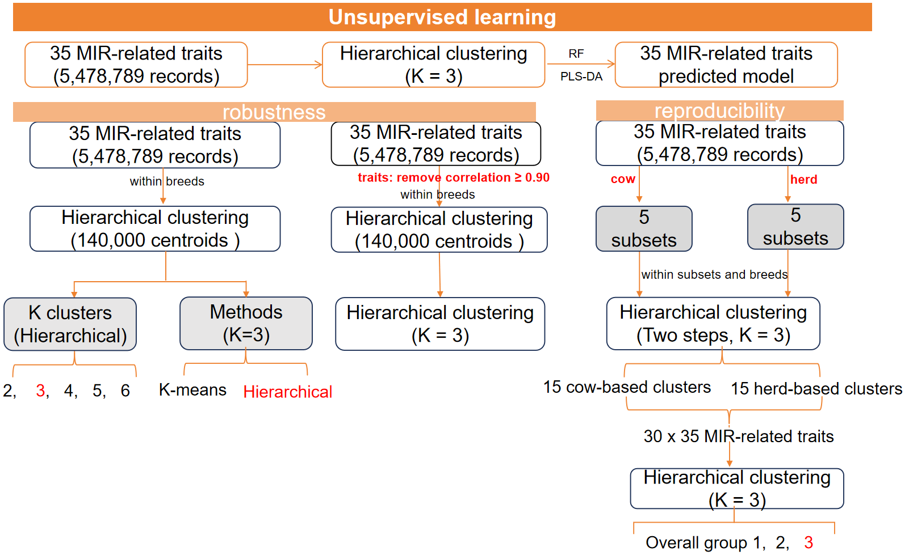
Supplemental Figure S1. Analytical framework used to evaluate cluster-number selection, clustering-method sensitivity, trait-redundancy robustness, and cow- and herd-level reproducibility.

- Robustness and reproducibility of the unsupervised clustering solution
The robustness and reproducibility of the unsupervised clustering framework was evaluated through sensitivity analyses of cluster number, clustering method, trait composition, and different datasets.
- Method (cluster number, K= 2-6): Using the 140,000 first-stage centroids derived from the complete dataset, Ward.D2 hierarchical clustering with Euclidean distance was performed, and the resulting dendrogram was cut to obtain solutions with K = 2–6 clusters. Candidate solutions were evaluated according to cluster size and balance, average silhouette width, and resampling-based stability. For computational feasibility, silhouette width was calculated using a fixed random sample of 10,000 centroids. Stability was evaluated on a separate fixed sample of 10,000 centroids using 100 repeated subsamples for each candidate K; each repeat sampled 80% of this stability set without replacement, corresponding to 8,000 centroids per repeat. The resampled data were reclustered using the same Ward.D2 procedure, and the resulting partitions were compared with the corresponding reference K-cluster solution using the adjusted Rand index, normalized mutual information, best-matched assignment agreement, and cluster-specific Jaccard indices after label alignment. Selection of the primary K = 3 solution considered cluster separation, stability, minimum cluster size, and biological interpretability collectively, rather than relying on a single numerical criterion.
Results: Cluster-number diagnostics did not converge on a single optimal solution (Supplemental Figure S1.1). Average silhouette width was highest for K = 2 (0.134). In the stability analysis, which comprised 100 repeated 80% subsamples of a fixed 10,000-centroid stability set (8,000 centroids per repeat), K = 2 also showed the highest mean adjusted Rand index (ARI = 0.282) and minimum cluster-wise Jaccard index (0.580). For K = 3, the average silhouette width, mean ARI, and minimum cluster-wise Jaccard index were 0.103, 0.198, and 0.297, respectively, and the three clusters accounted for 62.8%, 15.2%, and 22.1% of the centroids. Solutions with K = 4–6 showed lower average silhouette widths than K = 3 (0.089, 0.050, and 0.062, respectively) and only modest mean ARI values (0.216–0.233). In addition, the K = 6 solution produced a small cluster containing only 4.6% of the centroids.
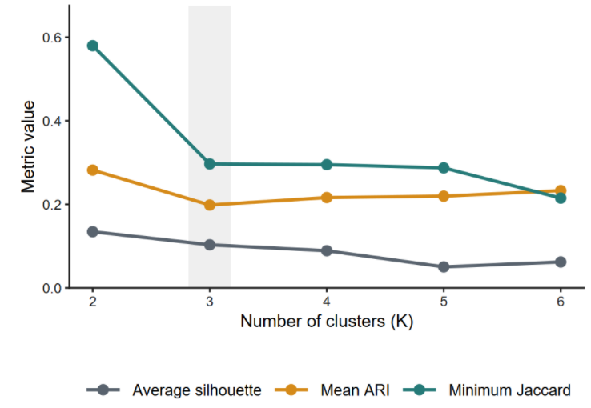
Interpretation: These diagnostics did not identify K = 3 as a uniquely optimal statistical solution, as the coarser K = 2 partition showed stronger separation and resampling stability. Nevertheless, K = 3 was retained as a balanced compromise between statistical support and biological interpretability. It provided a finer resolution of the phenotypic heterogeneity while maintaining three non-trivial clusters, whereas K = 4–6 reduced cluster separation and, at K = 6, generated a comparatively small cluster. Accordingly, the K = 3 solution should be interpreted as a biologically motivated working resolution rather than as an unequivocal optimum determined by the numerical diagnostics alone.
Supplemental Figure S1.1. Comparison of cluster separation and stability metrics across candidate cluster numbers (K = 2–6).

- Method (clustering method, hierarchical vs. K-means): The To assess the sensitivity of the K = 3 solution to the choice of clustering algorithm, the primary Ward.D2 hierarchical solution was compared with a k-means solution generated from exactly the same 140,000 first-stage centroids. Both analyses used the same 35 standardized MIR-related traits and the same scaling parameters, ensuring that the clustering algorithm was the only component that differed between the two analyses. The Ward.D2 solution was obtained by cutting the hierarchical clustering dendrogram at K = 3, whereas k-means clustering was fitted with K = 3 by minimizing the within-cluster sum of squared Euclidean distances. Because cluster labels are arbitrary across algorithms, the k-means labels were aligned with the Ward.D2 labels using the Hungarian assignment algorithm, which selected the one-to-one cluster mapping that maximized agreement in the contingency table. Agreement between the aligned partitions was quantified using the best-matched assignment rate, adjusted Rand index (ARI), and normalized mutual information (NMI). To determine whether the two algorithms recovered similar multivariate phenotypic patterns despite possible differences in record-level membership, cluster prototype profiles were calculated as the mean standardized trait values within each cluster. Similarity between matched Ward.D2 and k-means prototypes was then evaluated using Pearson profile correlations and the sum of squared profile differences.
Results: After optimal one-to-one label alignment using the Hungarian algorithm, the Ward.D2 and k-means partitions agreed for 93,068 of the 140,000 first-stage centroids, corresponding to a best-matched agreement of 66.5% (Supplemental Figure S1.2). The adjusted Rand index (ARI = 0.229) and normalized mutual information (NMI = 0.289) indicated only moderate concordance in exact cluster membership. In contrast, the overall correlation between the matched prototype profiles was high (r = 0.961), and cluster-specific profile correlations ranged from 0.935 to 0.989. Within the Ward.D2 clusters, 56.9%, 67.9%, and 92.8% of the centroids were retained in the corresponding aligned k-means clusters for Clusters 1, 2, and 3, respectively. However, the aligned k-means Cluster 3 also contained 34.2% of Ward.D2 Cluster 1 and 24.1% of Ward.D2 Cluster 2, indicating substantial differences in cluster boundaries and composition.
Interpretation: The Ward.D2 hierarchical clustering was retained as the primary clustering method, whereas k-means was used as an alternative sensitivity analysis. The high correlations between the matched prototype profiles indicated that the two algorithms recovered broadly similar multivariate trait patterns. However, the modest ARI, NMI, and best-matched agreement demonstrated that exact centroid membership and cluster boundaries were sensitive to the clustering algorithm. Thus, the results support the partial robustness of the broad phenotypic profiles underlying the Ward.D2 solution, while indicating that individual cluster assignments and cluster composition were algorithm dependent.
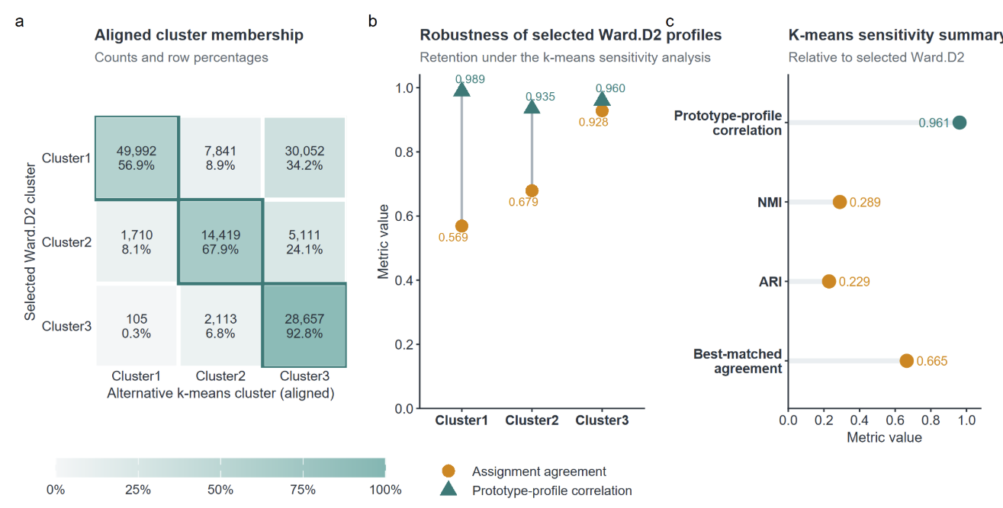
Supplemental Figure S1.2. Ward.D2 hierarchical clustering was retained as the primary K = 3 solution
c
b
a

- Methods (trait composition, 35 traits vs. 33 traits). To evaluate whether highly correlated traits disproportionately influenced the clustering structure, pairwise Pearson correlations were calculated among the 35 traits using all 5,478,789 quality-controlled records. Trait pairs with an absolute correlation of |r| ≥ 0.90 were considered highly correlated. For each identified pair, the trait showing the higher mean absolute correlation with the remaining traits was temporarily excluded from the sensitivity analysis. This procedure identified two highly correlated pairs: MAP–PROT (r = 0.992) and M_LCFA–M_C18_1cis9 (r = 0.928), resulting in the temporary exclusion of MAP and M_LCFA.
The remaining 33 traits were re-standardized using means and standard deviations estimated from the complete quality-controlled dataset. The entire two-stage Ward.D2 clustering procedure was then repeated using the same settings as the primary analysis. Briefly, records were stratified by breed, reproducibly randomized within breed, divided into chunks of no more than 20,000 records, and reduced to up to 500 Ward.D2 centroids per chunk. The resulting first-stage centroids were pooled, and exact Ward.D2 hierarchical clustering was applied to obtain the prespecified K = 3 solution. The 33-trait sensitivity solution was compared with the primary 35-trait solution using a fixed simple random sample of 200,000 records drawn without replacement from the 5,478,789 quality-controlled records (evaluation seed = 20261611). This sampling was used only for solution comparison; both clustering solutions were constructed using the complete dataset. Records were assigned to the nearest prototype under the corresponding trait set and scaling parameters. The three reduced-solution clusters were optimally matched to the primary clusters by minimizing the total squared distance between prototype profiles in the shared 33-trait space. Agreement was quantified using best-matched record agreement, adjusted Rand index (ARI), normalized mutual information (NMI), cluster-specific assignment agreement, and Pearson correlations between matched prototype profiles.
Results: The correlation screening identified two trait pairs exceeding the |r| ≥ 0.90 threshold: MAP–PROT (r = 0.992) and M_LCFA–M_C18_1cis9 (r = 0.928) (Supplemental Figure S1.3). MAP and M_LCFA were therefore temporarily excluded from the correlation-reduced sensitivity model, leaving 33 traits. Across the 200,000 evaluation records, the 33-trait and primary 35-trait solutions showed 79.7% best-matched record agreement (ARI = 0.435; NMI = 0.506). The mean Pearson correlation between matched prototype profiles was 0.971. Cluster-specific assignment agreement was 67.9%, 71.6%, and 98.5% for Clusters 1, 2, and 3, respectively. The corresponding prototype-profile correlations were 0.972, 0.993, and 0.948.
Interpretation: Removing the two highly correlated traits preserved the broad prototype-profile structure, as indicated by the high mean profile correlation of 0.971. However, the reduced-trait solution reassigned 20.3% of the evaluation records, and the moderate ARI of 0.435 indicated that individual cluster membership was not invariant to trait removal. Reassignment occurred mainly across Clusters 1 and 2, whereas Cluster 3 membership remained nearly unchanged.
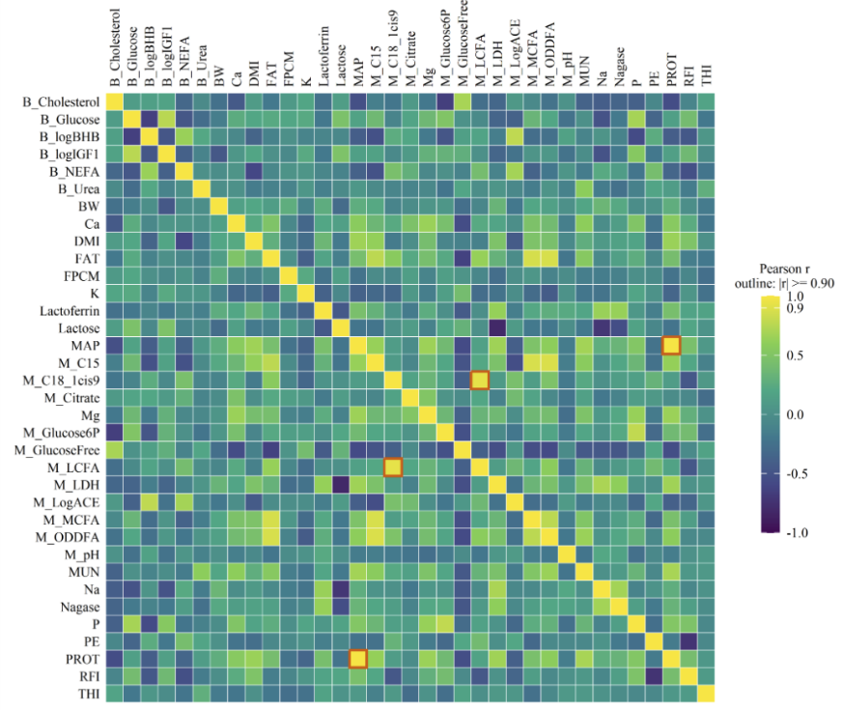
Therefore, the analysis supports robustness of the principal cluster profiles to trait redundancy, but it does not support removing MAP or M_LCFA from the primary feature set solely on the basis of pairwise correlation. In particular, MAP cannot be assumed to be fully interchangeable with PROT, nor M_LCFA with M_C18_1cis9, for individual-record classification. Accordingly, all 35 traits were retained in the primary clustering model, while the 33-trait analysis was presented only as a sensitivity analysis.
Supplemental Figure S1.3. Pairwise Pearson correlations among the 35 traits used for clustering (n = 5,478,789)
- Methods (differet datasets, Reproducibility across cow- and herd-grouped populations)：Population-level reproducibility was assessed using two complementary partitions of the complete quality-controlled dataset. Cows were assigned to five mutually exclusive cow subsets, and herds were independently assigned to five mutually exclusive herd subsets. All repeated records from the same cow were retained within one cow subset, and all records from the same herd were retained within one herd subset. Thus, no cow or herd was shared across subsets within its corresponding validation scheme.
The complete two-stage Ward.D2 clustering procedure was independently repeated in each of the ten subsets. Scaling parameters were estimated separately within each subset. Within breed, records were reproducibly randomized and divided into chunks of no more than 20,000 records, and each chunk was reduced to up to 500 Ward.D2 centroids. The subset-specific centroids were subsequently pooled within each subset and subjected to exact Ward.D2 clustering with K = 3. This produced three independently estimated profiles per subset: 15 cow-based and 15 herd-based profiles.
The 30 profiles were pooled and hierarchically clustered by Ward.D2 in the 35-dimensional subset-standardized profile space, with the tree cut into three pooled overall groups. Reproducibility was evaluated by the number of subsets contributing zero, one, or two profiles to each pooled group, the number recovering exactly one profile from each group, and Pearson correlations and Euclidean distances between profiles assigned to the same versus different groups. To relate the pooled groups to the primary full-data solution, local profile means were converted to the full-data standardization scale and matched one-to-one to the three full-data reference profiles by maximizing total Pearson profile similarity.
Results：The 30 independently estimated subset profiles formed three pooled overall groups containing 13, 5, and 12 profiles, respectively (Supplemental Figure S1.4). Exactly one profile from each pooled group was recovered in five of the ten subsets: Cow Subsets 1 and 5 and Herd Subsets 1, 2, and 3. Thus, complete one-to-one recovery occurred in two of five cow subsets and three of five herd subsets.
Overall Groups 1 and 3 were represented in all five cow and all five herd subsets, whereas Overall Group 2 was represented only in Cow Subsets 1 and 5 and Herd Subsets 1–3. Profiles assigned to the same pooled group were more similar than those assigned to different groups. Mean within-group Pearson correlation was 0.643, compared with −0.400 between groups. Mean within-group Euclidean distance was 1.984, compared with 5.342 between groups
Interpretation: The consistent representation of Overall Groups 1 and 3 across all cow- and herd-grouped subsets, together with the higher within-group similarity and lower within-group distance, supports recurrence of the two dominant physiological profiles across independent animal and herd populations. In particular, the pooled profile aligned with full-data Cluster 3 was recovered in all ten subsets, supporting strong profile-level reproducibility of Cluster 3.
However, exact one-to-one recovery of all three profiles occurred in only half of the subsets. The smaller Overall Group 2, corresponding to the full-data Cluster 2-like profile, was not separated as a distinct local profile in five subsets, while some of the more prevalent profiles split into two local clusters. Because Cluster 2 contained fewer records, its representation and separation were more sensitive to differences in population composition and effective sample size. Its non-recovery in individual subsets should therefore not be interpreted as evidence that this physiological profile was absent. Indeed, the full-data analysis based on 5,478,789 records resolved this less prevalent profile as a distinct cluster, indicating that the much larger population provided sufficient representation to identify it. Reproducibility was therefore strongest for the broad Cluster 1-like and Cluster 3-like structures, whereas reliable separation of the less prevalent Cluster 2-like profile depended more strongly on population coverage and sample size.
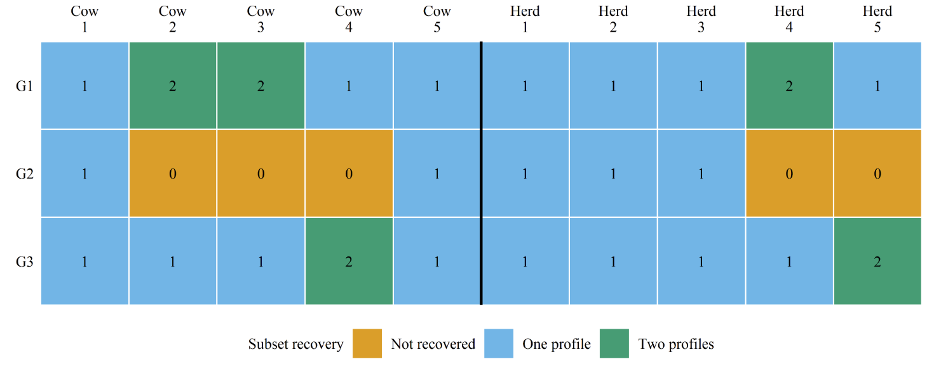
Supplemental Figure S1.4. Recovery of three overall physiological profile groups across 5 cow- and 5 herd-grouped subsets. G1–G3 denote Overall Groups 1–3, respectively.
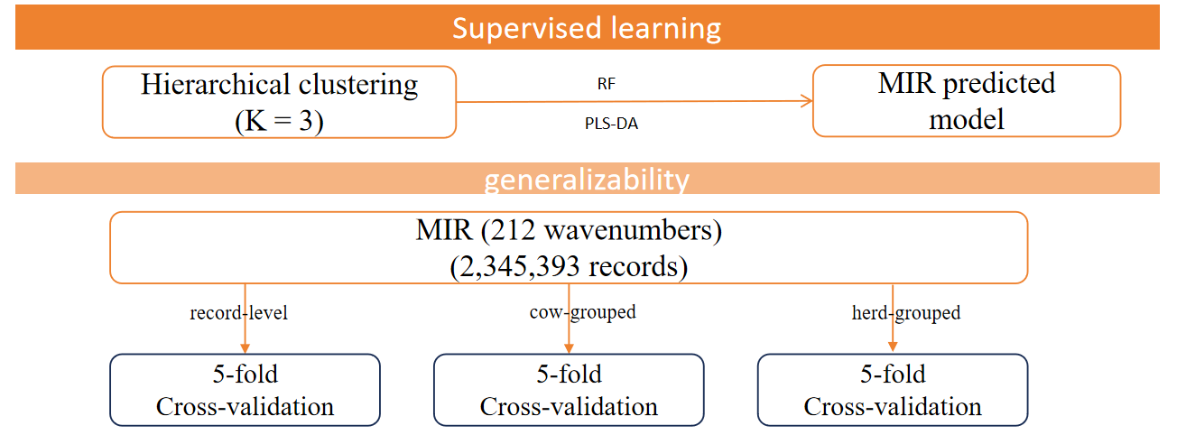
Supplemental work 2: supervised learning by MIR directly predicted the model
Supplemental Figure S2. Framework for evaluating the predictive performance and generalizability of direct MIR-based reconstruction of unsupervised cluster labels.

Methods: Reference cluster labels for individual test-day records were obtained from the final Ward.D2 (K=3) unsupervised clustering solution based on the 35 MIR-related predicted traits. These labels were linked to the corresponding MIR spectra at the record level. Partial least squares discriminant analysis (PLS-DA; 50 components) and random forest (RF; 500 trees, mtry=40, minimum node size = 1, and Gini splitting) were trained to reconstruct the three reference cluster labels. The analytical dataset comprised 2,345,393 test-day records from 266,580 unique cows distributed across 5,437 herds. Each model was evaluated using five-fold cross-validation under record-level, cow-grouped, and herd-grouped splitting. In cow- and herd-grouped cross-validation, all records from the same cow or herd were retained within one-fold, respectively, and fold-level leakage audits were used to confirm that the grouping entity did not overlap between training and validation data. Performance was evaluated from pooled out-of-fold predictions using balanced accuracy, Cohen’s kappa, multiclass AUC, and macro-F1. Cluster-specific Performance was evaluated out-of-fold predictions using precision, recall, and F1 score.
Results: Across record-, cow-, and herd-level validation, RF achieved multiclass AUC values of 0.989, 0.989, and 0.989; balanced accuracies of 0.893, 0.893, and 0.893; kappa values of 0.888, 0.888, and 0.887; and Macro-F1 values of 0.909, 0.909, and 0.909, respectively. The corresponding PLS-DA values were 0.986, 0.986, and 0.986 for multiclass AUC; 0.872, 0.872, and 0.872 for balanced accuracy; 0.889, 0.889, and 0.889 for kappa; and 0.901, 0.901, and 0.901 for Macro-F1 (Supplementary Fig. S2.1).
Across the three validation strategies, RF exceeded PLS-DA by approximately 0.003 in multiclass AUC, 0.021 in balanced accuracy, and 0.008–0.009 in Macro-F1. In contrast, PLS-DA yielded slightly higher kappa values, with an advantage of 0.001–0.002. Moving from record-level to herd-grouped validation reduced all RF performance estimates by less than 0.001, while PLS-DA performance was similarly stable.
Cluster-specific performance was also consistent across the three validation strategies (Supplementary Fig. S2.2). Cluster 2, which contained 281,418 records compared with 1,236,006 and 827,969 records for Clusters 1 and 3, respectively, was the most difficult class to recover. For RF, Cluster 2 precision remained at 0.923, recall ranged from 0.768 to 0.769, and F1 ranged from 0.838 to 0.839. PLS-DA achieved substantially higher precision for Cluster 2 (0.993) but lower recall (0.676) and F1 (0.804). Thus, RF improved Cluster 2 recall by 0.091–0.093 and F1 by 0.034–0.035, although its precision was 0.069–0.070 lower. By comparison, recall remained at approximately 0.968 and 0.943 for Clusters 1 and 3 with RF and at 0.980 and 0.961 with PLS-DA, respectively.
Interpretation: The consistently higher multiclass AUC, balanced accuracy, and Macro-F1 obtained with RF indicate that RF provided the stronger overall reconstruction of the three reference clusters, particularly when performance was evaluated with equal emphasis on each class. Although PLS-DA produced slightly higher kappa values, the absolute differences were small and were not accompanied by higher balanced accuracy or Macro-F1. Thus, when the four aggregate metrics are considered jointly, the results favour RF in terms of overall predictive performance.
The cluster-specific analysis further showed that the main difference between the models concerned recovery of Cluster 2. PLS-DA classified Cluster 2 conservatively, producing very high precision but missing approximately one-third of the reference Cluster 2 records. RF accepted a modest reduction in precision but recovered substantially more Cluster 2 records, resulting in higher recall and F1. This improved recovery of the least prevalent cluster contributed to the higher balanced accuracy and Macro-F1 observed for RF. In contrast, both models recovered Clusters 1 and 3 with consistently high recall.
The preservation of both aggregate and cluster-specific performance under cow- and herd-grouped cross-validation suggests that discrimination was not explained solely by repeated spectra from the same cows or herds appearing in both training and validation data. The models therefore showed internal generalizability to previously unseen cows and herds within the study population.
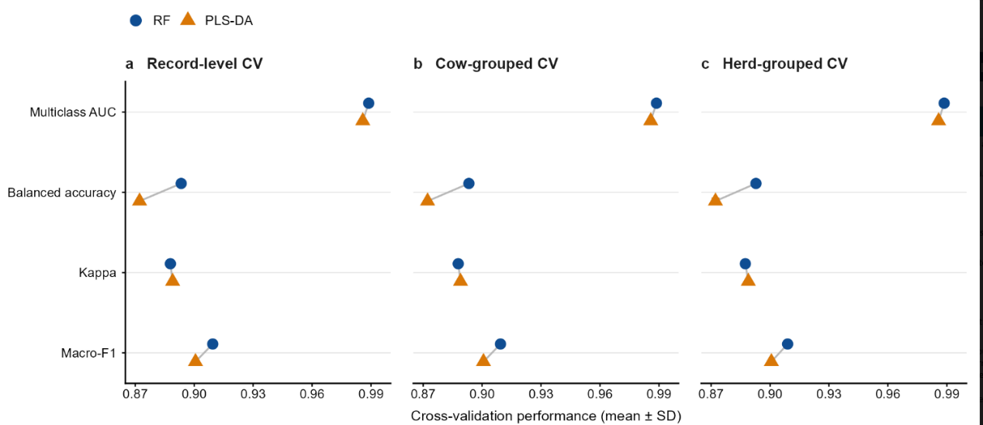
Supplemental Figure S2.1. Cross-validation overall performance of RF and PLS-DA in reconstructing MIR-derived clusters

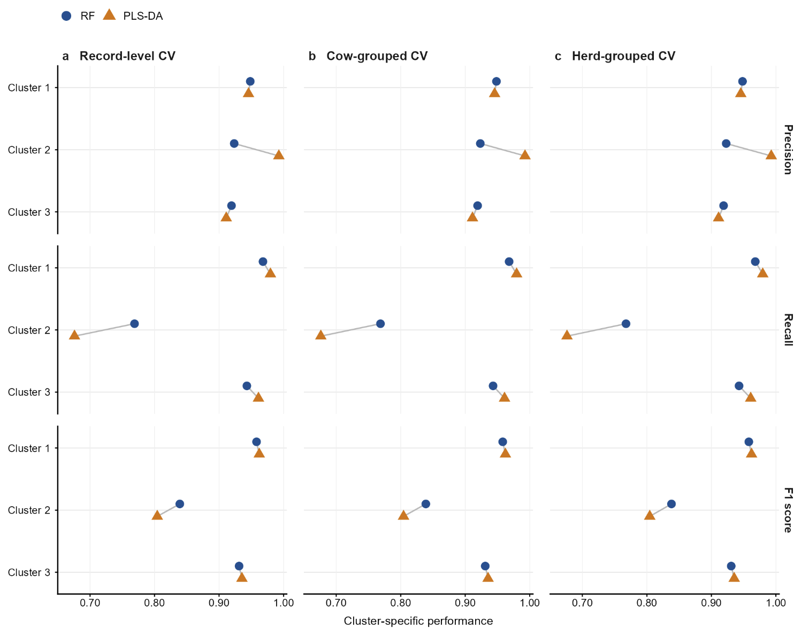
Supplemental Figure S2.2. Cluster-specific cross-validation performance of RF and PLS-DA MIR classifiers

