Assignment 1
Ans-1
- Frontend :- The visible part of a website that users interact with directly (UI).
Exp: the product images, buttons, and search box on Amazon. Made with HTML, CSS, JavaScript
- Backend :- The server-side logic that processes user requests and interacts with the database.
Exp: when you click “buy”, the backend checks your payment, saves the order, and sends confirmation. Built with Node.js, Python, Java, PHP, etc
- Full-stack Development:- Combines both frontend and backend skills. Uses both frontend and backend tools.
Exp: a person who builds the website layout and also writes the code that saves orders to the database.

Ans-2
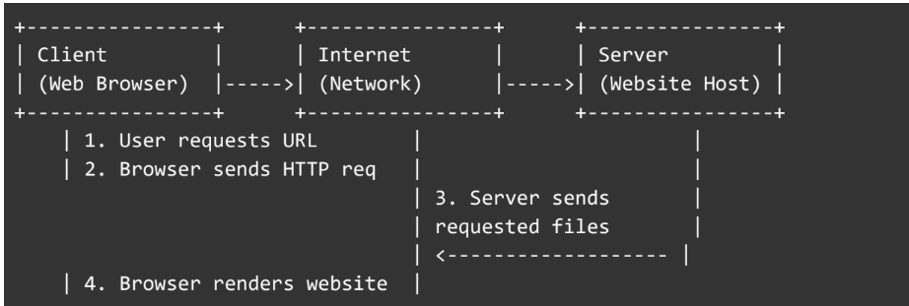
Ans-3
- User type a web address (or click a link).
- Browser finds the server’s address.
- Browser sends an HTTP(S) request to the server.
- Server sends back files (HTML, CSS, JS) or data.
- Browser renders the page to the user.
Ans-4
- Code editor (VS Code) — write HTML/CSS/JS.
- Browser (Chrome, Firefox) — test and see pages.
- Live Server extension (in VS Code) — preview page while editing.
- Node.js — run JavaScript on the server and install helpful tools.
- Git & GitHub — save versions of your code and share it.
- Terminal / Command Prompt — run commands (start server, install packages).
- Database (MySQL, MongoDB) — if your site stores data (users, posts, orders).

Ans-5
It is a software that stores, processes, and delivers web pages to users via the Internet. Example:- Apache HTTP Server (Open-source, widely used),Nginx (High performance, used by Netflix),Node.js (JavaScript runtime often used as a lightweight web server).

Ans-6
- Frontend developer: builds the pages people see, makes things interactive and nice-looking.
- Backend developer: writes the code that does logic, talks to the database, and secures the app.
- Database administrator: organizes the database, keeps it fast and safe, and makes backups.

Ans-7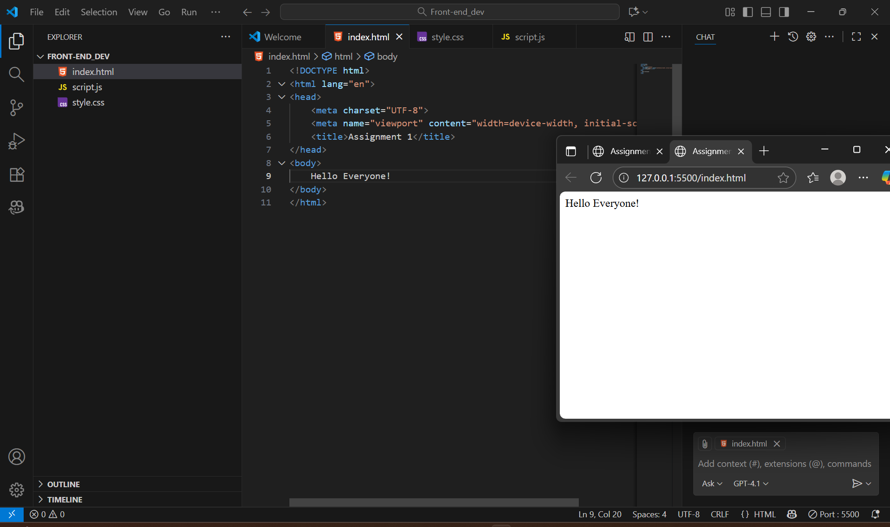

Ans-8
- Static site: displays fixed content, every user sees the same page.
Exp: a simple portfolio site with only HTML and CSS.
- Dynamic site: Changes content based on user input or database.
Exp: Facebook feed, or an online store that shows products from a database.
Ans-9
- Google Chrome — uses Blink. Fast and common.
- Mozilla Firefox — uses Gecko. Different layout and privacy features.
- Microsoft Edge — uses Blink (Edge is now Chromium-based).
- Apple Safari — uses WebKit. Default on iPhones/Macs.
- Opera — uses Blink (Chromium-based with extra features).
Rendering engine converts HTML, CSS, and JS into visual content displayed on screen. Each engine reads HTML/CSS/JS and draws the page. They mostly do the same job, but small differences in layout, features, or CSS support can cause things to look slightly different.

Ans-10
