I download the dataset “wdbc” from the package “MMST” and split the dataset to training and test set.

For the boosting, I find that when shrinkage equals to 0.6 and n.trees equals 730 I get the minimum error which is 0.02323512 .

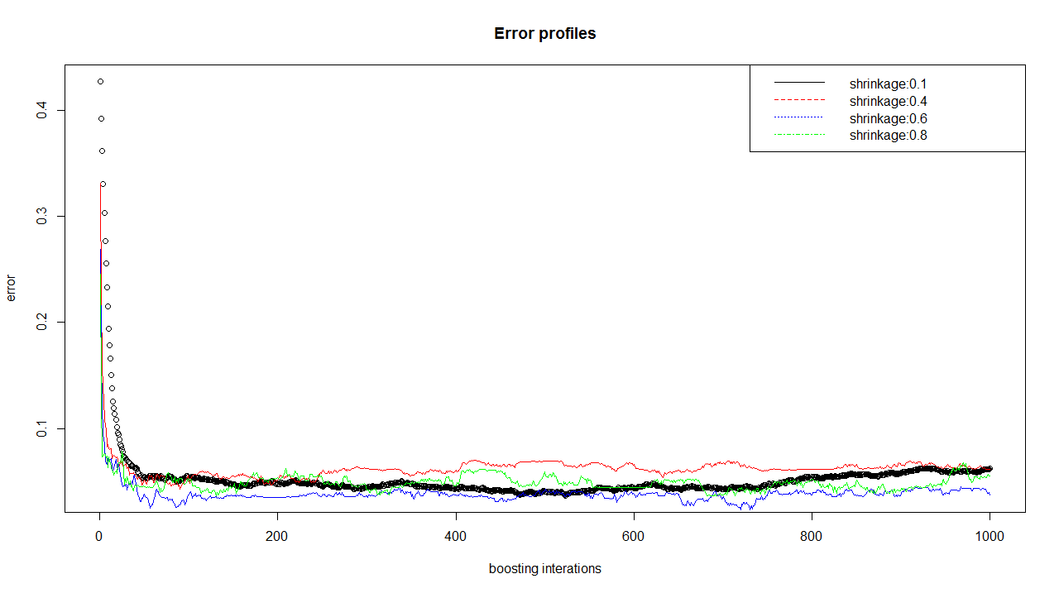

For the KNN, when K=6 I get the minimum test error which is 0.02631579.

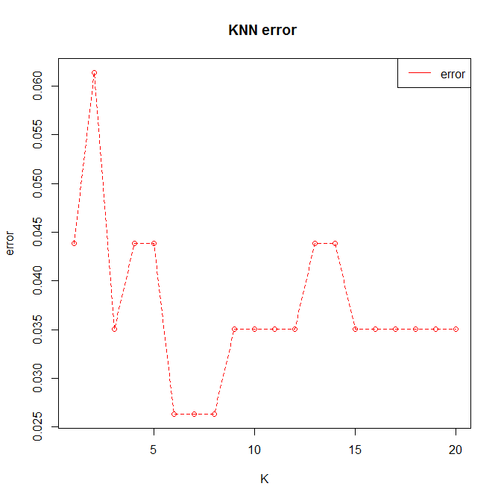

|  |  |  |  |  |  |
| --- | --- | --- | --- | --- | --- |
|  | Random forest | Bagging | Boosting | Logistic regression | KNN |
| Test error | 0.03508772 | 0.07017544 | 0.02323512 | 0.0877193 | 0.02631579 |

Finally, we can see that the boosting is the best one followed by KNN, random forest ,bagging and logistic regression.