First, I used 1/3 data as test data and the other data as training data.

A,

I set the cost equals (0.01, 0.05, 0.1, 0.5, 1, 5, 10) and the kernel is the linear. The test error and the train error are on the following table

linear.test.err linear.train.err cost

[1,] 0.1540616246 0.1697054698 0.01

[2,] 0.1512605042 0.1683029453 0.05

[3,] 0.1540616246 0.1669004208 0.10

[4,] 0.1596638655 0.1654978962 0.50

[5,] 0.1568627451 0.1640953717 1.00

[6,] 0.1540616246 0.1654978962 5.00

[7,] 0.1540616246 0.1640953717 10.00

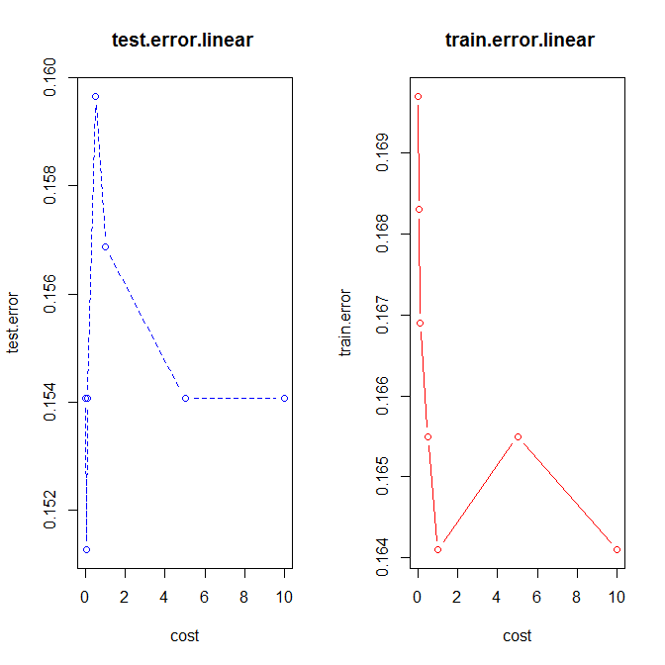

From the figure, we can see that when cost equals to 0.05 we have the minimum test error which is 0.1512605042 so the model whose cost is 0.05 is the best model. But from the table we can see that the test error is smaller than train error. I don’t know the reason.

B,

I set the cost equals (0.01, 0.05, 0.1, 0.5, 1, 5, 10) and the kernel is the radial. The test error and the train error are on the following table

rad.test.err.1 rad.train.err.1 cost

[1,] 0.3837535014 0.3927068724 0.01

[2,] 0.2016806723 0.2033660589 0.05

[3,] 0.1764705882 0.1739130435 0.10

[4,] 0.1736694678 0.1640953717 0.50

[5,] 0.1736694678 0.1598877980 1.00

[6,] 0.1708683473 0.1430575035 5.00

[7,] 0.1792717087 0.1290322581 10.00

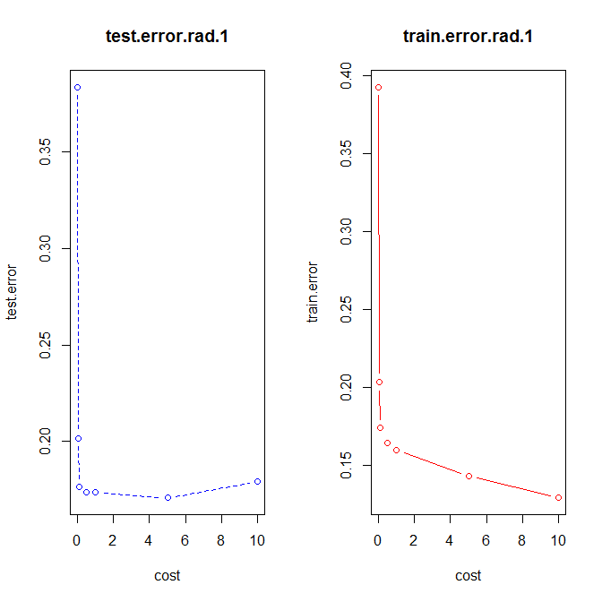

From the figure, we can see that when cost equals to 5 we have the minimum test error which is 0.1708683473 so the model whose cost is 5 is the best model.

I set the cost equals (0.01, 0.05, 0.1, 0.5, 1, 5, 10) and the kernel is the polynomial. The test error and the train error are on the following table

polynomial.test.err polynomial.train.err cost

[1,] 0.3809523810 0.3927068724 0.01

[2,] 0.3193277311 0.3281907433 0.05

[3,] 0.2941176471 0.2973352034 0.10

[4,] 0.1848739496 0.1935483871 0.50

[5,] 0.1960784314 0.1935483871 1.00

[6,] 0.1680672269 0.1556802244 5.00

[7,] 0.1596638655 0.1514726508 10.00

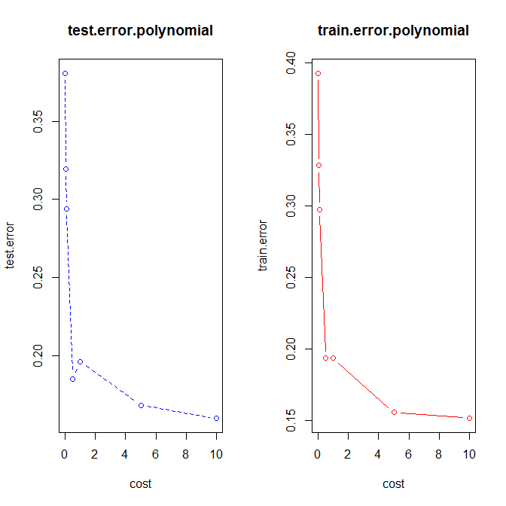

From the figure, we can see that when cost equals to 10 we have the minimum test error which is 0.1596638655 so the model whose cost is 10 is the best model.