**Installing ROS**

Unfortunately, ROS Kinetic does not fully support its software on OS X and Windows so we’re going have to create a VM and use Ubuntu through that.

**Creating VM**

Step 1.

Download Ubuntu for OS X.

<https://www.ubuntu.com/download>

Step 2.

Download Oracle VM Virtual Box. Select Mac OS X (64-bit)

<http://www.oracle.com/technetwork/server-storage/virtualbox/downloads/index.html>

Step 3.

After VM download is complete, select installation file (VirtualBox.pkg) and follow the steps that appear.

Step 4.

Open the VM application and that top left corner, select the New Button. You’ll be asked to input a  name and to select an operating system. We’ll be naming out VM Ubuntu and the Type will be Linux and version Ubuntu (64-bit). (Note: if you insert the name Ubuntu, the Type and version will be selected for you). Click continue.

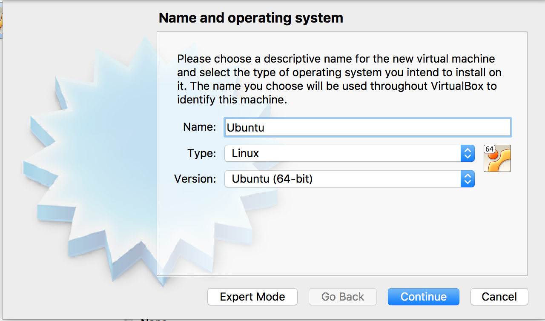

Step 5.

Next, we select amount memory. I usually choose 8192 because we require a lot memory to install and use ROS. Then, click continue.

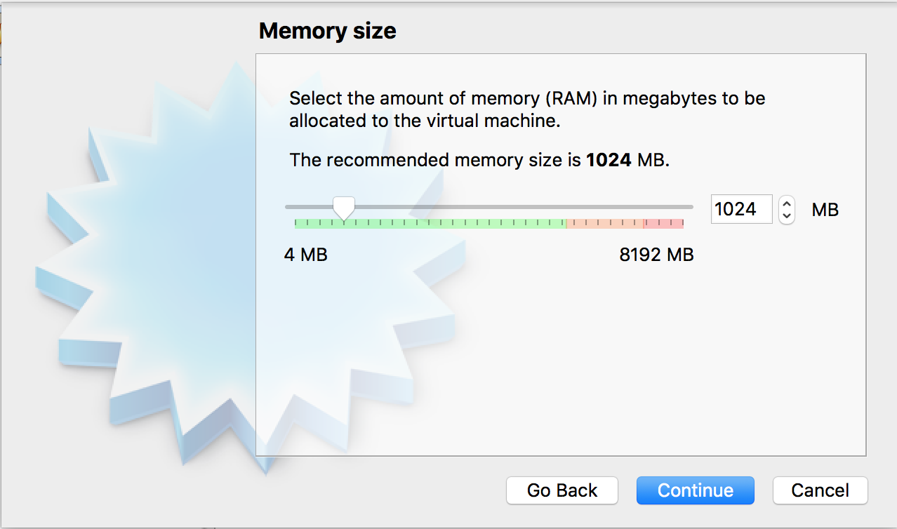

Step 6.

We need to add a virtual hard disk to our VM, here we select “Create a virtual hard disk now”. Then a pop up will appear and we select, “Virtual Hard Disk Image” and we’ll select “Dynamically allocated” as we want our hard disk to grow in side in case we need more space for our VM. Then we chose our OS size and we chose 10 GB.

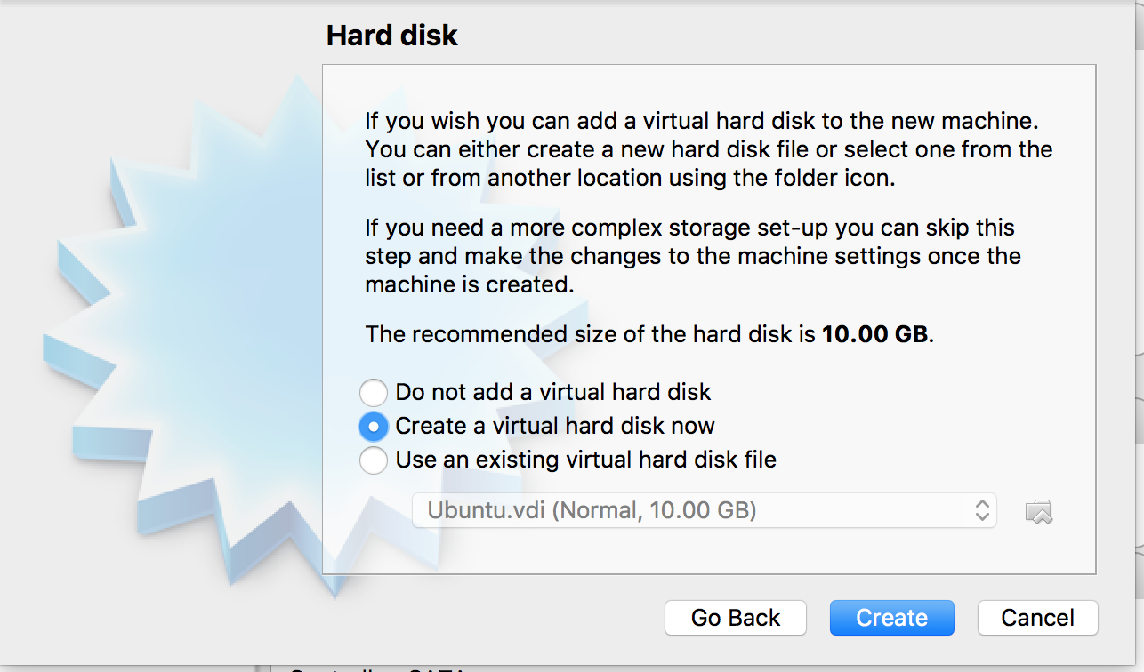

Step 7.

We then need to click on the machine we created and add IDE controller this is where we put our Ubuntu source. From here we click “Settings” then select “Storage”.

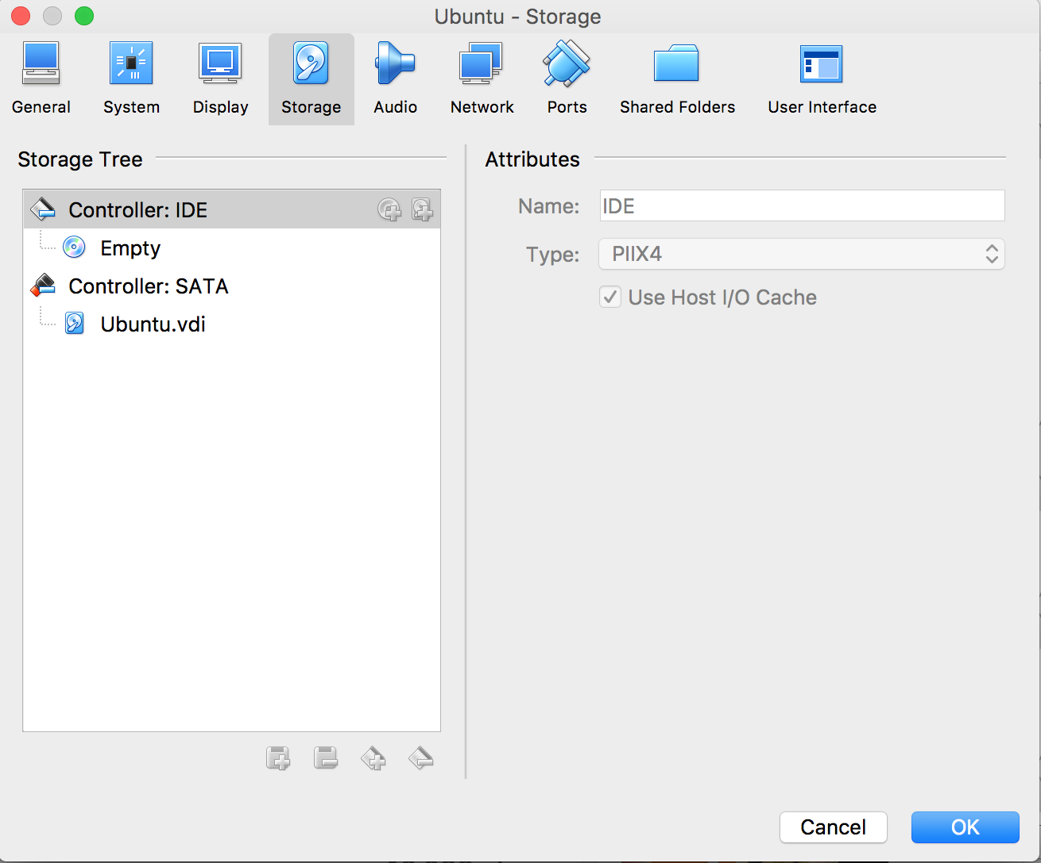

On the left-and side, there will be a dropdown called IDE Controller. Click on empty and on the right-hand side we add the source. We do that by selecting the “IDE Secondary Master”. and then the tiny disk beside it. Select “Chose a virtual CD/DVD disk file” and wherever you installed Ubuntu, navigate to that folder and select the dmg file.

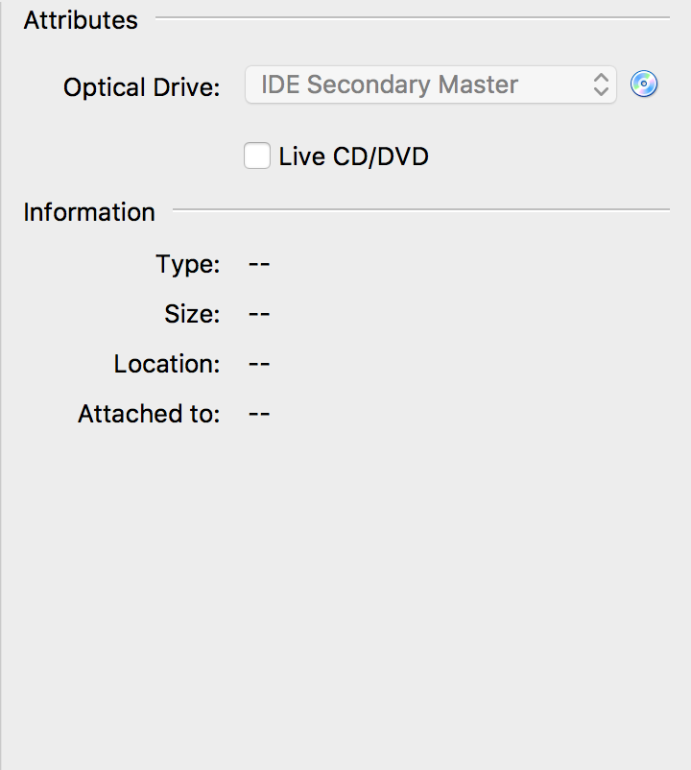

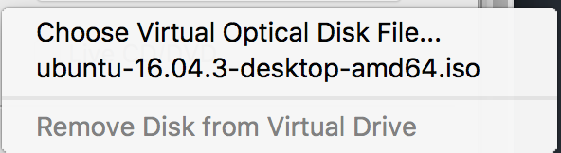

Step 7. Download extension package.

This package will allow you to easily use your usb devices with your vm. Follow this link,

<https://www.virtualbox.org/wiki/Downloads>

and click ‘All supported platforms button’. And an extpack should download.

Step 8.

In the vm, select ‘Preferences’. From there, select ‘Extension’ tab and click the little down arrow button. There you will add the package you just download. Once, complete select Ok and Start your VM.

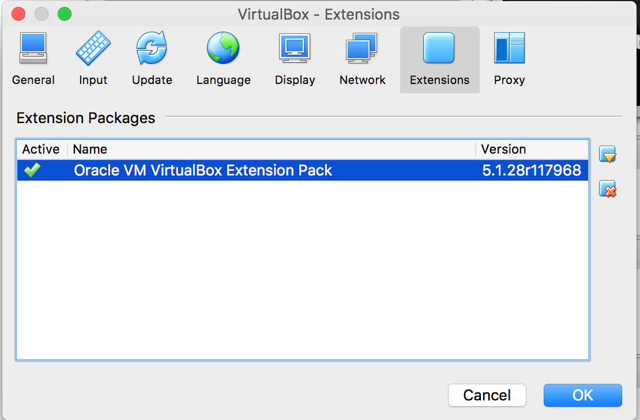

**Installing Ubuntu**

Step 1.

Once Ubuntu is running on your VM, the first pop-up will ask you to select how you want to use Ubuntu. Select “Install Ubuntu”

Step 2.

Then, “In preparing to install Ubuntu” select all check-boxes. Click “Continue” and select “Install now”.

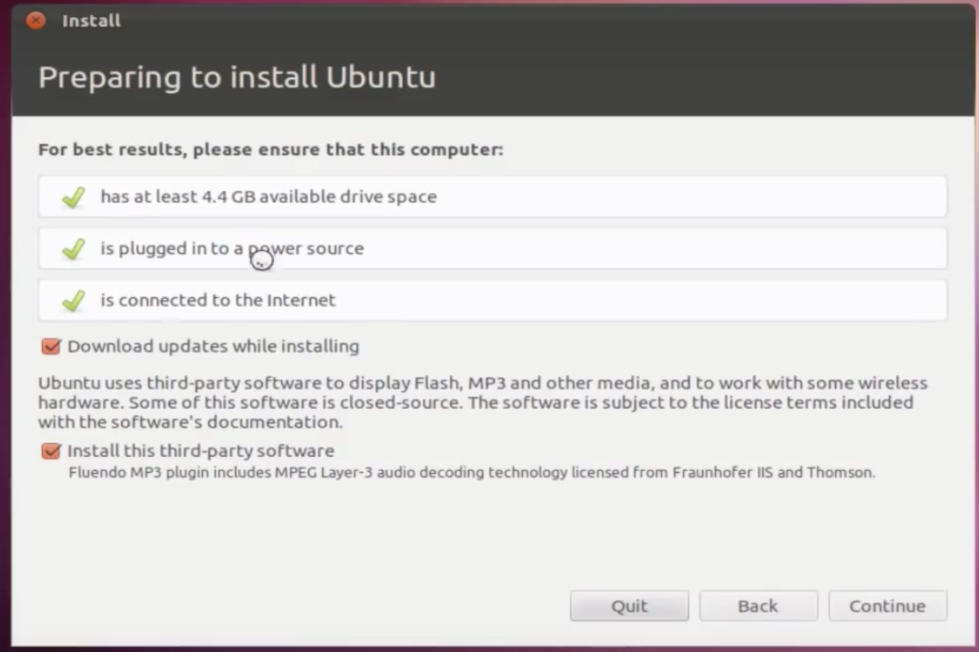

Step 3.

Ubuntu will then require you to input your options and settings, such has general location, language, user name and password. Then Ubuntu will then install. Once complete Ubuntu will require you to reboot, select “Restart Now” and you’ll have a VM version on your MAC.

**Installing ROS**

Step 1.

Select terminal. Click on “Search computer icon” and type in “Terminal”.

Step 2.

Step up your sources.list

sudo sh -c 'echo "deb http://packages.ros.org/ros/ubuntu $(lsb_release -sc) main" > /etc/apt/sources.list.d/ros-latest.list'

Step 3.

Step up your keys

sudo apt-key adv --keyserver hkp://ha.pool.sks-keyservers.net:80 --recv-key 421C365BD9FF1F717815A3895523BAEEB01FA116

Step 4.

Install ROS

sudo apt-get update

Desktop Full Install

sudo apt-get install ros-kinetic-desktop-ful

if this step doesn’t work, your missing certain GPG keys. To fix that we must follow the following.

Step 4.1

First add the webupd8 repository for this program

sudo add-apt-repository ppa:webupd8team/y-ppa-manager

Step 4.2

Update your software list and install Y-PPA-Manager:

sudo apt-get update

sudo apt-get install y-ppa-manager

Step 4.3

y-ppa-manager

Step 4.4

When the main y-ppa-manager window appears, click on "Advanced."

Step 4.5

From the list of advanced tasks, select "Try to import all missing GPG keys" and click

Step 5.

Initialize rosdep

sudo rosdep init

rosdep update

Step 6

Set up environment

echo "source /opt/ros/kinetic/setup.bash" >> ~/.bashrc

source ~/.bashrc

Note: whenever you need to update your environment, you must type in the following command

source /opt/ros/kinetic/setup.bash

Step 7 Dependencies for building packages

sudo apt-get install python-rosinstall python-rosinstall-generator python-wstool build-essential

Now you should have ROS working on your system ☺

**Create a Workspace**

Step 1. Create and build catkin workspace. Catkin is the official build system of ROS. So this is where you can modify, build, and install catkin packages

$ mkdir -p ~/catkin_ws/src

$ cd ~/catkin_ws/

$ catkin_make

Step 2. Before continuing you must source your new setup.*sh file. (This will be done everytime you start ROS or you can add it to your source file*)

$ source devel/setup.bash

Step 3. Check if workspace is properly overlapped with the scripted file

$ echo $ROS_PACKAGE_PATH

/home/youruser/catkin_ws/src:/opt/ros/kinetic/share