1、未使用组合索引的执行计划：

select /*+ index(positiveinfos IDX_POSITIVEINFO_ORGINTCODE) */ * from positiveinfos a where a.isemphasis=0 and a.orginternalcode like '1.1.%';

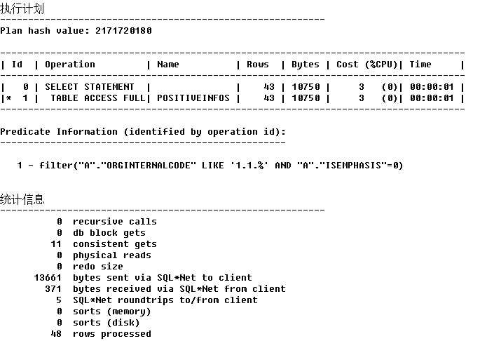

select * from positiveinfos a where a.isemphasis=0 and a.orginternalcode like '1.1.%';

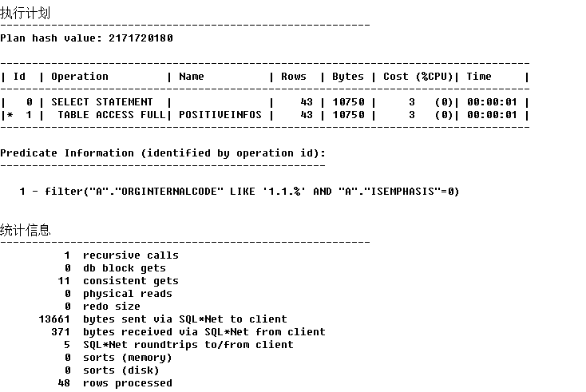

select /*+ index(positiveinfos IDX_POSITIVEINFO_ORGINTCODE) */ * from positiveinfos a where a.isemphasis=0 and a.orginternalcode like '1.1.1.1.1.1.%';

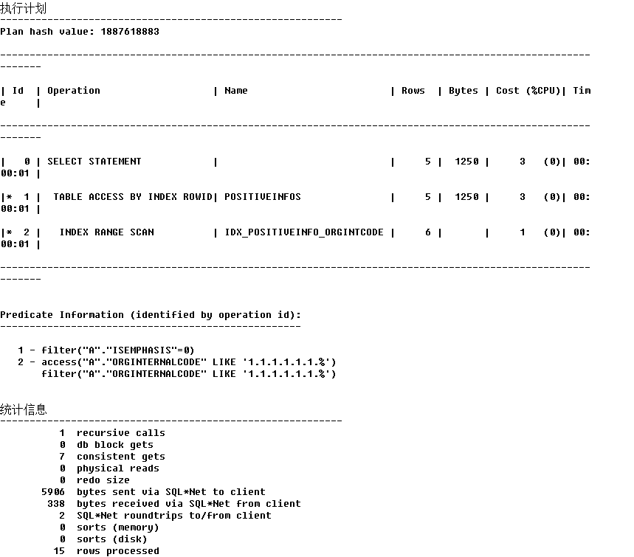

select * from positiveinfos a where a.isemphasis=0 and a.orginternalcode like '1.1.1.1.1.1.%';

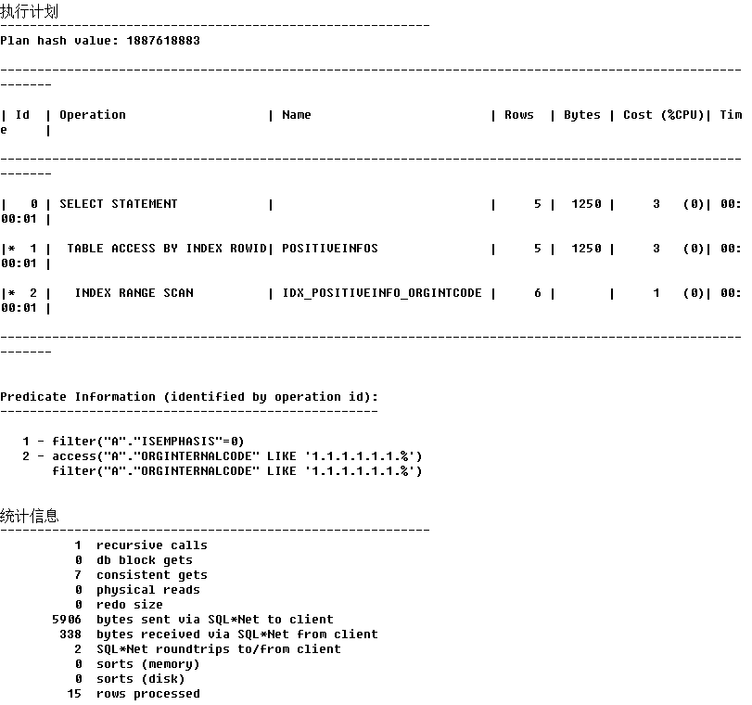

2、使用组合索引,orgInternalCode前置

select * from positiveinfos a where a.isemphasis=0 and a.orginternalcode like '1.1.%';

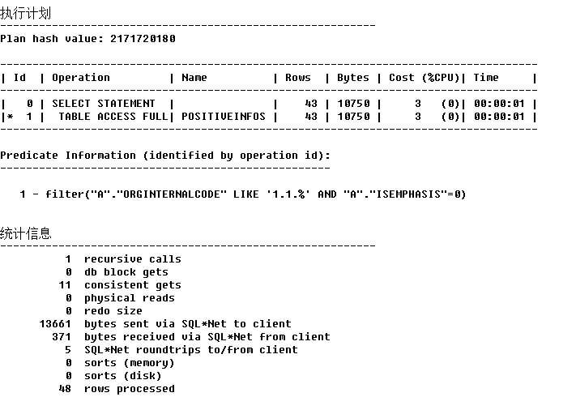

select /*+ index(positiveinfos IDX_POSITIVEINFO_ORGINTCODE) */ * from positiveinfos a where a.isemphasis=0 and a.orginternalcode like '1.1.%';

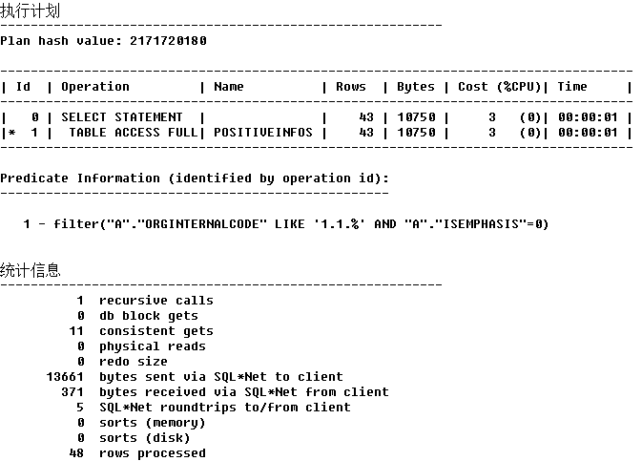

select * from positiveinfos a where a.isemphasis=0 and a.orginternalcode like '1.1.1.1.1.1.%';

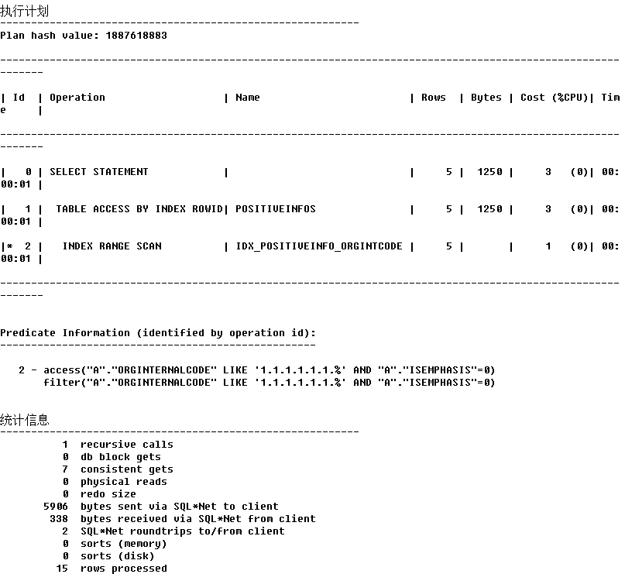

select /*+ index(positiveinfos IDX_POSITIVEINFO_ORGINTCODE) */ * from positiveinfos a where a.isemphasis=0 and a.orginternalcode like '1.1.1.1.1.1.%';

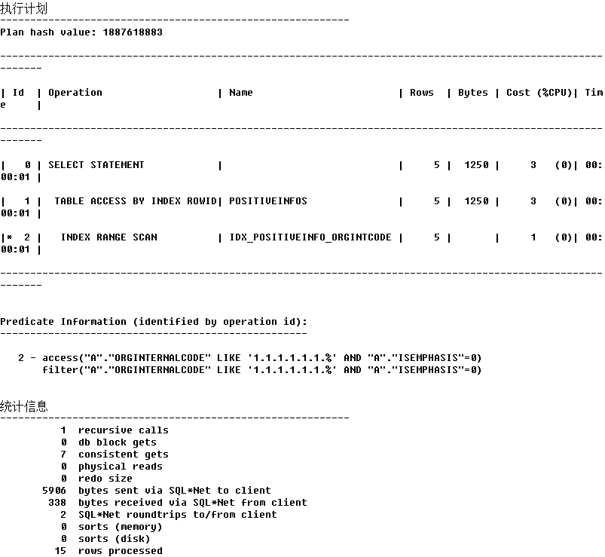

3、使用组合索引，isemphasis前置

select * from positiveinfos a where a.isemphasis=0 and a.orginternalcode like '1.1.%';

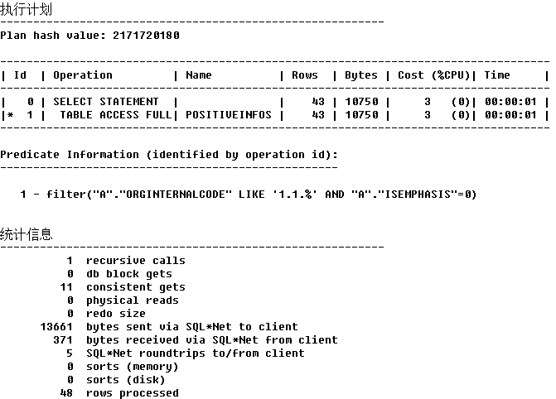

select /*+ index(positiveinfos IDX_POSITIVEINFO_ORGINTCODE) */ * from positiveinfos a where a.isemphasis=0 and a.orginternalcode like '1.1.%';

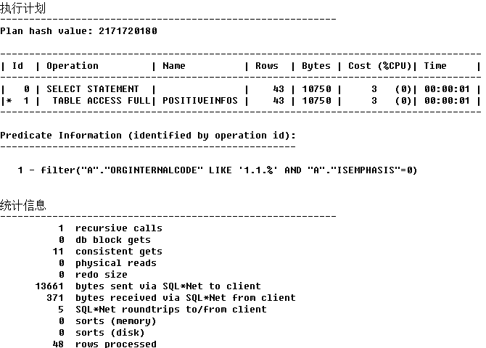

select * from positiveinfos a where a.isemphasis=0 and a.orginternalcode like '1.1.1.1.1.1.%';

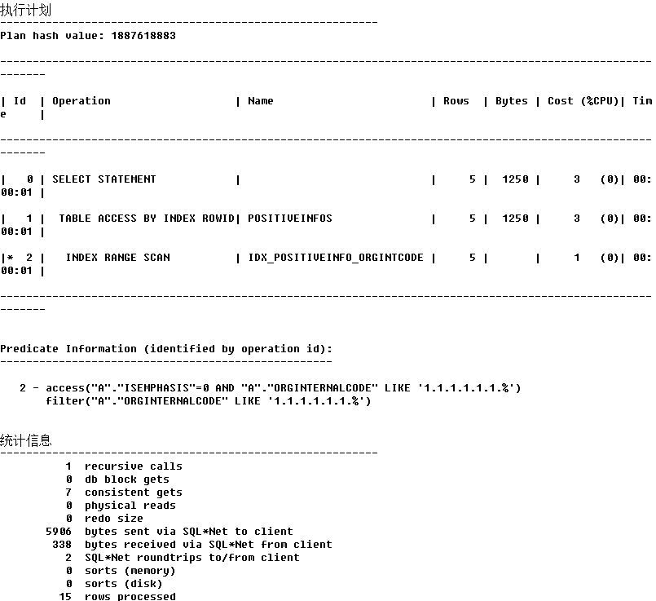

select /*+ index(positiveinfos IDX_POSITIVEINFO_ORGINTCODE) */ * from positiveinfos a where a.isemphasis=0 and a.orginternalcode like '1.1.1.1.1.1.%';

