**What factors influenced the attitude of media coverage?**

Department of Communication, HONG KONG Baptist University

**Introduction**

**Introduction to the epidemic situation in China**

At the end of 2019, Covid-19 was discovered in China, and it broke out in full swing in 2020. The virus has had a major impact on the global public health system and sparked heated discussions around the world. China has adopted a variety of measures to fight the epidemic, including large-scale lockdown measures, social distancing, early detection and strict entry and exit restrictions. In addition to focusing on its own country, China is also actively cooperating with the international community, sharing epidemic information and experience in prevention and control, sending medical expert teams to many countries to provide support, and providing medical supplies and equipment to some countries. In order to achieve "zeroing", China's epidemic prevention policy will continue until 2022. In December 2022, China announced the gradual liberalization of epidemic control policies. People no longer worry about being quarantined because they have the virus. Inbound and outbound tourism is also gradually opened up. The economy is also slowly recovering. However, China's epidemic prevention and control policies are still controversial.

**What is OPEC**

The Organization of the Petroleum Exporting Countries, referred to as OPEC in the following texts, was established in 1960 and headquartered in Vienna, Austria. International Petroleum Organization established for the benefit of the oil industry of its members. At present, the organization has 13 member countries, namely Algeria, Iran, Iraq, Kuwait, Libya, Nigeria, Saudi Arabia, United Arab Emirates, Venezuela, Angola, Gabon, Equatorial Guinea, Congo (Brazzaville). The oil resource reserves of these member states account for nearly 80% of the global total, and the daily output also accounts for about 44% of the global total. The organization and its decisions often affect global oil prices and supply and demand.

**The relationship between OPEC and China**

OPEC and China are mainly based on cooperation in energy trade and the international oil market. OPEC is one of China's important suppliers in terms of oil imports. According to data from the General Administration of Customs of China, China imported about 55 million tons of crude oil from OPEC members such as Saudi Arabia, Iran, Iraq and Kuwait in 2019, accounting for about 44% of China's total crude oil imports.

China is also an energy partner and investment target for OPEC members. The energy projects of Uzbekistan, Iran, Iraq and other OPEC members, including oil and gas exploration and production, pipeline construction, etc., have Chinese companies participating. In addition, OPEC members are also actively expanding the Chinese market and signing trade cooperation agreements with China.

**Why choose OPEC members as the research object**

*(They have important influence on China)*

We chose these countries for this study because China is one of the largest importers of fossil fuel energy, and OPEC members are the major exporters of such energy globally. In addition, since China has become the world's largest manufacturing economy through rapid growth and moderate inflation, the local markets of most OPEC members have been dominated by China, which means that China's imports to OPEC members are large. At the same time, the organization is diversified in terms of economic level, international affairs position and geographical location. And they all have an important impact on the global energy market. Therefore, we believe that media reports in these countries and regions usually have relatively high attention and influence.

**United Nation Vote**

United Nations voting means that member states of the United Nations vote on a certain issue in a United Nations meeting according to the prescribed procedures. UN votes usually require the support of a majority or a qualified majority of countries to pass. Each country can vote on each issue according to its own country's political leanings. The reason for choosing UN Vote to study the political relationship between the two countries is that the UN, as a global international organization, has extensive representation and influence in international affairs. As one of the main ways for UN member states to negotiate and make decisions, UN voting reflects the attitudes and policies of different countries in international affairs. By analyzing and comparing the ideal point estimates of the two countries in the UN voting, the political relationship and policy positions between the two countries can be revealed objectively.

**Total Bilateral Trade**

Total bilateral trade refers to the sum of import and export trade between two countries within a certain period of time. It is usually used to measure the economic relationship between two countries, and it is also an important basis for evaluating the level of trade and economic cooperation between the two countries. The larger the total trade volume, the more frequent and extensive exchanges of goods and services between the two countries. At the same time, it also means that they are mutually complementary and cooperative in terms of economic structure, resource allocation and industrial division of labor. For example, one country may export a certain product while another country provides the raw materials or market for that product. In addition, the development and change trend of the national economy can also be observed from the changes in the total amount of bilateral trade. When the total amount of bilateral trade increases, it means that the economic development of the two countries is relatively active, and the opportunities and potential for mutual trade increase. Conversely, if the total amount of bilateral trade declines, it may mean the impact of economic recession, trade barriers or other factors.

**Geographical location of the two countries**

The flight distance between the two countries reflects to a certain extent the geographical and transportation links between the two countries, and also reflects the number and frequency of business, tourism, and cultural exchanges between the two countries. Therefore, we choose the flight distance between the two countries as the standard to measure the geographic location of the two countries. The flight distance usually refers to the straight-line flight distance between the starting point and the destination point. We calculate the flight distance by looking up the flight information provided by the airline. By comparing the flight distance between the two countries, a preliminary assessment of the level of connection and exchange between the two countries is carried out. If the flight distance between the two countries is shorter, it means that the exchanges and cooperation between the two countries are closer, indicating that there are more opportunities and potentials for cooperation in the fields of economy, investment, and culture between the two countries; if the flight distance is longer, it means As there are more obstacles and challenges in exchanges and cooperation between the two countries, more efforts to strengthen exchanges and build mutual trust are needed.

**Research Questions**

**RQ1:**Whether differences in the degree of convergence of national political orientation will affect the attitudes and opinions reported by the media?

**RQ2:**Whether the closeness of economic and trade cooperation will affect the purpose and content of media reports?

**RQ3:**Whether the distance between different geographical locations will affect the media's attention and depth of coverage of the Covid19 issue?

Based on that, we propose following hypothesis:

**H1:** Differences in the degree of convergence of national political orientation will affect the attitudes and opinions reported by the media.

**H2:** The closeness of economic and trade cooperation will affect the purpose and content of media reports.

**H3:** The distance between different geographical locations will affect the media's attention and depth of coverage of the Covid19 issue.

**Methods**

**Research methodology**

Determine the thirteen existing members of OPEC, and select 2-3 authoritative media for each country. The time span of the statistical analysis is from December 2019 to the present. In December 2019, covid-19 broke out in Wuhan City, Hubei Province, China. At the end of 2022, China announced the opening up, marking the phased end of covid-19 in China. Use the two keywords "China" and "China Covid-19" to retrieve news, and both are retrieved from the official websites of the media organizations. A total of 13 countries, 29 authoritative media, and 668 news items were counted. Research all its news coverage on covid-19 in China. (Definition of authoritative media: Authoritative media usually refers to radio and television media, TV stations, newspapers, etc. authorized by the government or associations, officially recognized and managed uniformly. The content of their reports usually has a certain degree of objectivity and authority, and bears important political and social responsibility.)

**Encoding scheme**

Human coding is a method based on human annotation, which is used to add custom tags or attributes to articles. We read the collected news manually. The four members of the team coded the news reports of 2-3 countries respectively. Sentiment analysis is performed based on the expressions in the article, and the attitude of the news is marked as support or other. Articles with positive words such as "thanks, recognition, satisfaction, and effective results" are judged as "positive", and the rest of the articles with negative emotions or no emotional words are judged as "others" .

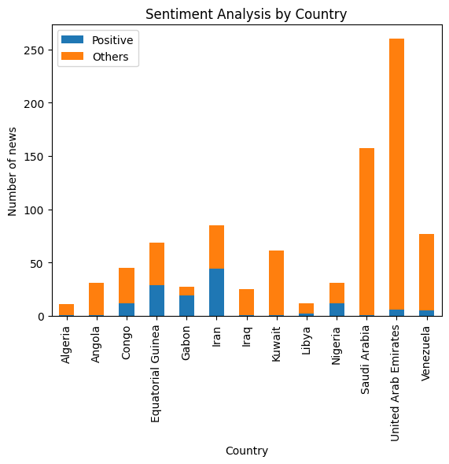

We found that there are 2 countries with more "positive" reports, namely Iran and Gabon. There are 11 countries with more "others" attitudes, namely: Algeria, Angola, Congo, Equatorial Guinea, Iraq, Kuwait, Libya, Nigeria, Saudi Arabia, United Arab Emirates, and Venezuela.

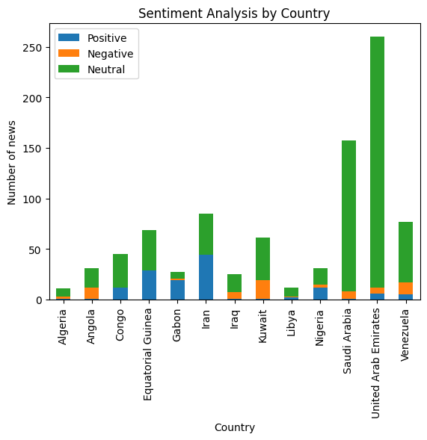

As can be seen from the figure, United Arab Emirates has the largest proportion of neutral news, followed by Saudi Arabia. We found that there is only one country with more reports of "support" - Iran, and 11 countries with more reports of "neutral", namely: Algeria, Angola, Congo, Equatorial Guinea, Iraq, Kuwait , Libya, Nigeria,Saudi Arabia,United Arab Emirates,and Venezuela.

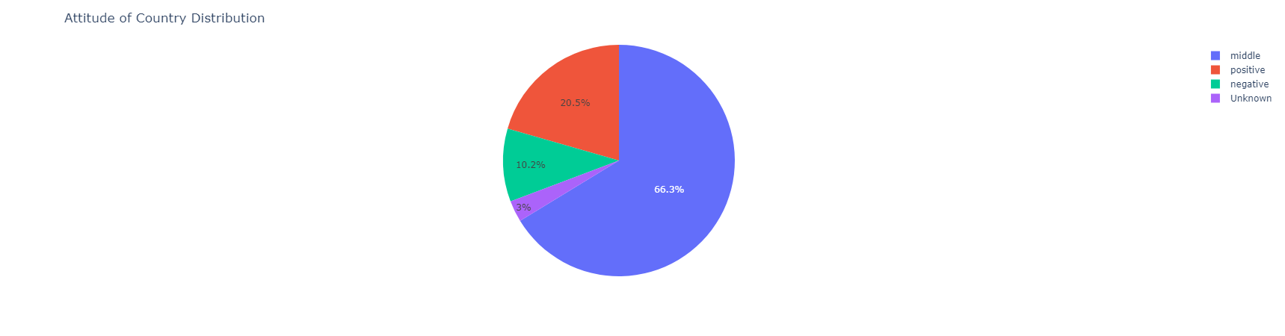

Through the statistics of the attitude of OPEC members to China-related reports, we find that the vast majority of countries have no obvious reporting tendency and have a neutral attitude, accounting for 66.3%, with a total of 442 news; followed by positive attitude, accounting for 20.5%, with a total of 137 news; The fewest reporting attitude was negative, with a total of 68 news. From this, we can find that the attitude of most OPEC members to China COVID-19 is still relatively fair and objective reporting, and some members have obvious support or opposition tendencies, so we will study whether it has an impact on reporting attitudes from the three aspects of studying political relations tendencies, route distances and economic and trade volumes

**Analysis of economic and trade data**

Data on economic and trade exchanges between the two countries can measure how the trade relationship between the two countries is developing, and the economic ties between the two countries. These data can include trade volume, trade structure, trade deficit or surplus, investment flow, etc. between the two countries. These data can help analyze the trade balance, degree of mutual benefit, and economic dependence between the two countries.

The study selected the total bilateral trade volume between China and OPEC members in 2020 and 2021 and calculated the average value.

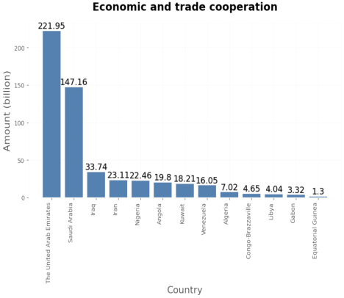

From the research results, it is found that the total trade volume between the United Arab Emirates and China is the highest, as high as 221.95 billion. Saudi Arabia ranks second with a trade volume of 14.16billion. It shows that the trade cooperation between the United Arab Emirates and Saudi Arabia and China is higher and more extensive than other member states. The country with the lowest total trade volume is Equatorial Guinea, only 1.3billion.

**Analysis of UN voting data**

According to the "ideal point" attribute in the joint voting dataset we used, we calculated the IP difference between OPEC member countries and China to measure whether the political leanings between them are converging. Countries with smaller differences have a higher degree of political convergence with China, while countries with larger differences indicate greater differences in political preferences.

First, we screened out all the issues that OPEC members and China jointly voted on. Then, for each issue, calculate the difference between the ideal point of different countries and the ideal point of China. For each country, we take the absolute values of these differences and find the average. Finally, sort according to the size of the average difference to get the following picture:

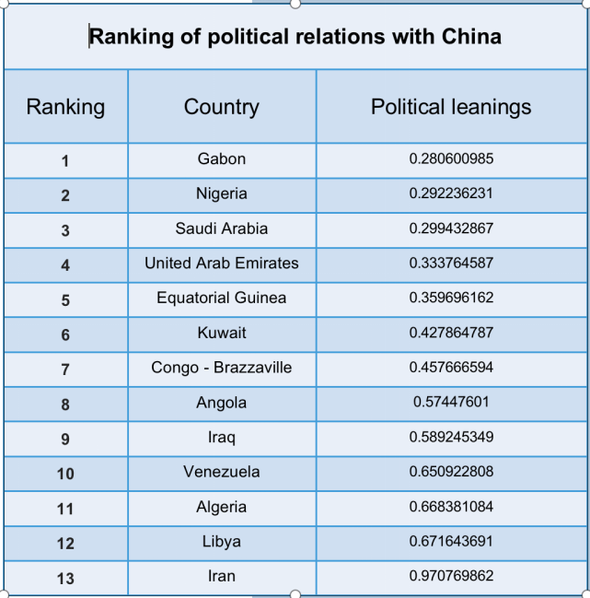

It can be seen from the figure above that Gabon, Nigeria, and Saudi Arabia are relatively close to China's political orientation, and the most similar is Gabon; while Iran is the farthest from China's political orientation, with a difference of 0.97.

**Results**

In this section, we use regression analysis method to analyze the relationship between political relation tendency, airline distance, economic trade amount and media attitude.

First of all, we have three kinds of media attitude, namely positive, neutral and negative. For each country, weighted average method is adopted to comprehensively describe the number of the three attitudes. Different weights are assigned to each attitude (positive: 1, neutral: 0, negative: -1) to reflect their importance in the comprehensive evaluation and obtain the comprehensive evaluation value.

After that, we used the statsmodels module in Python to conduct regression analysis on the relationship between the three elements and media attitudes respectively. Scatter plots and regression lines are drawn for each relationship, and heat maps of the correlation matrix between the three elements and media attitudes are drawn using the seaborn library's heatmap function.

**Political relationship tendency and media attitude**

We conducted a regression analysis on the data of political relation tendency and media attitude, and found that the F statistic is 0.06504678326206385, and the corresponding p value of F statistic is 0.803395682699059. The F statistic is small, and the corresponding p value is large, indicating that the independent variable political relationship tendency has a weak explanatory power on the dependent variable media attitude. We can also see from the scatter plot below that there is no significant linear relationship between the two.

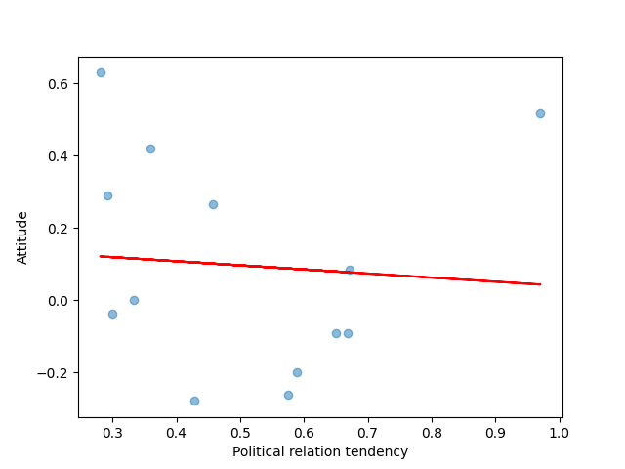

**Airline distance and media attitude**

We conducted a regression analysis on the data of airline distance and media attitude, and found that the F statistic was 0.11968720463603161, and the p value corresponding to F statistic was 0.7359001834909292. The p value corresponding to this F statistic is large, indicating that we cannot reject the null hypothesis under statistical significance, that is, there is no significant linear relationship between the independent variable and the dependent variable. In other words, there may not be a linear relationship between distance and attitude. We can also see from the scatter plot below that there is no significant linear relationship between the two.

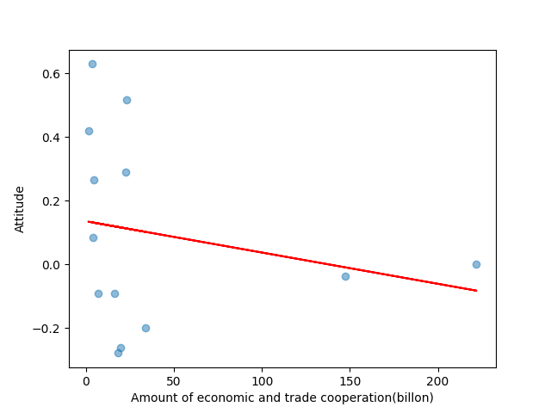

**Economic trade amount and media attitude**

We conducted a regression analysis on the data of economic trade amount and media attitude, and found that the F statistic was 0.06504678326206385, and the p value corresponding to the F statistic was 0.803395682699059. The F statistic of this regression model is small, and the corresponding p value is large, indicating that the explanatory power of the independent variable is weak to the dependent variable, that is, there is no significant linear relationship between economic trade amount and media attitude, which can also be observed from the scatter chart below.

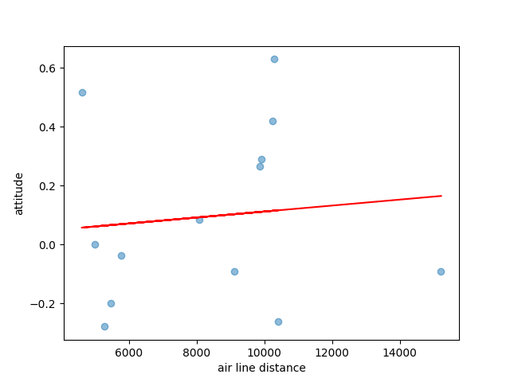

**Correlation between the three elements and media attitudes**

We calculate the correlation matrix between the three elements and the media attitude, and draw the heat map. As can be seen from the figure, the correlation between the three elements and the attitude of media is weak, and the tendency of political relationship and the amount of economic trade are weakly negatively correlated with the attitude of media. There is a weak positive correlation between distance and media attitude.

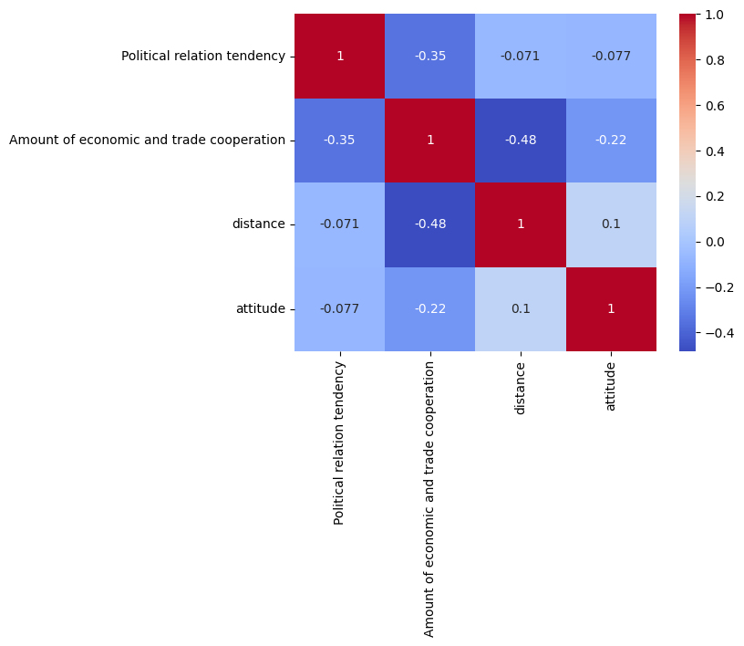

Based on the above results, we did not find a linear relationship between media attitude and political relationship inclination, airline distance and economic and trade amount. However, our study also has certain limitations, such as insufficient data samples, not detailed attitude division, and possible collinearity among independent variables.

**Conclusion and Limitation**

**Conclusion**

After sentiment analysis of 668 reports from 29 authoritative media outlets, this paper finds that most OPEC countries have relatively neutral reporting attitudes on China's new crown virus, and a few countries have obvious support or opposition tendencies, among which Iran and Gabon have a more positive reporting attitude, while Algeria, Angola, Congo, Equatorial Guinea, Iraq, Kuwait, Libya, Nigeria, Saudi Arabia, the United Arab Emirates and Venezuela have a relatively neutral reporting attitude, accounting for 66.3% The number of stories. For the factors that influence the attitude of OPEC countries to China's epidemic coverage, this study uses the methods of regression analysis and statistical correlation coefficients. We perform linear regression analysis on three factors (political relationship tendency, route distance, and economic and trade quantity) and conclude that in the linear regression equation between political relationship tendency and media attitude, the F statistic is 0.06504678326206385, corresponding to the F statistic p The value is 0.803395682699059, which cannot reject the null hypothesis at the statistically significant level, indicating that the political relationship tends to have a weak ability to explain media attitudes, and there is no obvious linear relationship between the two. In the linear regression equation between route distance and media attitude, the F statistic is 0.11968720463603161, and the corresponding F statistic p-value is 0.7359001834909292, which cannot reject the null hypothesis at the statistical significance level, indicating that the ability of route distance to explain media attitude is weak, and there is no obvious linear relationship between the two. In the linear regression equation between economic and trade quantity and media attitude, the F statistic is 0.06504678326206385, and the corresponding F statistic p-value is 0.803395682699059, which cannot reject the null hypothesis at the statistical significance level, indicating that the economic and trade quantity has a weak ability to explain media attitudes, and there is no obvious linear relationship between the two. In addition, we calculated a matrix of correlation coefficients between these three factors and media attitudes, and statistically plotted a heat map. The results show that the influence of these three factors on media attitude is weak, among which the political relationship tendency and the number of economic and trade are weakly correlated, while the route distance is weakly positively correlated with the media attitude. After the analysis of multiple regression models, we did not find a clear linear relationship between the three factors of political relationship tendency, route distance, and economic and trade quantity and media attitude. Although skews have been reported in individual countries, there is no statistically significant correlation between these declinations and their geopolitics, geographical location, and economic and trade scale. Therefore, the media should be as objective and impartial as possible when reporting the epidemic, regardless of factors such as geopolitics, geographical location and economic and trade scale. There are still some limitations in this study, such as small sample size and insufficient fineness of attitude classification, and more attention needs to be paid to data collection methods and improving the reliability of research data and robustness of research methods in future studies.

**Limitation**

1.Limited sample: The study only focuses on media coverage from OPEC countries, which may not be representative of media coverage from other regions or countries.

2. Limited scope: The study only focuses on events related to Covid-19 in China, which may not be generalizable to other events or issues. In other words, the external validity of the study was not well realized.

3. Lack of control: The study does not control for other factors that may influence media coverage, such as the size and type of media outlet, the journalist's background and experience, and the editorial policies of the media outlet.

**Reference**

Curran, J., Iyengar, S., Lund, A. B., & Salovaara-Moring, I. (2009). Media system, public knowledge and democracy: A comparative study. European Journal of Communication, 24(1), 5–26.

Boydstun, A. E., Highton, B., & Linn, S. (2018). Assessing the Relationship between Economic News Coverage and Mass Economic Attitudes. Political Research Quarterly, 71(4), 989–1000.

Tausch, F., & Zumbuehl, M. (2018). Stability of risk attitudes and media coverage of economic news. Journal of Economic Behavior & Organization, 150, 295-310.

McNair, B. (2017). Whose News? The Media and Its Publics in Twenty-First Century Europe. Bristol University Press.