# Introduction/background to the project

Solar power nowadays produces 4% of electricity in the United Kingdom, with up to 20% efficiency. Many UK homes, however, have little or no space for solar panels since they lack roofs or gardens in which to install them. These households may aspire to become carbon neutral, but solar panels are not an option.

Another issue is that gas boilers, which are in desperate need of replacement with (possibly carbon-neutral) Hydrogen-ready boilers, are still in their infancy. Even if homeowners purchase Hydrogen-ready gas boilers, they will not be converted to Hydrogen until the entire street has been converted, as the gas supply is shared which may take at least 10 years.

The aim of this project is to build a website that helps people to reduce the carbon benefits in the world. The website will allow households to donate solar panels to some other countries which have high carbon emissions and consider an excellent environment for installing solar panels.

This project allows the donator to compare different countries depending on their features and then choose some to donate for.

Our system provides a registration feature to allow the user for donating frequently without the need to provide his/her information each time.

# Project scope and objectives

* Design and build a donating website.
* It is about donating solar panels not only money.
* Allows people to reduce the total carbon emission even if they can’t depend on the solar system in their daily life.
* Provides a secure donating method.
* Provides an easy way to donate a solar panel.
* Encourage people to donate and help reduce carbon emissions.
* The targeted user is people who live in the United Kingdom, but they could be from anywhere.
* The targeted country is any country with high carbon emissions.

# Team name and list of members

Team name: Sunlight

## Team member:

* Arwa Alfitni
* Yifei Guo
* Zeyu Li
* Yixiang Wang
* Yue Zhou

Product backlog

## Household User Stories:

### Information about countries:

* As a household, I prefer to see how many people are donated to a particular country.
* As a household, I prefer to be able to see how many panels are donated to a particular country.
* As a household, I am interested in how donations helped reduce carbon emissions.
* As a household, I want to be able to read some information about the country I want to donate to Information like what is the current situation for providing electricity.

### Donation process:

* As a household, I want to be able to select different countries to donate to in one payment.
* As a household, I want to be able to donate panels in an easy and secure way.
* As a household, I want to be able to compare prices and carbon emissions for different countries.

### Log in and registration:

* As a household, I want to be able to register with the minimum number of steps and required information.
* As a household, I want a privacy grantee to my information, so it isn’t used for commercial purposes or any other purposes.
* As a household, I want to log in to the website easily and directly.

## Client User Stories:

* As a client, my goal is to encourage people to donate panels not only money.
* As a client, I want to show the number of panels donated not the amount of donated money.
* As a client, I want the user to be able to register easily. registration step shouldn't be exhausting and should require the only necessary information.
* As a client, I want a “get started” button which will allow the user to donate right away.
* As a client, I want to provide some suggested countries for donation.

### Management:

* As a client, I want my staff to be able to produce reports and statistics about the donation processes.
* As a client, I want to be able to manage the provided data.
* As a client, I want to upgrade the staff accounts to some other level to give them some privileges.

Analysis & Design

System architecture:

### Programming Languages and Database:

frontend: HTML and CSS

backend: Node JS

Database: MySQL

First, we decide to use MySQL because "Arwa" who oversaw database structure has some experience with MySQL then we decide to switch to MongoDB for more easily SQL structure. After that, we decide to return to MySQL when we were trying to produce some statistics from the data.

## UML diagrams

### Use case Diagram:

Our system deals with five different types of stakeholders. Firstly, a Visitor, which is any person who visits our website. This actor can view the home page and see the country list, navigates to the detailed page of each country, and can add any number of panels to the basket. he can also log in if he has a valid username and password or can register to our website as a household. Secondly, the admin, which has some management tasks for the household and the staff accounts. Thirdly, the staff who is responsible for extracting reports about the donations and managing the country list. Then the Household, which represents anyone who wants to donate to some country. Paypal is a third party that is used for payment authorization.

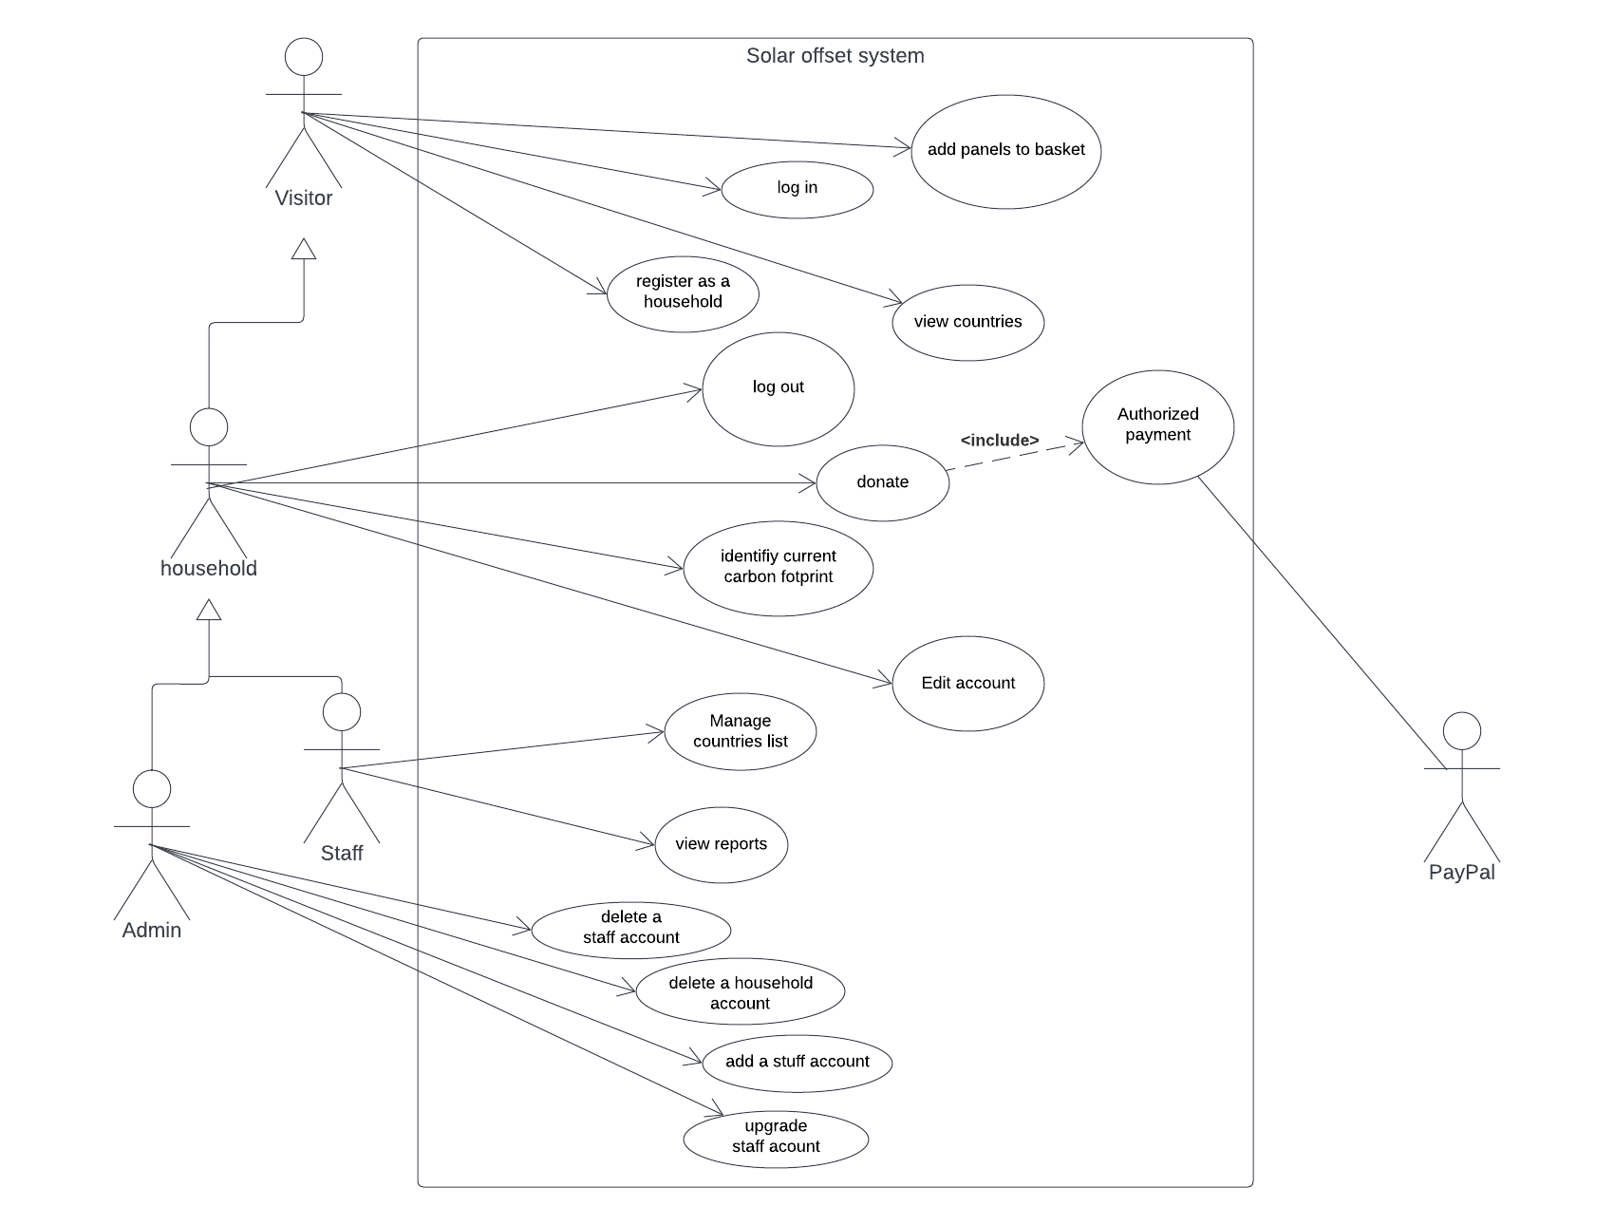

Figure : use case diagram

## Algorithm:

## Database design:

### Entity Relationship Diagram:

We use a simple database design. Figure 2 illustrates the design of our system. It is consisting of three tables: User, Transaction, and country. The User table represents all types of users which cloud be an admin, a staff, or a household. The “user type” feature will distinguish between the three types.

The Country table represents a country that a household wants to donate to. Each country has an id, name, flag picture, a description, its GDP, carbon emission, and the cost of installing a solar panel. “carbon_intensity” represents … while “kwh/m2/mon” represents the number of kilowatt per hour produced by a squared meter solar panel each month.

The Transaction table is where we keep a record of all donations. Each transaction represents one operation of transferring money through the sandbox. The status feature could be accepted, failed, or pending.

Each user can make many donations to different countries. Similarly, each country may receive many donations from either the same or different users.

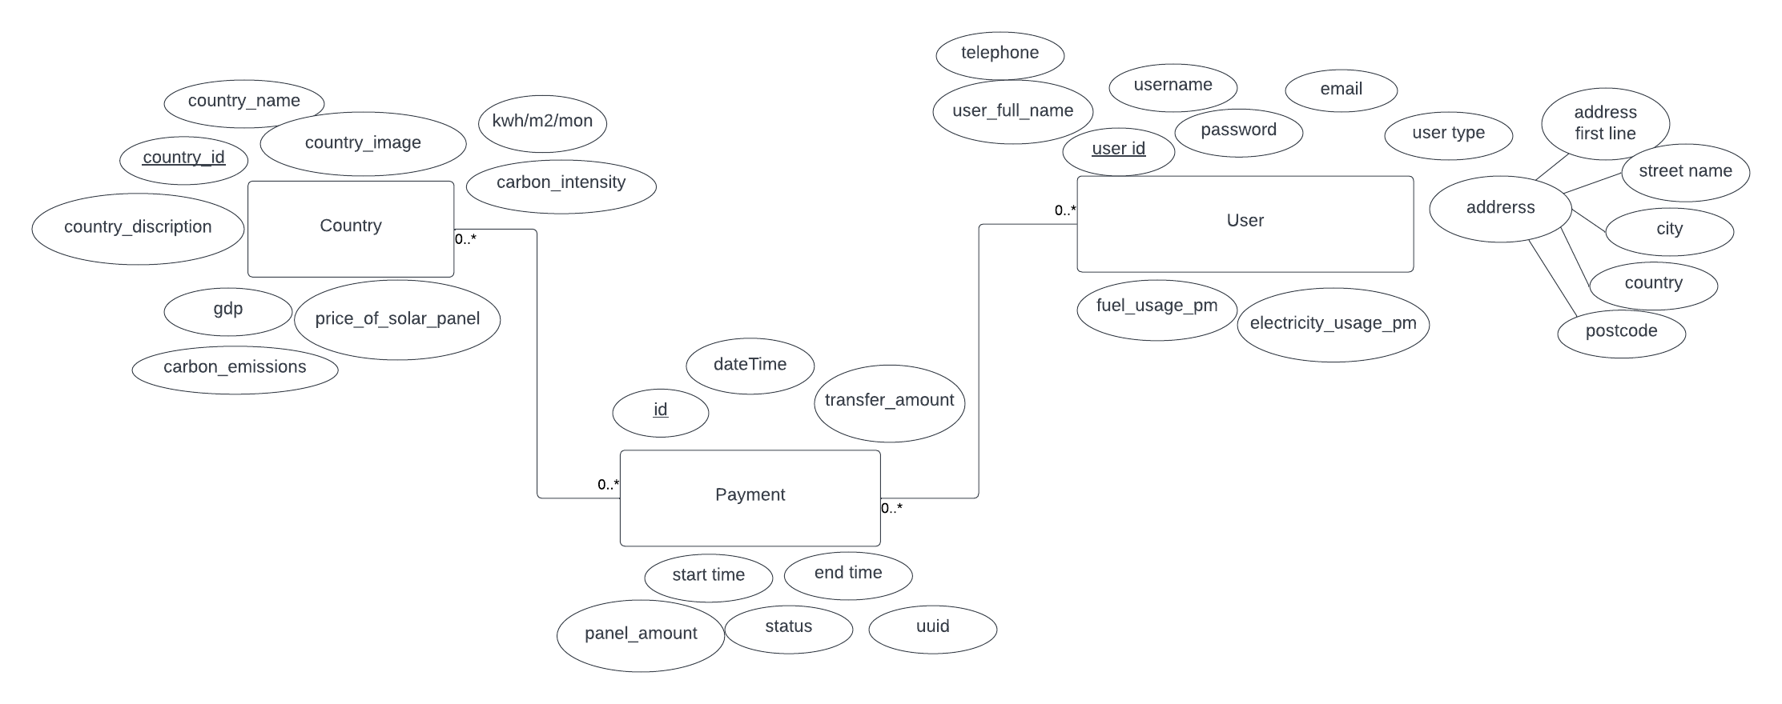

Figure : ERD

Evidence of Testing

## Test plan:

We will do manual testing for our website. The test cases will be generated from the requirements and the user stories.

### During development:

Postman for checking the connection between the frontend, backend, and the database.

## Test documentation:

### Test cases:

#### Test number: 1

Test name: login

Actor: any user (household, staff, or admin)

Pre-condition(s): none

Post-condition(s):

Success: homepage present with the username shown on the top-left corner.

failed: failed message popped up.

Steps:

- Open the website

- Click on the login button

- Enter the username and password in the correct box

- Click login

#### Test number: 2

Test name: register

Actor: household

Pre-condition(s): none

Post-condition(s):

Success: household account is created, and the home page is displayed with the username appease on the top-left corner.

Failed: fail message popped up.

Steps:

- Open the website

- Click on the Register button

- Enter your username (email), and password in the correct box.

- an authentication code will be sent to the user email.

- Enter the code in the correct box.

- account verified and created.

#### Test number: 3

Test name: browse the country list

Actor: visitor

pre-condition(s): none

post-condition(s):

success: present the page for all countries.

failed: “page not found” message popped up.

steps:

- open the website

- from the top-right tabs – choose the country list

#### Test number: 4

Test name: forget password

Actor: household

pre-condition(s): none

post-condition(s):

success: homepage present with the username shown on the top-left corner.

failed: failed message popped up.

steps:

- open the website

- click on login button

- click forget password button

- click login

#### Test number: 5

Test name: donate

Actor: any user (household, staff, admin)

Pre-condition(s): login

Post-condition(s):

success:

Success message of donation popped up.

Transaction successfully finished. and stored at the transaction table.

The number of donated panels is updated on the relevant country detailed page.

failed:

a failed message popped up.

no transaction is stored at the transaction table.

the number of donated panels didn't change in the relevant country detailed page.

## Test results

|  |  |  |  |
| --- | --- | --- | --- |
| Test number | Test name | Success or Failure? | Notes |
| 1 | Login |  |  |
| 2 | Register |  |  |
| 3 | Browse country list |  |  |
| 4 | Forget password |  |  |
| 5 | donate |  |  |
|  |  |  |  |

## After development:

Automated testing pros:

No human bugs

Frequent testing

Fast. Save time and effort.

### Selenium:

<https://www.youtube.com/watch?v=cobEbkTwbwY>

<https://geteasyqa.com/qa/test-website/>

<https://www.softwaretestinghelp.com/web-application-testing/>

# Team management & communication

Workload:

### First iteration – week 3 to 5:

The first iteration was mainly about understanding the system, collecting the requirements, and finding data sources. All team members participate in those tasks as they required brainstorming. By the last week of the iteration, we were able to start building the system, and hence it was the time to divide the work.

* Frontend team: Yifei Guo and Zeyu Li
* Backend team: Yixiang Wang and Yue Zhou
* Database team: Arwa Alfitni

### Second iteration – week 6 to 8:

For the second iteration, we were working on building the system and as a team, we continued to work as we planned by the end of the first iteration.

* Frontend team: Yifei Guo and Zeyu Li
* Backend team: Yixiang Wang and Yue Zhou
* Database team: Arwa Alfitni

### Third iteration – week 9 to 11:

In the third iteration, we faced some difficulties dealing with executing quires. Yixiang Wang suggested exchanging our DBMS to MongoDB since this will facilitate dealing with inserting and retrieving data. We will deal with an object, not with rows in tables.

Two weeks later we faced another issue with our structure using MongoDB. We designed the database as a relational model but then used it as non-relational model. This caused some difficulties when we were trying to extract some statistics like the number of people donated to a specific country or the number of donated panels.

We figured out that the best way is to use the relational model through MySQL and by using the “Sequelize” package we can deal with each row as an object.

On the other hand, it was the time to work on the final report and

* Frontend team: Yifei Guo and Zeyu Li
* Backend team: Yixiang Wang and Yue Zhou
* Database team: Arwa Alfitni, Yixiang Wang, and Yue Zhou
* Documentation:
  + Final report: Arwa Alfitni
    - UML: Arwa Alfitni
    - Meeting Minutes: Arwa
    - Conclusion: Yixiang
  + Setup guide: Yixiang and Yue
  + User guide:
* Testing:
  + Test cases: Arwa

Communication:

We decided to share our code and documents through the GitLab repository. As a daily communication base and for arranging meetings we used WeChat. The team members meet twice a week. Before each meeting, we discuss what each of us will work on. Then at the meeting, we work together to solve any difficulties. Our meetings are usually 4-5 hours, each one of us works on his/her part and we share thoughts and help each other with any hardness.

Meeting minutes samples:

### First iteration – week 3 to 5:

|  |  |  |  |  |  |
| --- | --- | --- | --- | --- | --- |
| **Meeting Minutes sample 1** | | | | | |
| **Subject** | | **Team Software Project Meeting** | | **Date** | **8th February 2021** |
| **Chaired** | | - | | **Time** | 12:00 AM – 1:00 PM |
| **Location** | | Portobello Center – room C29 | | **Prepared by** | Arwa Alfitni |
| **Attendees** | | Arwa Alfitni, Yifei Guo, Zeyu Li, Yixiang Wang, Yue Zhou | | | |
| Key Points Discussed | | | | | |
| No. | Topic | | **Highlights** | | |
| 1. | Introducing members | | * Each member introduced him/herself in terms of technical skills and experiences. * Wanying Wang is still in China and will not join us. | | |
| 2. | Choosing a project | | * Discus all the projects provided by the clients:   + The project Idea   + The required technical skills * A primitive list of preferences was made. * The final decision is left to the next day. Each member will read all the descriptions and vote for the preferred three projects in the WeChat group. The final list will be drawn from the voting result. | | |
| 3. | Contacting methods | | * We will use WeChat app as a primary app to contact each other and to arrange any proceeding meeting. * GitHub will be used to manage the teamwork. | | |
| Plans for the next meeting | | | | | |
| No. | **Description** | | | | |
| 1. | Prepare questions for the client | | | | |
| 2. | Chose a name for the team | | | | |
| Approvals | | | | | |
| 1. | Arwa Alfitni | | | | |
| 2. | Yifei Guo | | | | |
| 3. | Zeyu Li | | | | |
| 4. | Yixiang Wang | | | | |
| 5. | Yue Zhou | | | | |

|  |  |  |  |  |  |
| --- | --- | --- | --- | --- | --- |
| **Meeting Minutes sample 2** | | | | | |
| **Subject** | | **Team Software Project Meeting** | | **Date** | **8th March 2021** |
| **Chaired** | | Yue Zhou | | **Time** | 11:00 AM – 1:00 PM |
| **Location** | | Portobello Center – room C29 | | **Prepared by** | Arwa Alfitni |
| **Attendees** | | Arwa Alfitni, Yifei Guo, Zeyu Li, Yixiang Wang, Yue Zhou | | | |
| Key Points Discussed | | | | | |
| No. | Topic | | **Highlights** | | |
| 1. | Client meeting | | * Present the system prototype to the client. * Discus any thoughts on the design. * The client prefers a simple way to present all countries. * There isn’t any need to select two countries and compare them. | | |
| 2. | Database | | * Discus the database design and the required data. * A primitive sketch design was made. | | |
| Plans for the next meeting | | | | | |
| No. | **Description** | | | | |
| 1. | Agreed to the final database design | | | | |
| 2. | Distribute tasks between the members | | | | |
| Approvals | | | | | |
| 1. | Arwa Alfitni | | | | |
| 2. | Yifei Guo | | | | |
| 3. | Zeyu Li | | | | |
| 4. | Yixiang Wang | | | | |
| 5. | Yue Zhou | | | | |

Second iteration – week 6 to 8:

|  |  |  |  |  |  |
| --- | --- | --- | --- | --- | --- |
| **Meeting Minutes sample 3** | | | | | |
| **Subject** | | **Team Software Project Meeting** | | **Date** | **25th March 2021** |
| **Chaired** | | Yue Zhou | | **Time** | 4:00 PM – 8:00 PM |
| **Location** | | Information Common – room 4.23 | | **Prepared by** | Arwa Alfitni |
| **Attendees** | | Arwa Alfitni, Yifei Guo, Zeyu Li, Yixiang Wang, Yue Zhou | | | |
| Key Points Discussed | | | | | |
| No. | Topic | | **Highlights** | | |
| 1. | **Development tools** | | * Using “Postman” to check the connection between frontend, backend and the database. (Yixiang) | | |
| **2**. | Front end | | * Designing and building the country list page. (Yifei and Zeyu) | | |
| **3**. | Backend | | * Ranking the country list by (gdp, panel price, carbon emmisions) (Yue) | | |
| **4.** | Database (Arwa) | | * Add two column to country table: country_image and country_discription * Insert sample data. | | |
| Plans for the next meeting | | | | | |
| 1. | Insert, delete, and update country data – sql statements. (Arwa) | | | | |
| 2. | The frontend team will continue their work on the country list page. | | | | |
| 3. | The backend team will continue their work on the country list page. | | | | |
| Approvals | | | | | |
| 1. | Arwa Alfitni | | | | |
| 2. | Yifei Guo | | | | |
| 3. | Zeyu Li | | | | |
| 4. | Yixiang Wang | | | | |
| 5. | Yue Zhou | | | | |

Third iteration – week 9 to 11:

|  |  |  |  |  |  |
| --- | --- | --- | --- | --- | --- |
| **Meeting Minutes sample 5** | | | | | |
| **Subject** | | **Team Software Project Meeting** | | **Date** | **26th April 2022** |
| **Chaired** | | - | | **Time** | 11:00 AM – 1:00 PM |
| **Location** | | 38 Mapping building – workroom 4 | | **Prepared by** | Arwa Alfitni |
| **Attendees** | | Arwa Alfitni, Yifei Guo, Zeyu Li, Yue Zhou | | | |
| Key Points Discussed | | | | | |
| No. | Topic | | **Highlights** | | |
| 1. | Client meeting. | | * The team presents the updated work of the project:   + Presents the country’s detailed page design.   + Demonstrates how the donation process will work. * Notes from the client:   + The number of donated people to a particular country.   + The number of donated panels to a particular country.   + the reducing rates in the carbon emissions.   + The cost of each panel.   + It is about donating a panel not an amount of money. | | |
| 2. | Group discussion | | The team discusses the following points:   * Calculating the number of donated people:   + How to do that using the current structure of the database.   + Using MySQL, the calculation is an easy process, but it is difficult in MongoDB.   + From the transaction table, we can calculate the number of transactions in each country and then extract the number of people from that by comparing the result with the user table. * Calculating the number of donated panels:   + Take the summation of the total transactions to a country and divided it by the cost of the panel. * Find out an equation to calculate the carbon emission reduction depending on the donation:   (Watts produced by a panel * number of panels) | | |
| 3. | Project documentation | | * Review the Meeting minutes. * Review user stories. | | |
| Plans for the next meeting | | | | | |
| No. | **Description** | | | | |
| 1. | Arwa will work on counting the number of donating people and panels. | | | | |
| 2. | The backend team will continue working on the donation procedure. | | | | |
| 3. | The frontend team will continue working on the design of the donation page. | | | | |
| Approvals | | | | | |
| 1. | Arwa Alfitni | | | | |
| 2. | Yifei Guo | | | | |
| 3. | Zeyu Li | | | | |
| 4. | Yue Zhou | | | | |

|  |  |  |  |  |  |
| --- | --- | --- | --- | --- | --- |
| **Meeting Minutes sample 6** | | | | | |
| **Subject** | | **Team Software Project Meeting** | | **Date** | **3rd May 2022** |
| **Chaired** | | - | | **Time** | 11:00 AM – 1:00 PM |
| **Location** | | Portobello center –room C29 | | **Prepared by** | Arwa Alfitni |
| **Attendees** | | Arwa Alfitni, Yifei Guo, Zeyu Li, Yue Zhou | | | |
| Key Points Discussed | | | | | |
| No. | Topic | | **Highlights** | | |
| 1. | Database structure | | * Update the Transaction table to include:   + Transaction start time.   + Transaction end time.   + Transaction status (pending, success, failed). | | |
| 2. | Group discussion About the report | | * The test plan must be written. * The setup guide will include:   + Any specific configuration to run the project locally on the teacher’s computer.   + Steps to manage the website. * At the demonstration for next week:   + Provide a demo as user story from login to the send donation successfully. | | |
| 3. | Project documentation | | * Review the Meeting minutes. * Review user stories. * Strat writing the documentation. | | |
| Plans for the next meeting | | | | | |
| No. | **Description** | | | | |
| 1. | Arwa will work on the testing plan. | | | | |
| 2. | The backend team will continue working on the donation procedure. | | | | |
| 3. | The frontend team will continue working on the design of the donation page. | | | | |
| Approvals | | | | | |
| 1. | Arwa Alfitni | | | | |
| 2. | Yifei Guo | | | | |
| 3. | Zeyu Li | | | | |
| 4. | Yue Zhou | | | | |

Planned & Completed Features

## First iteration - week 2 - 5:

|  |  |  |
| --- | --- | --- |
| Category | Planed task | Completed? |
| Requirements | Defining the system requirements | Yes |
|  | Review the requirements with the client | Yes |
|  | Draw a use case diagram | Yes |
|  | Programming languages | Yes |
|  | Communication tools | Yes |
| Database structure | Resource of the data. | Yes |
|  | Database design. | Yes |
|  | Build database. | Yes |
|  | Insert some sample data. | No |
| UI design: | Pages needed. | Yes |
|  | Designing Log in page. | Yes |
|  | Designing registration page | No |
|  |  |  |
| Backend programming: | Connect to the database | Yes |
|  | Log in | Yes |
|  | Setting up the GitLap repository | Yes |
|  | Installing development IDEs | Yes |

## Second iteration – week 6 - 8:

|  |  |  |
| --- | --- | --- |
| Category | Planed task | Completed? |
| Database structure | Change to MongoDB | Yes |
|  | Review the design | Yes |
|  | Insert some sample data. | yes |
| UI design: | Registration page. | Yes |
|  | Country list page. | Yes |
|  | Ranking country list upon some features | yes |
|  |  |  |
| Backend programming: | Mail authentication | yes |
|  | Ranking country list upon some features | yes |
|  |  |  |

## Third iteration – week 9 - 11:

|  |  |  |
| --- | --- | --- |
| Category | Planed task | Completed? |
| Database structure | Change to MongoDB | Yes |
|  | Review the design | Yes |
|  | Insert some sample data. | yes |
| UI design: | Personal information page | Yes |
|  | Donating page | Yes |
|  | Staff page | yes |
|  | Admin page |  |
| Backend programming: | Donation process | yes |
|  |  | yes |
|  | Staff page |  |
|  | Admin page |  |
| Documentation | Writing the final report | Yes |
|  | User guide |  |
|  | Setup guide |  |
| Testing the system | Write test cases | Yes |
|  | Executing test case |  |
|  | Writing test result |  |

Uncompleted Features

○ What features were not completed and why?

Screenshots of relevant pages

Conclusion

○ Ideally, this should include what was learnt, challenges faced and how it was resolved

Appendix

○ User guide (maximum 2 pages)

○ Setup guide (maximum 2 pages)

○ Other documents you think are relevant can be added here