PERT Calculations

As you saw in the last worksheet, DuPont used CPM to control the variance in completing their new plants. Since DuPont knew exactly how things should go, they were able to estimate exactly how long each activity would take and exactly what it would cost to speed up each activity. This is called a “deterministic” model, because everything is completely under the decision maker’s control. PERT was developed in an entirely different situation. The Navy wasn’t worried about costs, they were simply worried about getting everything done correctly. The Navy had no precise idea how long any one activity would take, instead they had a number of time estimates for each activity. They chose to consider three time estimates for activity, one on the low, or quick, side (called the optimistic estimate), one on the high, or slow, side (called the pessimistic estimate), and one in the middle, a reasonable number (called the most likely estimate). Now you or I, if we were to assign variables to represent these three numbers, would probably call them “o” for optimistic, “p” for pessimistic, and “m” for most likely, but that would be too simple. Instead, the Navy used “a” for the optimistic, “b” for the pessimistic, and suddenly reverted to intelligence (I’m sure it was a mistake) and used “m” for most likely. So, for the example we have been using, the PERT data would be:

Optimistic Most Likely Pessimistic
Activity Predecessors Time Time Time
A -- 4 5 9
B -- 3 6 15
C A 3 4 5
D A 2 7 9
E B, C 3 5 7
F D 6 8 13
G D, E 1 3 11

With three time estimates, one possibility would be to draw three different networks and see what happens in each. The Navy, though, decided to calculate an average, or expected, time based on the three time estimates. Mathematically, three estimates like these describe a “Beta” probability distribution. You probably have not worked with a Beta distribution before, so you need to know that it has a couple of interesting properties. First, the mean of Beta distribution is not found by simply averaging the three numbers (called the parameters of the Beta distribution). Instead, the mean is found by the formula:

(a + 4*m + b)
Mean = -----------------
6
You use this formula for each activity, to find the mean time for each activity, and then you have the data you need to perform the calculations on the network, so:

Optimistic Most Likely Pessimistic Expected
Activity Predecessors Time Time Time Calculation Time
A -- 4 5 9 (4+4*5+9)/6 = 33/6 = 5.5
B -- 3 6 15 (3+4*6+15)/6 = 42/6 = 7
C A 3 4 5 (3+4*4+5)/6 = 24/6 = 4
D A 2 7 9 (2+4*7+9)/6 = 39/6 = 6.5
E B, C 3 5 7 (3+4*5+7)/6 = 30/6 = 5
F D 6 8 13 (6+4*8+13)/6 = 51/6 = 8.5
G D, E 1 3 11 (1+4*3+11)/6 = 24/6 = 4

Notice that the mean times can be above, below, or equal to the most likely times. The expected time for each activity is copied onto the network and used to calculate the ES, EF, LF, and LS, as in:
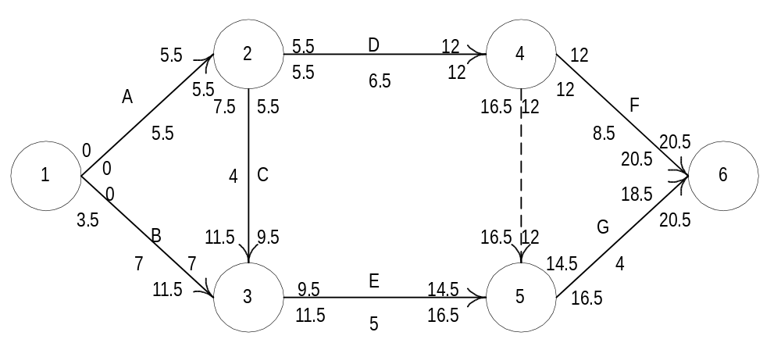
Notice all the changes! The completion time has been pushed off by one half of a week, and the slack for the non-critical activities has changed. Sometimes, even the critical path itself can change; you simply must perform the calculations and find out.

Now, remember that PERT assumes that all variances are beyond the control of the decision maker. All PERT tries to do is make probabilistic statements, not improve the situation. So, the next thing PERT does is to assume that the critical path is long enough to bring the Central Limit Theorem into play. I’m sure you remember the Central Limit Theorem from your statistics class, it is the one that states that if a set of random variables are combined, then the sum will follow a normal distribution. Well, the expected activity times are simply the means of Beta distributions, so they are a set of random variables. Also, the project completion time is simply the sum of the expected activity times for the critical path activities. Therefore, the project completion time should be the mean of a normal distribution, and we can use the Normal Distribution Table at the back of your text to find out how likely it is that any particular deadline will be met. Below is a picture of the normal distribution for the project, with the mean of 20.5.
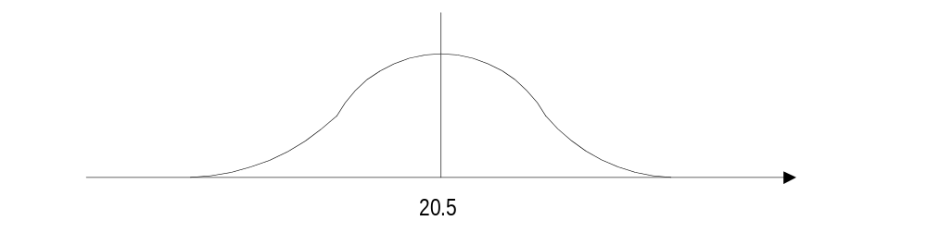
Now, a normal distribution needs two pieces of information, or parameters. The first is the mean, and we have that, and the second is the variance or standard deviation. To calculate that we go back to our data and calculate the variance of each activity. The formula we use is: [(b-a)/6]². Therefore, we get:

Opt. M/L Pess. Expected
Activity Pred. Time Time Time Time Calculation Variance
A -- 4 5 9 5.5 [(9-4)/6] ² = (5/6) ² = 0.6944*
B -- 3 6 15 7 [(15-3)/6] ² = (12/6) ² = 4.0000
C A 3 4 5 4 [(5-3)/6] ² = (2/6) ² = 0.1111
D A 2 7 9 6.5 [(9-2)/6] ² = (7/6) ² = 1.3611*
E B, C 3 5 7 5 [(7-3)/6] ² = (4/6) ² = 0.4444
F D 6 8 13 8.5 [(13-6)/6] ² = (7/6) ² = 1.3611*
G D, E 1 3 11 4 [(11-1)/6] ² = (10/6) ² = 2.7778

You only need the variance for the critical path activities, so I have again marked them with asterisks. Adding up the three critical path variances, we get a total variance of 3.417, and taking the square root of that number, we get a standard deviation of 1.8484. With this data we can perform two calculations: finding the probability of meeting a particular due date, and finding a limits for a confidence interval of a given probability. Notice that in the first calculation you are given a due date so you can find a probability and in the second you are given a probability so you can find due dates. The formula you need for the first calculation is:

(Due Date - Mean)
Z = -----------------------
Standard Deviation

“Z” is the number you can look up in the border of the Normal Distribution Table in the back of your textbook. You then read the probability out of the body of the table. Suppose you boss wants the project done in 25 weeks. You now have all the data you need to calculate Z. The Due Date is 25, the mean is 20.5, and the standard deviation is 1.85. Putting these values into the formula you get:

(25-20.5)
Z = ----------- = 2.43
1.85

and looking at the graph of the normal distribution you see:
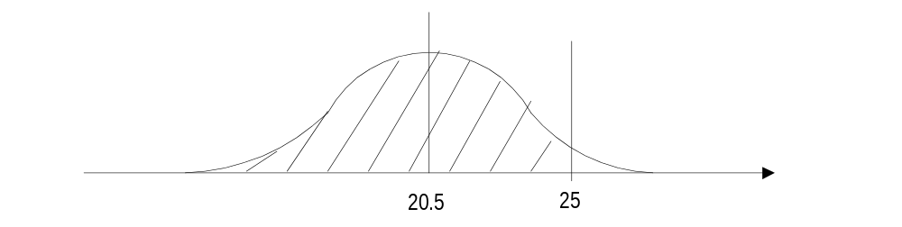
From the graph, you see that you are looking for the area that is shaded between left-hand side of the graph (equivalent to -Infinity) and the due date of 25. Looking in the appendix of your book, we find the normal table. If the table only gives the probabilities from the mean up, we know that the probability below the mean is .5, so we can remember to add .5 to all the probabilities in the table. To look up 2.43 on the border of the table, we notice that down the left-hand side of the table it shows 0.0 to 3.0, and across the top of the table it shows 0.00 through 0.09. Use 2.4 (from 2.43) to find the row of the table that we need, and use 0.03 (the rest of 2.43) to find the column. Look at where the row and column meet, and that is the probability of being between the mean and 2.43, which is 0.9925 (or if it reads 0.4925, we still need to add .5 to that number, so our probability of having the project done before 25 weeks is 0.5000 + 0.4925, or 0.9925). Translated, we over a 99% chance of being done by 25 weeks, which is pretty good. You can repeat this calculation for any other due date you might like, eventually building a table such as:

 | Due Date | Z-value | Probability of  On-Time Completion
 | 25 | 2.43 | 0.9925
 | 24 | 1.89 | 0.9706
 | 23 | 1.35 | 0.9115
 | 22 | 0.81 | 0.7910
 | 21 | 0.27 | 0.6064
 | 20 | -0.27 | 0.3936

For that last due date, we were below the mean, so we had to be a little clever to use the table. Since the Z-value is negative, we treat it as if it were positive and get the probability of 0.1064 from the table. Then, instead of adding 0.5000 to this number, we subtract 0.1064 from 0.5000 to get 0.3936. If you look at the normal distribution graph this makes sense. If that doesn’t work simply remember it.

Now, we are going to do everything in reverse. This time you boss wants to know a range of due dates, so that there is a stated probability of being done within that range, for example, a 90% probability. This time our normal graph looks a little different.
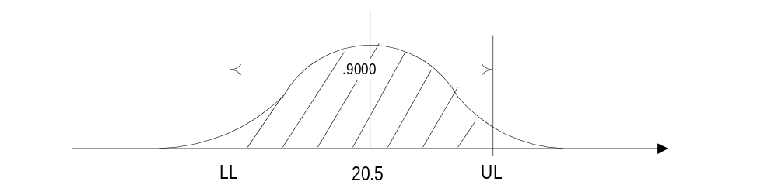
You have both an upper and a lower due date, shown as the Upper Limit (UL) and Lower Limit (LL). The shaded area represents the probability of being between the two limits, but we already know that probability is to be 90%. Now, we have to find the limits that make that probability correct. The formulae we use is simply a variation on the formula for Z, except that instead of calculating Z from the due date as we did before, we are going to get Z from the normal table and use Z to calculate the due date. Our formulae are:

UL = Mean + Z*Standard Deviation
LL = Mean - Z*Standard Deviation

To get Z from the table, we first have to look at the graph and notice that there is a little bit of a tail on the left-hand side of the graph that is not part of the shaded area. Since our calculations are based on including everything from -Infinity on up, we have to figure out how much area lies in that little tail. Well, we know three things: the area between the limits is 90%, the total area from -Infinity to +Infinity is 100%, and the lower and upper limits are symmetric around the mean. This tells us that 10% of the area lies in both tails, left and right, (100% - 90%), and half of that 10% lies in the lower tail, or 5%. That means that the total area from -Infinity to the upper limit is 90% (the area between the limits) + 5% (the area in the lower tail), or 95%.

We are now ready to work with the table. We look in the body of the table for the number closest to .9500, (subtract 0.5000 from our probability first, if needed so look for 0.9500 - 0.5000 = 0.4500). Actually, you find two numbers that bracket 0.9500, these are 0.9495 and 0.9505 (or 0.4495 and 0.4505, for the other table). You can use the smaller number and be optimistic (you will get a smaller range), the larger number and be conservative (you will get a larger range), or average the Z values together, which gives an in-between range and drives the mathematicians insane, since it is not mathematically proper. Since this is a Business course, we will average the Z-values. First, though, we have to get the Z-values. You get them by reading the row and column headings for the number you found and adding them together. For the lower number, you are in row 1.6 and in column 0.04, so added together your Z-value is 1.64. For the upper number, you are in the same row, 1.6, but are one column over, 0.05, so added together you get 1.65. Averaging these two gives you 1.645, and that is the Z-value we will use in the formulae with the mean 20.5 and the standard deviation of 1.85. This gives us:

UL = 20.5 + 1.645*1.85 = 23.54
LL = 20.5 - 1.645*1.85 = 17.46.

With this, you are 90% sure that the project will be completed between 17 and 1/2 weeks and 23 and 1/2 weeks. If you want, you can build another table to show a variety of confidence intervals, such as is shown at the top of the next page:

 | Probability | Z-Value | Lower  Limit | Upper  Limit
 | 99% | 2.575 | 15.74 | 25.26
 | 95% | 1.960 | 16.87 | 24.13
 | 90% | 1.645 | 17.46 | 23.54
 | 80% | 1.285 | 18.12 | 22.88
 | 67% | 0.975 | 18.70 | 22.30

This is all PERT can do for you. It has identified a critical path and given you some estimates for when the project will be completed. The next handout will cover how we will combine PERT and CPM so that we can perform both crashing of a project (exhibiting control) and probability calculations (acknowledging that some aspects of the project are beyond our control), which is a more realistic view.

