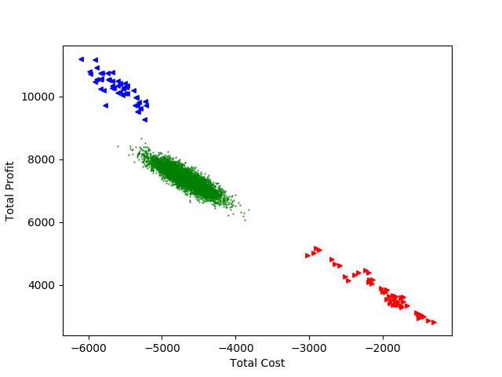 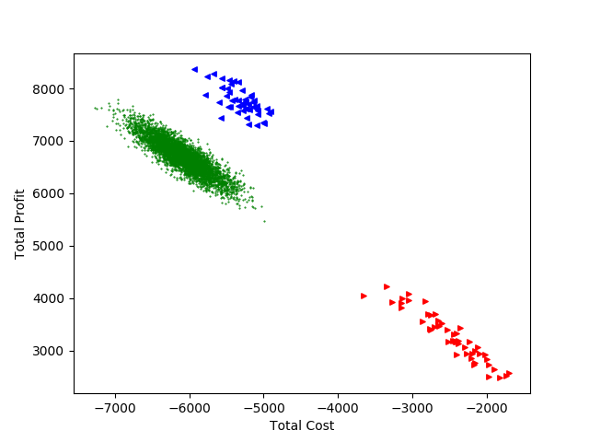

**Classic dataset Realistic dataset**

The red triangles are the result of multi-objective solution, the blue triangles are the result of single-objective solution and the green dots are the result of random solution.

We can see that:

1. With multi-objective solution we can get low cost and low profit, the absolute of these two values are relatively low.
2. With single-objective solution we can get high cost and high profit, the absolute of these two values are relatively high.
3. Random results are between multi-objective solution and single-objective solution, and the result (profit - cost) is lower than both of them.
4. In the realistic dataset, the result of single-objective solution is obviously better than the random solution.