CS 396 Project 3

Mobile App

BY: Yanzhou Huang

***Summarize and Requirements***

This project wasrequired to display menu for a restaurant. The menu should display price and quantity with each menu item. This app was required to enter the number of guest and split the final bill amount. This app also set a tip percent by dragging the thumb on the seek bar and Calculate the tip.

***Design Decisions***

Why I choose the Android because for me it is easy to test and debug. Also, the IOS system require to connect a mac computer.

I choose the Android Studio for develop because it is the platform create by google. Android Studio uses the quick growing Gradle build system that is so integrated, and Gradle is really a great tool.

Also, Android Studio is good for the UI part and the organization.

Finally, the android studio has the intelligent code editor. An intelligent code editor that helps you each step of the way.

Android Studio is built on IntelliJ and is capable of advanced code completion, refactoring, and code analysis.

This mobile app included 7 activity.

1. Main activity.

It is the cover page for this app. It included three button. start new order, social and information.

1. Menu activity.

It is the page that display the menu which has price and

quantity choice associated with each menu item to the guest.

1. Order product activity.

This page will show the description for the item and let guest choose the QTY they need.

1. Cart activity.

This page display guest(s) choices including quantity for each choice.

1. Checkout activity.

In this activity, it will calculate total bill amount due. Dragging the thumb on the seek bar to Choose the tip. enter number of guests and split the final bill amount (including tips) among the number of guests and display.

1. Social activity.

Not functional.

1. Information activity.

Not functional.

***Key Screen***

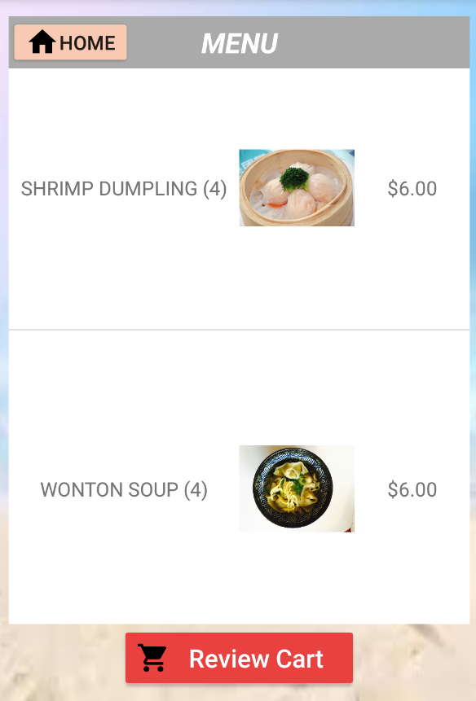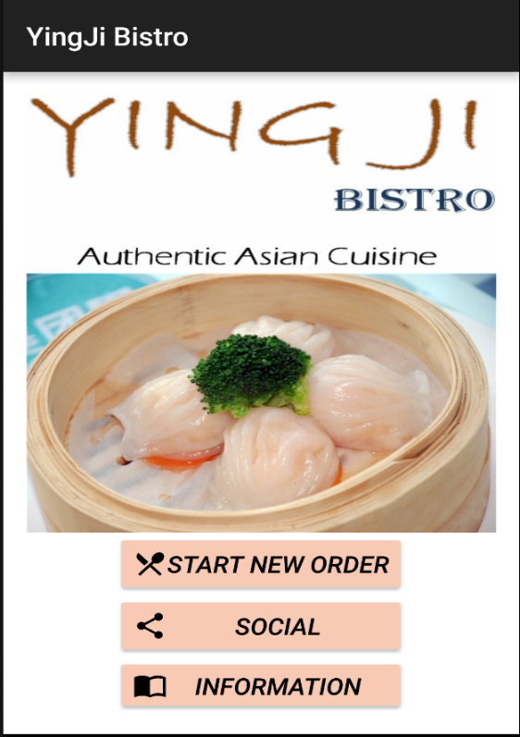

MainScreen Menu screen

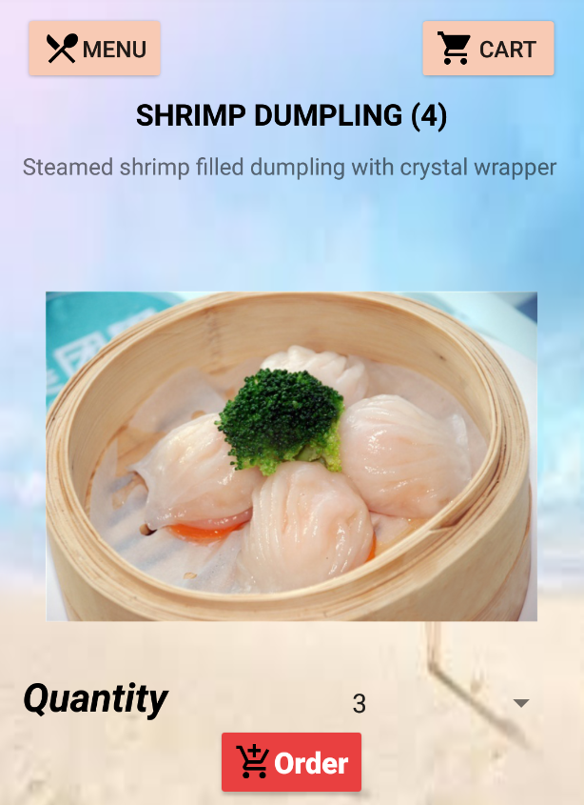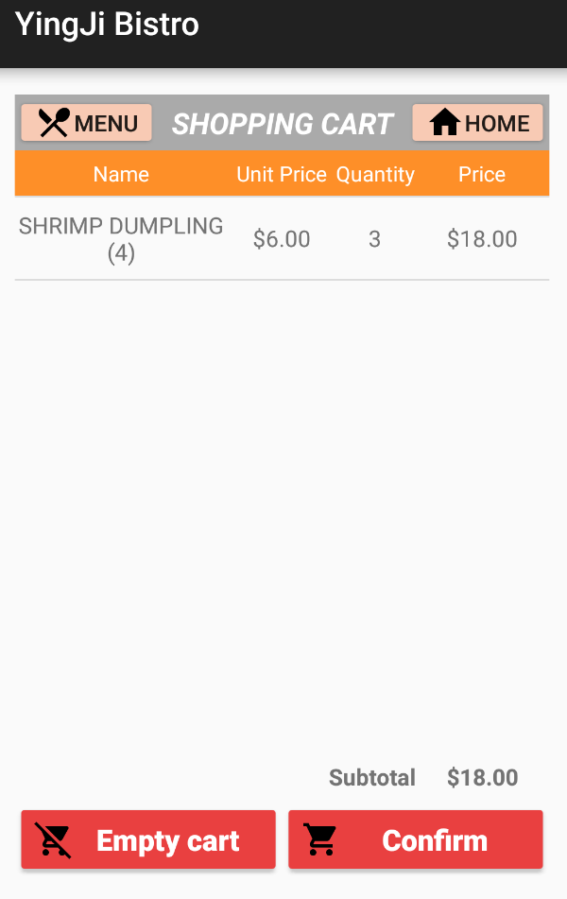

Order screen Cart screen

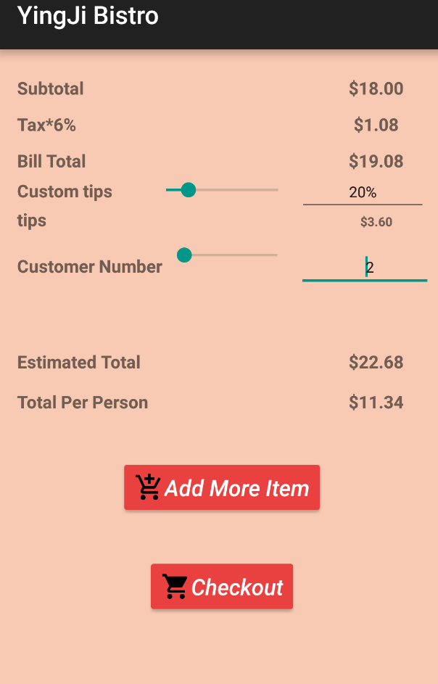

Check out screen

***Bugs/Problems***

In some cases will lost penny for bill spilt.

***Limitations***

QTY for each item between 1 to 10. Customer number between 1 to 100.

Later can finished the Social and information activity.

Create a navigation bar instead of button.

***Acknowledgements***

Android studio tutorial

<https://developer.android.com/training/basics/firstapp/index.html>

Android tutorials

***http://android.orthus.net/?p=1***