Beyond Averages:
Timestamp Gaps and Cancellation Concentration
at Shanghai Hongqiao Airport
Proposed revised research report
Exploratory analysis of 22 September–22 October 2026

Student: [Add your name]
Course: [Add course name and code]
Instructor: [Add instructor name]
Submission date: [Add date]

Scope note: This report extends the original departure-time analysis. Obtain instructor approval if it changes the approved proposal.
Measurement note: Recorded timestamp differences are not validated operational delays. Operating-carrier comparisons are not supported.
Main-text word count: 3,002 (abstract and sections 1–6, including headings; excluding tables, captions, cover, references and appendix).

Abstract
This study examines three complementary patterns in 23,705 flight-event records associated with Shanghai Hongqiao Airport across 31 local service dates. First, evening departures have a lower median recorded departure timestamp gap than morning departures, but a larger fraction of gaps of at least 60 minutes. A within-route, within-date comparison estimates an evening excess of 3.60 percentage points, with an exploratory date-cluster bootstrap interval of 0.96–7.74 points. Second, 82.6% of paired SHA departure records whose departure gap is at least 15 minutes have an arrival gap below 15 minutes. This apparent reduction is descriptive and may reflect different schedule and event definitions. Third, five dates account for 47.6% of cancellations but 15.8% of known-status records. The findings show why central tendency, extreme-tail risk, paired measurements and temporal concentration should be examined separately. They do not establish causal effects or verified operational punctuality.

1. Introduction
A single average can give an incomplete account of flight performance. A traveler may care about the typical departure experience, the chance of a very large departure discrepancy, whether a later departure is followed by a later arrival, or the risk of cancellation. These are different outcomes. A schedule period can look favorable on one measure and unfavorable on another, while a monthly cancellation rate can conceal substantial variation across individual dates.
The existing course analysis describes recorded departure-time differences by hour and compares morning with evening within route-weekday groups. This report extends that work rather than treating the original mean comparison as the only useful question. It studies distributional differences, paired departure and arrival timestamps, and cancellation concentration. The objective is to identify informative patterns while keeping the interpretation proportional to the evidence available in the supplied file.
Measurement is central to this objective. Every row marks timing semantics as unverified, and the operating-carrier field is blank throughout. Consequently, the report uses the expression recorded timestamp gap rather than validated operational delay. A subtraction can be arithmetically correct even when its two timestamps refer to different operational events. The dataset also covers only one airport and one month; completeness against an independent airport movement register has not been established.
The research questions are: (1) Do evening departures combine a smaller typical gap with a greater extreme-gap fraction, including when compared within the same route and date? (2) How frequently does a departure gap of at least 15 minutes accompany an arrival gap below 15 minutes? (3) How concentrated are cancellations across dates, and how cautiously should calendar-category differences be interpreted? These questions were developed after inspecting the data and are explicitly exploratory rather than preregistered hypotheses.

2. Literature and analytical framework
Mayer and Sinai (2003) study network effects, congestion externalities and hubbing in air travel. Their work provides context for considering schedule structure rather than treating every timestamp discrepancy as an isolated flight attribute. It does not establish that the patterns in this SHA file are caused by congestion. The present study has no validated measure of runway demand relative to capacity, air-traffic-control restrictions or connection-bank design, and therefore does not estimate those mechanisms.
The distinction between the center and the tail of a distribution is also substantively important. The median answers what a central observation looks like; a high percentile describes a more extreme part of the observed distribution; a threshold fraction describes how often a specified condition occurs. None is a substitute for the others. Reporting all three avoids the misleading conclusion that a period with the smaller median must be preferable under every definition of performance.
Efron (1979) develops the bootstrap as a resampling approach to uncertainty. Cameron and Miller (2015) discuss why dependence within clusters matters for inference. Flights associated with one date may share conditions, so treating every flight as independent could exaggerate precision. This report resamples whole local service dates. With only 31 clusters, the intervals remain exploratory summaries of observed-date variability, not assurances of population coverage or protection against measurement error.
These ideas motivate a descriptive framework with three safeguards. Outcomes are defined explicitly from fields in the file, uncertainty is summarized at the date level where feasible, and alternative interpretations are considered before operational explanations are proposed. Matching on route and date reduces some compositional differences but is not randomization. Likewise, a paired arithmetic reduction between departure and arrival gaps is not an independent measurement of aircraft recovery or schedule padding.

3. Methods

3.1 Data, units and inclusion criteria
The supplied file contains 23,705 unique event identifiers: 11,873 arrival records and 11,832 departure records. Local service dates run from 22 September to 22 October 2026 inclusive. The unit is a flight-event record, not a passenger or an independently verified aircraft rotation. Although identifiers are unique within the file, this does not prove that all real-world movements are represented or that event identities have been fully validated.
A known status is any nonblank status other than Unknown, after trimming whitespace and ignoring case. Canceled records remain in cancellation denominators but are excluded from timing comparisons. There are 34 unknown-status records and 487 canceled records. Departure-gap analyses additionally require both scheduled and actual departure timestamps, leaving 11,560 records. This complete-case design can introduce selection if missing or unresolved records differ systematically from observed completed records.
Paired analyses additionally require scheduled departure, actual departure, scheduled arrival and recorded landing timestamps. The SHA departure cohort contains 11,551 paired records; the SHA arrival cohort contains 11,599. The cohorts are reported separately because their endpoints and SHA service-date definitions differ. Within departures, 262 unknown or canceled rows and 19 additional rows lacking a paired timestamp reconcile to the full total; the corresponding arrival exclusions are 259 and 15.

3.2 Outcome definitions
All differences are calculated from timezone-aware UTC timestamps and expressed in minutes. Departure gap equals actual departure minus scheduled departure. Arrival gap equals recorded landing minus scheduled arrival. Positive values mean the recorded event is later than schedule; negative values mean it is earlier. The 15-minute and 60-minute thresholds are descriptive choices for this exploration, not validated regulatory delay classifications.
The paired reduction equals departure gap minus arrival gap. Algebraically, this is also scheduled duration minus recorded elapsed duration. The identity is checked during computation, but it provides no independent verification of event meaning. In particular, a scheduled gate-arrival time and an observed landing time can differ even without operational improvement. The conditional percentage uses records with departure gap at least 15 minutes as its denominator and those with arrival gap below 15 minutes as its numerator.

3.3 Morning–evening comparison and uncertainty
Morning is 06:00–11:59 and evening is 17:00–22:59 Shanghai local scheduled departure time, retaining the original notebook's windows. Other hours remain part of the full departure dataset but are not included in this contrast. Unadjusted summaries report each window's mean, median, 95th percentile and fraction at least 60 minutes. These describe the observed sample rather than a causal effect of choosing a departure hour.
For matching, records are grouped by directional route and local date. A cell is included when it has at least one eligible morning and one eligible evening record. Within each cell, the morning mean or threshold fraction is subtracted from the evening equivalent. The overall estimate is the equal-weight mean of cell contrasts. Thus it targets the average eligible route-date cell, not the average flight, and excludes routes lacking observations in both windows.
Uncertainty intervals use 2,000 whole-date bootstrap replicates with seed 20261024, taking the 2.5th and 97.5th percentiles of replicate estimates. For matched analyses, each sampled date brings its observed eligible cells and their contrasts; eligibility is determined within date and is not recreated by pooling duplicate dates. Paired conditional fractions resample date-level numerator and denominator totals. For SHA arrivals, the cluster is the SHA arrival service date, not necessarily the origin departure date.
Two checks assess robustness of the extreme-tail contrast: requiring at least two records in each matched window, and omitting each date in turn. Paired results are also recalculated after excluding records flagged in either identity-review field, and route medians are examined for routes with at least 100 paired observations. These are sensitivity descriptions, not corrections for all possible bias or substitutes for source validation.

3.4 Cancellation concentration and calendar categories
Cancellation rates divide canceled records by known-status records. Daily summaries combine arrival and departure events for an airport-event description, without assuming they represent independent traveler experiences. Dates are ranked by cancellation count, and the five largest are compared with the remaining dates. Because this selection deliberately chooses the largest counts after inspection, its concentration statistic is not a prospective risk rule and is not assigned a significance test.
Calendar categories use the dataset's existing labels: ordinary weekday, public holiday, weekend and adjusted workday. Both the number of dates and the number of records are reported. Date-bootstrap intervals are provided only for categories with at least two dates; the one-date adjusted-workday category has no such interval. Neither these labels nor their comparisons can isolate holidays from weather, schedule changes or other date-specific conditions that are not measured here.

3.5 Reproducibility and interpretation rules
The analysis script recomputes outcomes directly from the input timestamps rather than relying solely on precomputed gap fields. It checks unique event identifiers, positive leg durations, consistent date-category labels and the paired arithmetic identity. Independent validation also reconciles cohort exclusions to direction totals and recomputes daily cancellation denominators. These checks detect several calculation or processing errors, but they cannot establish that a source timestamp represents the intended physical event.
Interpretation follows the selected estimand. Percentage-point contrasts are absolute differences between fractions, whereas the approximate 2.8-fold unadjusted comparison is a ratio. The matched percentage-point contrast should not be described as an adjusted risk ratio. Likewise, conditional arrival percentages apply only to observed paired records that meet the departure threshold; they do not describe canceled flights or the full scheduled-flight population. Keeping those denominators visible prevents apparently similar percentages from being compared as if they measured the same event.

4. Results

4.1 Lower evening median, greater extreme-tail fraction
Table 1. Unadjusted departure-gap summaries by local scheduled window.
Window | Records | Mean (min) | Median (min) | P95 (min) | Gap ≥60 (%)
Morning | 4,531 | 21.69 | 18.88 | 44.18 | 2.43
Evening | 3,406 | 22.85 | 15.96 | 72.73 | 6.84

Morning contributes 4,531 records and evening contributes 3,406. The median is 18.88 minutes in the morning and 15.96 minutes in the evening, so the central evening observation has a smaller gap. However, the 95th percentile is 44.18 minutes in the morning versus 72.73 minutes in the evening. The fraction at least 60 minutes is 2.43% versus 6.84%, an unadjusted ratio of approximately 2.8. The evening mean is also slightly larger despite its smaller median.
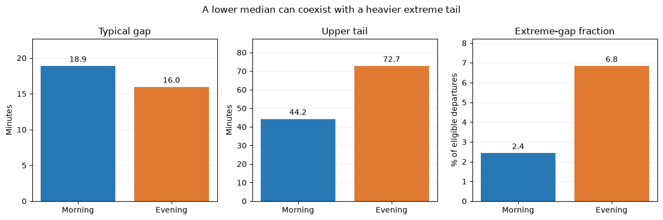
Figure 1. Central tendency and extreme-tail measures give different morning–evening comparisons. Bars describe unadjusted observed records; they are not causal estimates.
The matched comparison includes 860 route-date cells, 6,948 records and all 31 dates. The equal-cell average evening-minus-morning mean difference is +0.52 minutes, with a date-bootstrap interval of −2.31 to +4.71 minutes. By contrast, the matched difference in the fraction at least 60 minutes is +3.60 percentage points, with an interval of +0.96 to +7.74 points. The observed tail difference therefore persists in this matched description even though the average-gap contrast is close to zero.
Table 2. Within-route, within-date contrasts; all signs are evening minus morning.
Comparison | Cells | Estimate | 95% date-bootstrap interval
Mean gap | 860 | +0.52 min | −2.31 to +4.71 min
Gap ≥60 fraction | 860 | +3.60 pp | +0.96 to +7.74 pp
Mean gap; ≥2 per window | 644 | +0.50 min | −2.49 to +4.81 min
Gap ≥60; ≥2 per window | 644 | +3.86 pp | +0.93 to +8.21 pp

The stricter matching rule retains 644 cells across all 31 dates and gives an extreme-fraction difference of +3.86 percentage points. Omitting each date in turn gives differences ranging from +1.79 to +3.93 points, so no single omitted date reverses the direction. These checks support the descriptive stability of the selected contrast, but the exploratory choice of outcome and windows still requires caution. They do not establish that changing a flight's hour would change its outcome.

4.2 The paired departure–arrival pattern
Table 3. Paired timestamp summaries. Conditional fraction: arrival gap <15 among records with departure gap ≥15.
Cohort | Paired n | Median dep. (min) | Median arr. (min) | Conditional % | 95% interval
SHA arrivals | 11,599 | 13.35 | -15.47 | 80.95% | 78.46–83.66%
SHA departures | 11,551 | 17.30 | -8.97 | 82.64% | 78.68–86.37%

In the SHA departure cohort, the median departure gap is +17.30 minutes and the median arrival gap is −8.97 minutes. Among the 6,923 paired records whose departure gap is at least 15 minutes, 5,721 have an arrival gap below 15 minutes. This is 82.64%, with a date-bootstrap interval of 78.68%–86.37%. The criterion means less than 15 minutes after scheduled arrival; it does not require an early arrival or an exact on-time event.
The SHA arrival cohort shows a similar descriptive pattern: 4,125 of 5,096 records meeting the departure threshold have arrival gaps below 15 minutes, or 80.95%, with an interval of 78.46%–83.66%. The median paired reduction is 27.32 minutes for SHA departures and 29.68 minutes for SHA arrivals. These are medians of record-level paired reductions, not subtractions of separately computed cohort medians.
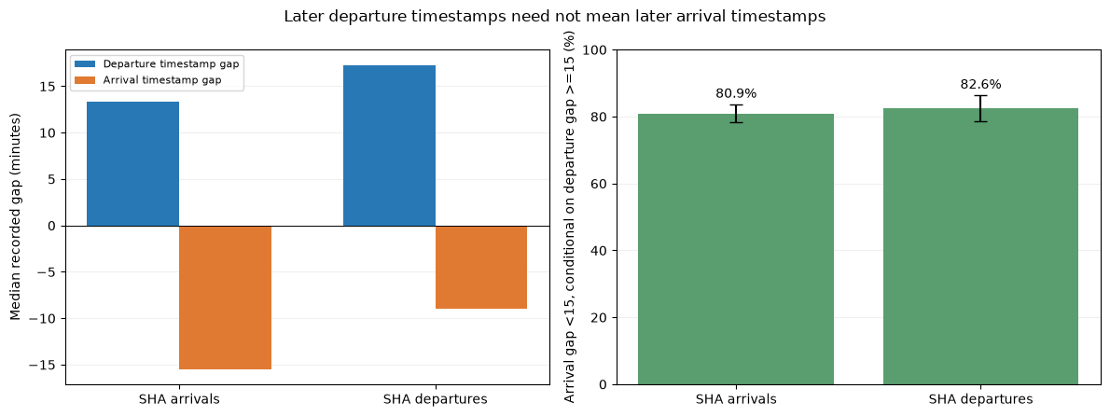
Figure 2. Paired-cohort medians and conditional arrival-gap fractions. Error bars are exploratory 95% date-bootstrap intervals. Event semantics remain unverified.
After excluding identity-review flags, conditional percentages are 82.66% for SHA departures and 80.93% for SHA arrivals, very close to the main results. For each cohort, all 31 routes with at least 100 paired records have a positive median paired reduction. This suggests the arithmetic pattern is not confined to one qualifying route. It does not resolve the possibility that the same event-definition mismatch is present systematically across routes.

4.3 Cancellations are concentrated on particular dates
Table 4. Five dates with the largest observed cancellation counts.
Date | Canceled | Known-status records | Cancellation rate (%)
2026-09-29 | 62 | 761 | 8.15
2026-09-28 | 46 | 751 | 6.13
2026-09-26 | 45 | 721 | 6.24
2026-10-08 | 42 | 769 | 5.46
2026-10-03 | 37 | 748 | 4.95

The five selected dates contain 232 of 487 cancellations, or 47.64%, while accounting for 15.84% of known-status records. Their combined cancellation rate is 6.19%, compared with 1.28% on the other dates. The highest cancellation count occurs on 29 September, with 62 of 761 known-status records canceled. The contrast demonstrates temporal concentration in this file, not that the selected dates form a predefined high-risk category.
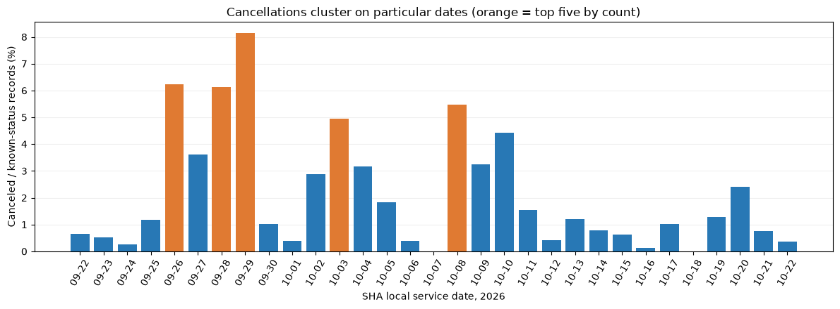
Figure 3. Daily cancellation rates among known-status event records. Orange identifies the five dates selected retrospectively by cancellation count.
Table 5. Calendar-category cancellation summaries; pp denotes percentage points elsewhere.
Category | Dates | Known | Canceled | Rate (%) | 95% interval (%)
adjusted workday | 1 | 680 | 30 | 4.41 | Not estimable
ordinary weekday | 17 | 13,089 | 253 | 1.93 | 0.94–3.08
public holiday | 10 | 7,634 | 185 | 2.42 | 1.32–3.69
weekend | 3 | 2,268 | 19 | 0.84 | 0.00–1.54

Public holidays have a cancellation rate of 2.42% across ten dates, compared with 1.93% across 17 ordinary weekdays. Their separate date-bootstrap intervals overlap, but overlap is not itself a formal test of a difference or proof of equality. Weekends contribute only three dates. The adjusted-workday rate is 4.41%, but it comes entirely from one date. A large number of records within that date does not provide independent replication of adjusted-workday conditions.

5. Discussion
The first contribution is to separate typical outcomes from extreme-tail risk. Saying that evening is better because its median is smaller would omit the larger fraction of very large gaps. Saying that evening is uniformly worse would also be inaccurate. The matched mean contrast is small, whereas the matched extreme-fraction contrast is positive. A defensible summary states both results and specifies which outcome supports each statement.
The second contribution is measurement-aware interpretation of paired timestamps. The common combination of later departure timestamps and earlier arrival timestamps is striking, but an appealing operational story is not necessarily the correct one. Different event definitions, scheduled buffers, timestamp provenance or other recording processes could contribute. Claims about pilots flying faster, deliberate padding or successful delay recovery require additional evidence that this study does not contain.
The third contribution is to distinguish calendar labels from date-specific concentration. The concentration chart identifies where many cancellations occur, but it cannot explain why. A holiday interpretation would require stronger design and additional observations, including ordinary and holiday periods across a longer span. Weather and operational restrictions are not available, and cancellation effects may connect several related events rather than representing independent decisions for every row.
Several limitations apply jointly. The sample is restricted to one airport and 31 dates, so annual seasonality and general airport performance are outside its scope. Complete-case filtering may select a nonrepresentative set of records. Matched analyses retain only route-date cells observed in both windows and weight them equally. Bootstrap intervals address resampling variability, not unknown measurement errors, missing confounders, incomplete coverage or the exploratory search that preceded these questions.
Practical recommendations must therefore remain modest. The observed patterns justify further data validation and a replication study, not advice that passengers should always choose a particular hour or airline. An independently collected month could test the predefined morning–evening extreme-gap comparison. Verified event definitions would make paired timing interpretations more credible. A documented observation frame, weather measures and validated operator identities would support more ambitious research questions.
A useful replication would select its outcome and thresholds before examining the new month. The primary descriptive target could be the equal-cell evening-minus-morning difference in the fraction of departure gaps of at least 60 minutes, retaining the same windows and matching criteria. Reporting all eligible dates, the matched sample coverage and any exclusions would help distinguish a repeated pattern from one driven by changes in observation or schedule composition. A changed result would be informative rather than a reason to search for a different favorable threshold.
The figures should also be read in their proper roles. The first shows unadjusted distribution summaries and should be accompanied by the matched estimates in Table 2. The second separates inbound and outbound cohorts and displays uncertainty for a conditional fraction, not for every bar. The third highlights retrospectively selected cancellation dates. Clear captions and explicit units make these distinctions visible and prevent a visually persuasive chart from carrying a claim that the underlying analysis does not support.
Finally, record-level findings are not passenger-weighted measures. The file does not provide passenger loads, missed connections, rebooking outcomes or the costs associated with a disruption. A small number of canceled events could affect many travelers, while a large timestamp discrepancy on another event could affect fewer. The research therefore evaluates patterns in observed flight-event records, not total traveler welfare or an airport's overall service quality.

6. Conclusion
This exploratory study finds that evening departures can have a smaller median recorded gap while showing a larger extreme-gap fraction, including within matched routes and dates. It also documents a frequent reduction between recorded departure and arrival gaps and substantial cancellation concentration on a few dates. The strongest conclusion is methodological as well as empirical: averages, tail fractions, paired outcomes and temporal concentration reveal different features of the same dataset and should not be conflated.
The findings are useful as a transparent, reproducible and measurement-aware course-project analysis, provided they are presented as descriptive associations. Timing semantics remain unverified, operating-carrier comparisons cannot be supported, and no causal mechanism has been identified. Reproducible computation, explicit denominators, sensitivity checks and candid limitations make the conclusions more defensible than a stronger-sounding but unsupported operational claim.

References
Cameron, A. C., & Miller, D. L. (2015). A practitioner's guide to cluster-robust inference. Journal of Human Resources, 50(2), 317–372. https://doi.org/10.3368/jhr.50.2.317
Efron, B. (1979). Bootstrap methods: Another look at the jackknife. The Annals of Statistics, 7(1), 1–26. https://doi.org/10.1214/aos/1176344552
Mayer, C., & Sinai, T. (2003). Network effects, congestion externalities, and air traffic delays: Or why not all delays are evil. American Economic Review, 93(4), 1194–1215. https://doi.org/10.1257/000282803769206269
SHA flight dataset. (2026). sha_master.csv [User-supplied flight-event dataset; analyzed 24 October 2026]. Source URLs and retrieval timestamps are included in the file. Event semantics and operating-carrier identities are unverified.

Appendix A. Reproducibility and submission checklist
Numerical source: research_extensions_results.json, recomputed from sha_master.csv by scripts/explore_research.py. Notebook: research_extensions.ipynb. Figures: research_extensions_figures. This Word generator refuses to build if the saved numerical results differ from a fresh analysis.
Rebuild numbers: uv run python scripts/explore_research.py. Rebuild this document: uv run --group report python scripts/generate_extensions_document.py. If the input data change, rerun the research notebook to refresh its three figures before generating a report; figure files are not regenerated by this document builder.
Before submission: replace the cover placeholders; confirm the approved research scope and course word-count rules; check all figures and references; disclose tool assistance if required by course policy; retain the unverified-timestamp warning. The original notebook and original PDF report have not been replaced.

