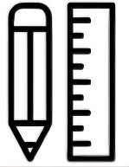




Semi-structured
Interview

SUS
Questionnaire

Controlled Experiment
Control Group：
Sou-yun

Experimental Group：
VerseColor
15Min
Background & Pre-test Questionnaire
RQ
Formative Study

Workshop User Study
Semi-structured
Interview

