Report By: Yao Xinchen

### Total: ____/20

Lab Partner:

Lab TA:  Junjie Gao

Section: AB2

## Report Guidelines: ___/20

For this report you will need three files:

1. LabReport0.m (the main file that runs the other two)
2. StepResponseMetrics.m (a file you will edit to show Mp, tr and tss)
3. controllerlab0.mdl (A Simulink model)

All three files must be saved in the same directory. You only need to edit StepResponseMetrics.m. You can run all three by typing **LabReport0** in the Matlab command window because LabReport0.m calls the other two files.

## What to hand in:

Use this file as a template (put your name for the *Report By* line, your partner’s name in the *lab partner* line, etc.).

You must submit a printout showing Mp, tr and tss, as found in StepResponseMetrics.m. It should look *something* like the following:

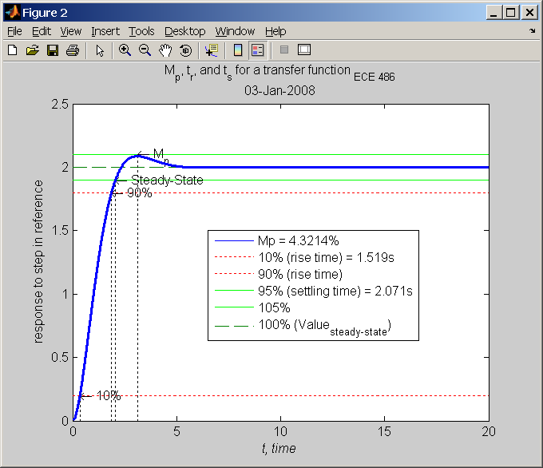

*Note: you must show Mp, tr, tss values and must have similar titles and labels.*

