Report By: Xinchen Yao

# Total ___/45

Lab Partner: Rebecca Rauschmayer

Lab TA: Junjie Gao

Section: AB2

## Part 1. ___/15

### Plots ___/6

*(Attach time response plots to end or include them here)*

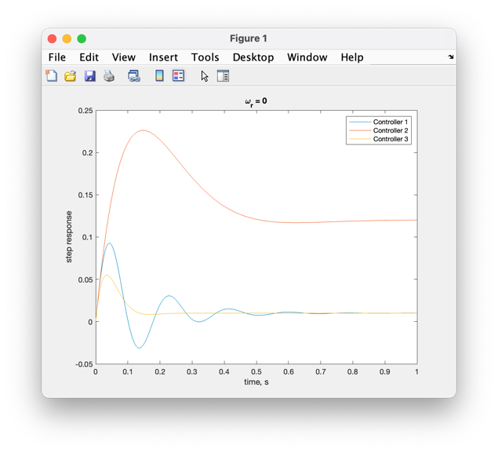

Fig. 1 Fig. 2

### Time Response to a Unit step for ωr ___/6

|  |  |  |  |  |  |  |
| --- | --- | --- | --- | --- | --- | --- |
|  | **Controller 1** | | **Controller 2** | | **Controller 3** | |
| **Prelab** | **Lab** | **Prelab** | **Lab** | **Prelab** | **Lab** |
| **Mp (%)** | 49.8% | 49.8% | 2.8% | 2.84% | 2.85% | 2.83% |
| t­r (s) | 0.052 | 0.035 | 0.23 | 0.228 | 0.07 | 0.067 |
| t­s (s) | 0.4 | 0.390 | 0.33 | 0.312 | 0.097 | 0.089 |
| K | 19.4 | | 1.07 | | 19.4 | |
| Kr | 1.03 | | 1.56 | | 1.03 | |
| Kd | 0 | | 0 | | 0.03 | |

Table 1

### Compare/contrast ___/3

* *Mp, tr, and ts from Prelab with those from Lab*
* *Which controllers met the specifications?*
* *Those from Prelab are very close to the ones from Lab.*
* *The third.*

## Part 2. ___/12 Deriving ess components

*For the system in Figure 3.1, derive the relationship between steady-state error (ess= ωr – ω) and natural frequency, ωn. Consider the error as a function of both ωr and τd, and model these as step inputs. Since the system is linear, superposition allows the two components to be calculated separately and then summed. Notice that ess is not the same thing as “e” in the block diagram (e= Kr ωr – ω).*

 $60K+36$ (1)

 $ω_{r} - \frac{60KK_{r}}{(s + 3)(s + 12) + 60K}ω_{r} + \frac{4(s + 3)}{(s + 3)(s + 12) + 60K}τ_{r}$ (2)

*Hint: Use the Final Value Theorem, (page 93, FPE).*

*Make sure you answer the following questions:*

*ess due to a step in ωr (τd = 0) is: $ω_{r} - \frac{60KK_{r}}{(s + 3)(s + 12) + 60K}ω_{r}$*

*To minimize this error component, should be $\sqrt{60KK_{r}}$*

*ess due to a step in τd (ωr = 0) is: $\frac{4(s + 3)}{(s + 3)(s + 12) + 60K}τ_{r}$*

*To minimize this error component, should be as large as possible*

## Part 3. ___/18

### For controller 3, derive the relationship between ζ, *ωn*, and the gains K and Kd. ___/12

 $s^{2} + (15 + 60KK_{d})s + 60K + 36$ (3)

 $\sqrt{60K + 36}$ (4)

 $\frac{15 + 60KK_{d}}{2\sqrt{60K + 36}}$ (5)

*Discussion: Increasing K does what to ωn2, what to ζ*

*(and at what rate: linearly, exponentially, as K2, etc.)*

*Increasing Kd does what to ωn2, what to ζ*

*(and at what rate)*

Increasing K increase ωn2 and ζ at the rate of $\sqrt{K}$

Increasing Kd doesn’t affect ωn2 but increase ζ at the rate of $\frac{30K}{\sqrt{60K + 36}}$

### Using these equations, show how the pole locations change as Kd>0 increases in value. ___/6

Poles = $-ζ ω_{n} ± jω_{n}\sqrt{1 - ζ^{2}}$ (6)

*Discuss: As Kd grows, the poles move…(remember there are two components of this, depending on the damping)*

*When ζ < 1, as Kd grows, the poles move closer to the real axis. When ζ > 1, as Kd grows, the poles move further from the origin on the real axis.*