Report By: Xinchen Yao

***Total: /90***

Lab Partner: Rebecca Rauschmayer

Lab TA: Junjie Gao

Section: AB2

## Part I. Calibration of Tachometer: \_\_\_/5

### Computing the Tachometer Gain \_\_\_/3

*Briefly explain the procedure and the importance of computing the gain for the Tachometer. Why is it important to know Ktach?*

We get $K_{tach}$ with $\frac{V_{tach}}{ω}$

We will need it for computing $ω$

### Experimental Parameters for the Tachometer. \_\_\_/2

|  |  |  |  |  |
| --- | --- | --- | --- | --- |
| Vi (V) | Δt (s) | Vtach (V) | ω (rad/s) | Ktach (Vs/rad) |
| 5 | 96.6 | 1.98 | 65.04 | 0.03044 |
| 10 | 41.2 | 4.66 | 152.5 | 0.03055 |
| 15 | 26.4 | 7.31 | 238.0 | 0.03071 |
| Average | | | | 0.03057 |

## Part II. Armature Resistance and Back-EMF: \_\_\_/10

### Measuring the Armature Resistance and Back-EMF \_\_\_/4

*Explain the procedure for obtaining the Armature Resistance and the torque gain (Kv = Kτ,). Why can we ignore L­a?*

We use $(R_{a}, K_{v}) = ([ I_{a}, w] \backslash V_{i})’$

We ignore $L_{a}$ because the voltage there is 0 at steady state

### Experimental Values \_\_\_/2

|  |  |  |  |
| --- | --- | --- | --- |
| Vi (V) | Iss-a (A) | Vtach (V) | ωss(rad/s) |
| 5 | 0.26 | 2.09 | 68.37 |
| 6 | 0.26 | 2.65 | 86.69 |
| 7 | 0.27 | 3.19 | 104.36 |
| 8 | 0.28 | 3.73 | 122.03 |
| 9 | 0.29 | 4.26 | 139.37 |
| 10 | 0.31 | 4.79 | 156.7 |
| 11 | 0.33 | 5.32 | 174.05 |
| 12 | 0.35 | 5.83 | 190.73 |
| -5 | -0.26 | -2.04 | -66.74 |
| -6 | -0.27 | -2.60 | -85.06 |
| -7 | -0.28 | -3.15 | -103.06 |
| -8 | -0.28 | -3.69 | -120.72 |
| -9 | -0.29 | -4.21 | -137.74 |
| -10 | -0.30 | -4.73 | -154.75 |
| -11 | -0.31 | -5.25 | -171.76 |
| -12 | -0.33 | -5.78 | -189.1 |

### Experimental Parameters \_\_\_/4

|  |  |
| --- | --- |
| Parameter | Value |
| RA (Ω) | 5.09 |
| K­V (Vs/rad) | 0.0542 |

## Part III. Constant and Viscous Friction Coefficients: \_\_\_/10

### Measuring the constant and viscous coefficients \_\_\_/6

*Explain the procedure for obtaining the friction coefficients. Include equations. Plot the friction torque (KτIa) against ω. Use a different plot for each direction and estimate the Coulomb and viscous coefficients by using a linear fit.*

We have $K_{τ} I_{A}– (bω + c) = 0$ so we can then get b and c with a linear fitA screenshot of a computer

Description automatically generatedA screenshot of a computer

Description automatically generated

### Experimental Values. \_\_\_/4

|  |  |  |  |
| --- | --- | --- | --- |
| Viscous Coefficient | | Coulomb Coefficient | |
| b+ | 0.000041 Nms/rad | c+ | 0.010590 Nm |
| b- | 0.000028 Nms/rad | c- | -0.012094 Nm |

## Part IV. Armature Inductance: \_\_\_/20

### Procedure for Measuring Rs and La \_\_\_/14

*Explain the process of measuring both parameters. Explain how holding the motor still with the rotor-locking attachment allows us to more easily measure La. Include equations (do not forget the logarithm fit).*

*Include two plots. In the first plot, overlay the linear region for the six sets of data obtained after using the logarithm function (without plotting the linear fit). Then, take one (just one, as an example) of these plots, and do a linear fit showing the equation.*

We use ${ln(v}_{ss} - v_{0}) = \frac{-1}{τ_{e}}t + C$ to get $τ_{e}$

And use to get

*A screenshot of a computer

Description automatically generated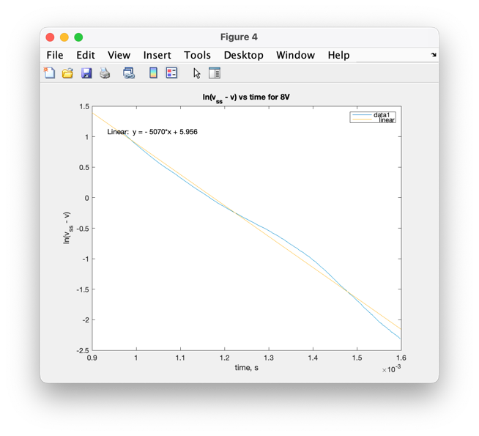*

### Experimental Parameters \_\_\_/6

|  |  |  |  |  |  |  |  |
| --- | --- | --- | --- | --- | --- | --- | --- |
| Parameter | Value 1 | Value 2 | Value 3 | Value 4 | Value 5 | Value 6 | Average |
| Rs (Ω) | 2.538 |  |  |  |  |  | 0.538 |
| τe (s) | 0.000199 | 0.000209 | 0.000253 | 0.000197 | 0.000199 | 0.000186 | 0.000207 |
| La (mH) | 0.001518 | 0.001598 | 0.001927 | 0.001505 | 0.001522 | 0.001421 | 0.001582 |

## Part V. Rotor Moment of Inertia: \_\_\_/18

### Procedure for measuring the moment of Inertia J \_\_\_/14

*Explain how to obtain J. Include equations for estimating J (use the natural logarithm function to obtain a linear relation between time and the angular velocity of the rotor). Also explain why we need to measure transient behavior to obtain J. Using the estimates found in part III, plot the linear region for the six sets of data on a single graph. Take one of these plots and do a linear fit showing the linear coefficients (i.e. an equation).*

$$ln\left(ωm+c/b\right)=\frac{-b}{J}t+C$$

We can get J with a linear fit of $t$ and $ω$

We measure the transient behavior because $\frac{-b}{J}t$ is 0 at steady stateA screenshot of a computer

Description automatically generatedA screen shot of a computer

Description automatically generated

### Experimental Values for J \_\_\_/4

|  |  |  |  |  |  |  |  |
| --- | --- | --- | --- | --- | --- | --- | --- |
| Inertia | Value 1 | Value 2 | Value 3 | Value 4 | Value 5 | Value 6 | Average |
| J (kg m2) | 0.000089 | 0.00009 | 0.00009 | 0.00009 | 0.00009 | 0.00009 | 0.00009 |

## Part VI. Conservation of Energy: \_\_/12

### Prove that Kv=Kτ

1. *Ignoring losses such as friction and applying the conservation of energy law, show that Kv=Kτ are identical. (Hint: electrical power is voltage\*current and mechanical power is torque\*velocity.)*
2. *Use unit conversions to show that their units in SI are equivalent (units are on page 21 of the lab manual).*

$$P = V i = K_{v }ω i$$

$$P = T ω = K_{τ} i ω$$

So, $K_{v }=K_{τ}$

$K_{τ}$ has unit $N m / A$

$K_{v }$ has unit $V s / rad$

They are the same

## Part VII. System Transfer Function: \_\_/10

### Transfer Function Ω(s)/Vi(s) \_\_\_/5

*Find the second order transfer function (from part e of the prelab). Use the experimental parameter values and compute the pole locations.*

$$\frac{0.0542}{1.424E-7 s^{2} + 4.58E-4 s + 3.15E-3 }$$

Poles are -3209.4 and -6.8925

### Transfer Function Ωapprox(s)/Vi(s), first order approximation \_\_\_/5

*Find the first order transfer function approximation of the system when ignoring La (set La = 0). Compute the pole location.*

$$\frac{0.0542}{4.57E-4 s + 3.15E-3 }$$

The pole is -6.8925

### *Part VIII: Steady-state response of non-linear system \_\_\_/5*

*Compute the steady-state angular velocity (ω) for a 4V input in Vi. Include the effect of Coulomb friction (c) in your computation.*

$$V_{i}K_{τ}=\left(bR_{A}+{K_{V}}^{2}\right)ω+R_{A}c$$

So, $\frac{4}{s}K_{V} = (bR_{A}+{K_{V}}^{2})Ω + \frac{R_{A}c}{s}$

By final value theorem, the steady state $ω$ is $\frac{4K_{V} - R_{A}c}{bR_{A}+{K_{V}}^{2}} = 50$

## Attachments (6)

* Friction torque vs. the angular velocity *(to estimate the friction coefficients for positive and negative rotation)* (2 plots).
* Linear region of the six sets of data for inductance La (plot).
* One of the six sets of the inductance’s data, with a linear fit approximation (plot).
* Linear region of the six sets of data for the Inertia parameter (plot).
* One of the six sets of Inertia data, with a linear fit approximation (plot)