**Assignment 1**

1. What is JDK? JRE? JVM?

JDK : Java development Kit is a development environment for developing Java applications. It includes JRE, a Java interpreter/loader, a javac compiler, a jar archiver and some tools for development.

JRE : Java Runtime Environment which provides the minimum requirements/environment for executing your Java application. It includes JVM, core classes and some supporting files.

JVM: Java virtual machine is the specification for a software program that execute code. So like Kotlin can also be compiled and interpreted to same Java bytecode and be executed in JVM.

1. What is java compiler?

Java compiler takes the java source code and compiles it to the .class file or the bytecode and not the machine native code. The bytecode generated is a non-executable code and needs an interpreter to execute on a machine.

1. Why is java platform independent?

Java compiled code(byte code) can run on all operating systems with compatible JVM installed. Java uses this interpreter “JVM” and then the Bytecode is executed by the JVM. And JVM in platform-dependent so it can interpret the bytecode into different real machine instructions.

1. What is IDE? Why is it important for developers?

An IDE, or Integrated Development Environment, enables programmers to consolidate the different aspects of writing a computer program. IDEs increase programmer productivity by combining common activities of writing software into a single application.

1. Is java case sensitive?

Yes

1. What do the following key words do?  
   static, final, public, private, void, null, package, Class, new

static : A non-access modifier used for methods and attributes. Static methods/attributes can be accessed without creating an object of a class

final: A non-access modifier used for classes, attributes and methods, which makes them non-changeable (impossible to inherit or override)

public : An access modifier used for classes, attributes, methods and constructors, making them accessible by any other class

private: An access modifier used for attributes, methods and constructors, making them only accessible within the declared class

void : Specifies that a method should not have a return value

null :  indicate that the variable does not refer to any object or array

package : some relevant classes would be grouped by as a package so that others would be able to use and manage easier( avoid name conflict)

Class : like a blueprint of creating an object, you can define attributes and methods within it

new : enables you to instantiate an object

1. What is primitive type and reference type?

Primitives are data types, which store primitive values. While reference types are pointers, which do not hold their values but point to their values and are used on/with objects. Reference variables store addresses to locations in memory for where the data is stored.

Primitive types in Java: Boolean byte short char int Long float double.

All the other types are reference types: they reference objects.

1. Is parameter passed by value or reference?

Java is pass-by-value.

1. What is the output: System.out.println(1 > 0 : “A”:”B”);

Error

(if the answer is “A” then I think the code should be

System.out.println(1 > 0 ? “A”:”B”); )

1. How to define constants in java?  
   Add the keyword “final” in front of the variable declaration.
2. What is String? Is it primitive type?

The String data type is used to store a sequence of characters (text). String values must be surrounded by double quotes. A String in Java is a non-primitive data type, because it refers to an object.

1. How to check if a String is representing a number?

We can use “plain java”, “Regular Expressions”,” Apache Commons”,” Benchmarks” to check.

“Plain java” is the most reliable way to check.

For example, Integer.parseInt(String); Float.parseFloat(String); Double.parseDouble(String);

If these methods don't throw any NumberFormatException, it means the parsing was successful and the String is numeric.

1. Write a program to implement the following activity diagram:

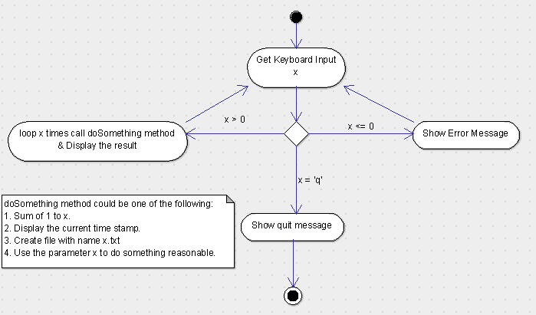

1. Write a program to merge two array of int.
2. Write a program to find the second largest number inside an array of int.