影像處理作業 HW3

統計碩二 蔡耀德

Q1.

(a)

隨機選取特定比例個數的座標idx，再將其一半轉為salt(pixel值為0)，另一半轉為pepper ( pixel值為255)，baboon與peppers之比例為0.1、0.3、0.5、0.7、0.9之雜訊轉換結果詳見zip檔案。

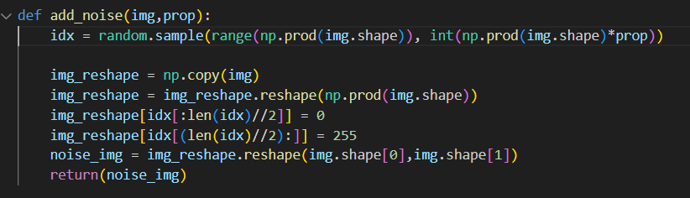

(b)

|  |  |  |  |  |  |  |  |  |  |  |
| --- | --- | --- | --- | --- | --- | --- | --- | --- | --- | --- |
| PSNR | Before denoising | | | | | After denoising | | | | |
| 10 | 30 | 50 | 70 | 90 | 10 | 30 | 50 | 70 | 90 |
| Baboon | 38.02 | 33.29 | 31.04 | 29.60 | 28.52 | 28.78 | 28.34 | 28.14 | 28.52 | 28.06 |
| Peppers | 37.73 | 32.98 | 30.76 | 29.31 | 28.22 | 29.74 | 28.44 | 28.03 | 27.87 | 27.78 |

排除pixel值為0及255的部分進行5x5之mean filtering，帶入PSNR公式後可得出以下表格

(c)

|  |  |  |  |  |  |  |  |  |  |  |
| --- | --- | --- | --- | --- | --- | --- | --- | --- | --- | --- |
| PSNR | Before denoising | | | | | After denoising | | | | |
| 10 | 30 | 50 | 70 | 90 | 10 | 30 | 50 | 70 | 90 |
| Baboon | 38.03 | 33.29 | 31.07 | 29.61 | 28.50 | 28.74 | 28.32 | 28.18 | 28.08 | 28.05 |
| Peppers | 37.79 | 32.98 | 30.76 | 29.31 | 28.22 | 29.84 | 28.42 | 28.04 | 27.88 | 27.79 |

排除pixel值為0及255的部分進行5x5之 $μ=0$ 且 $σ=2$ 之Gauss filtering，帶入PSNR公式後可得出以下表格

(d)

|  |  |  |  |  |  |  |  |  |  |  |
| --- | --- | --- | --- | --- | --- | --- | --- | --- | --- | --- |
| PSNR | Before denoising | | | | | After denoising | | | | |
| 10 | 30 | 50 | 70 | 90 | 10 | 30 | 50 | 70 | 90 |
| Baboon | 38.07 | 33.26 | 31.06 | 29.60 | 28.52 | 28.05 | 28.06 | 28.14 | 28.14 | 28.10 |
| Peppers | 37.79 | 32.99 | 30.76 | 29.29 | 28.23 | 28.00 | 28.00 | 27.98 | 27.90 | 27.83 |

Q2

(a)

先定義橫向與縱向之sobel kernel，再使用函數cv2.filter2D將原始影像帶入捲積後，結合橫向與縱向的gradient得出結果。

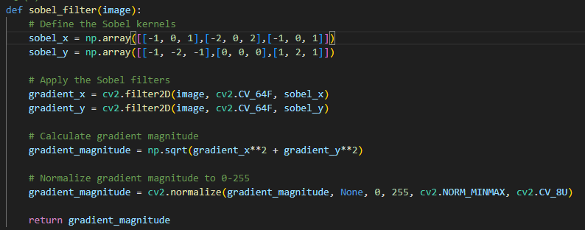

左圖及右圖分別為pepper.bmp、pepper_0.04.bmp使用Sobel filter所得出的結果。

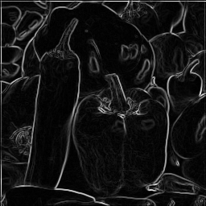 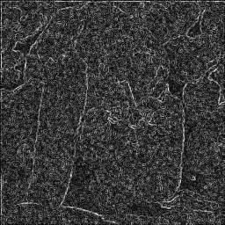

(b)

先使用5x5且μ=0、σ=1之Gauss filtering，再進行Laplacian operator，最後在標準化轉換回來。

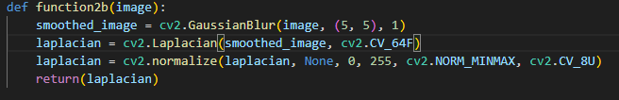

左圖及右圖分別為pepper.bmp、pepper_0.04.bmp使用Gaussian filter及Laplacian operator所得出的結果。

