1. Introduction

Dynamic Group Formation in Shared Spaces

|  |  |  |  |
| --- | --- | --- | --- |
|  | Yao LI  University/Institute  Address  City, Country  Email address | Monika Sester  University/Institute  Address  City, Country  Email address |  |

Abstract

Forming groups is natural and essential in modern traffic. E.g. pedestrians form groups to gain dominance from vehicles before they cross; grouping can reduce the number of agents that need to be considered, which makes traffic planning less complicated. However, grouping is not well investigated in shared spaces given the dynamic environment and interactions in mixed traffic. In this paper, we apply a dynamic facility location algorithm based on appearence time, origin and destination of road users before they crossing to explore an appropriate grouping strategy in shared spaces to improve the safety and efficiency of road users.

In urban traffic, road users are often found moving in groups. These groups can be formed for different reasons. For instance, social connections (e.g. friends, couples, families) between pedestrians; mixed groups formed by traffic regulations, i.e. road users who follow the same phase of traffic lights, etc. The members of the same group interact differently to other road users in comparison to individuals (Aveni, 1977), and they tend to keep similar speed and appropriate distance (Yamaguchi et al., 2011).

An obvious benefit that comes from grouping is safety. Being in a group creates a buddy system where people can look after one another on the streets. Jacobsen (Jacobsen, 2003) found that people walking and bicycling in larger groups are less likely to be injured by motorists because the motorists are more cautious with groups. It will also have a beneficial effect on traffic planning: if groups are formed, this leads to a reduction in the number of road users that have to be included in computations, thus leading to a decrease in computational complexity for later applications, e.g. for traffic simulation and pedestrian navigation.

Although forming groups are common and natural for road users in normal traffic scenarios, there are only a few pieces of research on how to form groups in the shared space, where the traffic features (e.g. curbs, zebra lines and traffic lights) are removed to minimizes demarcations between vehicles and pedestrians. Some studies suggested an increased risk at higher traffic volumes in shared spaces (Quimby and Castle, 2006; Reid et al., 2009). Later, Holmes (Holmes, 2015) launched a survey to find out about people’s experiences of using shared spaces in towns and cities. Pedestrians felt strongly that drivers did not recognize a shared space and were not slowing down to allow people to cross. Problems were pronounced in areas with high volumes of traffic or through traffic. Apart from safety aspects, currently shared spaces have efficiency problems as well: the bottleneck effect happens when traffic density is high. With the background above, we can conclude that the formation of road user groups before and during crossing will improve the safety and efficiency in shared spaces.

However, how to form groups is not a trivial task in shared spaces. Firstly, the traffic signs are removed from the road surface, therefore, the location and number of groups should be decided, which is different from most area traffic management methods (Qadri et al., 2020; Ramadhan et al., 2020). Secondly, in shared spaces, the coming and leaving slots could be different in different periods, therefore, a dynamic algorithm is needed. Last but not least, a group may gain or lose members on the fly (Coleman and James, 1961), which is called splitting and merging. The methods should consider the coexistence of users' trajectories.

Early techniques have been mainly used to simulate static or fixed-sized groups and perform group-based collision avoidance (Graciano and Chaimowicz, 2014; He and Berg, 2013; Karamouzas and Guy, 2015). Group initialization has also been addressed. (Szkandera et al., 2017) simply used a threshold based on the distance between the team leader and members to group the pedestrians with similar OD. However, this approach is sensitive to the order of the input data because the algorithm is greedy - once the first possible solution is accepted, other solutions will never be reconsidered. (He et al., 2016) clustered the original groups by the pairwise similarity metric defined over agents based on their starting positions and velocities. This works for the simulation application because the agents who are together at the beginning will keep coherent until the end of the experiment. However, the traffic scenario is more complicated. E.g. the road users who have the same origin and velocity at the beginning may split and reach different goals later. (Huang et al., 2014) considered the dynamic group behaviors via specifying the group shape as a queue and give a deformation penalty, which is effective but cannot be generalized to other group shapes. However, none of these methods can efficiently simulate groups with dynamic settings.

In this paper, we concentrate on the following application scenario: Road users can appear from random locations around the shared space, then pass through, finally leave to their destinations. We are searching for a clustering algorithm to assign those road users to several groups according to their origins, destinations, time, and even trajectory shapes.

1. Methodology

In the following, we present a definition suitable for shared spaces. Assuming a stream of road users who come continuously and independently from all the directions of a shared space. For each road user, the coordinates of its origin *(ox,oy)*, destination *(dx,dy),* and appearance time *t* are known. All road users have a static waiting time *w* before crossing, a number *h* to take historical data for the initial coarse solution, and a threshold *f* to estimate the data points similarity. The goal is to find a dynamic algorithm to cluster the road users who have similar origins and destinations before they are tired of waiting.

The problem above can be formulated as a series of facility location problems. In a basic formulation, the facility location problem is the following: giving a set of demand points and a set of candidate facility sites with costs of building facilities at each of them, the goal is to select a subset of sites where facilities should be built. Each demand point is then assigned to the closest facility, incurring a service cost equal to the distance to its assigned facility. The objective is to minimize the sum of facility costs and the sum of the service costs for the demand points (Charikar and Guha, 1999). In our application, where the incoming road users need to form a group, the group center can be seen as the facility, and all road users are customers. However, solving a series of problems by once is NP-hard, so the best hope is to use an algorithm with a provable approximation of the best solution.

Our algorithm is based on the framework proposed by (Cohen-Addad, 2019), which clusters dynamic and consistent points with a sliding window. The framework is suitable for points other than trajectories. Moreover, it continuously takes single point each time regardless of the restriction in time. Therefore, the framework is modified to adapt to our application. The pseudo-code of the current algorithm is shown in Algorithm 1.

When the interval does not exceed *w*, a new point is taken, the transport cost from the new data point to all current centers is calculated. If the minimum distance d is larger than the facility construction cost *f*, a new center is built at the location of the new point (update), otherwise, the new point will be assigned to its closet centers. The update will continue until the update interval reaches the threshold of update *θ/4αf* (recompute again). The reason for *θ/4αf* is given in (Cohen-Addad, 2019).

|  |
| --- |
| **Algorithm 1**: Dynamic clustering in shared spaces |
| **Input:** A set of data points *X* , distance metrics *ODsimilarity(o1,o2,d1,d2)*  **Output:** A set of centers *F*, an assignment *B* of point to centers  **Initialize:** coarse solution *MeyersonManyTimes( first h number of data points,n )* |
| **while** *X* is not empty **do**  *Δt* ← max time interval of first h items in *X*  **if***Δt > w* **then**  remove first item from *X* until max time interval < *Δt*  recompute centers with removed items by *MeyersonManyTimes*  add centers to *F*  // recompute because of over waiting time  **else**  take the first *h* items  **if** current time - last recompute > θ/4αf **then**  recompute by *MeyersonManyTimes*  add centers to *F*  // recompute because of cost criteria  **else**  **if** min(*ODsimilarity*) *< f* **then**  **break**  // too close to open a new facil  **else**  add the *h* item of *X* to *F*  // update  **end**  remove first item from *X*  **end**  **end**  **end** |
| Procedure *MeyersonManyTimes(first h number of data points,n)*  repeat Meyerson *n* times  initial centers ← solutions with lowerest cost θ  Procedure *ODsimilarity(o1,o2,d1,d2)*  *|o1-o2| + |d1-d2|* |

1. Experiments and Results

The proposed method was implemented in python all experiments were performed on a computer with the CPU Intel Core i5-8250U CPU @ 1.60GHz × 8 and Memory 7.7 GiB. The code is available at [github](https://github.com/YaoLIII/GroupFormation.git).

* 1. Datasets and Setup

1. Data set "DeathCircle_video0" provided by (Robicquet et al., 2016) contains 663 road users. The raw data is filtered via labels to make sure there are no lost or occluded trajectory points. The origin and destination (Figure 1) and appearance time are extracted as input of the experiment.
2. Synthetic data set "GRID" (Figure 2) is based on a 10m*10m map. The origin and destination sets are generated randomly from 4 edges of the map. For each trajectory, assuming the enter direction is always point to the center and leaving direction is always the opposite of the map center. The waypoints are automatically generated heuristically from a set of 2-dimensional movements and rotation (Sakai et al., 2018). It contains 600 road users.

Figure 1: The OD plots of stanford drone dataset (colors represent different user types)

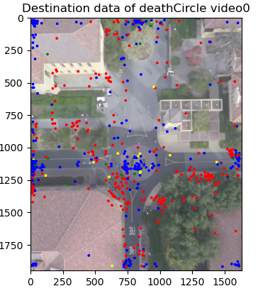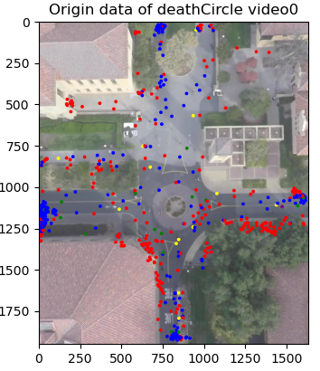

Figure 2: The trajectories of GRID dataset (Red crosses are location at current frame, green triangles are origins, blue lines are trajectories.)

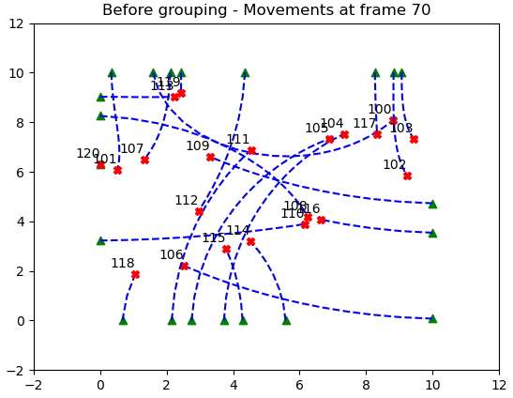

The parameters are shown in Table 1. Parameter selection is highly related to dataset properties. For instance, DeathCircle covers a huge area, and the road users distribute relatively sparse, therefore, to form more groups, road users have to wait longer time (*w*) and search for group members from a wider area (*f*). In contrast, GRID is quite small and dense, so the small *w* and *f* are enough to form groups. For both datasets, the row data is not adaptive, i.e. the data stream will not adjust itself according to the applied algorithm. Therefore, a small *h* is enough to get coarse solutions.

Table 1: Parameters for 2 datasets

|  |  |  |  |
| --- | --- | --- | --- |
|  | *w (frames)* | *f (m)* | h |
| DeathCircle_video0 | 200 | 200 | 30 |
| Synthetic | 15 | 6 | 30 |

* 1. Results

Figure 3 shows a period of center sets (period 31, from frame 5226 to frame 5432) in "DeathCircle_video0", the trajectories with the same color belong to the same group. The orange circles are generated centers. All road users are clustered into a group with the maximum internal similarities.

Figure 3: Group result of one period

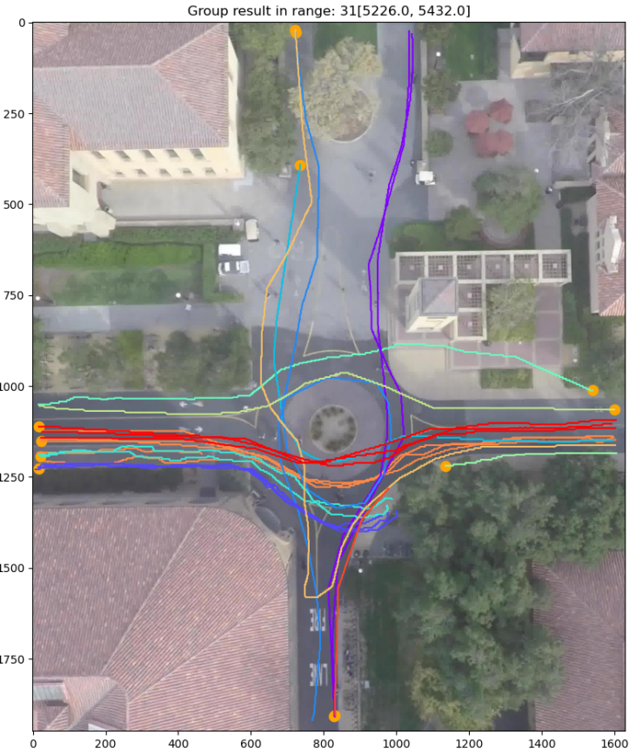

Another possible situation is the road users who have similar OD data but diverse waypoints. We import symmetrical Hausdorff distance as a distance metric to avoid wrong clustering in this case (see Figure 4).

Figure 4: Benefit from Hausdorff distance (marked by rectangles: the dark blue road user is separated from the green group even they have similar OD)

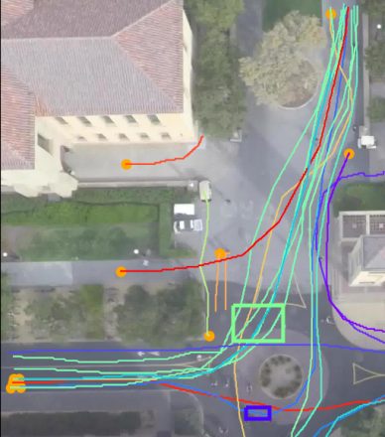

1. Discussion

In this section, we will discuss some interesting parts for optimizing the parameters w, f, h and potential aspects for improvement. In the previous section, we have shown that waiting time and search area are two important factors to form a group. However, in general, they may not be the same static value for all road users but highly depend on the road user‘s personality (e.g. patient or reckless). For sparse traffic scenario, it is not necessary to apply the method, because people need a trade-off of waiting time and forming group, and sparse dataset take advantages of being alone.

One drawback of the method is that, if you check the red and dark blue trajectories that start crossing from left to right in Figure 3, they can be good groups at the beginning, but split to different destinations in the end. When the splitting distance is not far away, Hausdorff distance works well, but for instance, we both come from the north, then split to west and east direction, the current algorithm cannot help.

1. Conclusion and future work

In this paper, we propose a dynamic facility location method to cluster road users which has similar OD and existing time in a shared space. In future work, we will adopt this method for all kinds of road users with the help of type labels and average velocities.

1. References

A. F. Aveni, “The not-so-lonely crowd: Friendship groups in collective behavior,” Sociometry, pp. 96–99, 1977.

A. Meyerson. Online facility location. Technical report, 2001

A. Quimby and J. Castle. A Review of Simplified Streetscape Schemes. Technical report, 2006.

A. Robicquet, A. Sadeghian, A. Alahi, and S. Savarese. Learning social etiquette: Human trajectory understanding in crowded scenes. In Lecture Notes in Computer Science (including subseries Lecture Notes in Artificial Intelligence and Lecture Notes in Bioinformatics), volume 9912 LNCS, pages 549–565, 2016.

A. Sakai, D. Ingram, J. Dinius, K. Chawla, A. Raffin, and A. Paques. Python robotics: A python code collection of robotics algorithms, 2018.

I. Karamouzas and S. J. Guy. Prioritized group navigation with Formation Velocity Obstacles. In Proceedings - IEEE International Conference on Robotics and Automation, volume 2015-June, pages 5983–5989.Institute of Electrical and Electronics Engineers Inc., jun 2015.

J. Szkandera, I. Kolingerova, and M. Manak. Path Planning for Groups on Graphs. In Procedia Computer Science, volume 108, pages 2338–2342. Elsevier B.V., jan 2017.

J. S. Coleman and J. James, “The equilibrium size distribution of freely-forming groups,” Sociometry, vol. 24, no. 1, pp. 36–45, 1961.

K. Yamaguchi, A. C. Berg, L. E. Ortiz, and T. L. Berg, “Who are you with and where are you going?” in Computer Vision and Pattern Recognition (CVPR), 2011 IEEE Conference on. IEEE, 2011, pp. 1345–1352.

L. He and J. V. D. Berg. Mesoscale planning for multi-agent navigation. In Proceedings - IEEE International Conference on Robotics and Automation, pages 2839–2844, 2013.

L. Holmes. Accidents by Design: The Holmes Report on ”shared space” in the United Kingdom. (July):1, 2015.

L. He, J. Pan, S. Narang, W. P. Wang, and D. Manocha. Dynamic Group Behaviors for Interactive Crowd Simulation. 2016.

M. Charikar and S. Guha. Improved combinatorial algorithms for the facility location and k-median problems. In Annual Symposium on Foundations of Computer Science Proceedings, pages 378–388. Institute of Electrical and Electronics Engineers Computer Society, 1999.

P. L. Jacobsen. Safety in numbers: More walkers and bicyclists, safer walking and bicycling. Injury Prevention, 9(3): 205–209, sep 2003.

Qadri, S.S.S.M., Gökçe, M.A. & Öner, E. State-of-art review of traffic signal control methods: challenges and opportunities. Eur. Transp. Res. Rev. 12, 55 (2020). https://doi.org/10.1186/s12544-020-00439-1

S. A. Ramadhan, H. Y. Sutarto, G. S. Kuswana, and E. Joelianto. Application of area traffic control using the max-pressure algorithm. Transportation Planning and Technology, 43(8): 783–802, Nov 2020.

S. Reid, N. Kocak, L. H. Reviewer, and J. Emslie. DfT Shared Space Project Stage 1: Appraisal of Shared Space Report for Department for Transport Document Control Project Title: Shared Space Research MVA Project Number: C3783100 Document Type: Report Document Approval. Technical report, 2009.

T. Huang, M. Kapadia, N. I. Badler, and M. Kall-mann. Path planning for coherent and persistent groups. In Proceedings IEEE International Conference on Robotics and Automation, pages 1652–1659. Institute of Electrical and Electronics Engineers Inc., sep 2014.

V. Cohen-Addad, N. Hjuler, N. Parotsidis, D. Saulpic, and C. Schwiegelshohn. Fully dynamic consistent facility location. In Advances in Neural Information Processing Systems, volume 32, dec 2019.

V. G. Santos and L. Chaimowicz. Cohesion and segregation in swarm navigation. In Robotica, volume 32, pages 209–223. Cambridge University Press, 2014.