I'm currently looking at which variables best predict the earnings of a film. I turned genre and studio into dummy binary variables (one genre per column, 0/1 for each genre for each film), turned release date into an ordinal variable, and rescaled all variables so they can be meaningfully compared.

I struggled a surprising amount with data scraping. I relaxed because I had all the data for my movies downloaded and was slowly pulling variables out of the mass of html. At some point it became clear that the way I had downloaded the films in week 1 was not conducive to extracting all the variables I needed, and I had to start over in week 2. I'm catching up!

I think I know what's going wrong with my model and am going to continue working with it. I feel the most confident I have while on this project, so as long as I keep pushing I should have something a lot more exciting to show on Friday.

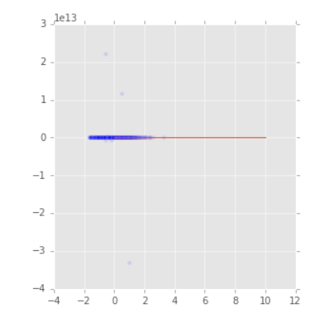
Difference between my train and test results. Something is clearly wrong here, but I'm still figuring out what.

