5.13题
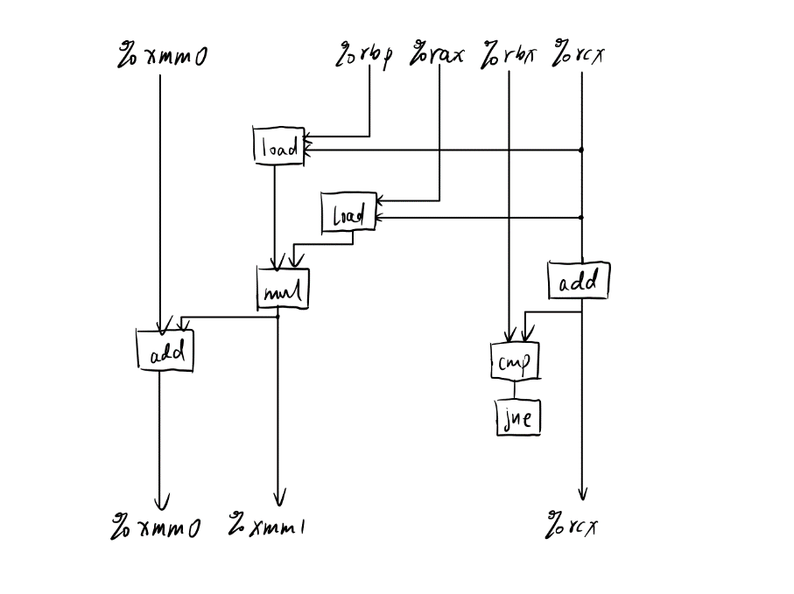
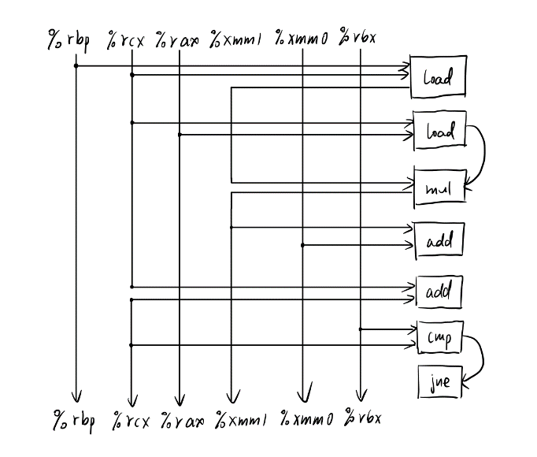
A．
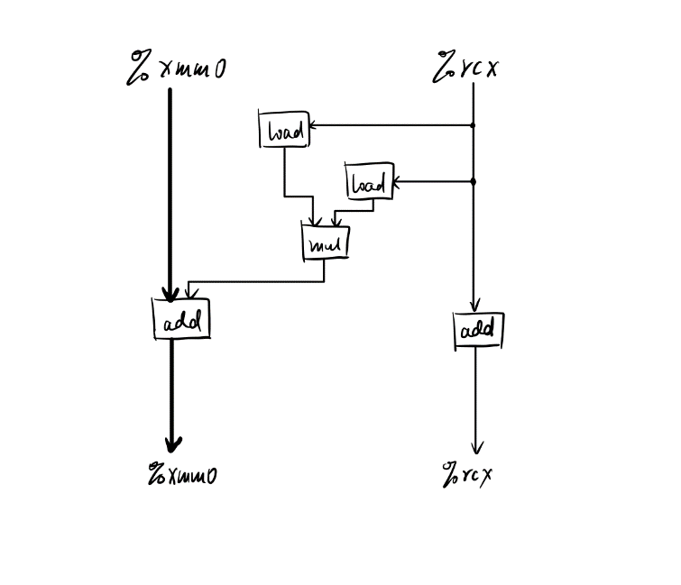
B．
这条关键路径决定的CPE下界为3
C.
对于整数数据的关键路径决定的CPE的下界为1
D.
在关键路径上只涉及到浮点数的加法

5.15题
void unroll6(vec_ptr u,vec_ptr v,data_t *dest)
{
long i;
long length=vec_length(u);
long limit=length-5;
data_t *udata=get_vec_start(u);
data_t *vdata=get_vec_start(v);
data_t sum0 = (data_t)0;
data_t sum1 = (data_t)0;
data_t sum2 = (data_t)0;
data_t sum3 = (data_t)0;
data_t sum4 = (data_t)0;
data_t sum5 = (data_t)0;
for (i=0;i<limit;i+=6) {
sum0+=udata[i]*vdata[i];
sum1+=udata[i+1]*vdata[i+1];
sum2+=udata[i+2]*vdata[i+2];
sum3+=udata[i+3]*vdata[i+3];
sum4+=udata[i+4]*vdata[i+4];
sum5+=udata[i+5]*vdata[i+5];
}
for (;i<length;i++) {
sum0+=udata[i]*vdata[i];
}
*dest=sum0+sum1+sum2+sum3+sum4+sum5;
}

5.17题
（此题参考了标准答案后基本理解。）
word表示以八字节进行覆盖的变量。首先用单个字节进行覆盖直至对齐，然后用八字节的word进行覆盖。最后剩余的空间以单个字节进行覆盖到结束。
void *my_memset(void *s,int c,size_t n)
{
unsigned long word=0;
unsigned char *schar;
unsigned long *slong;
size_t cnt=0;
long i;
if (n<3*sizeof(word)) {
return basic_memset(s,c,n);
}
for (i=0;i<sizeof(word);i++) {
word=(word<<8)|(c&0xff);
}
schar=(unsigned char *)s;
while ((unsigned long) schar % sizeof(word)!=0) {
*schar++=(unsigned char)c;
cnt++;
}
slong=(unsigned long *)schar;
while (cnt<n-2*sizeof(word)+1) {
*slong=word;
*(slong+1)=word;
cnt+=2*sizeof(word);
slong+=2;
}
schar=(unsigned char *)slong;
while(cnt<n) {
*schar++=(unsigned char)c;
cnt++;
}
return s;
}

5.19题
void psum(float a[],float p[],long n)
{
long i;
int v=0;
for (i=0;i<n-1;i+=2) {
int v1=a[i];
int v2=v1+a[i+1];
p[i]=v+v1;
p[i+1]=v+v2;
v+=v2;
}
for (;i<n;i++) {
v+=a[i];
p[i]=v;
}
}

