**spatial references 讲解**

Features on a map refer to the actual locations of the objects they represent in the real world. The positions of objects on the earth's spherical surface are measured in degrees of latitude and longitude, also known as [geographic coordinates](http://resources.arcgis.com/en/help/arcgis-rest-api/02r3/02r300000105000000.htm). Though latitude and longitude can locate exact positions on the surface of the earth, they are not uniform units of measure; only along the equator does the distance represented by one degree of longitude approximate the distance represented by one degree of latitude. To overcome measurement difficulties, data is often transformed from the three-dimensional geographic coordinate system to the two-dimensional planar surface in a [projected coordinate system](http://resources.arcgis.com/en/help/arcgis-rest-api/02r3/02r3000000vt000000.htm). Projected coordinate systems describe the distance from an origin (0,0) along two separate axes: a horizontal x-axis representing east-west and a vertical y-axis representing north-south.

Because the earth is round and maps are flat, getting information from the curved surface to a flat one involves a mathematical formula called a map projection. A map projection transforms latitude and longitude to x,y coordinates in a projected coordinate system.

The term coordinate system, which includes both geographic and projected coordinate systems, is used to describe the information about the projection, as well as other specifics such as datum, units, and meridians.

地图上的实点能描述出物体在真实世界中的位置，物体在球形表面的位置是通过经纬度来测量，也就是我们常说的地理坐标。尽管经纬度能够准确定位地球表面的位置，但是并不是和地球表面单元一致；只有地球赤道附近的经度距离，才能大致近似于纬度的距离。为了客服测量上的困难，在投影坐标系统中，数据通常是从三维的地理坐标系统转换到二维的平面系统。

在投影坐标系统中，它描述的是沿着两个轴从（0，0）为起点的距离：水平的x轴代表东西方位，垂直的y轴代表南北方位。

因为地球是圆的但是地图是水平的，从弧形的表面获取信息到平面、并且还涉及了数学公式，也就是我们通常说的地图投影。地图投影，就是在投影坐标系统中，转换纬度经度到对应的x,y坐标。

坐标系术语，是指那些包括地理和投影的坐标系系统，被用来描述那些投影的信息，以及其他特定的数据、单元和子午线。

Each coordinate system is defined by both a well-known ID (WKID) or a definition string (WKT). For a complete list of supported IDs and their corresponding definition strings, see the following:

* [Projected coordinate systems listing](http://resources.arcgis.com/en/help/arcgis-rest-api/02r3/02r3000000vt000000.htm)
* [Geographic coordinate systems listing](http://resources.arcgis.com/en/help/arcgis-rest-api/02r3/02r300000105000000.htm)
* [Vertical coordinate systems listing](http://resources.arcgis.com/en/help/arcgis-rest-api/02r3/02r3000000rn000000.htm)

Datum transformations are available for projecting spatial data from one geographic coordinate system to another. For a complete list of supported transformations, including WKIDs and WKTs, see the following:

* [Datum transformations](http://resources.arcgis.com/en/help/arcgis-rest-api/02r3/02r3000000r8000000.htm)—Equation-based datum (geographic) transformations
* [Grid-based datum transformations](http://resources.arcgis.com/en/help/arcgis-rest-api/02r3/02r30000029z000000.htm)—Datum transformations that require on-disk files

每一个坐标系统都是被我们众所周知的ID(WKID)或者字符串WKT所定义。对应一个完整的受支持的ID串和相对应的定义字符串，如下：

1.投影坐标系统清单

2.地理坐标系统清单

3.垂直坐标系统清单

**地理坐标系统：**  
Each geographic coordinate system used by the ArcGIS REST API has an ID, a name, and a textual definition. These are described in the following table:

每一个地理坐标系统都可被ArcGIS使用，并且都有各自的ID、名字和文本定义。

**投影坐标系统：**

**垂直坐标系统：**

**数据转换：**

**spatialReference（sr）**

简单的说，代表坐标系。我们知道，有**地理坐标系统**（lon, lat）和**投影坐标系统**（x, y）之分，根据所取参数不同，又细分为形形色色的坐标系。**我们在应用里会调用多个地图服务，它们很有可能采用不同的坐标系**，即spatialReference.wkid值不同，但最终它们都得正确的落在同一个map上。**也就是layer要重新投影转换以使它的sr同map的sr保持一致。**有些layer可以自动转换，有些需要我们用代码控制转换，有些则无法转换。见下图（引用自

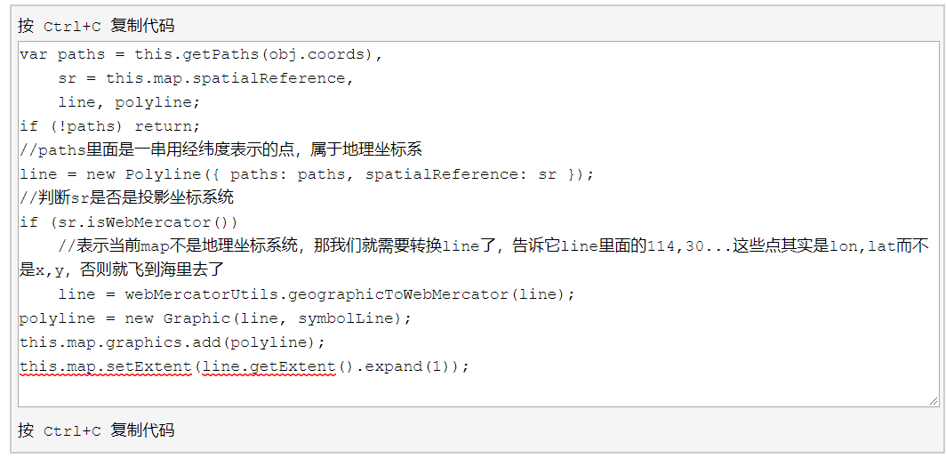

在此处谷歌显示地图的代码中：

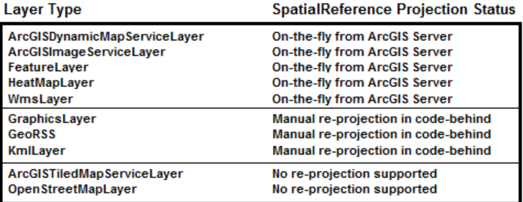

TiledMapServiceLayer 102113

The spatial reference is a combination of an ellipsoid, datum, and a coordinate system used to display geographic data of the three dimensional Earth on a two dimensional surface (such as a piece of paper of computer monitor). A good article for describing how a spatial reference works can be found [here](http://www.sharpgis.net/post/2007/05/Spatial-references2c-coordinate-systems2c-projections2c-datums2c-ellipsoids-e28093-confusing.aspx).

The SpatialReference is determined by the first layer in the Map that has this property set. When more than one layer is added to a Map, all subsequent layers (if they support re-projection on-the-fly from ArcGIS Server) are re-projected to the same SpatialReference as the first layer so that the spatial data overlays properly. The following diagram shows for each layer type whether its SpatialReference can be re-projected or not:

空间参照系统是椭圆球体、数据和坐标系统的结合，他们用来在二维的表面上显示三维的地理数据。一个描述好的参照系统如何工作的文章能够在这儿找到。

空间按参照是在地图上定义的第一个图层，并且还有很多属性。当越来越多的图层被加到地图中，如果后续增加的图层不支持在ArcGIS服务器中的映射，那么这些后续增加的图层就只能映射到相同空间参照中，这样参照的数据就会比较准确。

The SpatialReference of the Map can be overridden (meaning that you can set the Map.SpatialReference) by explicitly setting the [Map.Extent](http://help.arcgis.com/en/webapi/silverlight/apiref/ESRI.ArcGIS.Client~ESRI.ArcGIS.Client.Map~Extent.html) Property with an Envelope that has an [Envelope.SpatialReference](http://help.arcgis.com/en/webapi/silverlight/apiref/ESRI.ArcGIS.Client~ESRI.ArcGIS.Client.Geometry.SpatialReference.html)defined. Initializing a Map’s SpatialReference via the Map.Extent Property has to be done before any layers will be added to the Map. Once the SpatialReference of a Map has been set and the layers have been loaded, the SpatialReference can no longer be changed. If you need to change SpatialReference on the fly, you can instead create a new Map instance, move the layers to this Map, and replace the previous Map instance.

地图的空间参照可被扩展的图层所定义的空间参照覆盖，那就意味着你可重新设定空间参照。初始化一个空间参照可在图层被加进来之前，通过初始化扩展的图层的属性。一旦空间参照被设定好并且图层被加载，就不能改变。如果你想在运行中改变空间参照，你可以创建一个新的地图实例，将之前的图层移动到你新创建大的实例中，也就是覆盖之前的地图实例。

Tiled map services (specifically: [ArcGISTiledMapServiceLayer](http://help.arcgis.com/en/webapi/silverlight/apiref/ESRI.ArcGIS.Client~ESRI.ArcGIS.Client.ArcGISTiledMapServiceLayer.html) and [Client.Toolkit.DataSources.OpenStreetMapLayer](http://help.arcgis.com/en/webapi/silverlight/apiref/ESRI.ArcGIS.Client.Toolkit.DataSources~ESRI.ArcGIS.Client.Toolkit.DataSources.OpenStreetMapLayer.html)) do not support on-the-fly re-projection, and will not be displayed if the Map.SpatialReference does not match the tiled map service SpatialReference. Since tiled map services are typically the first layer in a Map to serve as a base layer for other layers to draw on top of, the tiled map service layer often becomes the default SpatialReference for the Map.

在ArcGISTiledMapServiceLayer和Client.Toolkit.DataSources.OpenStreetMapLayer这两个地图图层服务中，不支持运行过程中的二次投影，因此如果地图的空间参照不匹配切片地图服务的空间参照，地图就不会显示。因为切片地图服务在地图中是典型的第一层，常用来为地图服务，因此慢慢的，切片地图的空间参照慢慢的就变成了地图中默认的空间参照了。

If a layer is added to the Map and that layer’s SpatialReference does not match the Map.SpatialReference and it is not possible for that layer to be re-projected on the fly, then that layer will not display in the Map.

A listing of the well-known SpatialReference WKID Integer and WKT String values are available for [Projected Coordinate Systems](http://help.arcgis.com/en/webapi/javascript/arcgis/help/jshelp/pcs.htm) and [Geographic Coordinate Systems](http://help.arcgis.com/en/webapi/javascript/arcgis/help/jshelp/gcs.htm).

添加事件按钮：