Instructions
Do Task 1 to 7 and 8 in this lab.
Open a web browser and go to https://tryhackme.com/
- Create an account if you have not done so
- Go “Learn” -> Walkthroughts and search for “privilege” and click on “Linux Privilege Escalation”
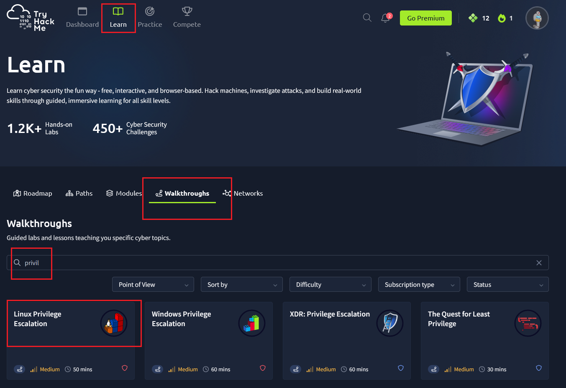
- If you can’t find the lab in the search, click on this link to access the lab
- Click on “Join Room”
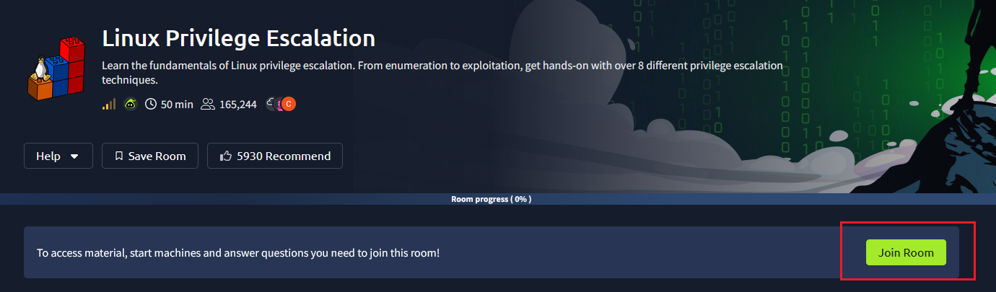
- Click “Start AttackBox”
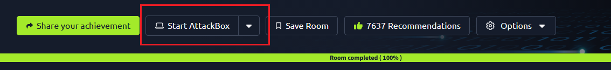
- To access via VPN, click on your profile picture and select “Manage Account”
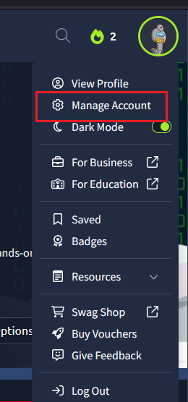
- Select “VM and VPN Settings”
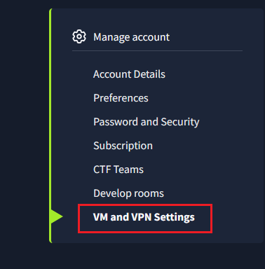
- Use any of the methods listed here
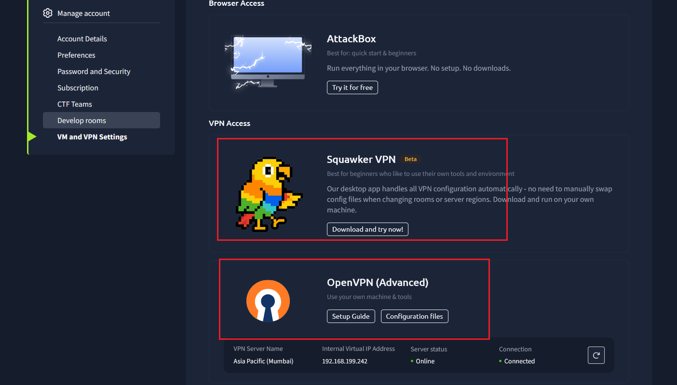
- After you have run the VPN access, test your connection by ping 192.168.128.1
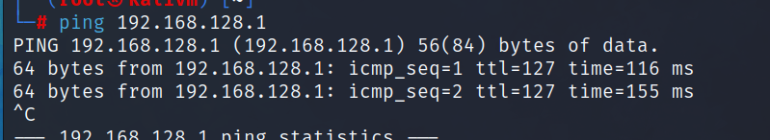
- Look for the target IP address to ssh in. The user account Karen’s password can be found in the lab instructions.
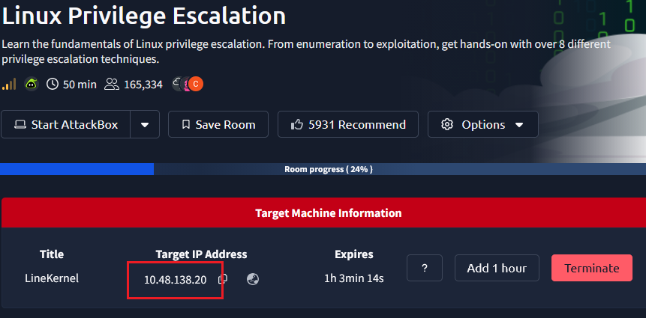
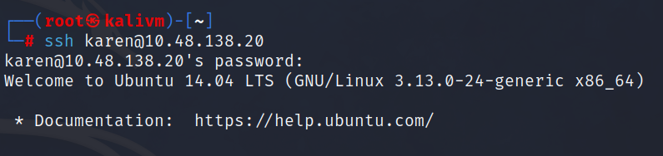
- In each section, do start machine when prompted else you cannot complete that section’s tasks. If you have an existing machine or the “Start Machine” is greyed out, terminate the existing machine first before starting a new one.
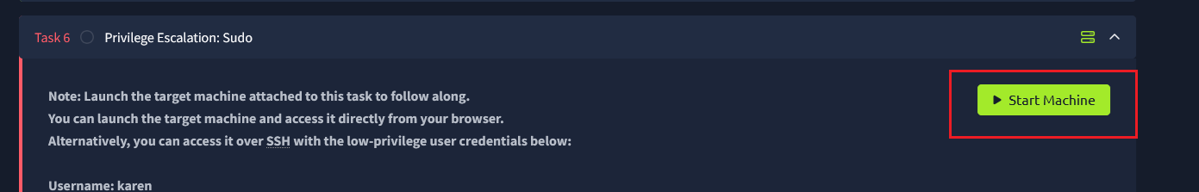
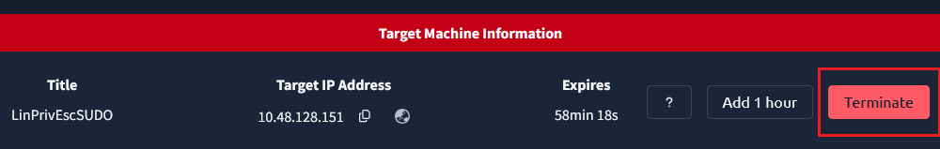
- Follow the instructions for Task 1 to 7 and 8 in this lab.

