Lab – Security Vulnerabilities

Learning Outcomes
By the end of this exercise, the student should be able to demonstrate the following items:
- Identify discrepancies within findings and suggest recommendations to improve the documentation process.
- Document a well-structured, concise report finding of a discovered security vulnerability.

Tasks

Findings Review
As part of the reporting workflow during a penetration test engagement, a report would usually go through a Quality Analysis (QA) process before it gets sent out to the intended client, and this is normally done by a senior consultant who has prior experience writing high quality reports.

For this exercise, you will be assuming the role of a senior consultant who is tasked to review on a report finding that was written by one of your peers. The marking rubric is shown below (note that this is the same table of expectations shown in the Case Study project specifications):
Criteria | Description / Expectation
CVSSv3.1 Calculation | - Risk Rating, Vector String and Risk Score are all thoroughly checked, correct and in unison.  - The chosen CVSS metric values must be reflected/described inside the Impact and Technical Details section of the finding to show synergy of the finding.
Impact | - Explains the impact of the vulnerability as listed in the CVSS metric value selected.  - Must be in sync with both the CVSSv3.1 Calculation and Technical Details section of the finding.
Technical Details | - Steps are well-documented and presented sequentially.  - Example payloads/commands are provided and the expected outcomes are shown as part of the replication of steps.  - Replication of steps are supplemented with screenshots that are relevant to depict the steps taken.
Recommendation | - Provided recommendation is clear, succinct and actionable, allowing the client to perform the necessary steps to fix the vulnerability if possible.  - Links/sources to support the recommendations are also included.
References | - Identify at least the Common Weakness Enumeration (CWE) and Common Attack Pattern Enumeration and Classification (CAPEC) reference numbers for the vulnerability.
Affected Assets and Formatting | - Formatting of the headers and text are justified in alignment.  - Correct use of affected assets table based on the nature of the documented vulnerability.  - Images are properly resized to reduce unnecessary whitespaces within the report.

Sample Finding Writeup
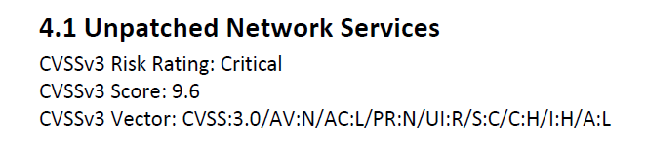
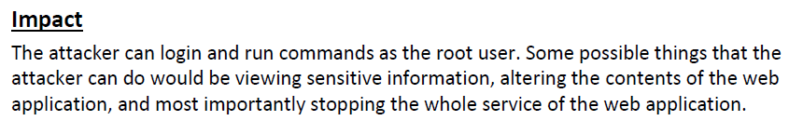
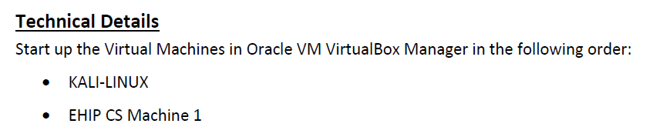
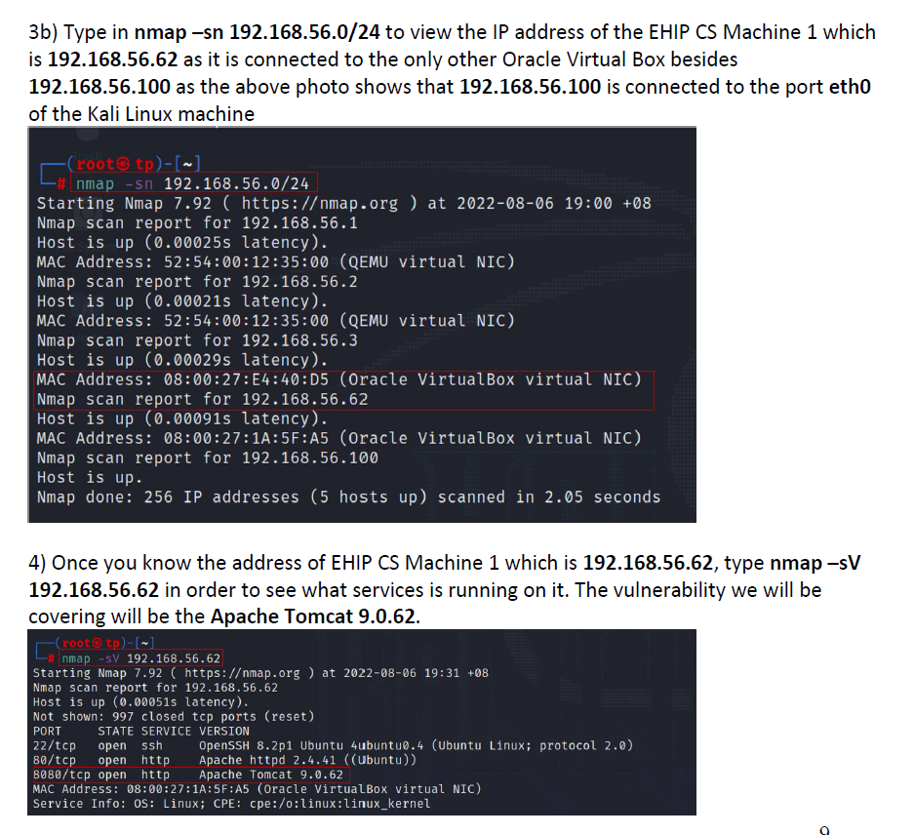
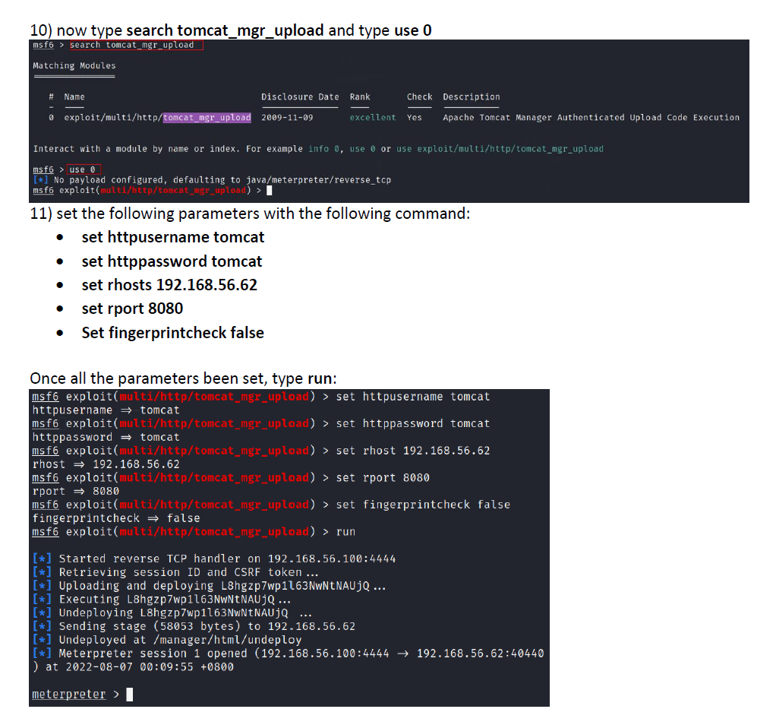
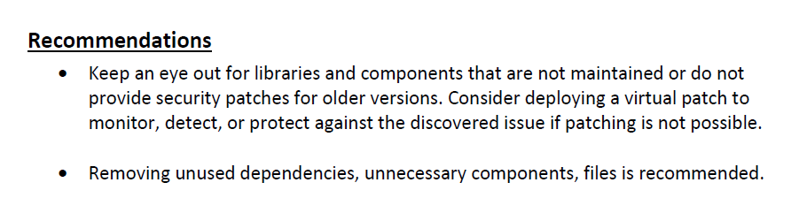
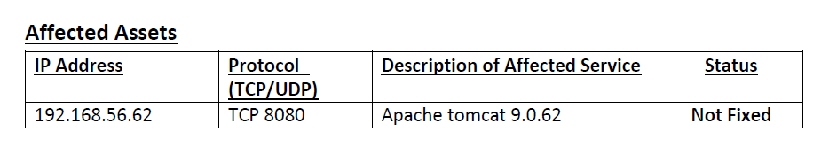
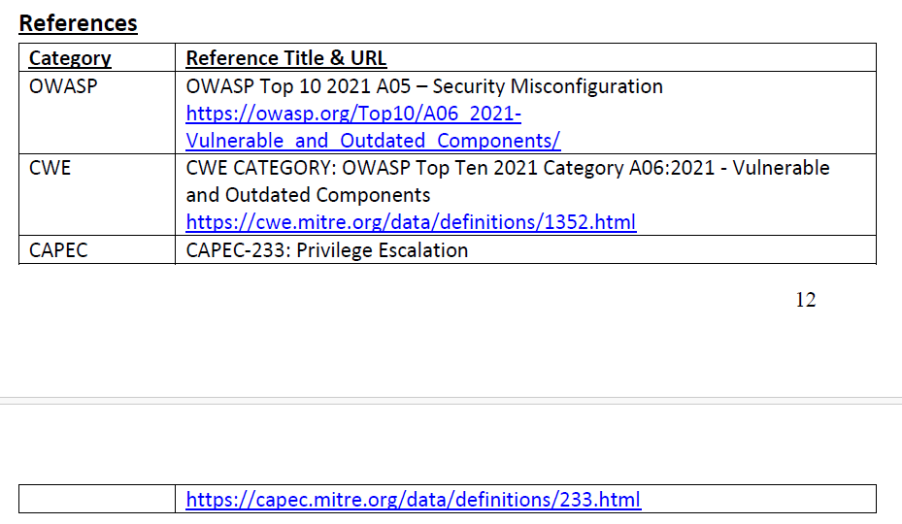

Peer Feedback
Criteria | Feedback
CVSSv3.1 Calculation
Impact
Technical Details
Recommendation
References
Affected Assets and Formatting

Findings Documentation Exercise
Based on the labs, document out two security vulnerabilities based on the requirements listed in the Findings template displayed in 2.2.1 and 2.2.2.
The two security vulnerabilities are as follows:
- 2.2.1: Arbitrary File Upload
  - References
    - Lab – Arbitrary File Upload
- 2.2.2: VSFTPD 2.3.4 Backdoor Remote Code Execution
  - References
    - Lab – Intro to Metasploit
    - Lab – Manual Exploitation via Scripts
When crafting out the write-up, take note of the following (for more information, please refer to C2 – Project Reporting v0.2.pptx):
- Impact
  - What can an attacker do with the exploited vulnerability?
  - This section should describe the CIA impacts listed in your CVSSv3.1 risk rating.
- Technical Details
  - Step by step process of exploiting the vulnerability.
- Recommendations
  - How can the finding be resolved?
  - If possible, provide a technical solution (steps to fix the vulnerability)
- REMOVE all document comments once completed.

2.2.1 Arbitrary File Upload
CVSSv3.1 Risk Rating: | CVSSv3.1 Score:
CVSSv3 Vector:
Tester Name:

Impact
Writeup here

Technical Details
Writeup here

Recommendations
Writeup here

Affected Assets (WEB)
Application URL | Affected Parameter(s) | Description of Affected Application Functionality | Status
 |  |  | Not Fixed

References
Category | Reference Title & URL

2.2.2 VSFTPD 2.3.4 Backdoor Remote Code Execution
CVSSv3.1 Risk Rating: | CVSSv3.1 Risk Score:
CVSSv3 Vector:
Tester Name:

Impact
Writeup here

Technical Details
Writeup here

Recommendations
Writeup here

Affected Assets (NETWORK)
IP Address | Protocol (TCP/UDP) & Port Number | Description of Affected Service | Status
 |  |  | Not Fixed

References
Category | Reference Title & URL

