ENTERPRISE NETWORKING (CCF2C06)
Project Proposal Report Submission

Practical Class : PC03
Submitted by: 2503587D Wang Yaohan

Lab Tutor: Mr John Leong
Submission Date: 24/05/2026

Declaration of Originality

I/We are the originator(s) of this work and I/we have appropriately acknowledged all other original sources used as our references for this work.

I/We understand that Plagiarism is the act of taking and using the whole or any part of another person’s work, including work generated by AI, and presenting it as my/our own.

I/We understand that Plagiarism is an academic offence
and if I/we are found to have committed or abetted the offence of plagiarism in relation to this submitted work, disciplinary action will be enforced.

Name and Signature of student: Wang Yaohan

Declaration on the use of Generative AI tools for assignments

Describe how you have used Generative AI tools such as ChatGPT or Dall.E-2 in your assignment.

Show snapshots of the conversations with the AI tool (i.e., the prompts you used and the response you get from the AI tool).

How do you indicate the reference?
The content generated by AI tools are not retrievable except by the user who generated them, so they are considered non-recoverable sources. Although non-recoverable data or quotations in APA Style papers are usually cited as personal communications, with ChatGPT-generated text there is no person communicating. Quoting text from ChatGPT chat is therefore more like sharing the output of an algorithm, with a reference list entry and the corresponding in-text citation.

According to the official APA Style site, ChatGPT references should be cited as:

E.g. OpenAI. (2023). ChatGPT (Sep 25 version) [Large language model].
https://chat.openai.com/chat

Important Note:

- Do not copy answers produced by the AI tool in totality as it is considered as plagiarism.

- Do not rely on any information produced by the AI tool blindly. You should always verify the answer with other sources. Do not assume that these answers provided by the AI tool are correct.

- To achieve quality outputs from the AI tool, you should provide good prompt that is clear and specific. Be precise and provide context. Avoid asking open-ended questions.

Suggested Project Report Format / Contents:

Table of contents:

- Network Diagram + Table
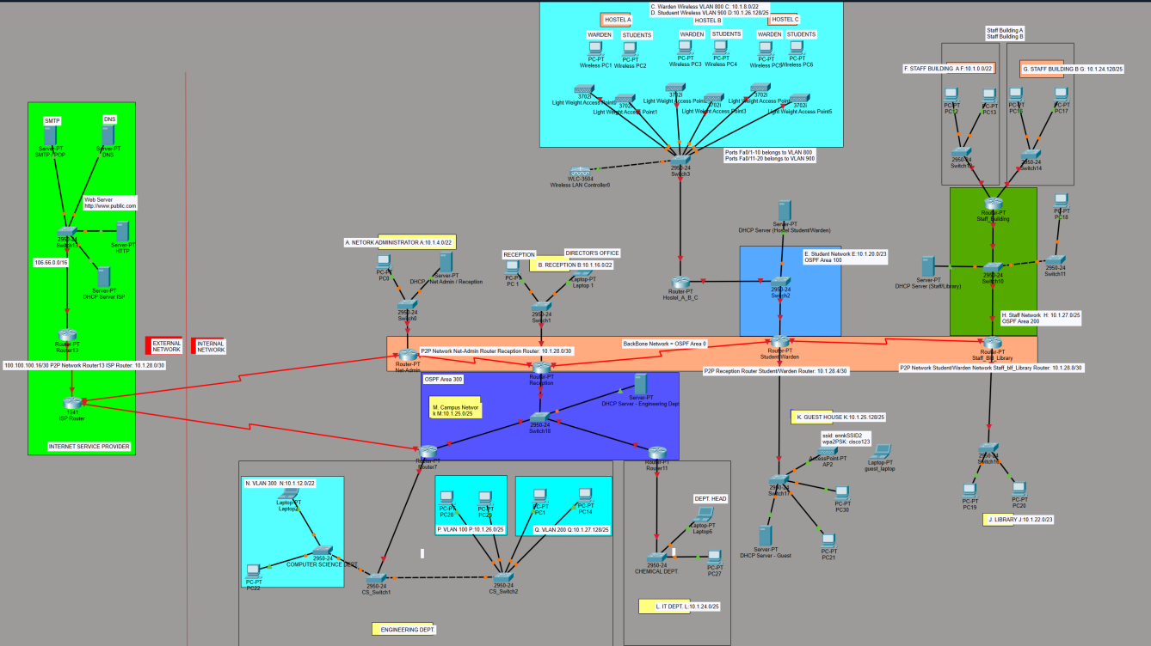
[Figure 1: Screenshot of Topology Y with annotation of Subnet Addresses labelled]

IP Address Table

Network Segment | Subnet Address | CIDR | Usable IP Range | Gateway | No. of Hosts
F | 10.1.0.0 | /22 | 10.1.0.1 – 10.1.3.254 | 10.1.3.254 | 854
A | 10.1.4.0 | /22 | 10.1.4.1 – 10.1.7.254 | 10.1.7.254 | 646
C | 10.1.8.0 | /22 | 10.1.8.1 – 10.1.11.254 | 10.1.11.254 | 643
N | 10.1.12.0 | /22 | 10.1.12.1 – 10.1.15.254 | 10.1.15.254 | 607
B | 10.1.16.0 | /22 | 10.1.16.1 – 10.1.19.254 | 10.1.19.254 | 554
E | 10.1.20.0 | /23 | 10.1.20.1 – 10.1.21.254 | 10.1.21.254 | 469
J | 10.1.22.0 | /23 | 10.1.22.1 – 10.1.23.254 | 10.1.23.254 | 302
L | 10.1.24.0 | /25 | 10.1.24.1 – 10.1.24.126 | 10.1.24.126 | 110
G | 10.1.24.128 | /25 | 10.1.24.129 – 10.1.24.254 | 10.1.24.254 | 98
M | 10.1.25.0 | /25 | 10.1.25.1 – 10.1.25.126 | 10.1.25.126 | 98
K | 10.1.25.128 | /25 | 10.1.25.129 – 10.1.25.254 | 10.1.25.254 | 85
P | 10.1.26.0 | /25 | 10.1.26.1 – 10.1.26.126 | 10.1.26.126 | 84
D | 10.1.26.128 | /25 | 10.1.26.129 – 10.1.26.254 | 10.1.26.254 | 83
H | 10.1.27.0 | /25 | 10.1.27.1 – 10.1.27.126 | 10.1.27.126 | 80
Q | 10.1.27.128 | /25 | 10.1.27.129 – 10.1.27.254 | 10.1.27.254 | 63
P2P - Net-Admin Router ↔ Reception Router | 10.1.28.0 | /30 | 10.1.28.1 – 10.1.28.2 | Router interfaces: 10.1.28.1 / 10.1.28.2 | 2
P2P - Reception Router ↔ Student/Warden Router | 10.1.28.4 | /30 | 10.1.28.5 – 10.1.28.6 | Router interfaces: 10.1.28.5 / 10.1.28.6 | 2
P2P - Student/Warden Router ↔ Staff_Bld_Library Router | 10.1.28.8 | /30 | 10.1.28.9 – 10.1.28.10 | Router interfaces: 10.1.28.9 / 10.1.28.10 | 2

- IP Address Table
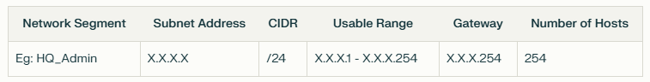
Explain how the first set of IP addresses can be obtained if you were to manually calculate.
The first subnet is allocated to the network requiring the highest number of hosts, which is Network F with 854 hosts.
To determine the required subnet size, the formula $2^{n} − 2 ≥$ required hosts is used, where n represents the number of host bits. The subtraction of 2 is required because the network address and broadcast address cannot be assigned to hosts.
For Network F:
$2^{9} − 2 = 510$ usable hosts, which is not enough. 510 < 854)
$2^{10} − 2 = 1022$ usable hosts, which is enough. (1022 > 854)

Therefore, 10 host bits are required. Since an IPv4 address has 32 bits, the subnet prefix is calculated as
32 − 10 = /22
Starting from the assigned base network 10.1.0.0/16, the first available /22 subnet is 10.1.0.0/22.
A /22 subnet has a subnet mask of 255.255.252.0, giving a block size of 4 in the third octet. Therefore, the first subnet covers 10.1.0.0 to 10.1.3.255.
Network address: 10.1.0.0
Usable range: 10.1.0.1 – 10.1.3.254
Broadcast address: 10.1.3.255
Network | Hosts Needed | Subnet Address | CIDR | Usable IP Range | Broadcast
F | 854 | 10.1.0.0 | /22 | 10.1.0.1 - 10.1.3.254 | 10.1.3.255
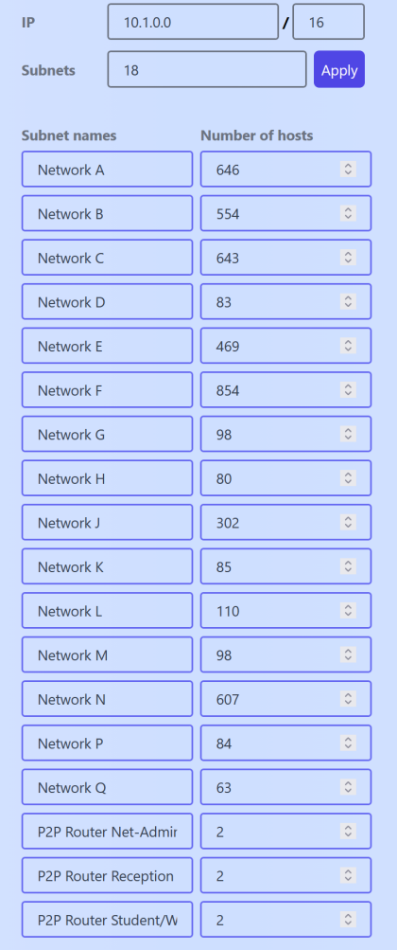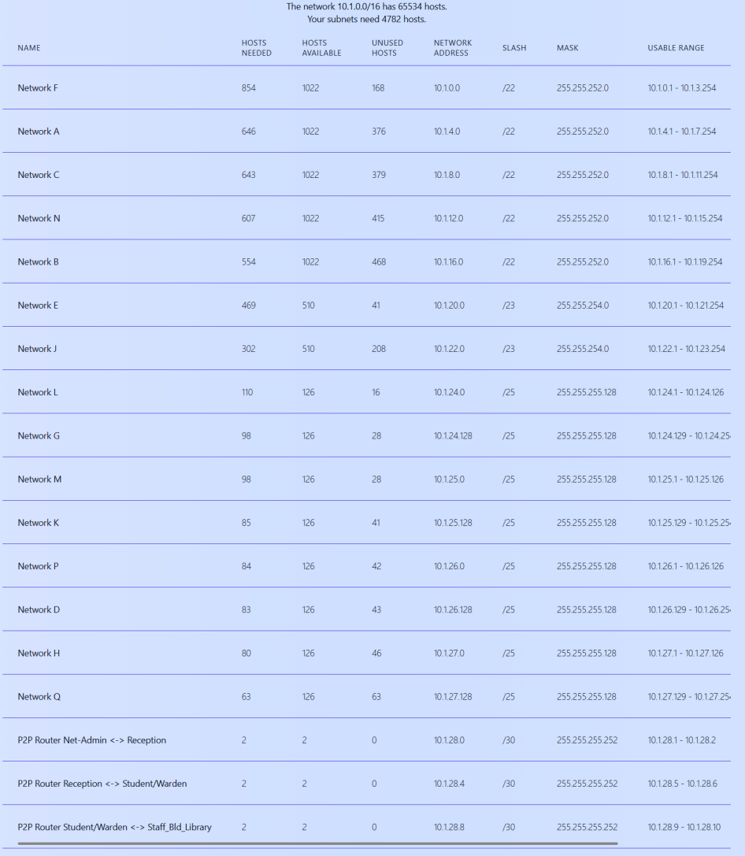
[Figure 2 and 3: IP address table created by using VLSM Calculator]
In addition to the main LAN and VLAN networks, the topology also contains point-to-point router links. A point-to-point network connects two router interfaces directly and therefore only requires 2 usable IP addresses. There are only 3 P2P Links as only the internal enterprise router-to-router links were included as point-to-point networks. ISP-side links were excluded because the assigned 10.1.0.0/16 private address block is intended for the internal enterprise network addressing scheme.
For these links, /30 subnets are used because each /30 subnet provides 4 total addresses: 1 network address, 2 usable host addresses, and 1 broadcast address. This matches the assignment requirement that point-to-point networks should be treated as 2-host networks.

Provide the information of unused IP addresses which are for future use.
After allocating all LAN/VLAN networks and point-to-point router links, the final allocated subnet is 10.1.28.8/30, with a usable range of 10.1.28.9 – 10.1.28.10 and a broadcast address of 10.1.28.11. Therefore, the remaining unused address range is 10.1.28.12– 10.1.255.255. This range is reserved for future network expansion and scalability without needing to redesign the existing IP addressing scheme.

- DNS Implementation
3.1 Objective
1. set up DNS service on a Windows Server residing on AWS EC2 instance
2. Add an A record onto the DNS server such as www.mytest.com pointing to (8.8.8.8).
3. Set up your laptop to use the DNS service and ping to www.mytest.com.
4. Successful pings means your DNS service is working correctly.
5. The steps to set up the DNS must to captured accurately in the report.

The objective of this task is to set up a DNS service on a Windows Server hosted on an AWS EC2 instance. The DNS server is configured with a forward lookup zone named mytest.com and an A record for www.mytest.com pointing to 8.8.8.8. The setup is then validated by configuring my laptop to use the EC2 instance as its DNS server and testing name resolution using nslookup and ping.

3.2 Creating the Windows Server EC2 Instance
A new EC2 instance was created in AWS Academy Learner Lab to host the DNS service. A Windows Server image was selected because the project requires the DNS service to be installed on a Windows Server EC2 instance. The instance was launched with a key pair so that the Administrator password could be retrieved for Remote Desktop access.
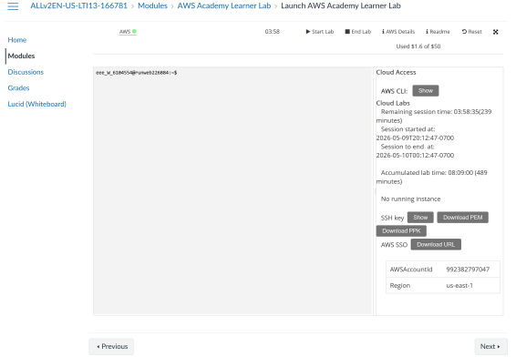
Figure 4: Logged into AWS Academy -> AWS Learner Lab -> Launch AWS Learner Lab
Start AWS Academy Lab [Click on AWS Details -> Download URL -> Click on URL]

[Open the downloaded URL, result will show on notepad app, then copy and paste the link onto the web browser and press ‘Enter’ key ]
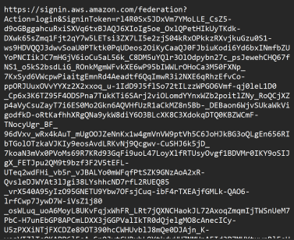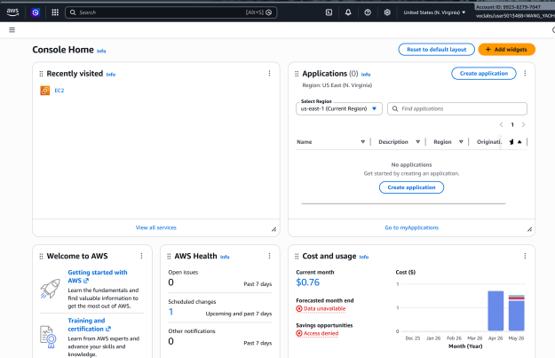
[Figure 5: URL of AWS Console] [Figure 6: Reached AWS Console Homepage]
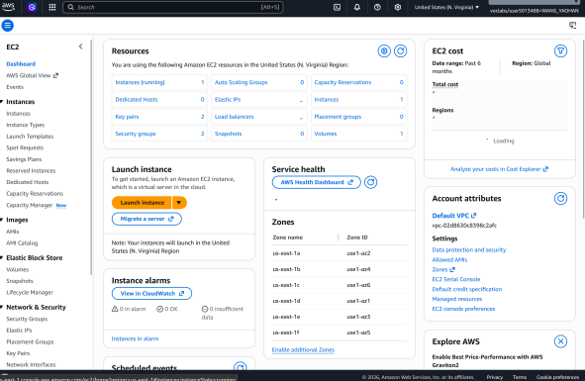[Figure 7:Search and Click on EC2]
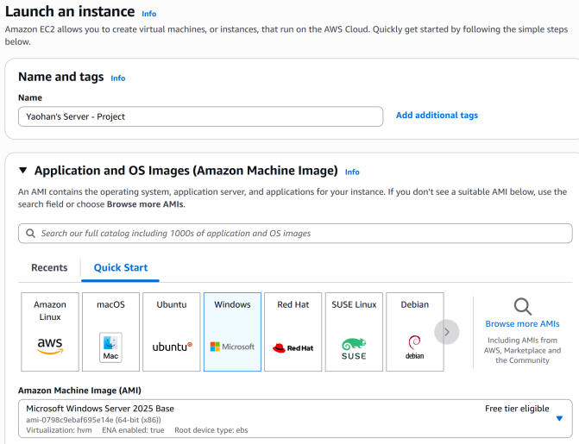[Figure 8:Set Name as Yaohan’s Server- Project]
[Later changed as Yaohan’s Project] Select Windows OS
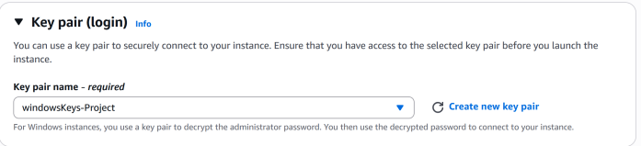 [ Figure 9:Obtain key pair and launch instance]
[Figure 10:Successfully initiated instance]
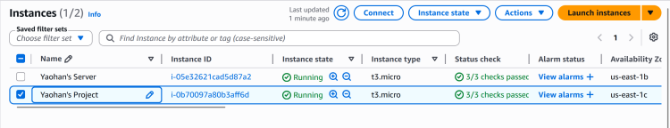
[Figure 11:Click on the created instance made to see its details]
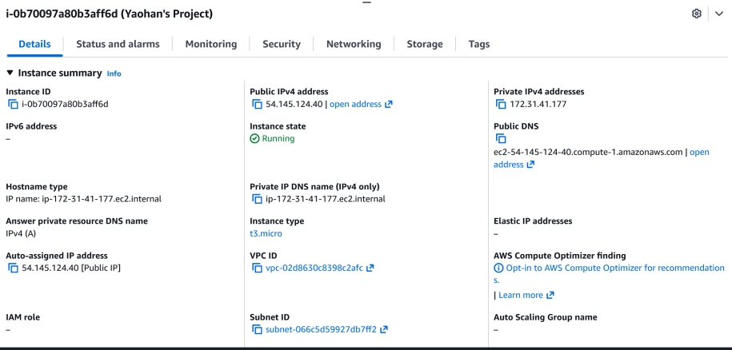
[Figure 12:Take note of IPv4 Address -> Used later using Remote Desktop Connection]

3.3 Connecting to the Windows Server
After the EC2 instance was running, I connected to it using Remote Desktop Protocol. The public IPv4 address of the EC2 instance was used as the remote connection address. The Administrator password was retrieved using the AWS key pair. This allowed me to access the Windows Server desktop.

[Figure 13: Open Remote Desktop Connection]
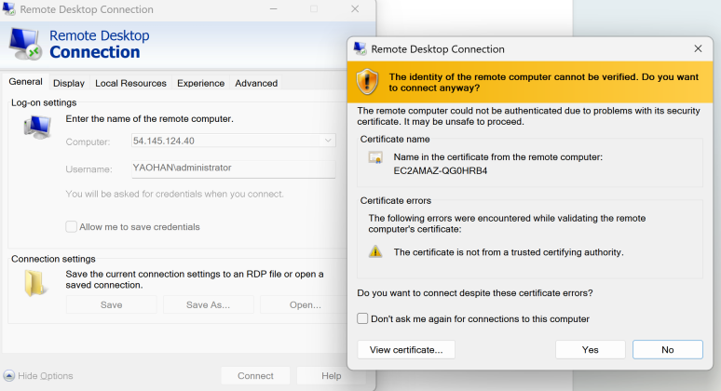
[Figure 14:Enter IPV4 Address and password to connect -> click yes]
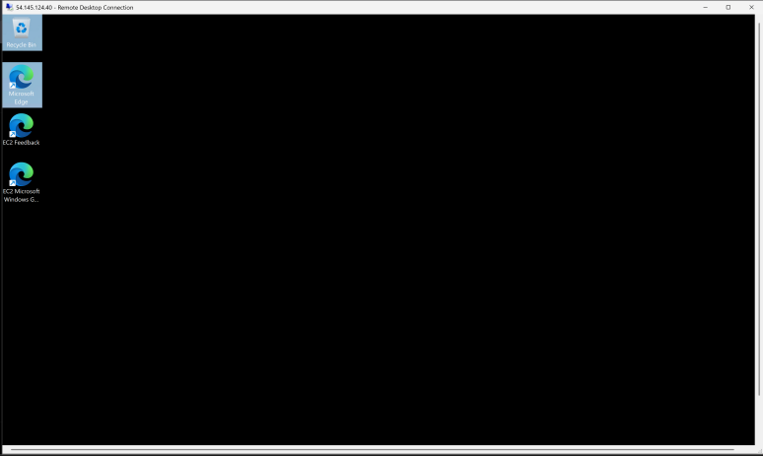[Figure 15: Remote Desktop Session established with the Windows Server EC2 Instance]
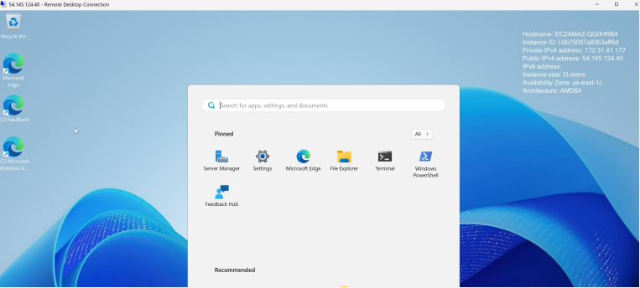
[Figure 16:Go to search Menu -> Server Manager ]
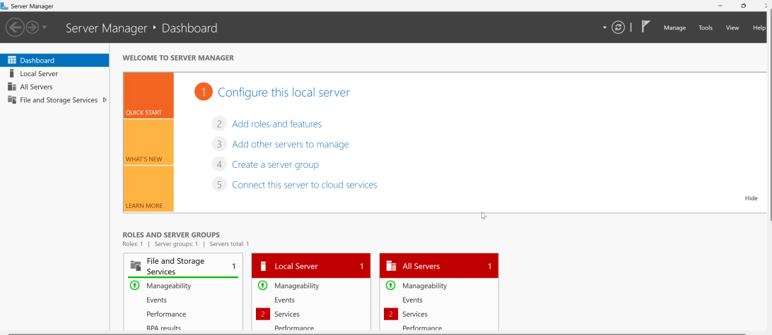
Reached Server Manager Dashboard

3.4 Installing the DNS Server Role
Manage → Add Roles and Features → Role-based or feature-based installation → Select server → DNS Server → Add Features → Install
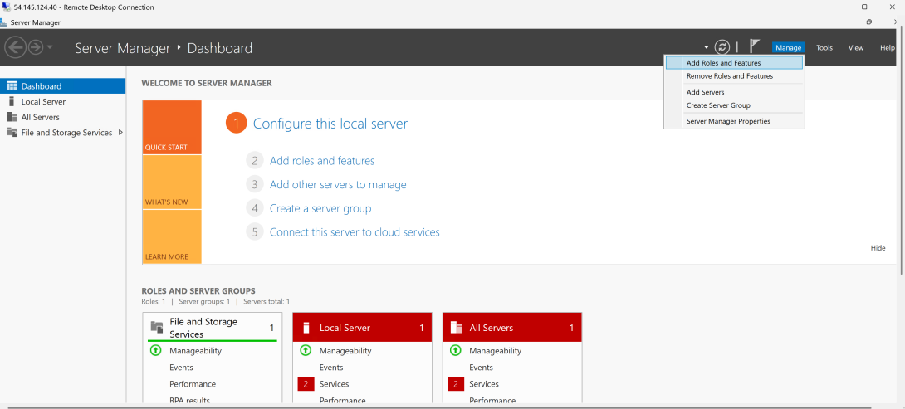
[Figure 17:Add DNS : Manage -> Add Roles and Features (used to add main server functions such as DNS, DHCP, Web Server, etc)]

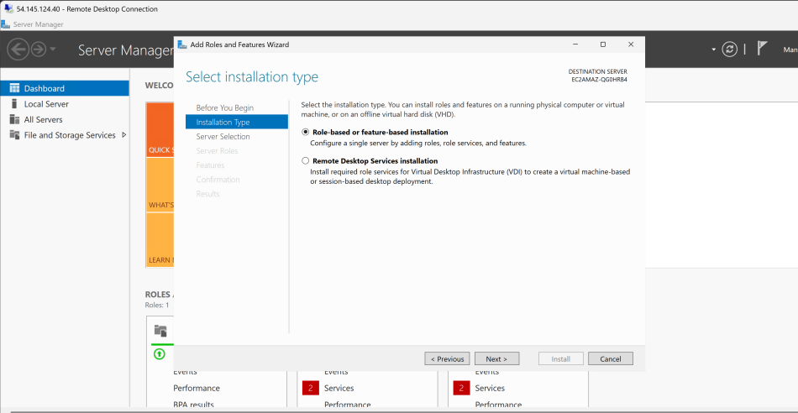
[Figure 18:Select Role-based or Feature-based Installation - Installs a role directly on to the server. The DNS Server role and its management tools were then selected and installed. This allowed the server to host DNS zones and respond to DNS queries from client devices.]

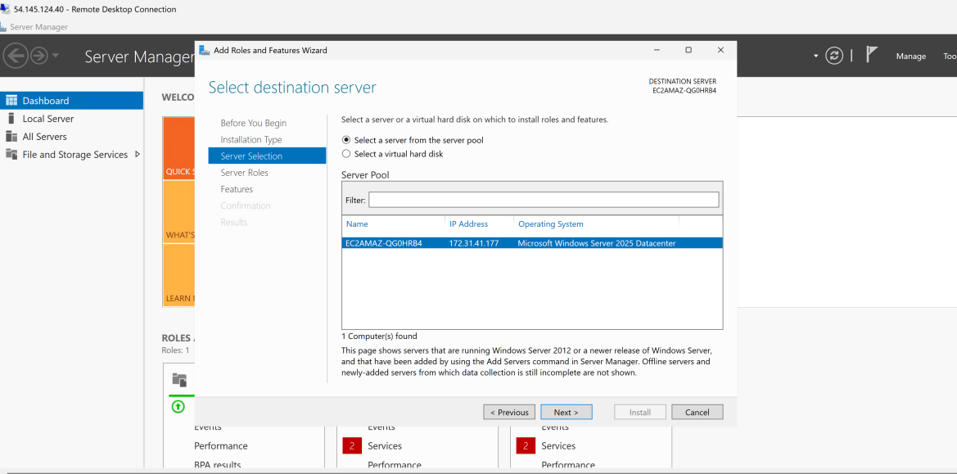
[Figure 19: Select current server from the server pool and then next -> ensures DNS is installed on the EC2 Windows Server ]
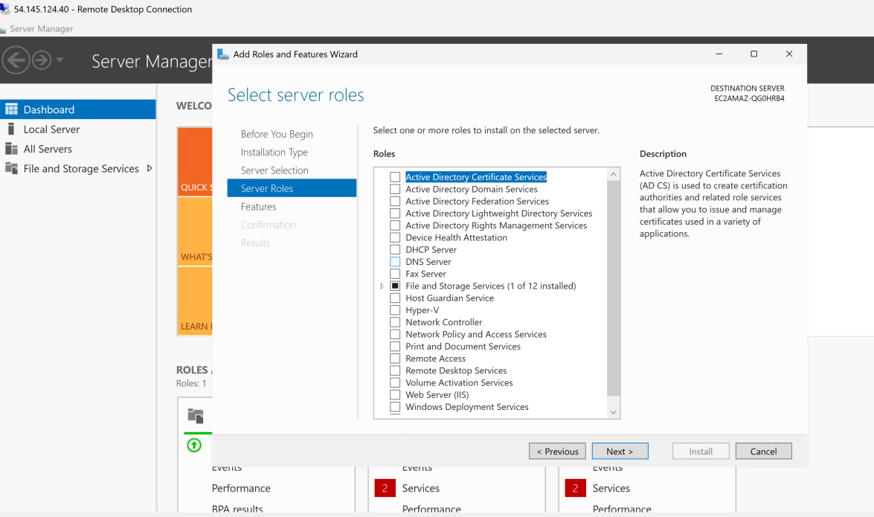
[Figure 20: Select DNS Server and press next -> Adds DNS Service Capability to server ]
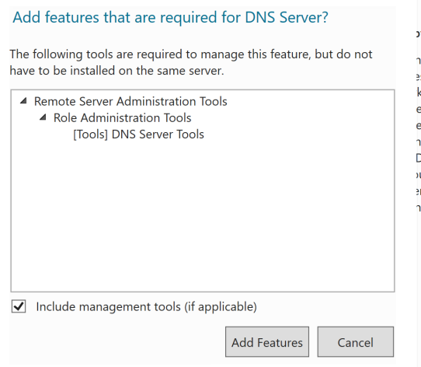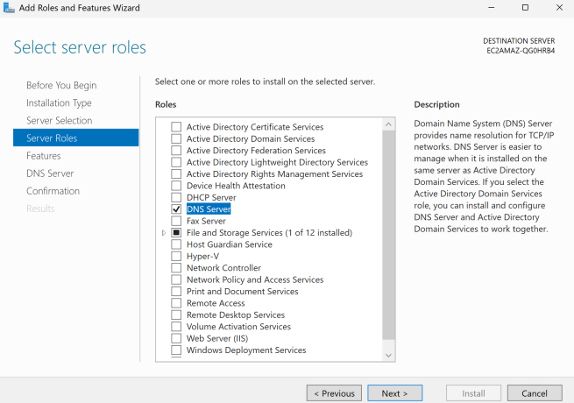
[Figure 21:Add Feature + Next -> Installs the management tools needed to control DNS ]

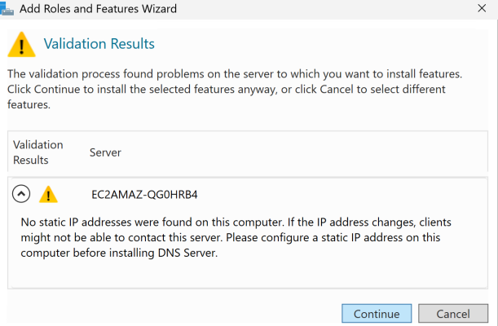
[Figure 22:Press Continue ]
During the DNS Server role installation, Windows displayed a warning that no static IP address was configured. This warning appears because DNS servers normally require a stable IP address so clients can consistently reach them. In this proof-of-concept, the EC2 instance public IPv4 address was used for testing. The Windows network adapter settings were left managed by AWS to avoid disrupting the EC2 network configuration.

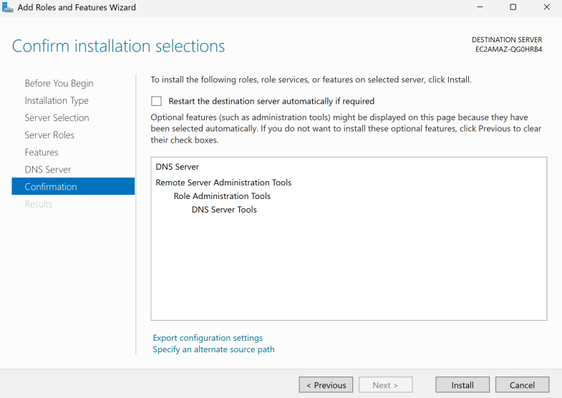
[Figure 23:Press Install and wait until installation complete ]
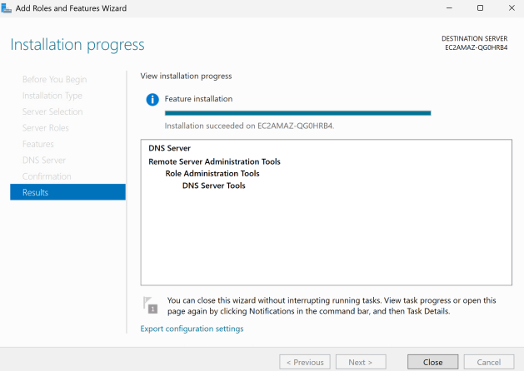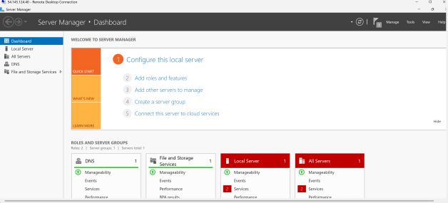
[Figure 24 and 25: DNS Server Role successfully installed on Windows Server EC2 Instance]

3.5 Creating the Forward Lookup Zone

Tools → DNS → Forward Lookup Zones → New Zone → Primary Zone → mytest.com
After the DNS Server role was installed, DNS Manager was opened from Server Manager. A new forward lookup zone named mytest.com was created. A forward lookup zone is used to store DNS records that resolve domain names to IP addresses. Since the required domain name is www.mytest.com, the zone was named mytest.com so that a host record named www could be created inside it.

A Primary Zone was selected because this DNS server is hosting and managing the zone directly. The DNS records are stored locally on this server.
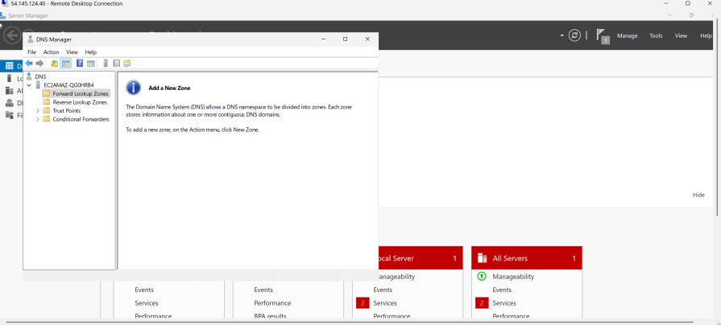
[Figure 26:Tools -> DNS ]
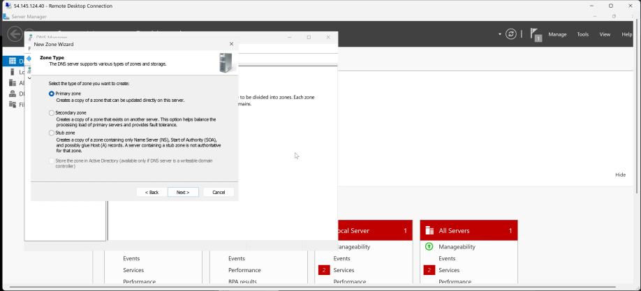
[Figure 27:Set as Primary Zone and Press Next ]
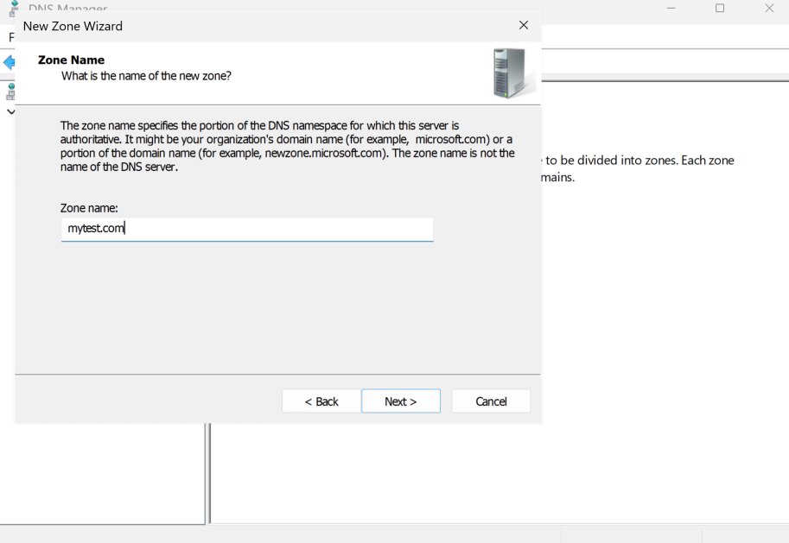
[Figure 28:Name zone name as mytest.com as stated in requirements ]
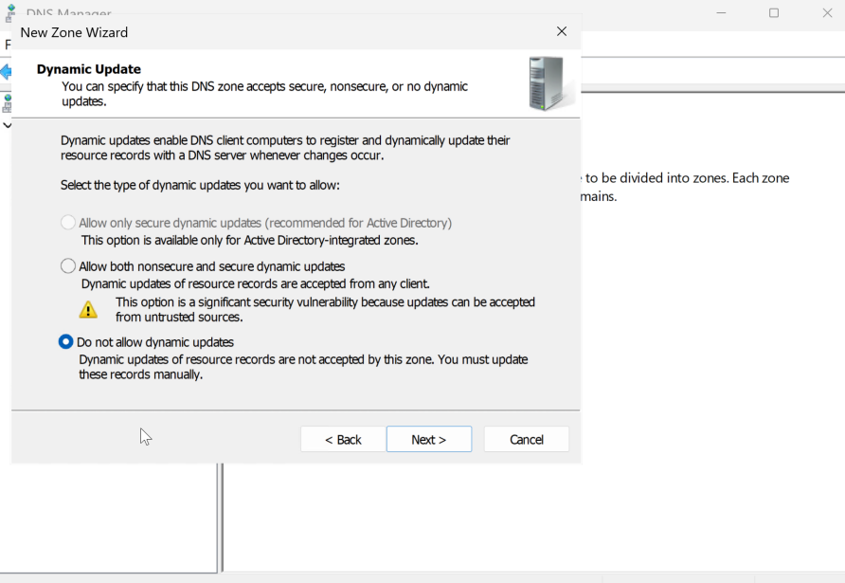
[Figure 29: Select do not allow dynamic updates and press next]
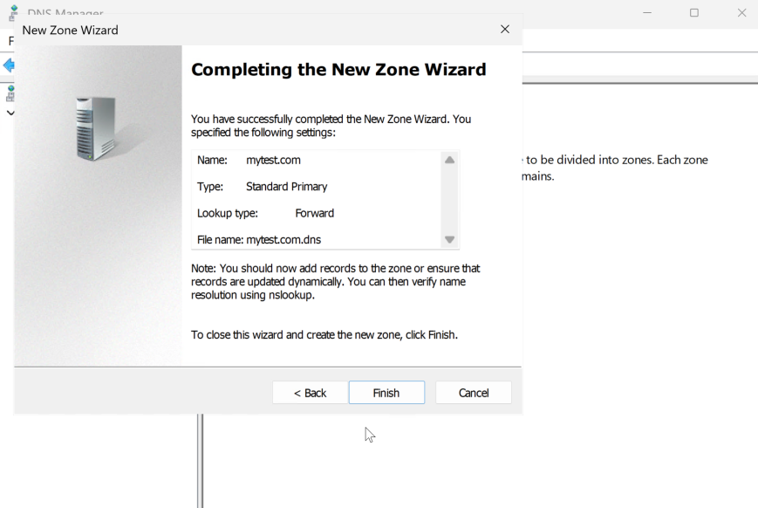
[Figure 30: Click on finish ]
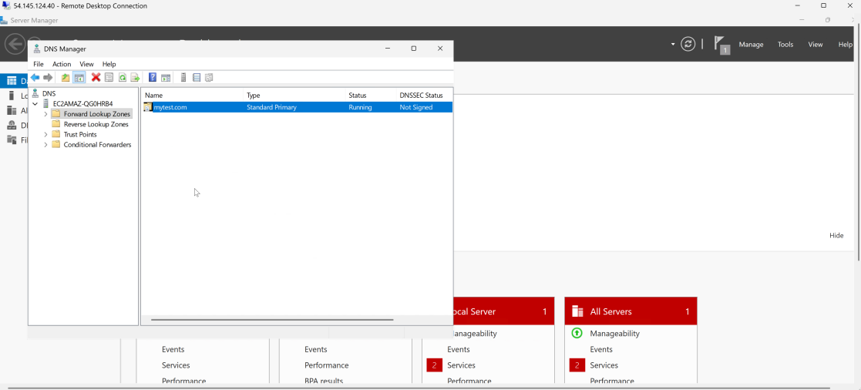
[Figure 31: Primary Zone Created]

3.6 Creating the A Record
Right-click blank area → New Host (A or AAAA) → Name: www → IP: 8.8.8.8
Inside the mytest.com forward lookup zone, a new Host (A) record was created. The host name was set to www, which forms the fully qualified domain name www.mytest.com. The IP address was set to 8.8.8.8 as required by the project brief. This record allows the DNS server to resolve www.mytest.com to 8.8.8.8.
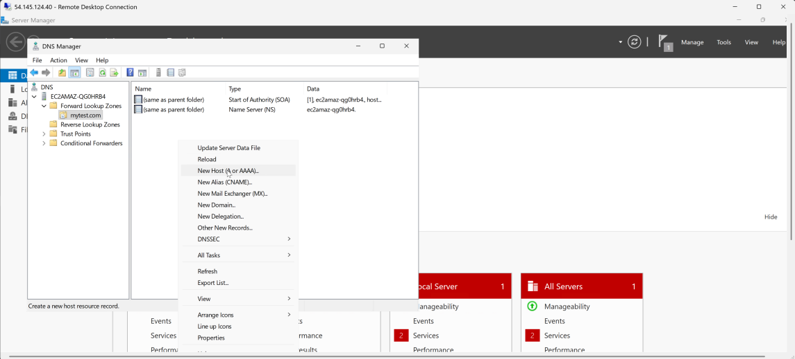
[Figure 32:Adding New Host ]
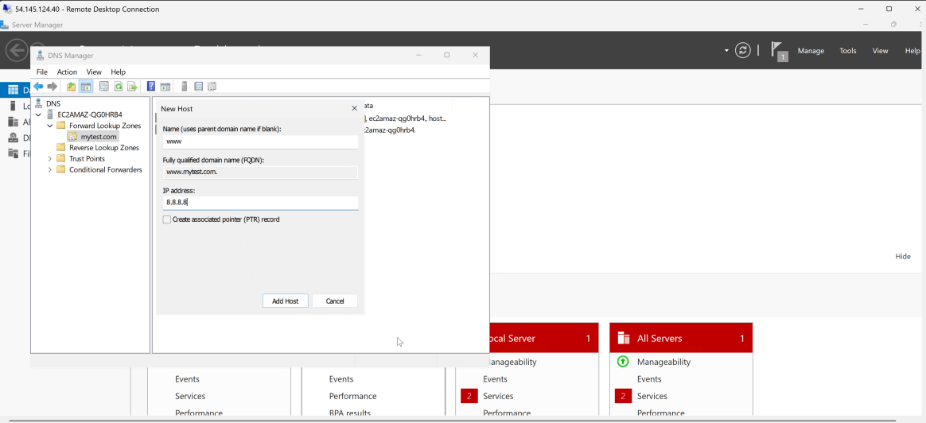
[Figure 33:Adding www. to make it www.mytest.com and setting IP address as 8.8.8.8]

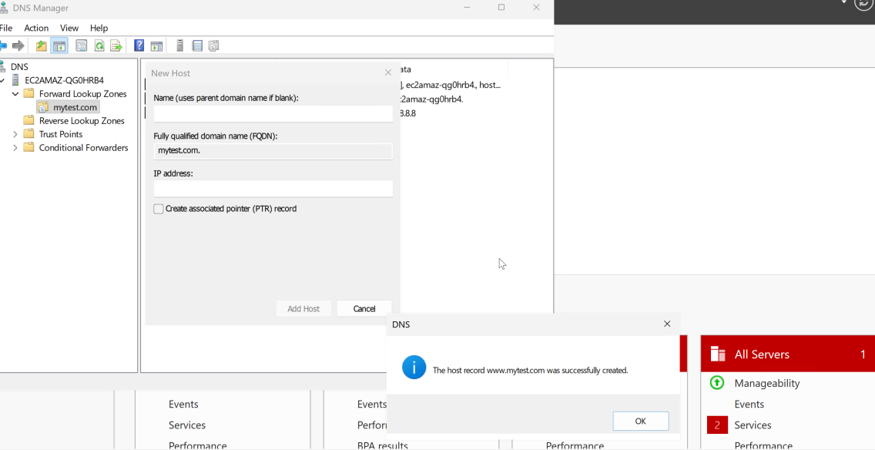
[Figure 34:New Host Created!]

Creating new Host (A) record inside mytest.com forward lookup zone with host name set as www so the formed domain name becomes www.mytest.com IP Address was set to 8.8.8.8 as required in the project specs, this record allows DNS server to resolve www.mytest.com to 8.8.8.8 .

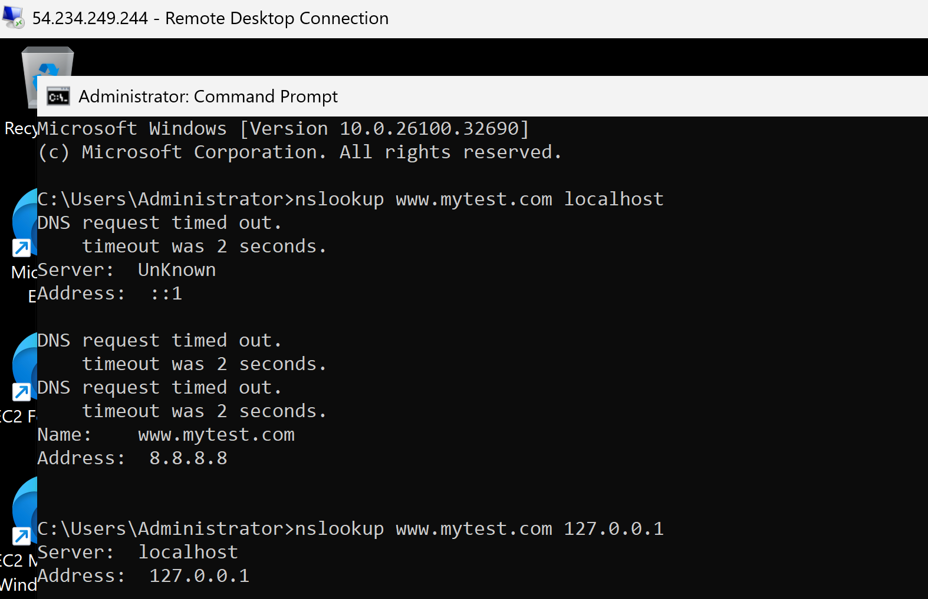
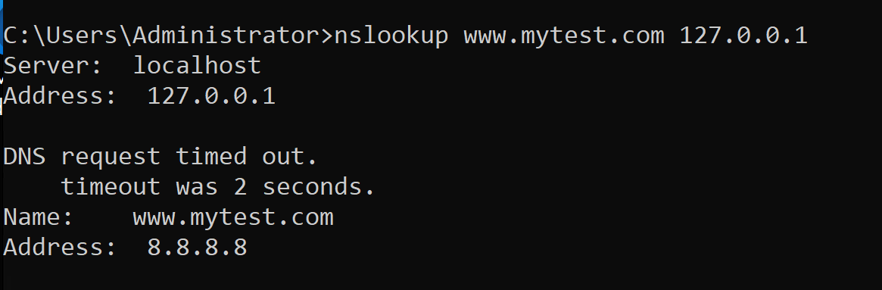
[Figure 35:DNS Server works when doing nslookup on virtual machine computer, with DNS server being the localhost]

3.7 Configuring AWS Security Group Rules
Before testing the DNS service from my laptop, the EC2 security group inbound rules were updated. RDP on TCP port 3389 was allowed for remote access to the Windows Server. DNS traffic was allowed on UDP port 53 and TCP port 53 so that external clients could query the DNS server. ICMP was also allowed to support ping validation. These rules were required because AWS security groups control what traffic is allowed to reach the EC2 instance.
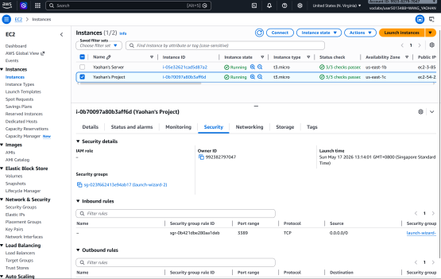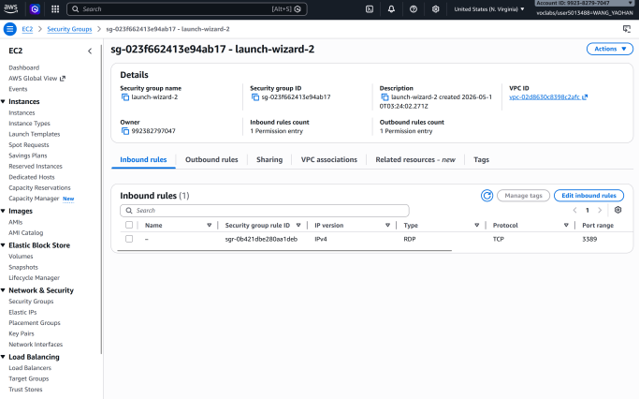
[Figure 36 and 37:Select on the instance “Yaohan’s Project” -> go to Security tab and click on the wizard link under “Security Groups”, then select edit inbound rules ]

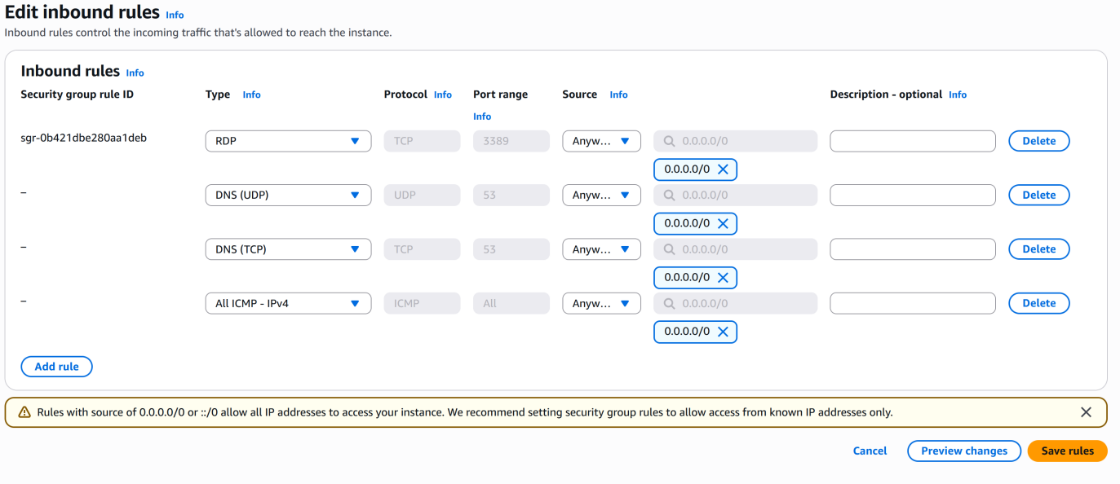
[Figure 38: Edited Inbound rules]
edited inbound rules and added:
Rule | Protocol | Port | Purpose
RDP | TCP | 3389 | Remote Access to Windows Server
DNS UDP | UDP | 53 | DNS Query Traffic
DNS TCP | TCP | 53 | DNS Fallback/Larger DNS Response
ICMP | ICMP | All/ Echo Ping Testing

AWS Security Groups act like a cloud firewall. Even if DNS is working inside Windows Server, your laptop cannot reach it unless AWS allows inbound DNS traffic.
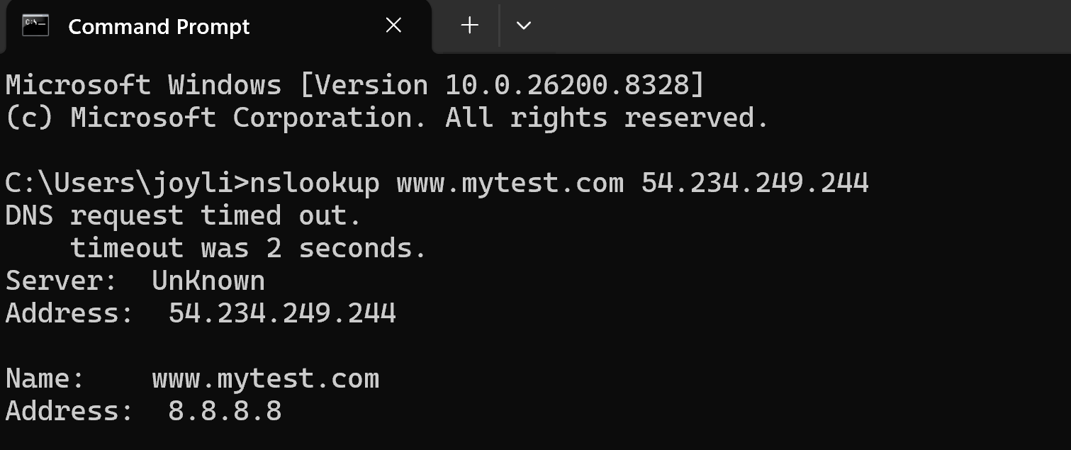
[Figure 39:The nslookup test on my laptop shows that the laptop queried the EC2 Windows Server DNS service using the server’s public IPv4 address, 54.234.249.244. The DNS server successfully resolved www.mytest.com to 8.8.8.8, confirming that the A record was configured correctly and that DNS traffic was allowed through the AWS security group.]

3.8 Configuring Laptop DNS Settings

The EC2 public IPv4 address is used as the DNS server address. When the laptop queries www.mytest.com, the DNS server returns 8.8.8.8 as the A record result.

After configuring the DNS Server on the Windows Server EC2 instance, my laptop was configured to use the EC2 instance as its preferred DNS server.

By default, a laptop usually uses the DNS server provided by the local Wi-Fi router or ISP. However, those DNS servers would not contain the custom DNS record created in this project. Therefore, the laptop’s DNS settings were manually changed so that DNS queries would be sent to the Windows Server EC2 instance.
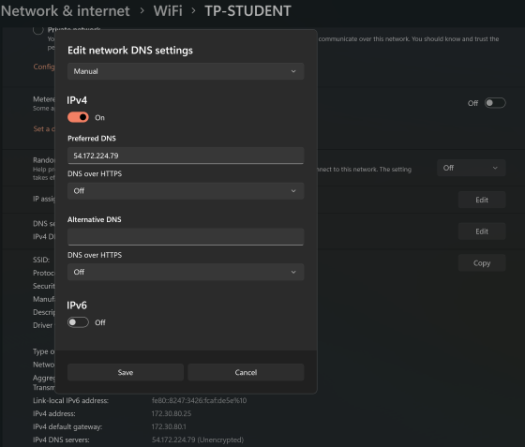
[Figure 40:Preferred DNS server: 54.172.224.79
Laptop DNS settings configured to use the EC2 Windows Server public IPv4 address as the preferred DNS server.]

The preferred DNS server was set to the public IPv4 address of the EC2 instance. The alternate DNS server field was left blank to prevent the laptop from using another DNS server during testing.
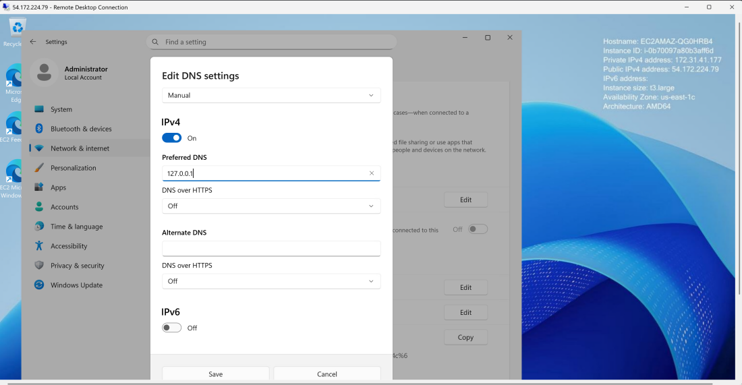
[Figure 41: Setting DNS Server as the Windows EC2 Server Public IPv4 Address]
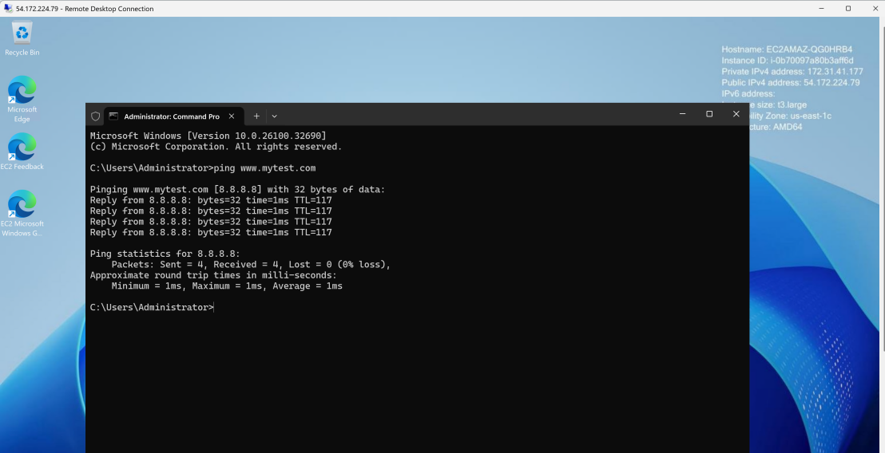
[Figure 42: Ping works on Remote Desktop ]

3.9 Validation Testing
The DNS configuration was tested using nslookup and ping.

First, nslookup was used to directly query the EC2 Windows Server DNS service:

Command:
nslookup www.mytest.com
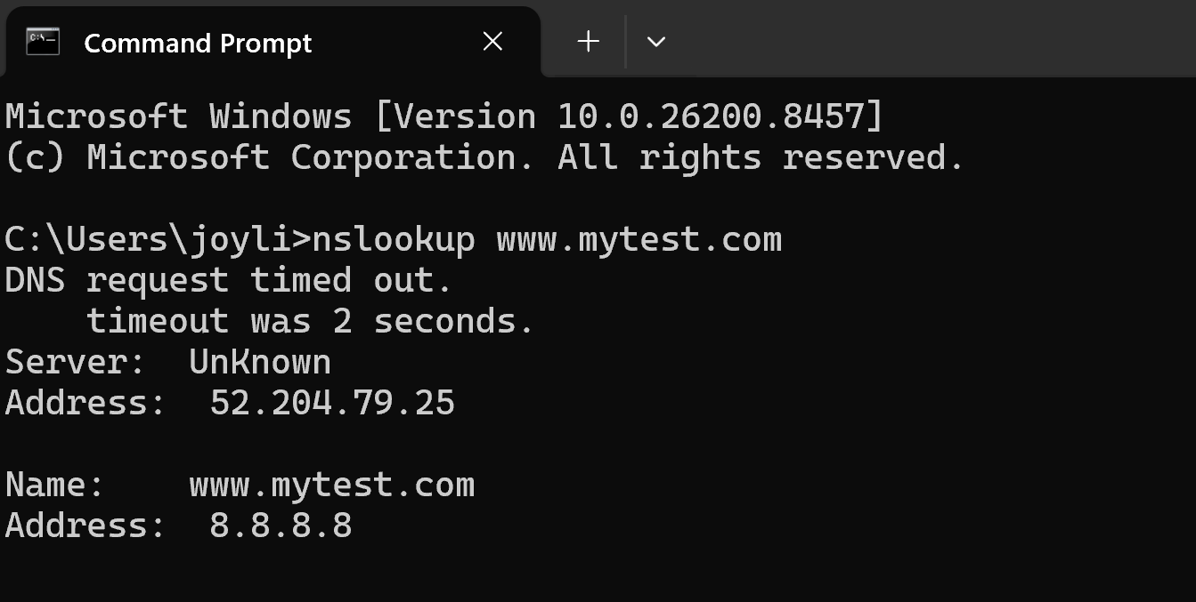
[Figure 43:nslookup on www.mytest.com works on laptop]

The result showed that www.mytest.com resolved to 8.8.8.8. This confirmed that the A record was created correctly and that the DNS server was reachable from my laptop.

Finally, the ping command was used:

ping www.mytest.com
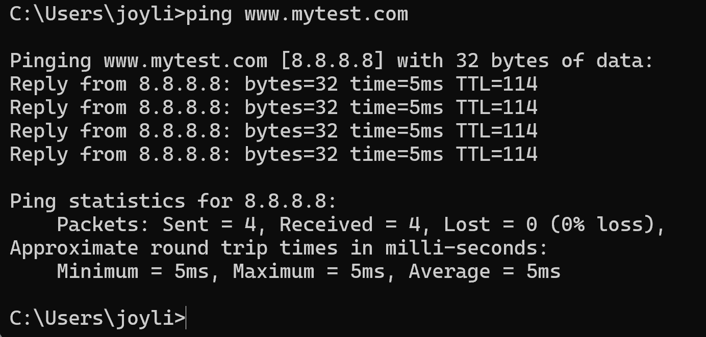
[Figure 44:ping on www.mytest.com works on laptop]

The result showed that www.mytest.com resolved to 8.8.8.8 before sending ICMP packets. This proves that the laptop was able to use the DNS service hosted on the Windows Server EC2 instance.
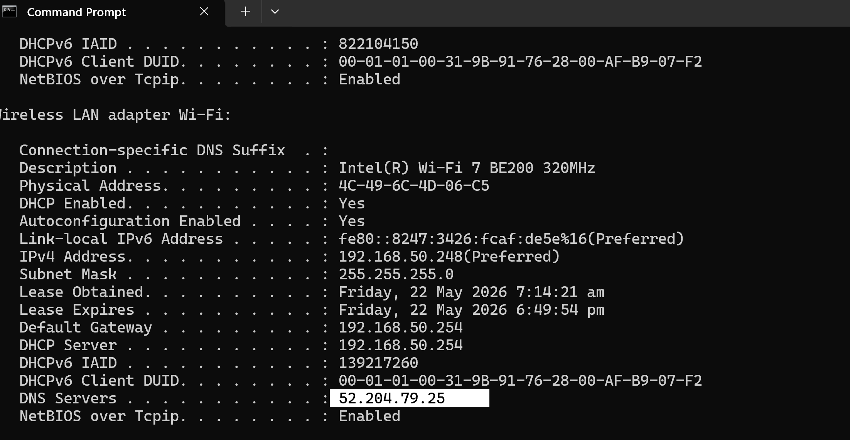
[Figure 43:The ipconfig /all command was used to verify the laptop’s network adapter settings. The output shows the active Wi-Fi adapter, IPv4 address, default gateway, DHCP server, and DNS server. The DNS Servers field confirms that the laptop was configured to use the EC2 Windows Server public IPv4 address as its DNS server for the DNS validation test.The ipconfig /all command was used to verify the laptop’s network adapter settings. The output shows the active Wi-Fi adapter, IPv4 address, default gateway, DHCP server, and DNS server. The DNS Servers field confirms that the laptop was configured to use the EC2 Windows Server public IPv4 address as its DNS server for the DNS validation test.]

3.10 Conclusion
The DNS proof-of-concept was successfully completed. A Windows Server EC2 instance was created and configured with the DNS Server role. A primary forward lookup zone named mytest.com was created, and an A record for www.mytest.com was added to point to 8.8.8.8.

The AWS security group was configured to allow DNS traffic using UDP and TCP port 53, while ICMP was allowed for ping testing. The laptop was then configured to use the EC2 instance public IPv4 address as its preferred DNS server.

The validation tests confirmed that www.mytest.com resolved to 8.8.8.8 using nslookup and ping. Therefore, the DNS service was successfully configured and verified to be working correctly.

- Appendices
  - References
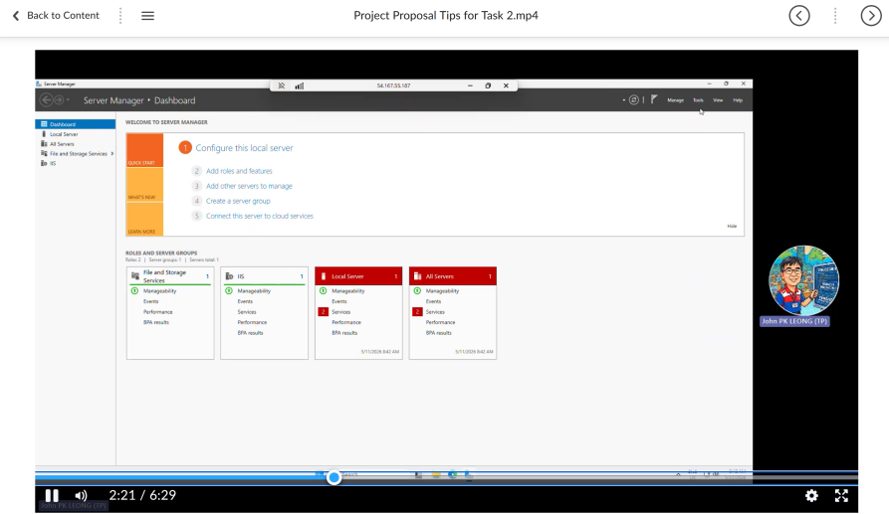
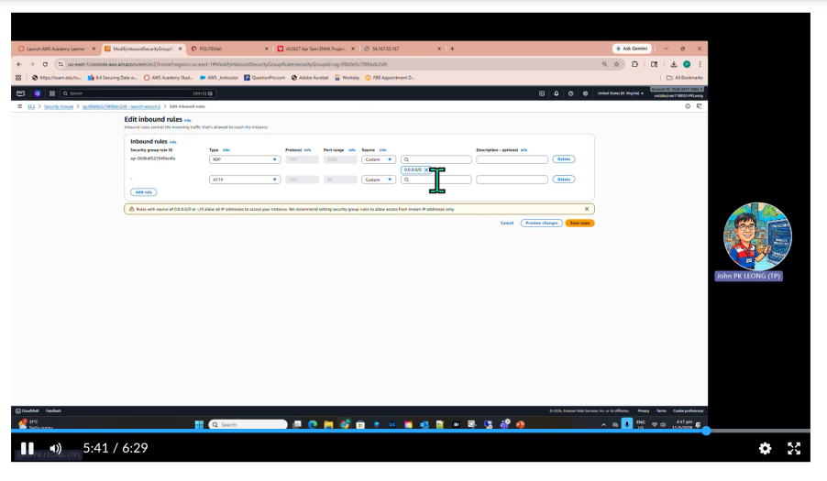
Project Proposal Tips for Task 2 Video on LMS

  - Video links
Jon Good. (2023, October 23). How to install and configure DNS on Windows Server 2022 [Video]. YouTube. https://www.youtube.com/watch?v=OtdOEiTozUE
NexTechIQ. (2024, September 14). Windows Server 2022 DNS Setup: Create Forward & Reverse Lookup Zones + Verify with nslookup | Part 3 [Video]. YouTube. https://www.youtube.com/watch?v=KvmK8L-TQgY

