ENTERPRISE NETWORKING (CCF2C06)
Project Report & Demo Submission

Practical Class : P03
Submitted by: 2503587D Wang Yaohan

Lab Tutor: Mr John Leong
Submission Date: 31/07/2026

Declaration of Originality

I/We are the originator(s) of this work and I/we have appropriately acknowledged all other original sources used as our references for this work.

I/We understand that Plagiarism is the act of taking and using the whole or any part of another person’s work, including work generated by AI, and presenting it as my/our own.

I/We understand that Plagiarism is an academic offence
and if I/we are found to have committed or abetted the offence of plagiarism in relation to this submitted work, disciplinary action will be enforced.

Name and Signature of student:



Declaration on the use of Generative AI tools for assignments

Describe how you have used Generative AI tools such as ChatGPT or Dall.E-2 in your assignment.

Show snapshots of the conversations with the AI tool (i.e., the prompts you used and the response you get from the AI tool).

How do you indicate the reference?
The content generated by AI tools are not retrievable except by the user who generated them, so they are considered non-recoverable sources. Although non-recoverable data or quotations in APA Style papers are usually cited as personal communications, with ChatGPT-generated text there is no person communicating. Quoting text from ChatGPT chat is therefore more like sharing the output of an algorithm, with a reference list entry and the corresponding in-text citation.

According to the official APA Style site, ChatGPT references should be cited as:

E.g. OpenAI. (2023). ChatGPT (Sep 25 version) [Large language model].
https://chat.openai.com/chat

Important Note:

- Do not copy answers produced by the AI tool in totality as it is considered as plagiarism.

- Do not rely on any information produced by the AI tool blindly. You should always verify the answer with other sources. Do not assume that these answers provided by the AI tool are correct.

- To achieve quality outputs from the AI tool, you should provide good prompt that is clear and specific. Be precise and provide context. Avoid asking open-ended questions.

Table of Contents
- Basic Router & Device Configuration
- VLAN & Trunk Configuration
- Multi-Area OSPF Configuration
- DHCP Server Configuration
- Wireless LAN Controller Configuration
- Dynamic PAT Configuration
- Primary and Backup Static Routing
- External Server Services
- Research Findings
- Conclusion
- References

Basic Router & Device Configuration

1.1 Objective
The objective of this stage was to configure the basic addressing, administrative security and remote-access settings required on the enterprise routers and switches. Meaningful hostnames were assigned to identify each device, while the required router interfaces were configured using the IPv4 addresses and subnet masks developed during the addressing-design stage.
All required interfaces were enabled using the no shutdown command. A clock rate of 64,000 bits per second was applied only to serial interfaces operating as the Data Communications Equipment endpoint.
In accordance with the common project requirements, all routers and switches were secured using an encrypted enable secret, an administrator account with full configuration privileges, password encryption, a warning banner and SSH-only remote access on VTY lines 0–4. RSA keys of 1024 bits were generated using the ENNK.COM domain, and SSH version 2 was enabled. Unused interfaces were administratively disabled where applicable, and each completed configuration was saved to startup configuration.

1.2 Router Addressing Summary

Device | Interface | IP Address | Subnet Mask | Connected Network/Device
Net-Admin | Fa0/0 | 10.1.7.254 | 255.255.252.0 | Network A – Network Administrator LAN
Net-Admin | Se2/0 | 10.1.28.1 | 255.255.255.252 | Reception router
Net-Admin | Se3/0 | 100.100.100.22 | 255.255.255.252 | ISP router
Reception | Fa0/0 | 10.1.19.254 | 255.255.252.0 | Network B – Reception LAN
Reception | Fa1/0 | 10.1.25.126 | 255.255.255.128 | Network M – Campus Network
Reception | Se2/0 | 10.1.28.2 | 255.255.255.252 | Net-Admin router
Reception | Se3/0 | 10.1.28.5 | 255.255.255.252 | Student-Warden router
Student-Warden | Fa0/0 | 10.1.21.254 | 255.255.254.0 | Network E through Switch2
Student-Warden | Fa1/0 | 10.1.25.254 | 255.255.255.128 | Network K through Switch17
Student-Warden | Se2/0 | 10.1.28.6 | 255.255.255.252 | Reception router
Student-Warden | Se3/0 | 10.1.28.9 | 255.255.255.252 | Staff_Bld_Library router
Staff_Bld_Library | Fa0/0 | 10.1.27.126 | 255.255.255.128 | Network H through Switch10
Staff_Bld_Library | Fa1/0 | 10.1.23.254 | 255.255.254.0 | Network J – Library network through Switch16
Staff_Bld_Library | Se2/0 | 10.1.28.10 | 255.255.255.252 | Student-Warden router
Staff_Building | Fa0/0 | 10.1.27.125 | 255.255.255.128 | Network H through Switch10
Staff_Building | Fa1/0 | 10.1.3.254 | 255.255.252.0 | Network F – Staff Building A
Staff_Building | Ethernet5/0 | 10.1.24.254 | 255.255.255.128 | Network G – Staff Building B
Hostel_A_B_C | Fa0/0 | 10.1.21.253 | 255.255.254.0 | Network E through Switch2
Hostel_A_B_C | Fa1/0 | Unassigned | N/A | 802.1Q trunk to Switch3 for VLANs 800 and 900
Router11 | Fa0/0 | 10.1.25.124 | 255.255.255.128 | Network M through Switch18
Router11 | Fa1/0 | 10.1.24.126 | 255.255.255.128 | Network L – IT/Chemical Department network
Router7 | Fa0/0 | 10.1.25.125 | 255.255.255.128 | Network M through Switch18
Router7 | Fa1/0 | Unassigned | N/A | Engineering VLAN trunk to CS_Switch1
Router7 | Se2/0 | 100.100.100.26 | 255.255.255.252 | Backup WAN connection to ISP

The addressing table summarises the IPv4 configuration of all router interfaces. Each address was selected from the usable range of the network connected to that interface. Router LAN addresses also act as the default gateways for the devices within their respective networks.
Point-to-point serial connections use /30 subnets because each connection requires only two usable addresses. Each end of a serial link was assigned one unique usable address from the same /30 network.

1.3 Representative Basic Router Configuration - Net-Admin Router

1.3.1 Router Role and Addressing
The Net-Admin router was selected as the representative router because it demonstrates LAN addressing, an internal point-to-point serial connection, an external WAN connection, DCE clocking, administrative security and SSH configuration.
Net-Admin provides the default gateway for the Network Administrator LAN and connects the internal network to the Reception router and the external ISP network. FastEthernet0/0 was assigned 10.1.7.254/22 for Network A. Serial2/0 was assigned 10.1.28.1/30 for the internal connection to Reception, while Serial3/0 was assigned 100.100.100.22/30 for the primary ISP connection.
Serial2/0 operates as the DCE endpoint of its serial connection and was therefore configured with a clock rate of 64,000 bits per second.

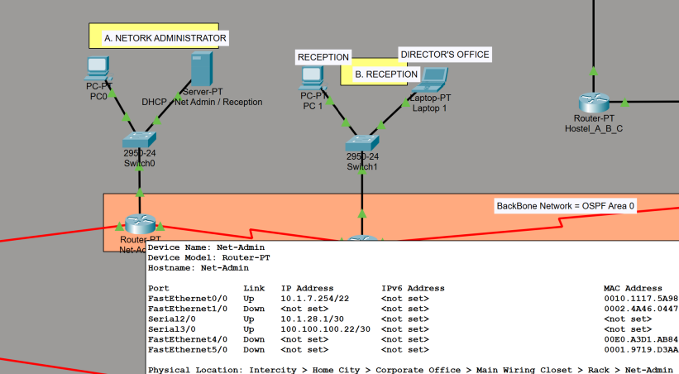
Figure 1.3.1 Location of the Net-Admin router and its directly connected devices.

1.3.2 Interface Configuration
The required interfaces were configured with their allocated addresses and enabled using no shutdown. The Net-Admin interface configuration provides a representative example of the addressing process applied to the remaining routers.
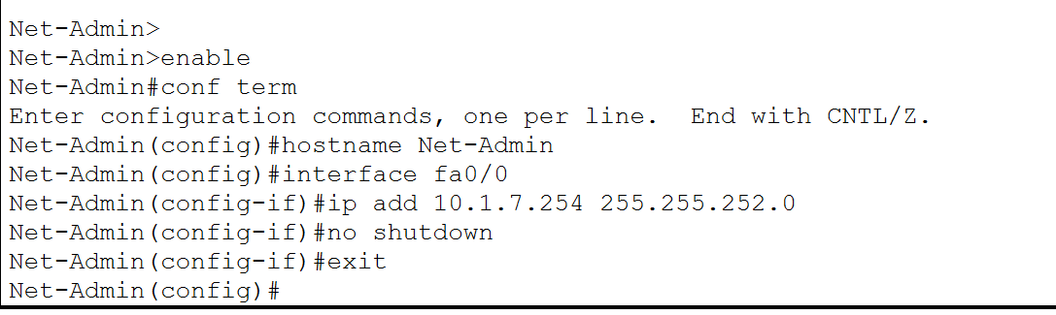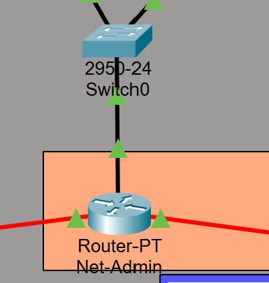
Figure 1.3.2. Configuration of the Net-Admin FastEthernet0/0 interface with IP address 10.1.7.254/22.
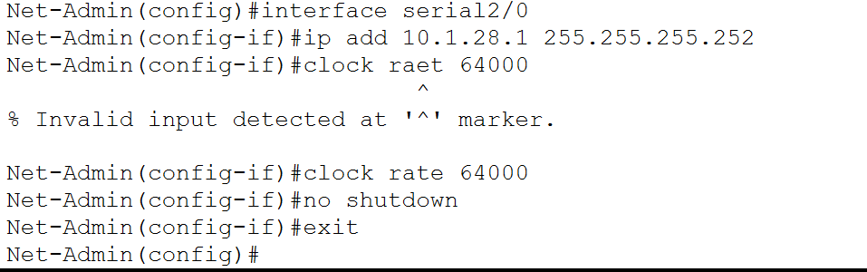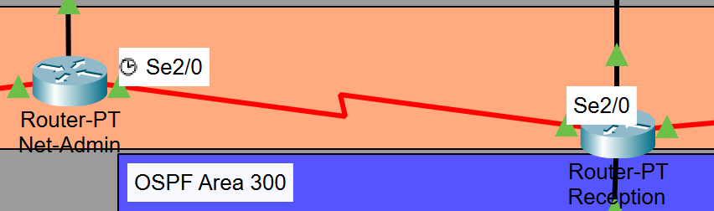
Figure 1.3.3. Configuration of the Net-Admin Serial2/0 interface with IP address 10.1.28.1/30

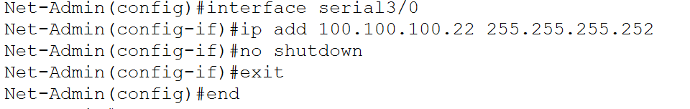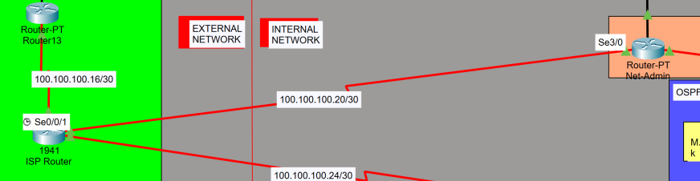
Figure 1.3.4. Configuration of the Net-Admin Serial3/0 interface with IP address 100.100.100.22/30
The remaining routers were configured using the same addressing procedure. Their complete interface assignments are provided in the router-addressing summary. Separate command screenshots for every router are unnecessary because they repeat the same ip address, clock rate and no shutdown process.

1.3.3 Security and SSH Configuration
Net-Admin was secured using the common administrative baseline required for all routers and switches. The enable secret was configured as specified by the project requirements, and service password-encryption was enabled to prevent supported plaintext passwords from appearing directly in the running configuration.
A local account named admin was created with privilege level 15 to provide full configuration access. The domain name ENNK.COM was configured before generating a 1024-bit RSA key pair. SSH version 2 was then enabled, and VTY lines 0–4 were restricted to SSH connections authenticated through the local user database.
An MOTD banner was configured to warn users that access is restricted. The completed running configuration was subsequently copied to startup configuration.

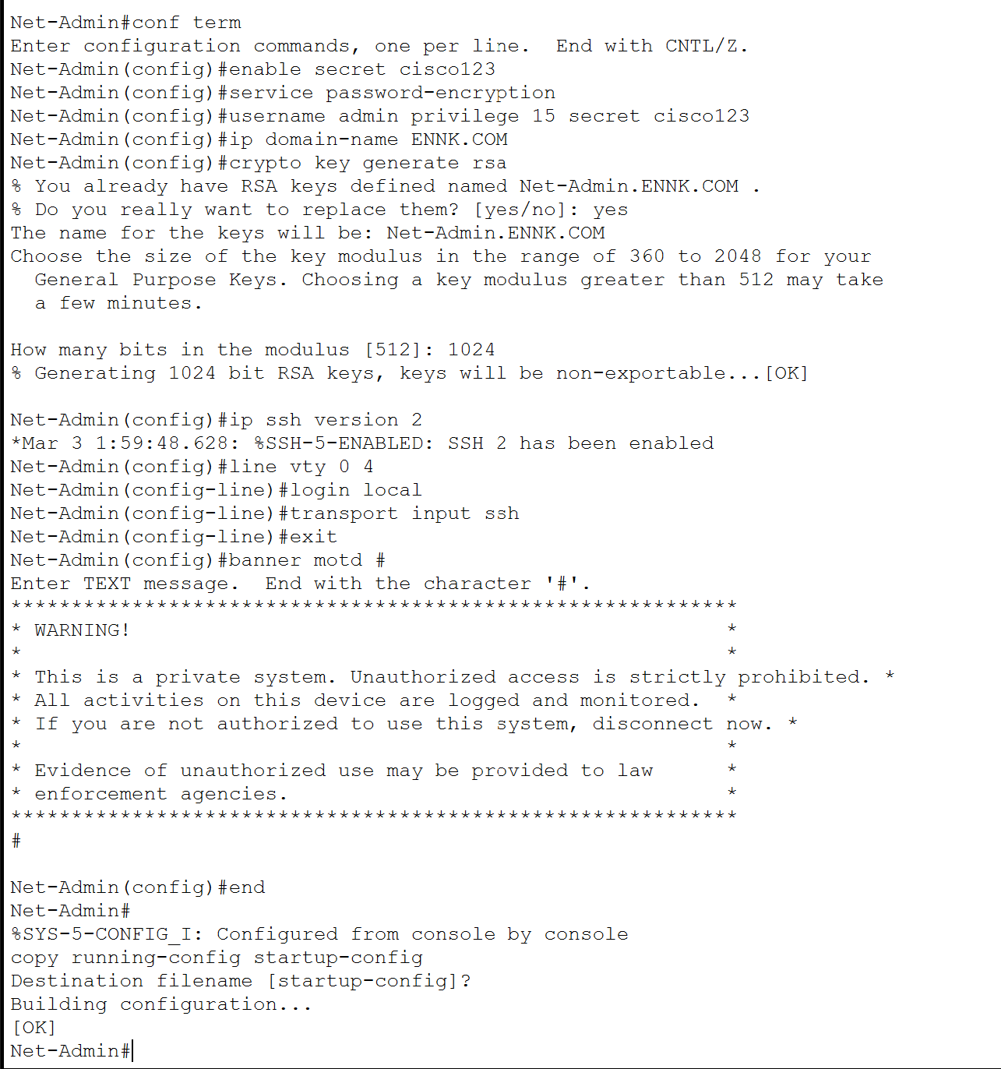
Figure 1.3.5. Security and SSH configuration on Net-Admin, including the encrypted secrets, local administrator account, 1024-bit RSA keys, SSH version 2, SSH-only VTY access and MOTD warning banner.

1.3.4 Router Verification

The screenshots show the Cisco IOS commands used to assign the Net-Admin hostname and configure the IP addresses, subnet masks, clock rate, and operational state of FastEthernet0/0, Serial2/0, and Serial3/0.

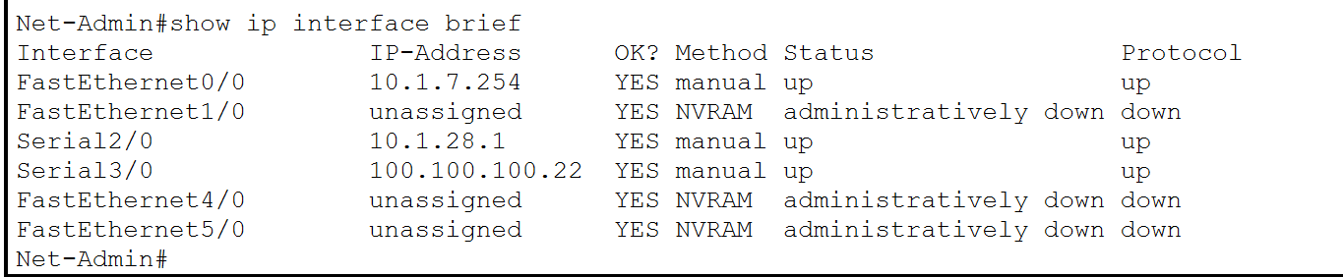
Figure 1.3.6. Verification of the Net-Admin interface addresses and operational states using show ip interface brief.

The show ip interface brief output verifies that the three configured interfaces have the correct IP addresses. Interfaces connected to configured neighbouring devices should display an up/up status.
The Net-Admin router provides connectivity for the Network Administrator LAN and connects the internal network to both the Reception router and the external ISP network. Its FastEthernet0/0 interface was assigned the default gateway address 10.1.7.254/22 for Network A. Serial2/0 was configured with 10.1.28.1/30 for the backbone connection to the Reception router, while Serial3/0 was assigned 100.100.100.22/30 for the connection to the ISP router.
As Serial2/0 is the DCE endpoint of the serial connection, a clock rate of 64000 bits per second was configured. All required interfaces were enabled using the no shutdown command.

Interface | IP Address | Subnet Mask | Connected network/device
FastEthernet0/0 | 10.1.7.254 | 255.255.252.0 | Network A <-> Net-Admin LAN via Switch 0
Serial2/0 | 10.1.28.1 | 255.255.255.252 | 10.1.28.0/30 <-> Reception Router
Serial3/0 | 100.100.100.22 | 255.255.255.252 | 100.100.100.20/30 <-> ISP Router

SSH operation was verified using show ip ssh. The output confirmed that SSH version 2 was enabled and that the device used the generated RSA key pair.

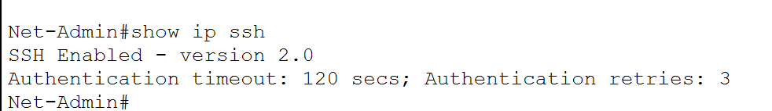
Figure 1.3.7. Verification that SSH version 2 is enabled on Net-Admin.
The security settings were also inspected using show running-config. The output confirmed that VTY lines 0–4 used local authentication and accepted only SSH connections. It also confirmed that the configured secrets were not readable in plaintext.

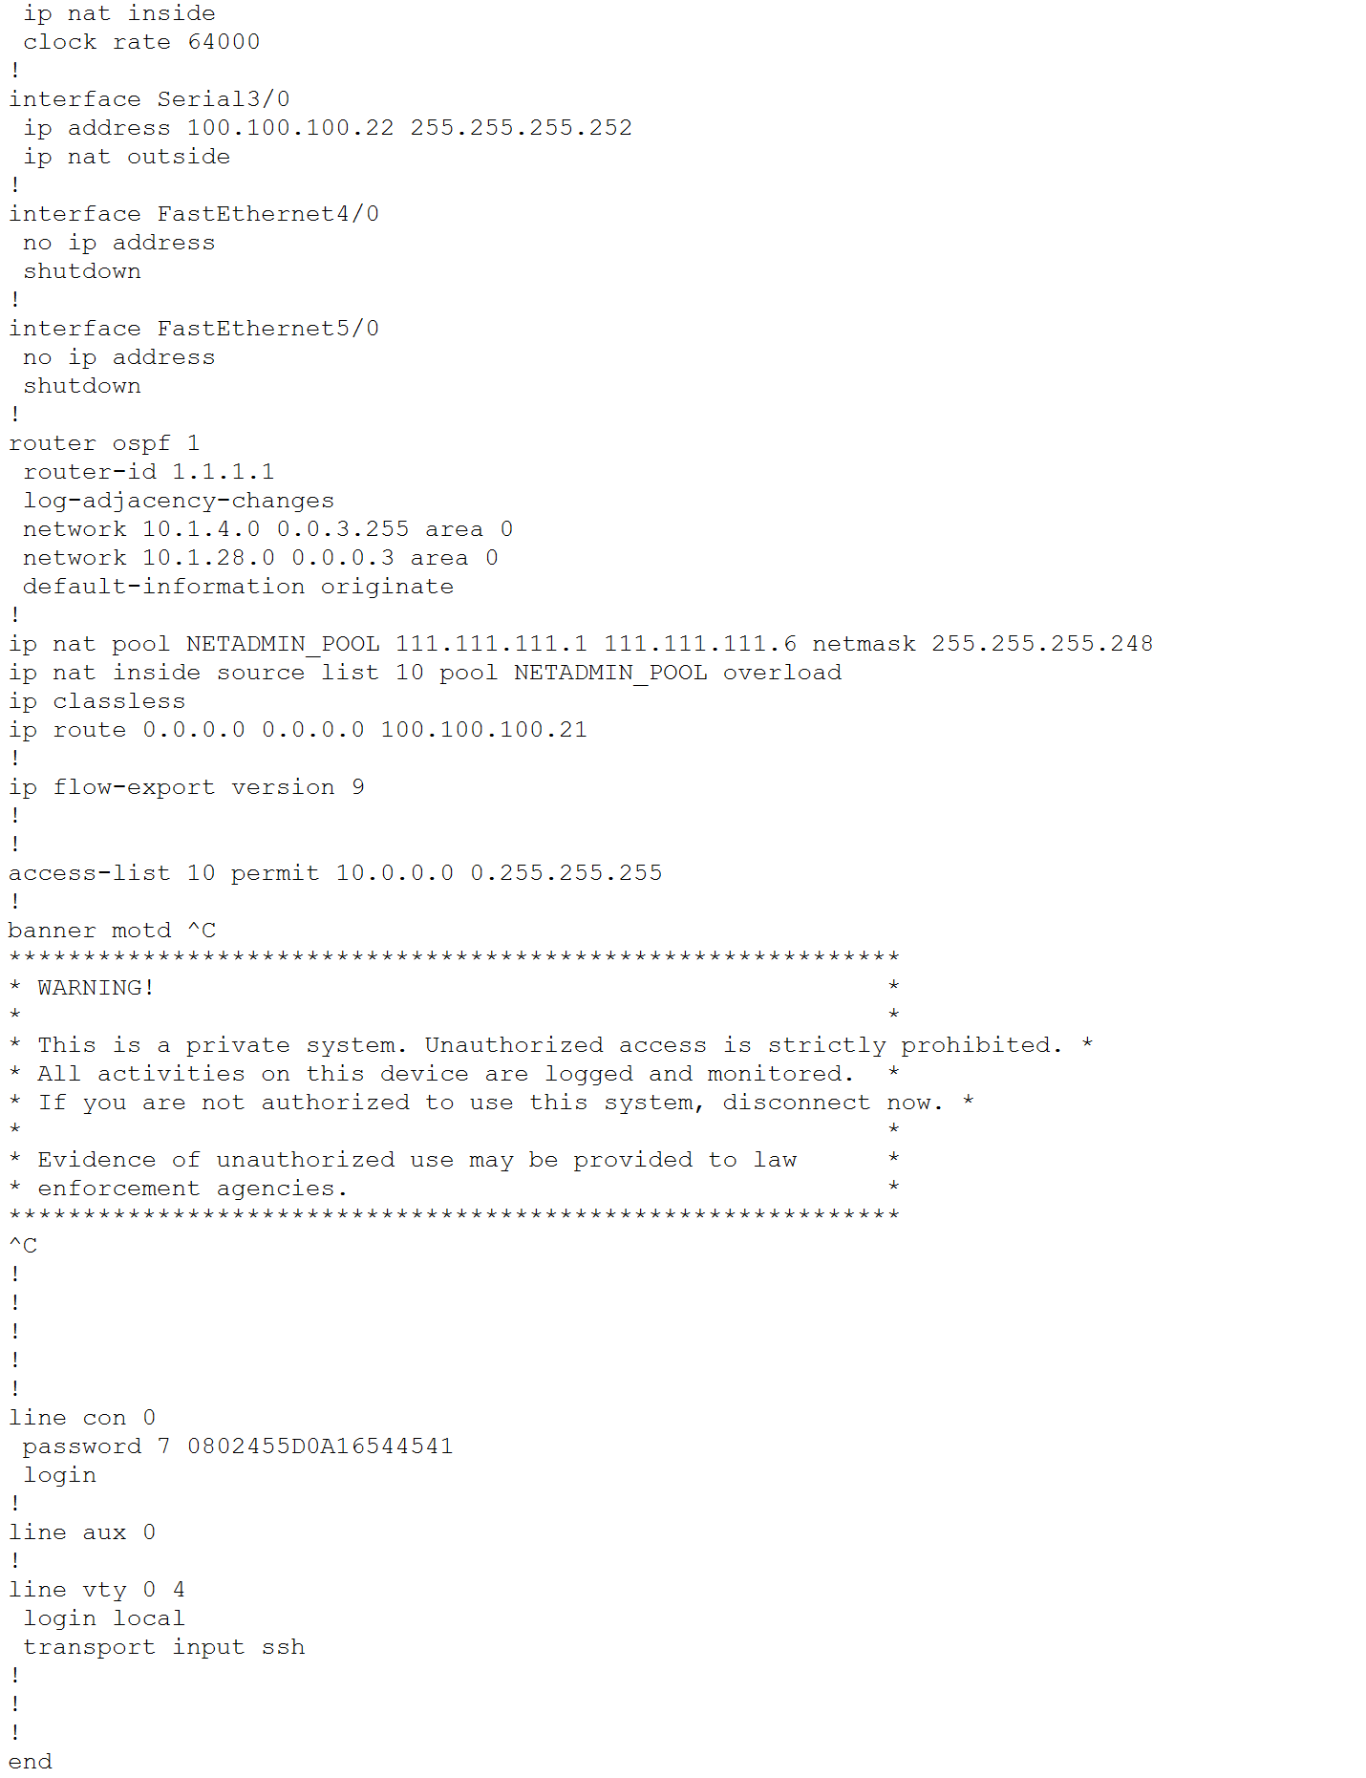
Figure 1.3.8. Verification of encrypted secrets, local authentication, SSH-only VTY access and the configured warning banner.
The configuration was saved using copy running-config startup-config, ensuring that the addressing and security settings remain available after the device restarts.
1.4 Representative Switch Security Configuration - Switch1
1.4.1 Security and SSH Configuration
Switch1 was selected as the representative Layer 2 switch. A meaningful hostname was assigned to distinguish it from the other switches in the topology. The same security baseline demonstrated on Net-Admin was applied to the switch.
The switch was configured with the required enable secret, password encryption, local privilege-15 administrator account, ENNK.COM domain, 1024-bit RSA keys, SSH version 2, SSH-only access on VTY lines 0–4 and the required MOTD warning banner.
The project requirements state that Management VLAN 1 configuration can be ignored. Therefore, no additional Management VLAN 1 addressing was introduced in this section.

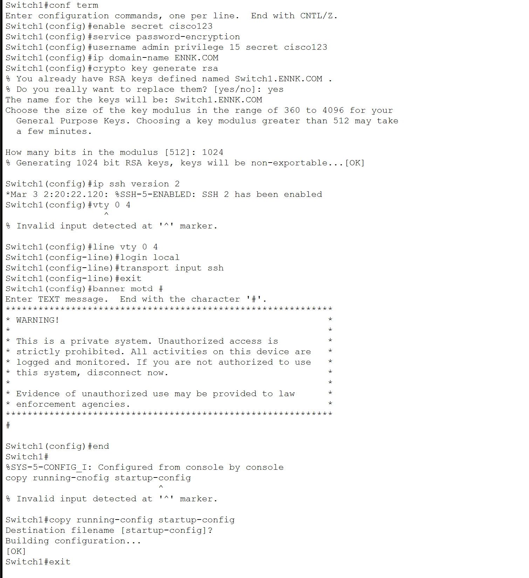
Figure 1.4.1. Representative switch security and SSH configuration on Switch1.
The same configuration procedure was applied to the remaining switches.
1.4.2 Switch Verification
The switch security configuration was checked using show ip ssh and show running-config. The output confirmed that SSH version 2 was enabled, VTY lines 0–4 accepted only SSH connections, local authentication was used, and the configured secrets were not readable in plaintext.
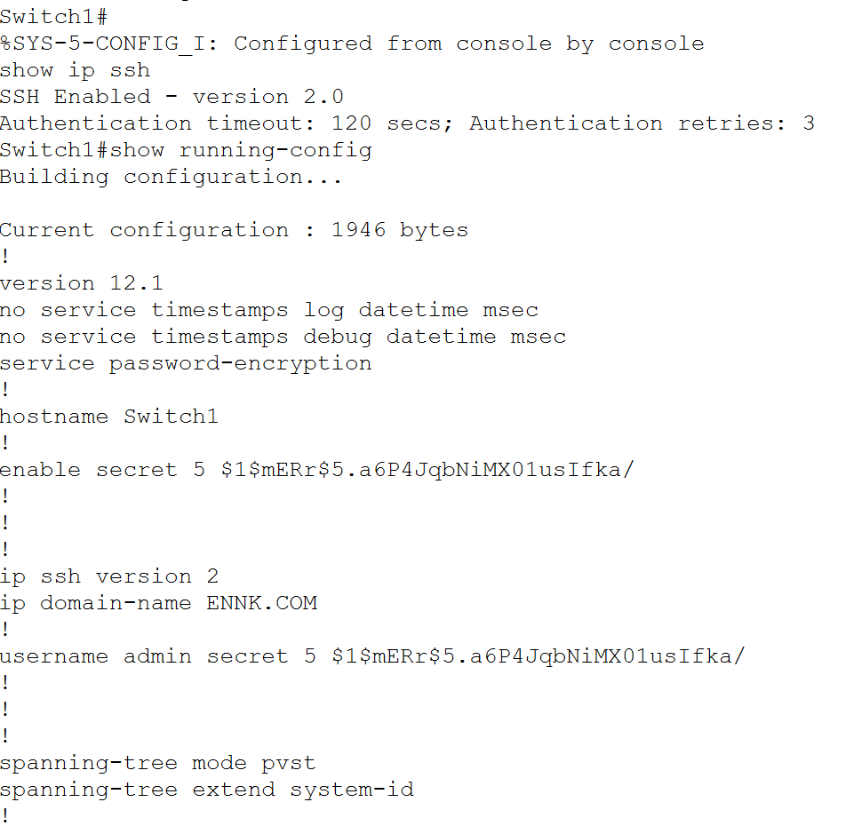
Figure 1.4.2. Verification of SSH version 2 and SSH-only VTY access on Switch1.

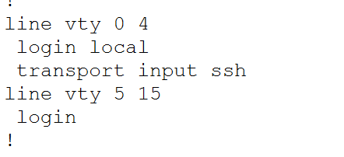
Figure 1.4.3. Verification of SSH version 2 and SSH-only VTY access on Switch1.

1.5 Special Router Interface Cases
Two router physical interfaces were intentionally configured without IPv4 addresses because they serve as parent interfaces for 802.1Q subinterfaces. Each subinterface represents a separate VLAN and is assigned the corresponding default-gateway IPv4 address.
Router | Physical Interface | Configuration | Reason
Hostel-A-B-C | FastEthernet1/0 | Enabled without a physical IP address | Carries VLANs 800 and 900; gateway addresses are configured on subinterfaces
Router7 | FastEthernet1/0 | Enabled without a physical IP address | Carries VLANs 100, 200 and 300; gateway addresses are configured on subinterfaces

The absence of a physical IP address does not mean that these interfaces are unused. Layer 3 gateway addresses are assigned to their respective VLAN subinterfaces in the VLAN and trunking section.
Serial clocking was configured only at the DCE end of each point-to-point connection. The opposite DTE endpoint did not require a clock-rate command.

1.6 Public Server Addressing

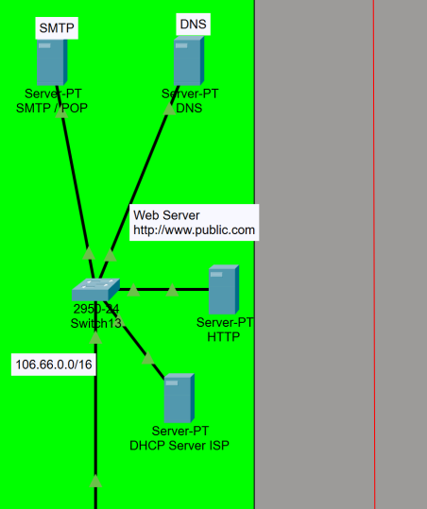
Figure 1.6.1. Public servers connected to Switch13 within the 106.66.0.0/16 network.

Server | IP address | Subnet Mask | Default Gateway | DNS Server
SMTP | 106.66.0.1 | 255.255.0.0 | 106.66.255.254 | 106.66.0.2
DNS | 106.66.0.2 | 255.255.0.0 | 106.66.255.254 | 106.66.0.2
HTTP | 106.66.0.3 | 255.255.0.0 | 106.66.255.254 | 106.66.0.2
DHCP SERVER ISP | 106.66.0.4 | 255.255.0.0 | 106.66.255.254 | 106.66.0.2

The external SMTP/POP3, DNS, HTTP and DHCP servers were assigned static IPv4 addresses in the 106.66.0.0/16 external-server network. Static addressing ensures that clients, DNS records and routing configurations can consistently locate each service.
Router13 FastEthernet0/0, configured as 106.66.255.254/16, provides the default gateway for the external-server network. The DNS server at 106.66.0.2 provides name resolution.
Router13 successfully reached all four server addresses. These ping results verify IP connectivity but do not independently prove that the application services are operational. DNS, HTTP and email functionality are verified in the External Server Services section.

Verification

Router13 successfully pinged all four server addresses. Each initial test received four out of five replies. The first timeout was most likely caused by the router performing ARP resolution before sending the remaining ICMP packets.
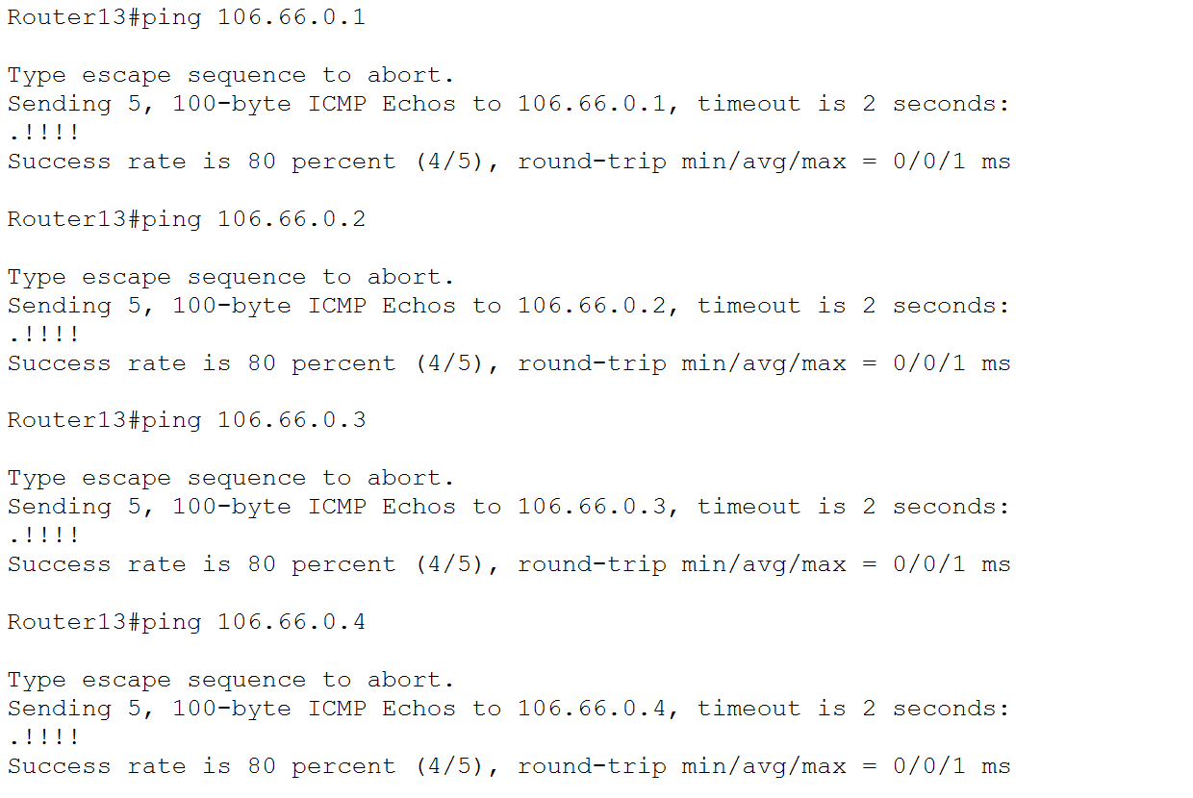
Figure 1.6.2. Consolidated connectivity tests from Router13 to the external servers.

These ping results confirm IP connectivity. They do not independently prove that the email, DNS, web or DHCP services are operating; application services should be tested in the later External Server Services section.

1.7 Internal DHCP Server Static Addressing

Each internal DHCP server was assigned a static IPv4 address so that routers and clients could locate it consistently. Static addressing is particularly important when routers use ip helper-address to forward DHCP requests to a remote server.
The Net-Admin/Reception DHCP server was selected as the representative server-addressing example. It was assigned 10.1.4.1/22 in Network A and uses Net-Admin FastEthernet0/0 at 10.1.7.254 as its default gateway.

DHCP Server | IP address | Subnet Mask | Default Gateway | DNS Server
Net-Admin/ Reception | 10.1.4.1 | 255.255.252.0 | 10.1.7.254 | 106.66.0.2
Hostel Student/Warden | 10.1.20.1 | 255.255.254.0 | 10.1.21.254 | 106.66.0.2
Staff/Library | 10.1.27.1 | 255.255.255.128 | 10.1.27.126 | 106.66.0.2
Guest | 10.1.25.129 | 255.255.255.128 | 10.1.25.254 | 106.66.0.2
Engineering Department | 10.1.25.1 | 255.255.255.128 | 10.1.25.126 | 106.66.0.2

Net-Admin/Reception DHCP Server

The Net-Admin/Reception DHCP server was assigned 10.1.4.1/22 in Network A. Net-Admin FastEthernet0/0 at 10.1.7.254 was configured as its default gateway.
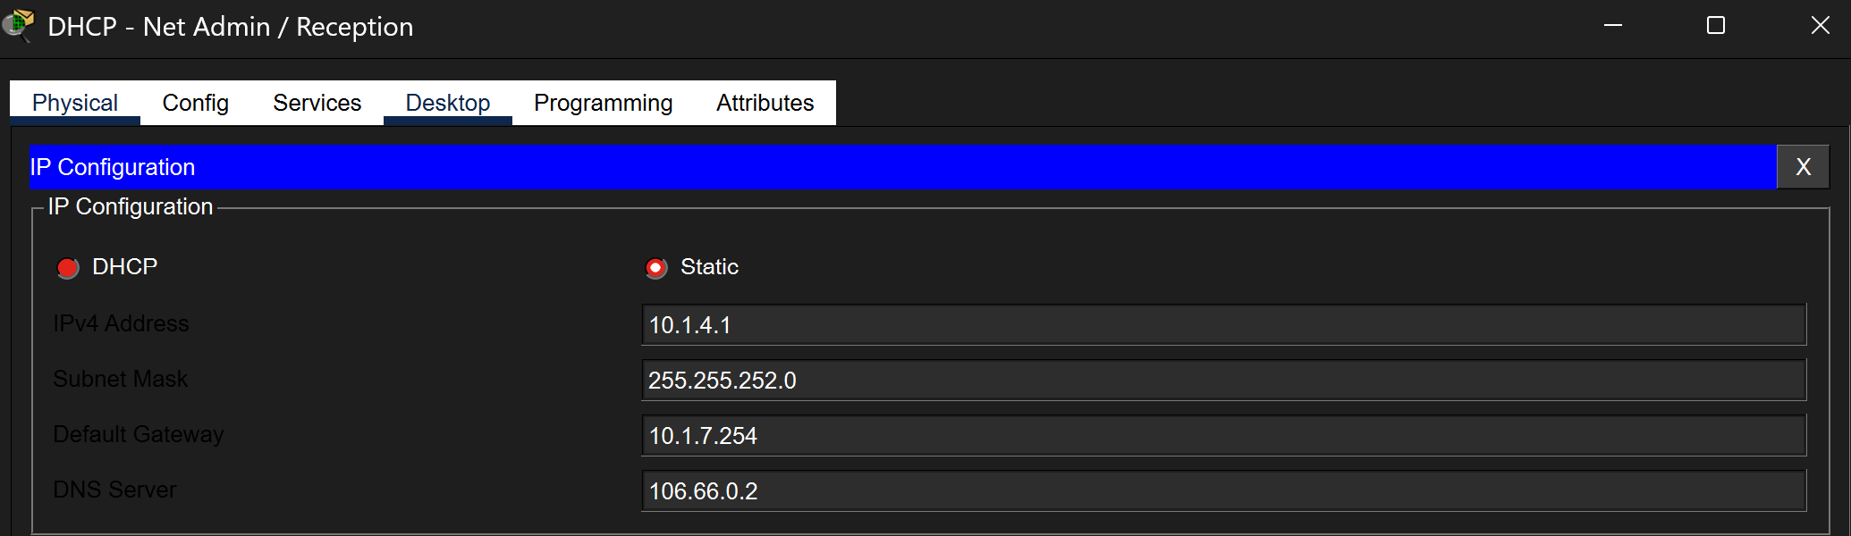
Figure 1.7.1. Static addressing of the Net-Admin/Reception DHCP server.
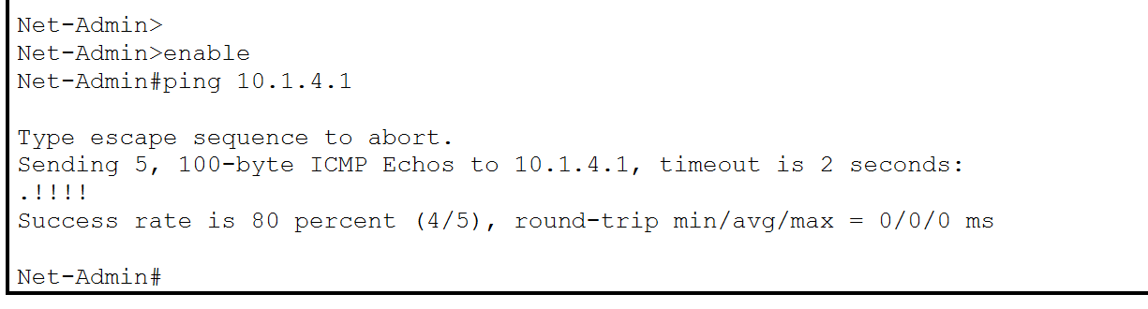
Figure 1.7.2. Successful connectivity between Net-Admin and the DHCP server.
The remaining DHCP-server addresses, masks, gateways and DNS settings are provided in the addressing table. Their DHCP pools and client assignments are documented in the DHCP Configuration section.

1.8 Section Verification and Conclusion
The basic router and device configuration was completed using the approved addressing plan and common security requirements. All routers were assigned meaningful hostnames and the required IPv4 interface addresses. Required interfaces were enabled, while clock rates were applied only to DCE serial endpoints.
All routers and switches were configured with the required enable secret, password encryption, local privilege-15 administrator, ENNK.COM domain, 1024-bit RSA keys, SSH version 2, local VTY authentication, SSH-only VTY transport and the required MOTD warning banner. Unused interfaces were administratively disabled where applicable, and the completed configurations were copied to startup configuration.
Interface status, SSH operation, protected configuration values and direct connectivity were verified using representative command outputs. The next stage configures VLANs, access ports, trunk links, router subinterfaces and DHCP relay.

VLAN, Trunking and Inter-VLAN Routing

2.1 Objective
The objective of this stage was to separate the enterprise network into logical broadcast domains using Virtual Local Area Networks. Access ports were assigned according to the connected devices, while IEEE 802.1Q trunk links were configured to carry traffic for multiple VLANs between switches and routers.
Router-on-a-stick was implemented on Router7 for Engineering VLANs 100, 200 and 300. A second router-on-a-stick implementation was configured on Hostel-A-B-C for Warden VLAN 800 and Student VLAN 900.
Because the relevant DHCP servers are located outside the client VLANs, DHCP relay was configured on the router subinterfaces using ip helper-address. The completed VLAN, access-port, trunk, subinterface and relay configurations were verified using representative Cisco IOS commands.

2.2 VLAN Addressing and Implementation Summary
The following VLANs were implemented in the Engineering, Computer Science and hostel wireless portions of the network.
VLAN | Department/Network | Subnet | Gateway | DHCP Server
100 | Network P - Engineering | 10.1.26.0/25 | 10.1.26.126 | 10.1.25.1
200 | Network Q - Engineering | 10.1.27.128/25 | 10.1.27.254 | 10.1.25.1
300 | Network N - Computer Science | 10.1.12.0/22 | 10.1.15.254 | 10.1.25.1
800 | Network C - Warden Wireless | 10.1.8.0/22 | 10.1.11.254 | 10.1.20.1
900 | Network D - Student Wireless | 10.1.26.128/25 | 10.1.26.254 | 10.1.20.1

2.3 Engineering and Computer Science VLANs
2.3.1 Engineering VLAN Topology
VLANs 100 and 200 serve the Engineering Department, while VLAN 300 serves the Computer Science Department. The three VLANs are transported through the Engineering switch infrastructure to Router7, which provides their default gateways and performs inter-VLAN routing.
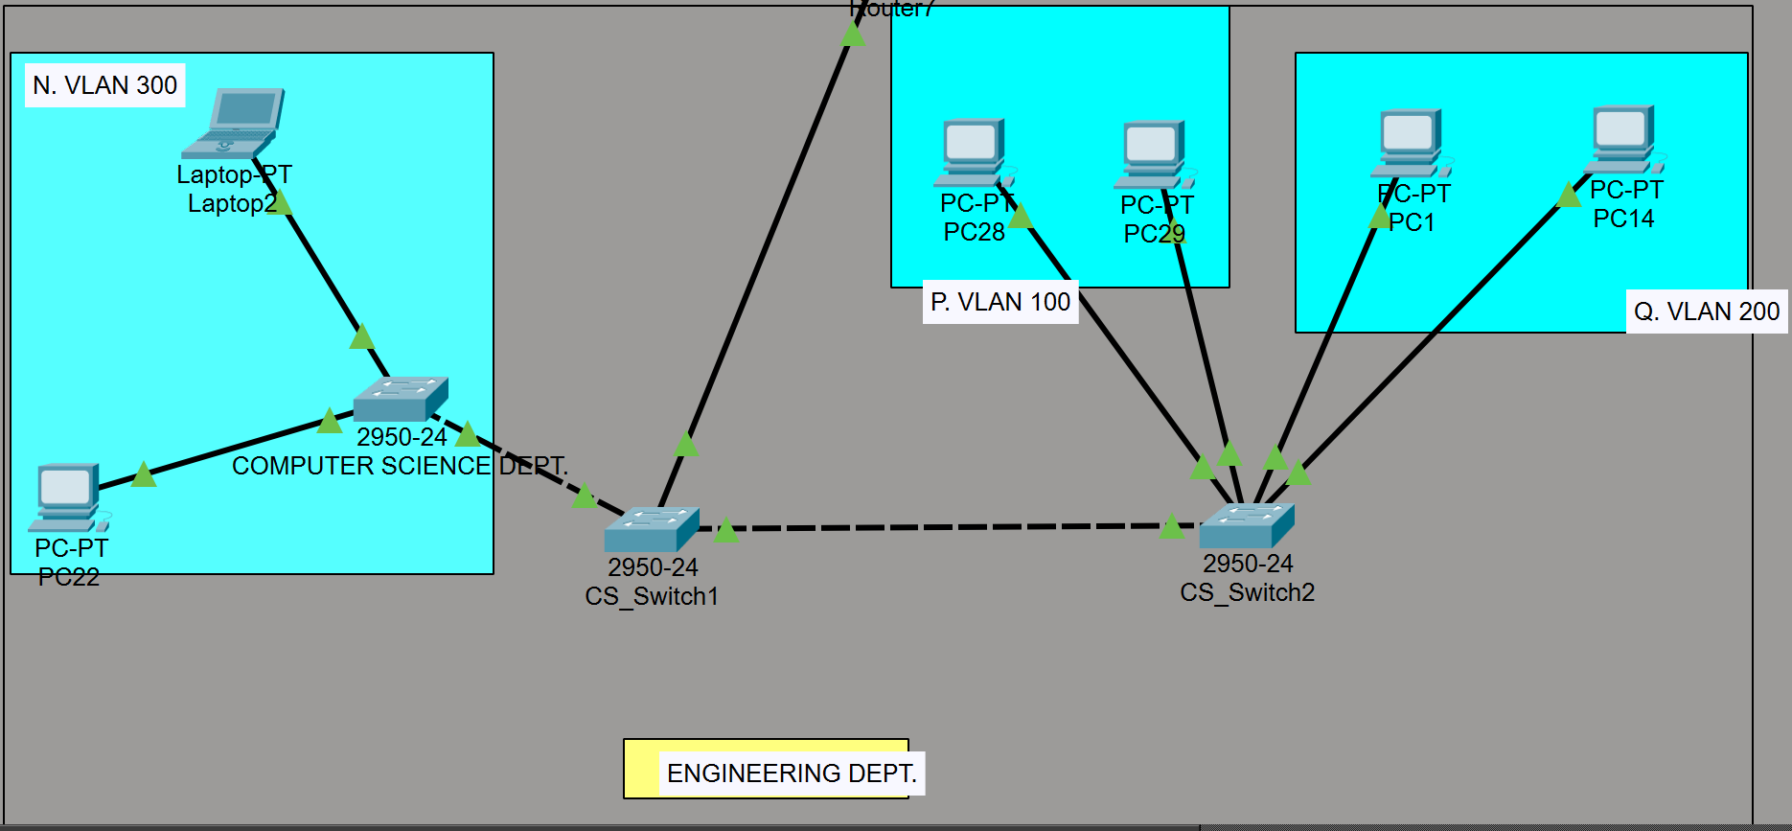
Figure 2.3.1. Engineering and Computer Science topology showing VLANs 100, 200 and 300, their switches and the connection to Router7.
2.3.2 VLAN Creation & Access-Port Assignment
The required VLANs were created only on switches that need to carry their traffic.
Switch | VLAN | VLAN Name | Purpose
CS-Switch1 | 100,200,300 | VLAN100_Engineering | Central switch carrying all three VLANs to Router7
CS-Switch2 | 100,200,300 | VLAN200_Engineering | Connects Engineering VLAN 100 and 200 devices and transports VLAN 300
CS-Dept-Switch | 300 | VLAN300_CS | Connects Computer Science Devices

CS-Switch2 was selected as the representative VLAN and access-port configuration because it demonstrates VLAN creation and access-port assignment for two separate Engineering networks.

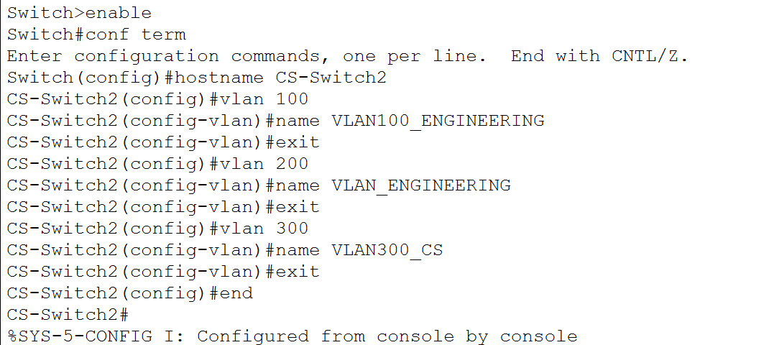
Figure 2.3.2. Creation and naming of VLANs 100, 200 and 300 on CS-Switch2.
The required access-port assignments were:
Switch | Interfaces | VLAN | Connected devices
CS-Switch2 | Fa0/2-3 | 100 | PC28 and PC29
CS-Switch2 | Fa0/4-5 | 200 | PC1 and PC14
CS-Dept-Switch | Fa0/2-3 | 300 | Laptop2 and PC22
The representative CS-Switch2 access-port configuration was:
Switch | Port Range | Connected Devices | VLAN
CS-Dept-Switch | Fa0/2-3 | Laptop2 and PC22 | 300
CS-Switch2 | Fa0/2-3 | PC28 and PC29 | 100
CS-Switch2 | Fa0/4-5 | PC1 and PC14 | 200
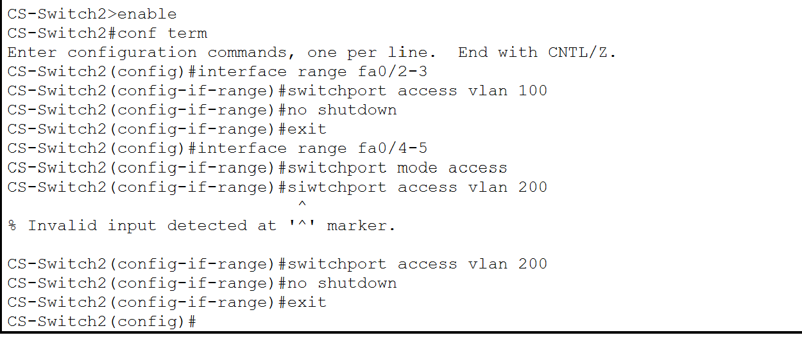
Figure 2.3.3. Assignment of CS-Switch2 FastEthernet0/2-3 to VLAN 100 and FastEthernet0/4-5 to VLAN 200.
Although these devices connect to the same physical switch, their access-port assignments place them into separate Layer 2 broadcast domains. Frames received through FastEthernet0/2-3 are associated with VLAN 100, while frames received through FastEthernet0/4-5 are associated with VLAN 200.
CS-Dept-Switch FastEthernet0/2-3 were configured using the same access-port procedure for VLAN 300. The configuration is summarised in the table rather than repeated in a separate subsection.
2.3.3 Engineering Trunk Configuration
Trunk links were configured to transport the required VLAN traffic between the switches and Router7.
Local interface | Connected interface | Purpose
CS-Dept-Switch Fa0/1 | CS-Switch1 Fa0/2 | Carries VLAN 300
CS-Switch2 Fa0/1 | CS-Switch1 Fa0/3 | Carries VLANs 100, 200 and 300
CS-Switch1 Fa0/1 | Router7 Fa1/0 | Carries VLANs 100, 200 and 300 to their gateways
A representative switch trunk was configured using:
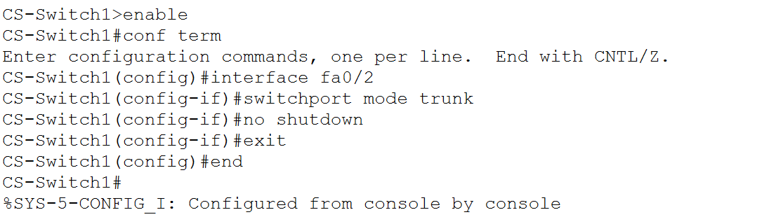
Figure 2.3.4. Representative Engineering trunk configuration on CS-Switch1.
The link between CS-Dept-Switch and CS-Switch1 carries VLAN 300 traffic from the Computer Science devices. The link between CS-Switch2 and CS-Switch1 carries VLANs 100, 200 and 300. CS-Switch1 then transports all three VLANs to Router7.
The default trunk allowed-VLAN list was retained in the implemented configuration. Consequently, show interfaces trunk may display VLANs 1–1005 as allowed. This does not prevent the required VLANs from operating, provided that VLANs 100, 200 and 300 are active and forwarding on the relevant trunk links.

2.3.4 Router7 Router-on-a-Stick Configuration
Router7 performs inter-VLAN routing for VLANs 100, 200 and 300. FastEthernet1/0 is the physical trunk interface and therefore has no physical IPv4 address. Separate logical subinterfaces provide the gateway for each VLAN.
The implemented configuration was:
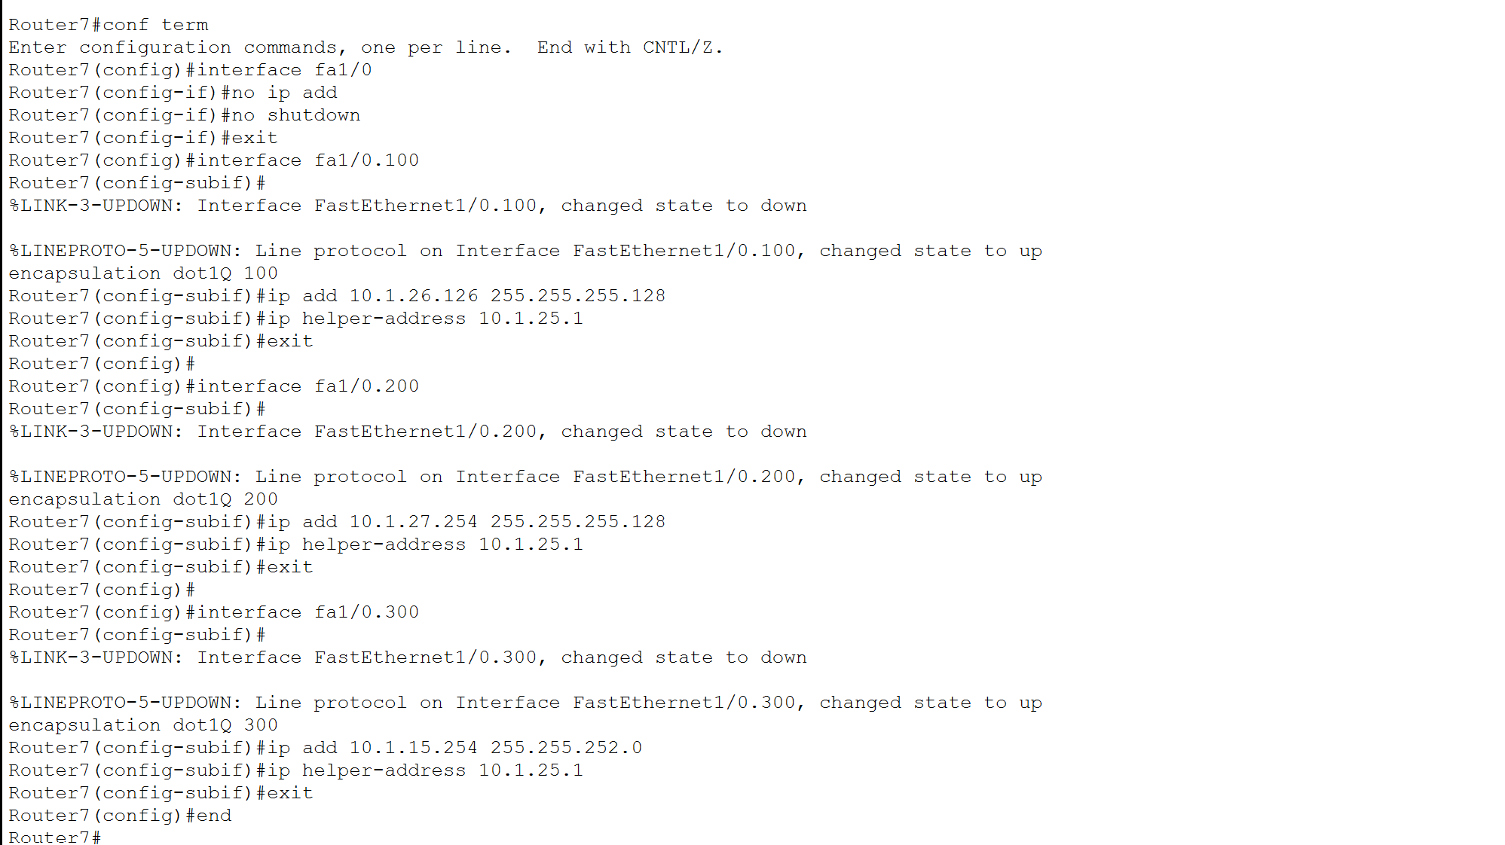
Figure 2.3.5. Router7 subinterfaces providing the gateways and DHCP relay for Engineering VLANs 100 and 200 and Computer Science VLAN 300.

2.3.5 DHCP Relay Configuration
DHCP clients initially transmit DHCP Discover messages as local broadcasts. These broadcasts are not normally forwarded by routers. The Engineering Department DHCP server is located at 10.1.25.1, outside VLANs 100, 200 and 300.
The following command was therefore applied to each Router7 VLAN subinterface:
ip helper-address 10.1.25.1
When Router7 receives a DHCP broadcast, the DHCP relay agent forwards it to the server as a unicast message. The relay inserts the gateway address of the client-facing interface into the relay information, enabling the server to identify the client subnet and select the appropriate DHCP pool.
This configuration allows clients in all three VLANs to receive an address, mask, default gateway and DNS server from the remote DHCP server.

2.3.6 Engineering VLAN Verification
The Engineering VLAN implementation was verified at the switching and routing layers.

VLAN and access-port verification
The following command was used on CS-Switch2:
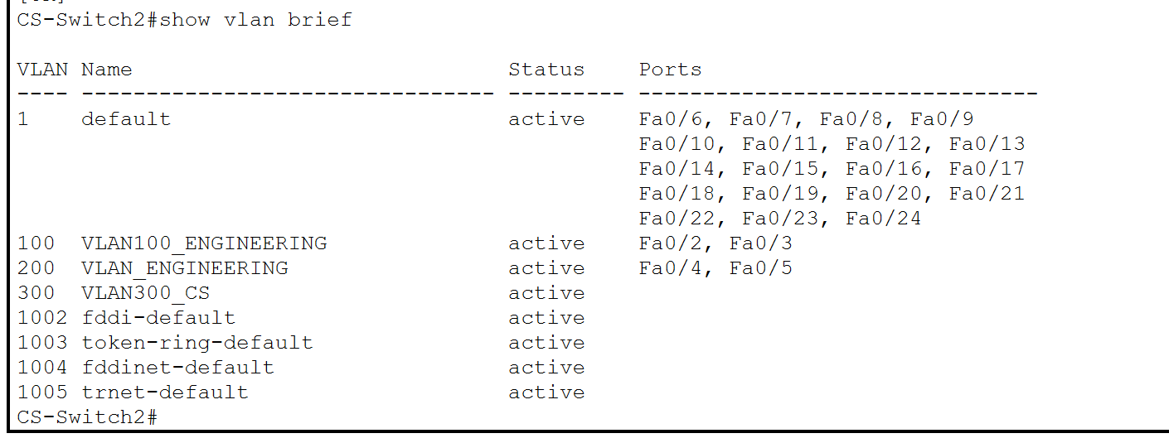
Figure 2.3.6. Verification of VLAN 100 and VLAN 200 access-port assignments on CS-Switch2.
The output confirmed that FastEthernet0/2 and FastEthernet0/3 belonged to VLAN 100, while FastEthernet0/4 and FastEthernet0/5 belonged to VLAN 200. VLAN 300 was also present and active because it is transported through the trunk infrastructure.
Trunk Verification
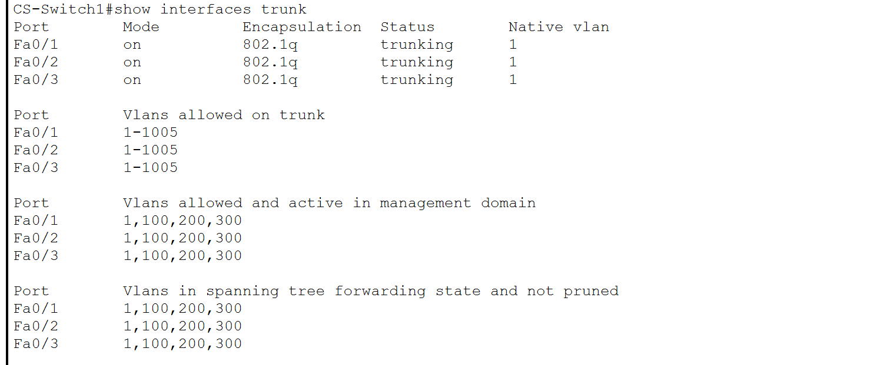
Figure 2.3.7. Verification of the Engineering trunk links on CS-Switch1.
The output confirmed that FastEthernet0/1, FastEthernet0/2 and FastEthernet0/3 were operating as IEEE 802.1Q trunks. VLANs 100, 200 and 300 were active and forwarding through the required trunk paths.
Router-subinterface verification
Router7 was verified using:
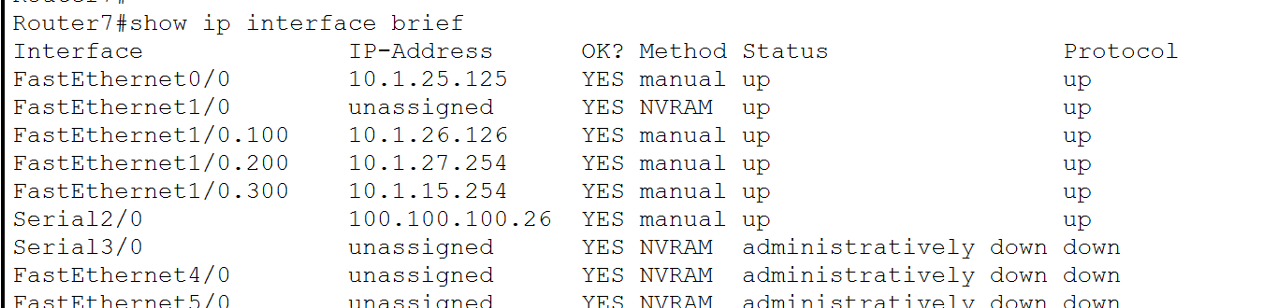
Figure 2.3.8. Verification of the Router7 physical trunk and VLAN subinterfaces.
The output confirmed that FastEthernet1/0 was operational without a physical IP address. Subinterfaces Fa1/0.100, Fa1/0.200 and Fa1/0.300 displayed the correct gateway addresses and an up/up status.
DHCP and Inter-VLAN Verification
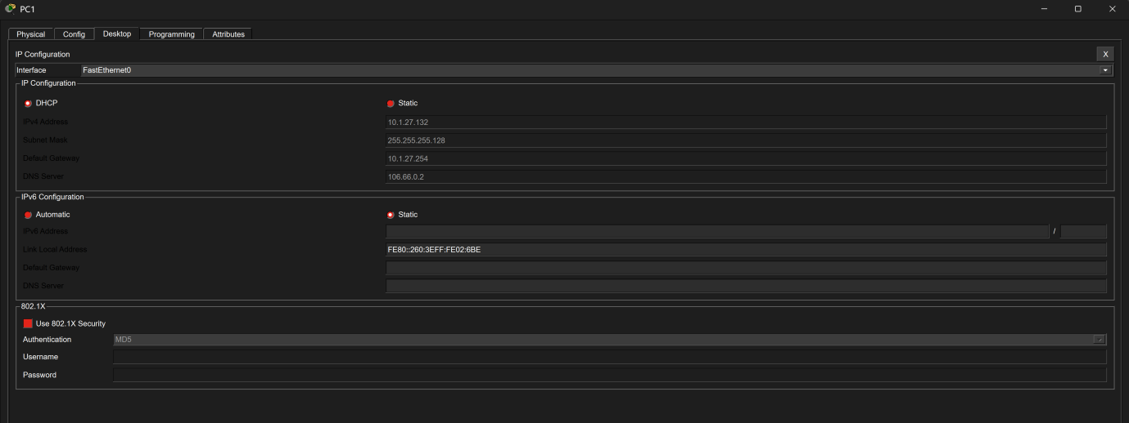
Figure 2.3.9. Successful DHCP assignment to PC1 in VLAN200
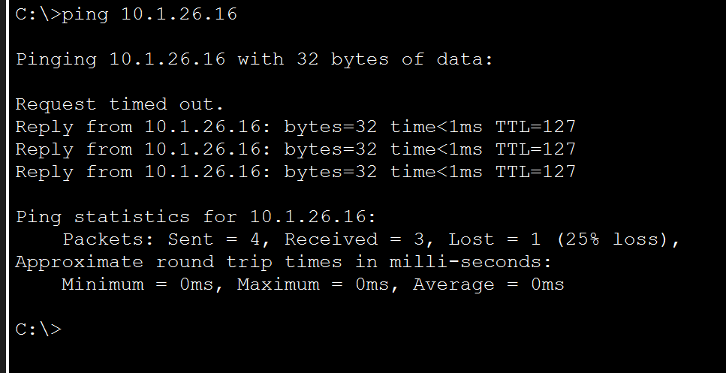
Figure 2.3.10. Figure 2.3.10. Successful inter-VLAN connectivity from PC1 in VLAN 200 to PC28 in VLAN 100 through Router7.
The DHCP result verifies the access-port, trunk, router-subinterface, helper-address and DHCP-pool configuration together. The inter-VLAN test verifies that Router7 successfully routes traffic between the VLANs.
2.4 Hostel Wireless VLAN Configuration

2.4.1 Wireless VLAN and Port Plan
The hostel wireless network uses two VLANs to separate Warden and Student traffic
VLAN | VLAN name | Network | Default gateway
800 | VLAN800_WARDEN | 10.1.8.0/22 | 10.1.11.254
900 | VLAN900_STUDENT | 10.1.26.128/25 | 10.1.26.254
The Hostel-Wireless-Switch, also identified as Switch3 in parts of the topology, connects Hostel-A-B-C, the Wireless LAN Controller and six lightweight access points.
The implemented port plan was:
Ports | Connected devices | Mode | Access VLAN
Fa0/2–4 | AP0, AP2 and AP4 | Access | 800
Fa0/17–19 | AP1, AP3 and AP5 | Access | 900
Fa0/1 | Hostel-A-B-C | Trunk | 800, 900
Fa0/24 | WLC | Trunk | 800, 900

2.4.2 Wireless VLAN and AP Trunk Configuration
VLANs 800 and 900 were created and named on Hostel-Wireless-Switch:
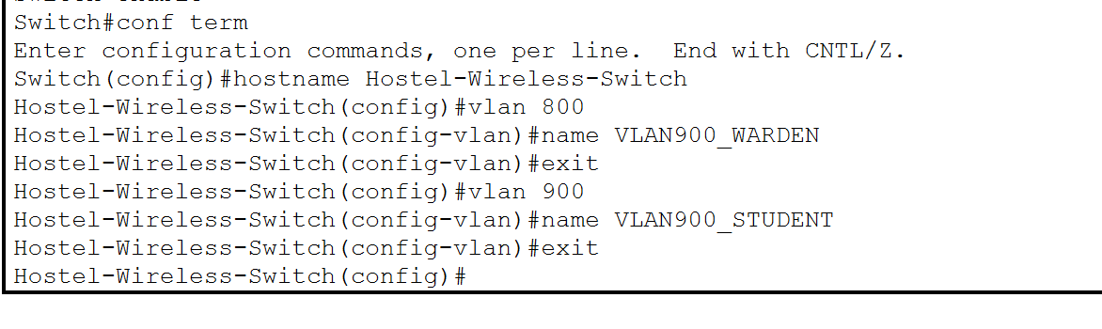
Figure 2.4.1. Creation and naming of Warden VLAN 800 and Student VLAN 900.The initial VLAN 800 name was entered incorrectly and was subsequently corrected to VLAN800_WARDEN, as confirmed by the final show vlan brief output.
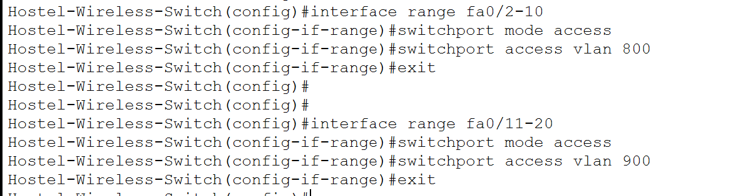
Figure 2.4.2. Assignment and activation of the access-point switch interfaces.
Only the six interfaces connected to access points were enabled. FastEthernet0/2–4 serve AP0, AP2 and AP4 in VLAN 800, while FastEthernet0/17–19 serve AP1, AP3 and AP5 in VLAN 900.
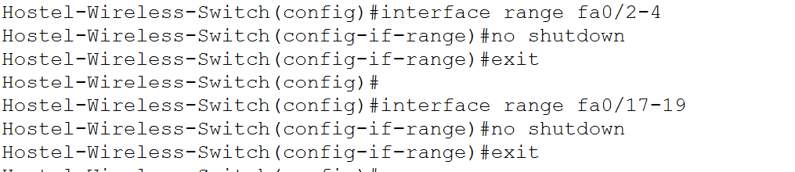
Figure 2.4.3. Activation of the six switch ports connected to the Warden and Student lightweight access points.
The unused interfaces were administratively disabled. Disabling unused switch ports reduces the possibility of unauthorised or accidental network connections.
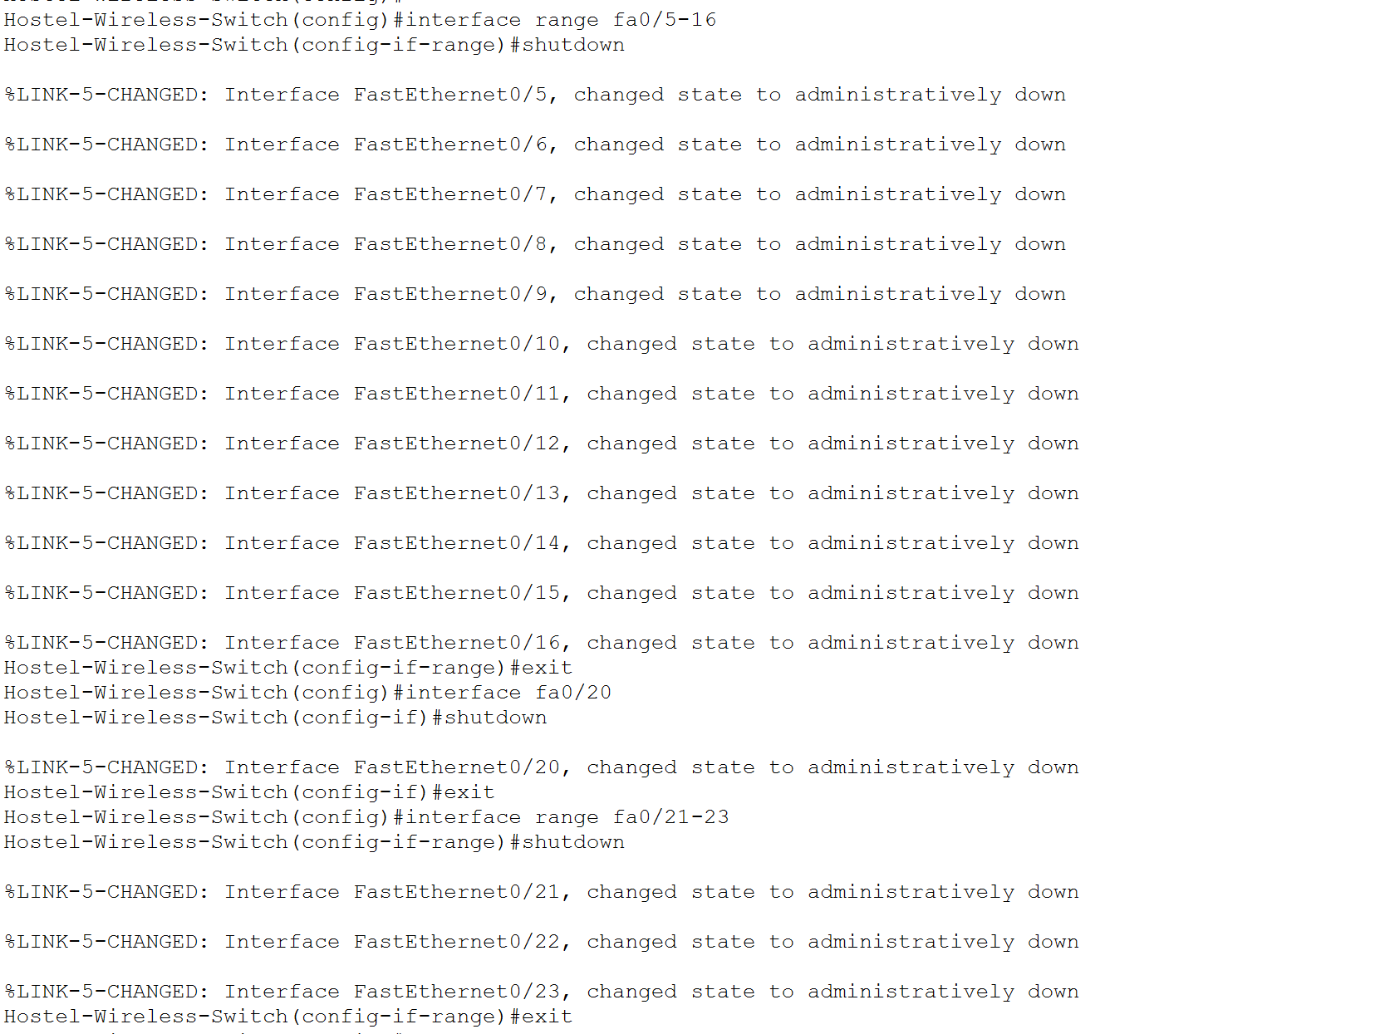
Figure 2.4.4. Administrative shutdown of unused access ports on Hostel-Wireless-Switch.
2.4.3 Wireless Trunk Configuration
Two trunk links were required for the wireless network. FastEthernet0/1 connects Hostel-Wireless-Switch to Hostel-A-B-C, while FastEthernet0/24 connects the switch to the Wireless LAN Controller.
The router trunk carries VLAN 800 and VLAN 900 traffic to their Layer 3 gateway subinterfaces. The WLC trunk carries wireless traffic between the controller and the two wireless VLANs.
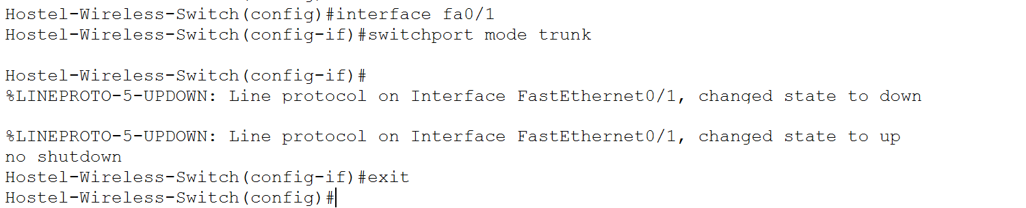
Figure 2.4.5. Configuration of FastEthernet0/1 as the trunk toward Hostel-A-B-C.

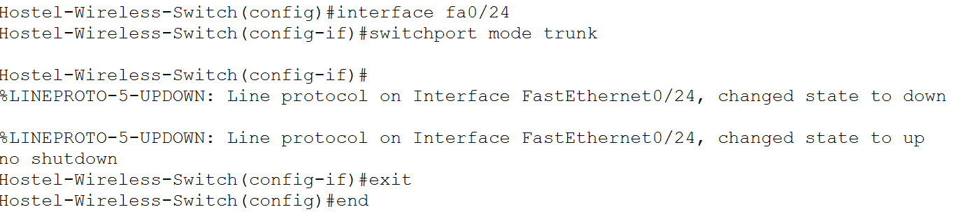
Figure 2.4.6. Configuration of FastEthernet0/24 as the trunk toward the Wireless LAN Controller.
Both links operate as IEEE 802.1Q trunks. On the WLC-facing trunk, VLAN 800 is the native VLAN and is transported untagged, while VLAN 900 is transported using an IEEE 802.1Q tag. The router-facing trunk carries traffic for both VLANs to the corresponding Hostel-A-B-C subinterfaces.
2.4.4 Hostel_A_B_C Router-on-a-Stick & DHCP Relay
Hostel-A-B-C provides inter-VLAN routing for the Warden and Student wireless networks. FastEthernet1/0 was used as the physical trunk interface and remained unassigned. Separate subinterfaces were configured for VLANs 800 and 900.
Subinterface | VLAN | IP address | Purpose
Fa1/0.800 | 800 | 10.1.11.254/22 | Warden wireless gateway
Fa1/0.900 | 900 | 10.1.26.254/25 | Student wireless gateway

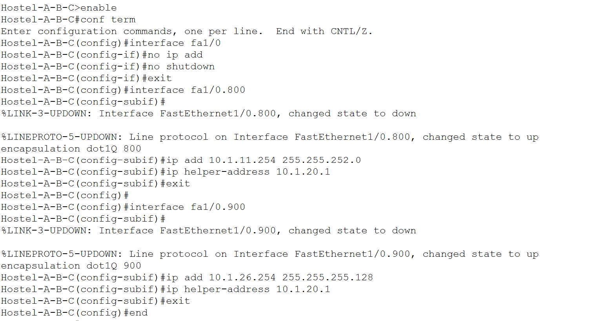
Figure 2.4.7. Hostel-A-B-C router-on-a-stick and DHCP-relay configuration for VLANs 800 and 900.
The encapsulation dot1Q 800 and encapsulation dot1Q 900 commands associate the subinterfaces with their respective VLANs. The configured IP addresses act as the default gateways for wireless clients.

2.4.5 Hostel VLAN Verification
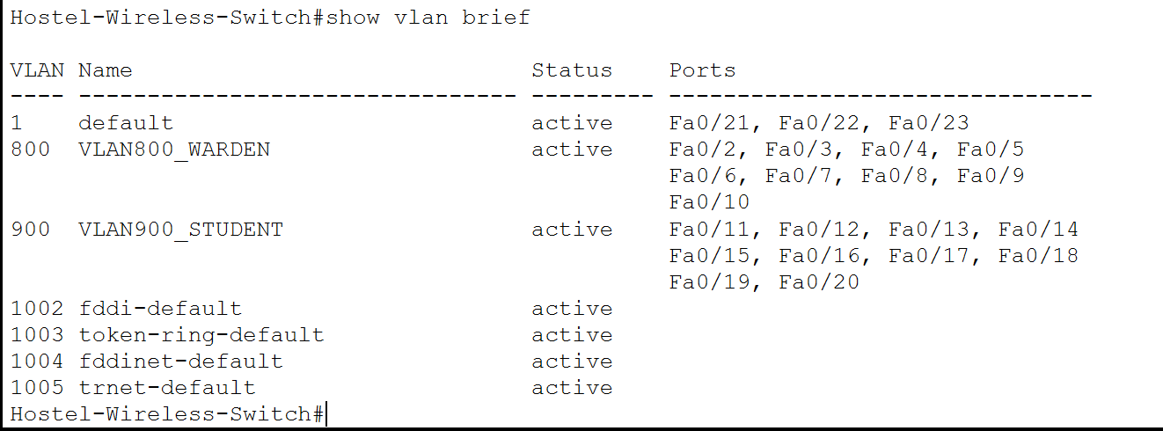
Figure 2.4.8. Verification of VLAN 800 and VLAN 900 access-port assignments on Hostel-Wireless-Switch.
The output confirmed that FastEthernet0/2–10 belonged to VLAN 800 and FastEthernet0/11–20 belonged to VLAN 900. The final output also confirmed the corrected VLAN names VLAN800_WARDEN and VLAN900_STUDENT.
Trunk Verification
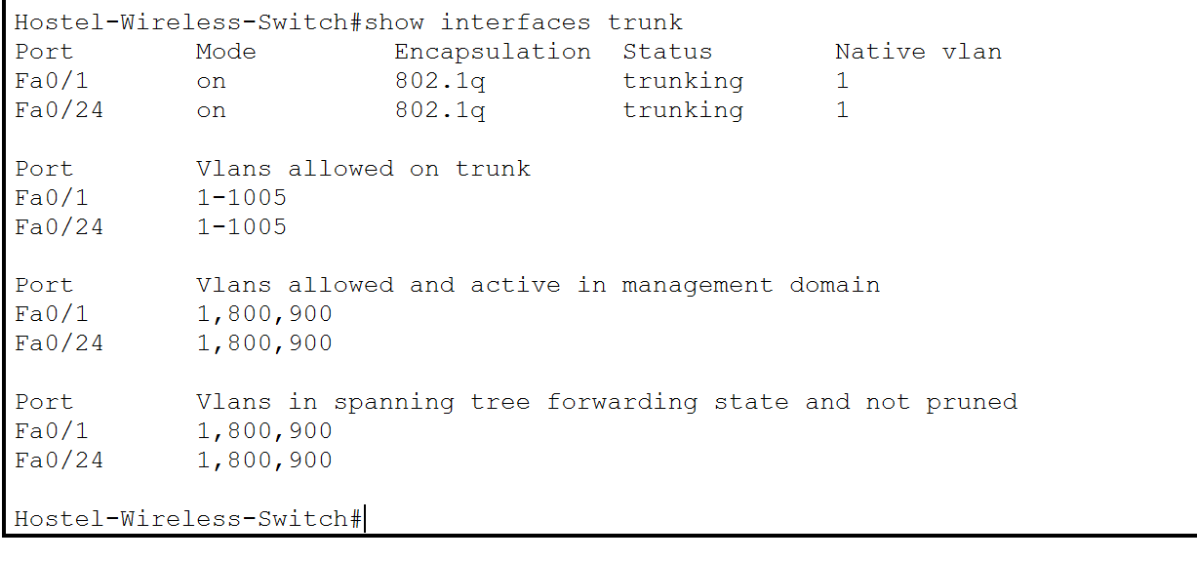
Figure 2.4.9. Verification of the router and WLC trunk links on Hostel-Wireless-Switch.
The output showed FastEthernet0/1 and FastEthernet0/24 operating as IEEE 802.1Q trunks. VLANs 800 and 900 were active and appeared in the spanning-tree forwarding state.
Hostel Router subinterface verification
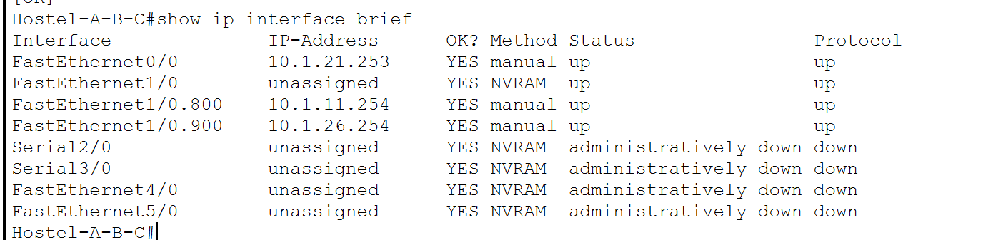
Figure 2.4.10. Verification of the Hostel-A-B-C wireless VLAN subinterfaces and gateway addresses.
The output confirmed that FastEthernet1/0 was operational without a physical IP address. Fa1/0.800 displayed 10.1.11.254, while Fa1/0.900 displayed 10.1.26.254. Both subinterfaces were in the up/up state.

2.5 Section Conclusion
The Engineering and Computer Science VLAN infrastructure was configured using VLANs 100, 200 and 300. The required access ports and trunk links were established, and Router7 was configured with separate 802.1Q subinterfaces to provide the correct default gateway and DHCP relay for each VLAN.
The hostel wireless infrastructure was configured using Warden VLAN 800 and Student VLAN 900. Hostel-Wireless-Switch carries the required VLANs between the lightweight access points, Hostel-A-B-C and the Wireless LAN Controller. Hostel-A-B-C provides the VLAN gateway addresses and forwards wireless-client DHCP requests to the Hostel Student/Warden DHCP server at 10.1.20.1.
Switching and routing verification confirmed that the VLANs, trunks and router subinterfaces were present and operational. Complete wireless-client association, DHCP addressing and end-to-end connectivity are assessed in the Wireless LAN Controller section and should not be declared successful until supported by client-level evidence.

Multi-Area OSPF Configuration

3.1 Objective
The objective of this stage was to configure Open Shortest Path First as the internal dynamic routing protocol for the enterprise network. OSPF allows the internal routers to exchange routing information automatically and calculate the shortest available path to each destination.
The enterprise network was divided into four OSPF areas. Area 0 forms the required backbone, while Areas 100, 200 and 300 group networks according to their location and function.
Manually assigned router IDs were used to identify the routers consistently. The passive-interface default command was applied to prevent OSPF neighbour formation on user-facing networks. OSPF Hello packets were enabled only on interfaces connected to other OSPF routers, while the passive interfaces’ connected networks continued to be advertised.
The external ISP connections using the 100.100.100.0 address range were deliberately excluded from OSPF. This prevents the external network from learning the internal private addressing structure.
3.2 OSPF Area Design
The internal topology was divided into the following areas:

Area | Function | Main networks
0 | OSPF backbone | Network A, Network B and the three internal serial links
100 | Student and hostel networks | Student, guest and hostel wireless networks
200 | Staff and library networks | Staff Building, staff and library networks
300 | Campus and engineering networks | Network M, Engineering VLANs and Chemical Department
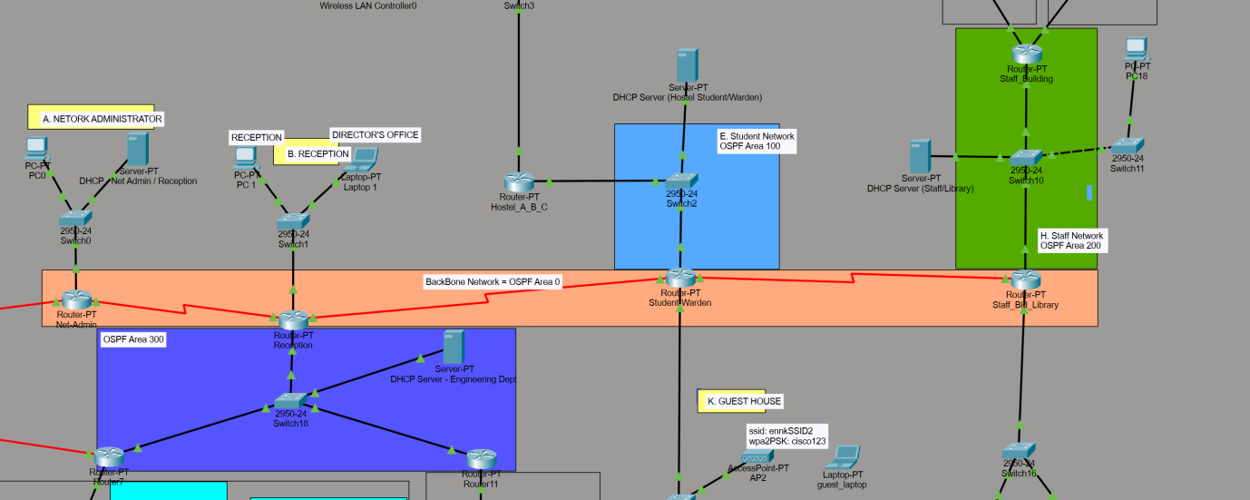
Figure 3.2.1. Enterprise OSPF topology showing backbone Area 0 and internal Areas 100, 200 and 300.
Area 0 connects Net-Admin, Reception, Student-Warden and Staff-Bld-Library. Reception, Student-Warden and Staff-Bld-Library operate as area border routers because each connects Area 0 to another area.
Reception connects Area 0 to Area 300. Student-Warden connects Area 0 to Area 100. Staff-Bld-Library connects Area 0 to Area 200.
3.3 Router IDs and OSPF Roles
Each internal router was assigned a manually configured router ID.
Router | Router ID | OSPF role
Net-Admin | 1.1.1.1 | Internal Area 0 router
Reception | 2.2.2.2 | ABR between Areas 0 and 300
Student-Warden | 3.3.3.3 | ABR between Areas 0 and 100
Staff-Bld-Library | 4.4.4.4 | ABR between Areas 0 and 200
Hostel-A-B-C | 5.5.5.5 | Internal Area 100 router
Staff-Building | 6.6.6.6 | Internal Area 200 router
Router7 | 7.7.7.7 | Internal Area 300 router
Router11 | 11.11.11.11 | Internal Area 300 router
The ISP router and Router13 were not included in the internal OSPF process. Static routing is used in the external network.

3.4 OSPF Network Assignment
The following network statements were used to advertise the internal networks through OSPF process 1.
Router | Network statement | Area
Net-Admin | network 10.1.4.0 0.0.3.255 area 0 | 0
Net-Admin | network 10.1.28.0 0.0.0.3 area 0 | 0
Reception | network 10.1.16.0 0.0.3.255 area 0 | 0
Reception | network 10.1.28.0 0.0.0.3 area 0 | 0
Reception | network 10.1.28.4 0.0.0.3 area 0 | 0
Reception | network 10.1.25.0 0.0.0.127 area 300 | 300
Student-Warden | network 10.1.28.4 0.0.0.3 area 0 | 0
Student-Warden | network 10.1.28.8 0.0.0.3 area 0 | 0
Student-Warden | network 10.1.20.0 0.0.1.255 area 100 | 100
Student-Warden | network 10.1.25.128 0.0.0.127 area 100 | 100
Staff-Bld-Library | network 10.1.28.8 0.0.0.3 area 0 | 0
Staff-Bld-Library | network 10.1.27.0 0.0.0.127 area 200 | 200
Staff-Bld-Library | network 10.1.22.0 0.0.1.255 area 200 | 200
Hostel-A-B-C | network 10.1.20.0 0.0.1.255 area 100 | 100
Hostel-A-B-C | network 10.1.8.0 0.0.3.255 area 100 | 100
Hostel-A-B-C | network 10.1.26.128 0.0.0.127 area 100 | 100
Staff-Building | network 10.1.27.0 0.0.0.127 area 200 | 200
Staff-Building | network 10.1.0.0 0.0.3.255 area 200 | 200
Staff-Building | network 10.1.24.128 0.0.0.127 area 200 | 200
Router7 | network 10.1.25.0 0.0.0.127 area 300 | 300
Router7 | network 10.1.26.0 0.0.0.127 area 300 | 300
Router7 | network 10.1.27.128 0.0.0.127 area 300 | 300
Router7 | network 10.1.12.0 0.0.3.255 area 300 | 300
Router11 | network 10.1.25.0 0.0.0.127 area 300 | 300
Router11 | network 10.1.24.0 0.0.0.127 area 300 | 300

The 100.100.100.20/30 Net-Admin ISP link and 100.100.100.24/30 Router7 backup ISP link were not included in these statements.
Network L, 10.1.24.0/25, is advertised by Router11 in Area 300. Advertising Network L allows devices in the remaining OSPF areas to reach the IT and Chemical Department network through Router11.

3.5 Passive Interface Design
To satisfy this requirement, all interfaces were made passive by default:
passive-interface default
Only interfaces that connect directly to another OSPF router were then activated using
no passive-interface.
Router | Non-passive interface | OSPF neighbour or network
Net-Admin | Serial2/0 | Reception
Reception | Serial2/0 | Net-Admin
Reception | Serial3/0 | Student-Warden
Reception | FastEthernet1/0 | Router7 and Router11 through Network M
Student-Warden | Serial2/0 | Reception
Student-Warden | Serial3/0 | Staff-Bld-Library
Student-Warden | FastEthernet0/0 | Hostel-A-B-C through Network E
Staff-Bld-Library | Serial2/0 | Student-Warden
Staff-Bld-Library | FastEthernet0/0 | Staff-Building through Network H
Hostel-A-B-C | FastEthernet0/0 | Student-Warden
Staff-Building | FastEthernet0/0 | Staff-Bld-Library
Router7 | FastEthernet0/0 | Reception and Router11 through Network M
Router11 | FastEthernet0/0 | Reception and Router7 through Network M

User-facing LAN interfaces remained passive. Passive interfaces still advertise their connected networks through OSPF, but they do not transmit Hello packets or attempt to establish neighbour relationships.
Router7 Serial2/0 and Net-Admin Serial3/0 remained outside the OSPF process because they connect to the external ISP.

3.6 Representative OSPF Configuration - Net-Admin
Net-Admin was selected as the representative OSPF configuration because it demonstrates a manually assigned router ID, Area 0 network advertisements, passive-interface security and the exclusion of an external ISP link.
Net-Admin advertises Network A and its internal serial connection to Reception:
Net-Admin Serial3/0 was deliberately excluded because it connects to the ISP through the external 100.100.100.20/30 network.

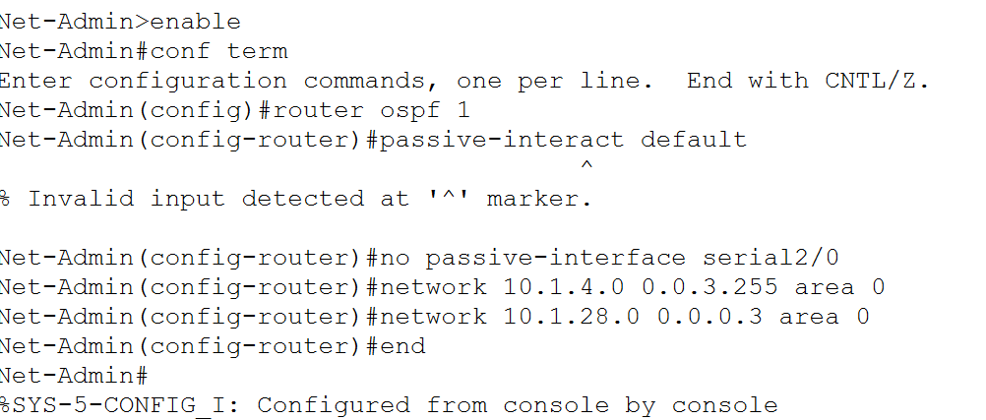
Figure 3.6.1. Representative OSPF configuration on Net-Admin.
The remaining internal routers were configured using the same method. Their router IDs, network statements, area assignments and non-passive interfaces are summarised in the preceding tables rather than documented through repetitive per-router command screenshots.
If a router ID is changed after the OSPF process has started, restart the process using:
clear ip ospf process

3.7 OSPF Verification
OSPF was verified using neighbour, protocol and routing-table information.

3.7.1 Protocol Verification
The OSPF process and router ID were checked using:
show ip protocols

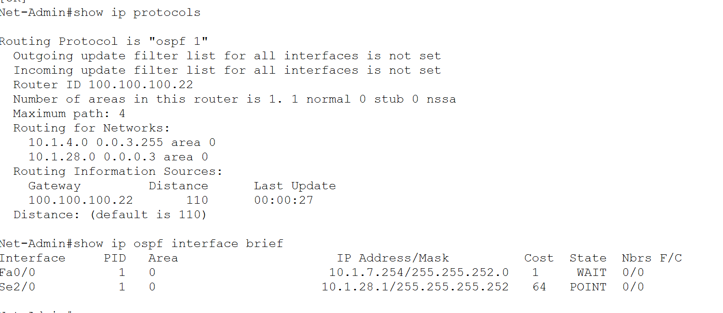
Figure 3.7.1. Verification of OSPF process 1, router ID 1.1.1.1, Area 0 networks and passive-interface configuration on Net-Admin.

3.7.2 Neighbor Verification
Neighbour relationships were checked using:
show ip ospf neighbor

The expected neighbour counts are:
Router | Expected neighbours | Neighbouring routers
Net-Admin | 1 | Reception
Reception | 4 | Net-Admin, Student-Warden, Router7 and Router11
Student-Warden | 3 | Reception, Staff-Bld-Library and Hostel-A-B-C
Staff-Bld-Library | 2 | Student-Warden and Staff-Building
Hostel-A-B-C | 1 | Student-Warden
Staff-Building | 1 | Staff-Bld-Library
Router7 | 2 | Reception and Router11
Router11 | 2 | Reception and Router7
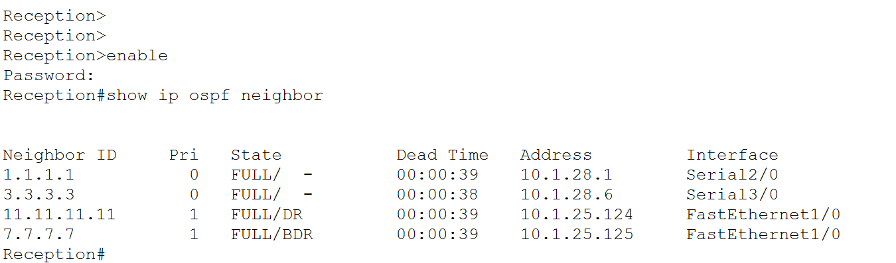
Figure 3.7.2. OSPF neighbour relationships on Reception.
On shared Ethernet Network M, Reception, Router7 and Router11 form neighbour relationships with each other. The OSPF output may identify one router as the designated router and another as the backup designated router. This is normal behaviour on a broadcast multi-access network.

3.7.3 OSPF Route Verification
Dynamically learned routes were checked using:
show ip route ospf

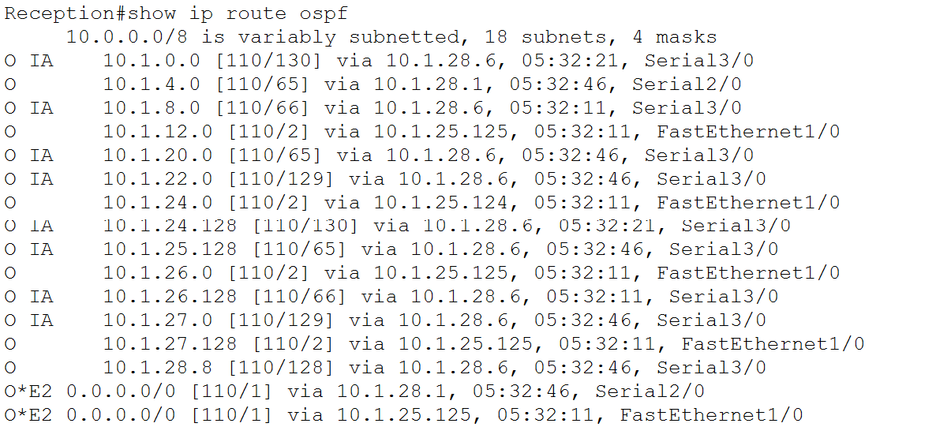
Figure 3.7.3. OSPF-learned routes to internal networks in other areas.

3.7.4 End-to-End Verification
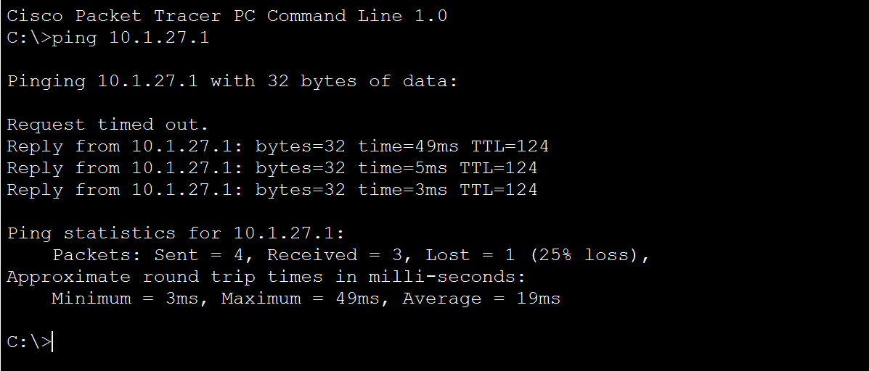
Figure 3.7.4. Successful communication between internal devices located in different OSPF areas.
This test verifies the complete forwarding path rather than only the local neighbour relationship. It confirms that connected networks are advertised, area border routers exchange inter-area routes and the destination network has a valid return route.

3.8 Section Conclusion
Multi-area OSPF was implemented across the internal enterprise network using Areas 0, 100, 200 and 300. Net-Admin operates as an internal Area 0 router, while Reception, Student-Warden and Staff-Bld-Library function as area border routers.
Manual router IDs were configured to provide consistent router identification. Passive interfaces were used to prevent unnecessary OSPF Hello packets on user-facing networks, while only router-to-router interfaces were enabled for neighbour formation.
The external ISP links were excluded from OSPF, preventing the external network from learning internal private routes. Protocol, neighbour, routing-table and inter-area connectivity tests were used to verify the completed implementation.

DHCP Server Configuration

4.1 Objective
The objective of this stage was to provide automatic IPv4 configuration to end devices throughout the enterprise network. Separate DHCP pools were created for each client broadcast domain so that devices could obtain an appropriate IPv4 address, subnet mask, default gateway and DNS server.
Five internal DHCP servers were used to distribute addresses to different parts of the network. Where a DHCP server resides in the same broadcast domain as its clients, the clients can reach it directly. Where the server is located in another subnet, the router interface serving the clients requires an ip helper-address command.
The external DNS server at 106.66.0.2 was distributed through the internal DHCP pools so that clients could resolve the externally hosted domain names.

4.2 DHCP Server Summary
Each DHCP server uses a static address to ensure that routers can consistently forward client requests to the correct destination.

DHCP server | Server address | Mask | Default gateway | Networks served | DHCP server
Net-Admin/Reception | 10.1.4.1 | 255.255.252.0 | 10.1.7.254 | Networks A and B | Net-Admin/Reception
Hostel Student/Warden | 10.1.20.1 | 255.255.254.0 | 10.1.21.254 | Network E and VLANs 800 and 900 | Hostel Student/Warden
Staff/Library | 10.1.27.1 | 255.255.255.128 | 10.1.27.126 | Networks F, G, H and J | Staff/Library
Guest | 10.1.25.129 | 255.255.255.128 | 10.1.25.254 | Network K | Guest
Engineering Department | 10.1.25.1 | 255.255.255.128 | 10.1.25.126 | VLANs 100, 200 and 300 | Engineering Department
4.3 DHCP Pool Plan
The following pool plan was used for the internal client networks.
Pool | Client network | Starting address | Mask | Gateway
NETADMIN_A | Network A | 10.1.4.10 | 255.255.252.0 | 10.1.7.254
RECEPTION_B | Network B | 10.1.16.10 | 255.255.252.0 | 10.1.19.254
STUDENT_E | Network E | 10.1.20.10 | 255.255.254.0 | 10.1.21.254
WARDEN_800 | VLAN 800 | 10.1.8.10 | 255.255.252.0 | 10.1.11.254
STUDENT_900 | VLAN 900 | 10.1.26.130 | 255.255.255.128 | 10.1.26.254
STAFF_F | Network F | 10.1.0.10 | 255.255.252.0 | 10.1.3.254
STAFF_G | Network G | 10.1.24.130 | 255.255.255.128 | 10.1.24.254
STAFF_H | Network H | 10.1.27.10 | 255.255.255.128 | 10.1.27.126
LIBRARY_J | Network J | 10.1.22.10 | 255.255.254.0 | 10.1.23.254
GUEST_K | Network K | 10.1.25.130 | 255.255.255.128 | 10.1.25.254
NETWORK_L | Network L | 10.1.24.10 | 255.255.255.128 | 10.1.24.126
ENGINEERING_100 | VLAN 100 | 10.1.26.10 | 255.255.255.128 | 10.1.26.126
ENGINEERING_200 | VLAN 200 | 10.1.27.130 | 255.255.255.128 | 10.1.27.254
CS_300 | VLAN 300 | 10.1.12.10 | 255.255.252.0 | 10.1.15.254
All pools distribute 106.66.0.2 as the DNS server.
Infrastructure addresses were excluded by selecting starting addresses above the statically assigned devices. For example, the Student VLAN 900 pool begins at 10.1.26.130 because 10.1.26.129 is assigned to the WLC’s VLAN 900 dynamic interface.
4.4 DHCP Relay Address
A DHCP relay is required whenever the server and clients are located in different broadcast domains.
Client network | Router interface receiving client broadcasts | Helper address
Network B | Reception Fa0/0 | 10.1.4.1
VLAN 800 | Hostel-A-B-C Fa1/0.800 | 10.1.20.1
VLAN 900 | Hostel-A-B-C Fa1/0.900 | 10.1.20.1
Network F | Staff-Building Fa1/0 | 10.1.27.1
Network G | Staff-Building Ethernet5/0 | 10.1.27.1
Network J | Staff-Bld-Library Fa1/0 | 10.1.27.1
Network L | Router11 Fa1/0 | 10.1.25.1
VLAN 100 | Router7 Fa1/0.100 | 10.1.25.1
VLAN 200 | Router7 Fa1/0.200 | 10.1.25.1
VLAN 300 | Router7 Fa1/0.300 | 10.1.25.1
Networks A, E, H and K do not require DHCP relay because their DHCP servers reside in the same broadcast domains as their clients.

4.5 Representative DHCP Configuration - Net Admin & Reception
The Net-Admin/Reception DHCP server was selected as the representative implementation because it demonstrates both direct DHCP delivery and DHCP relay.
The server is physically connected to Network A at 10.1.4.1/22. Two pools were created:
Pool | Start address | Mask | Gateway | DNS
NETADMIN_A | 10.1.4.10 | 255.255.252.0 | 10.1.7.254 | 106.66.0.2
RECEPTION_B | 10.1.16.10 | 255.255.252.0 | 10.1.19.254 | 106.66.0.2

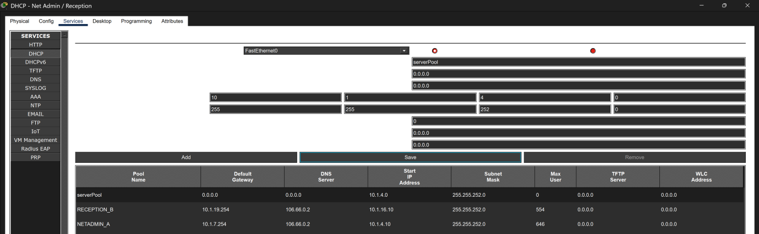Figure 4.5.1. DHCP pool configuration for Networks A and B.

Network A clients are located in the same broadcast domain as the server and can contact it directly. Network B clients are separated from the server by Reception and therefore require DHCP relay.

4.6 Representative DHCP Relay - Reception
Reception FastEthernet0/0 receives DHCP broadcasts from Network B clients. The following command forwards those requests to the Net-Admin/Reception DHCP server:

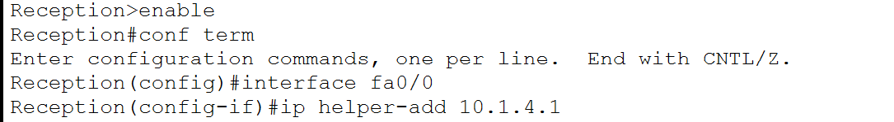
Figure 4.6.1. DHCP relay on Reception FastEthernet0/0.

4.7 Representative Client Verification
4.7.1 Direct DHCP Assignment
A Network A client was configured to obtain its IPv4 settings automatically.

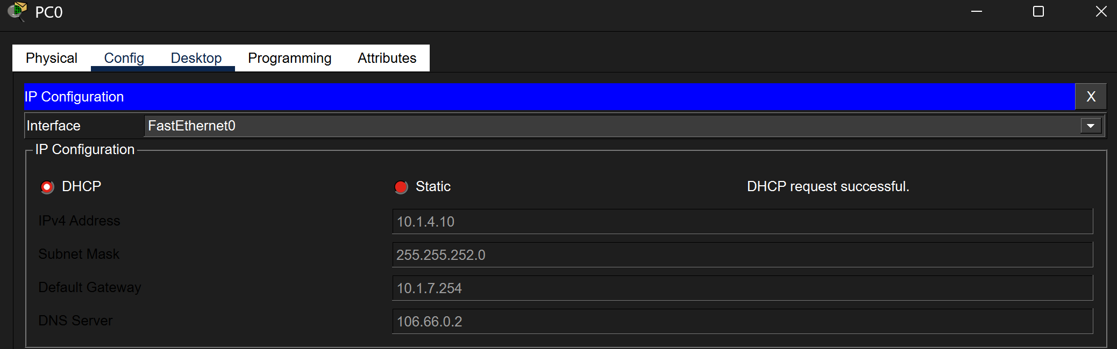Figure 4.7.1. Successful DHCP assignment to a Network A client from the directly connected NETADMIN_A pool.

4.7.2 Relayed DHCP Assignment
A Reception client in Network B was configured to obtain its settings automatically.
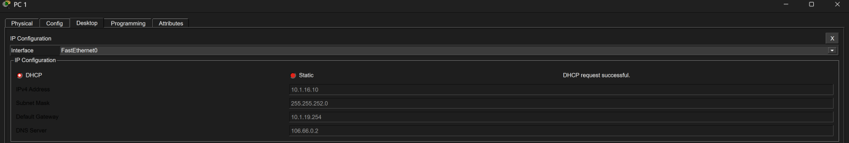
Figure 4.7.2. Successful DHCP assignment to a Network B client through Reception’s relay configuration.
This verifies the server pool, Reception relay configuration, routing path and return communication.

4.8 Remaining DHCP Implementations
The Net-Admin/Reception DHCP server was documented in detail as the representative implementation. The remaining DHCP servers were configured using the same procedure. To avoid repetitive evidence, one representative client assignment was retained for each server: Network E for the Hostel Student/Warden server, Network F, G or J for the Staff/Library server, Network K for the Guest server, VLAN 200 for the Engineering Department server and Network L through Router11.
4.9 Network L DHCP
Network L uses subnet 10.1.24.0/25, and Router11 FastEthernet1/0 at 10.1.24.126 is its default gateway. The nearest DHCP server is the Engineering Department server at 10.1.25.1.
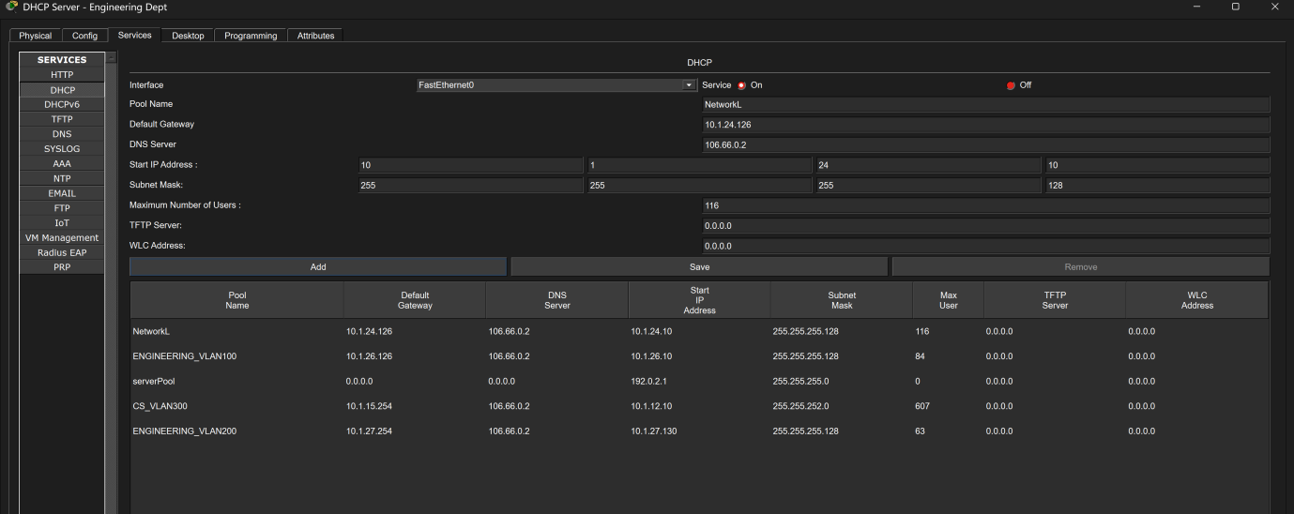
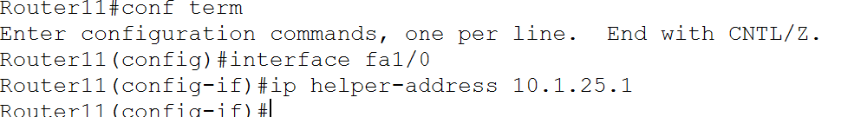
Figure 4.9.1. DHCP relay on Router11 FastEthernet1/0 for Network L.
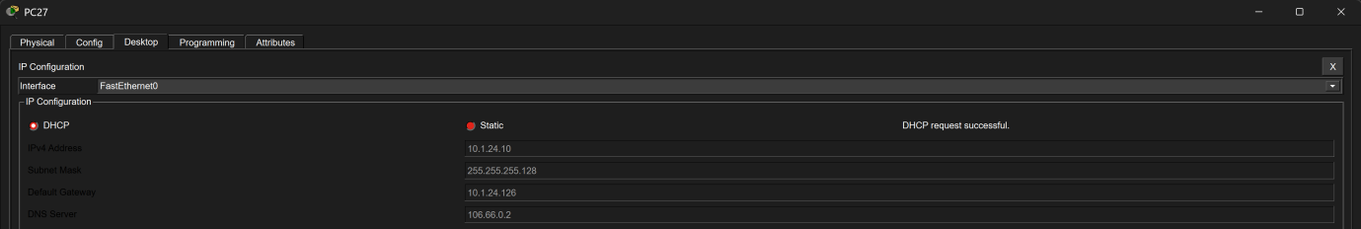
Figure 4.9.2. Successful DHCP assignment to a client in Network L.

4.10 DHCP Conclusion
DHCP services were distributed across five internal servers to provide addressing for the enterprise client networks. Direct DHCP delivery was used where the server and clients shared the same broadcast domain, while ip helper-address was applied to router interfaces serving remote client networks.
The Net-Admin and Reception networks demonstrate both direct and relayed DHCP operation. Engineering VLAN 200 was also successfully verified through Router7 and the Engineering Department DHCP server.

Wireless LAN Controller Configuration

5.1 Objective
The objective of this stage was to provide centrally managed wireless connectivity for Warden and Student users. A Cisco 3504 Wireless LAN Controller (WLC) was configured to manage six lightweight access points and two separate wireless networks.
The Warden wireless network uses VLAN 800, while the Student wireless network uses VLAN 900. Separate WLAN profiles, DHCP pools and logical interfaces were used to maintain separation between the two user groups.
The VLANs, access ports, trunk links, router subinterfaces and DHCP relay configurations required by the wireless implementation were introduced in Parts 2 and 4. This section therefore focuses on the WLC, wireless LAN profiles, lightweight access points and wireless verification.

5.2 Wireless Network Summary
User group | VLAN | SSID | Subnet | Gateway
Warden | 800 | WARDEN_WIFI | 10.1.8.0/22 | 10.1.11.254
Student | 900 | STUDENT_WIFI | 10.1.26.128/25 | 10.1.26.254
The WLC management interface is located in Warden VLAN 800. A separate dynamic interface was created for Student VLAN 900.

5.3 WLC Physical Connection
The WLC GigabitEthernet1 interface was connected to Hostel-Wireless-Switch FastEthernet0/24. This connection carries both WLC management traffic and wireless-user traffic.
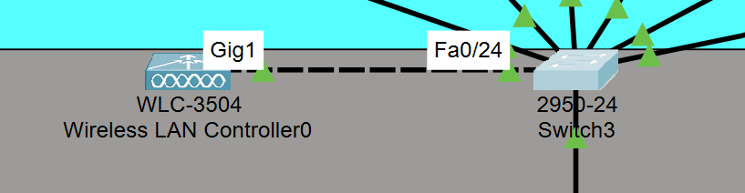
Figure 5.3.1. Physical connection between WLC GigabitEthernet1 and Hostel-Wireless-Switch FastEthernet0/24.

5.3.1 Switch Trunk Configuration
FastEthernet0/24 was configured as an IEEE 802.1Q trunk carrying VLANs 800 and 900
VLAN 800 was configured as the native VLAN because the WLC management interface sends untagged traffic. Student VLAN 900 is transported across the trunk as tagged traffic.
The AP-facing trunk configuration was documented in Part 2. VLAN 800 carries untagged management traffic as the native VLAN, while VLAN 900 traffic is carried as tagged IEEE 802.1Q traffic for FlexConnect Local Switching.

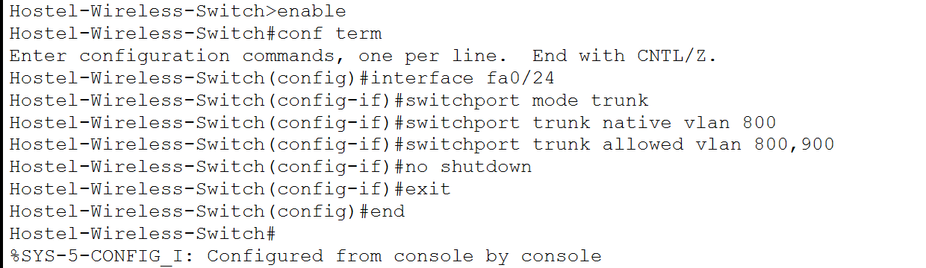
Figure 5.3.2. Trunk configuration on Hostel-Wireless-Switch FastEthernet0/24.

5.3.2 Trunk Verification
The trunk was verified using:
show interfaces trunk
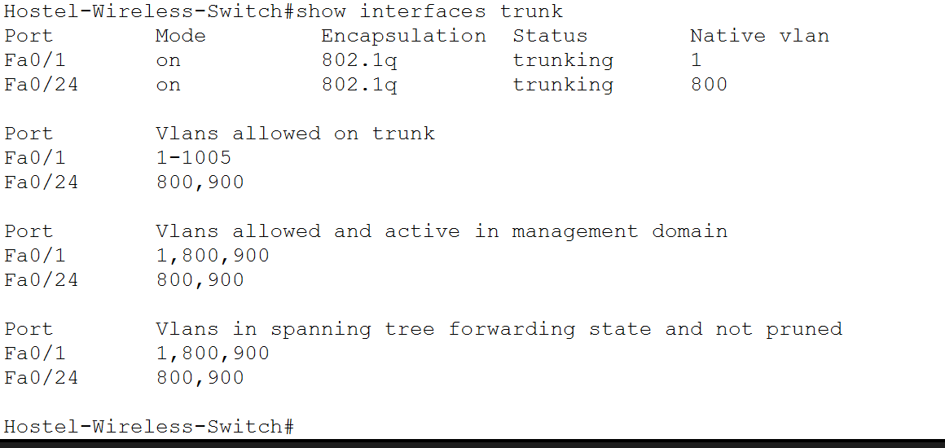
Figure 5.3.3. Verification of VLANs 800 and 900 on the WLC trunk.

5.4 WLC Management Interface

The WLC management interface was assigned a static address in Warden VLAN 800.
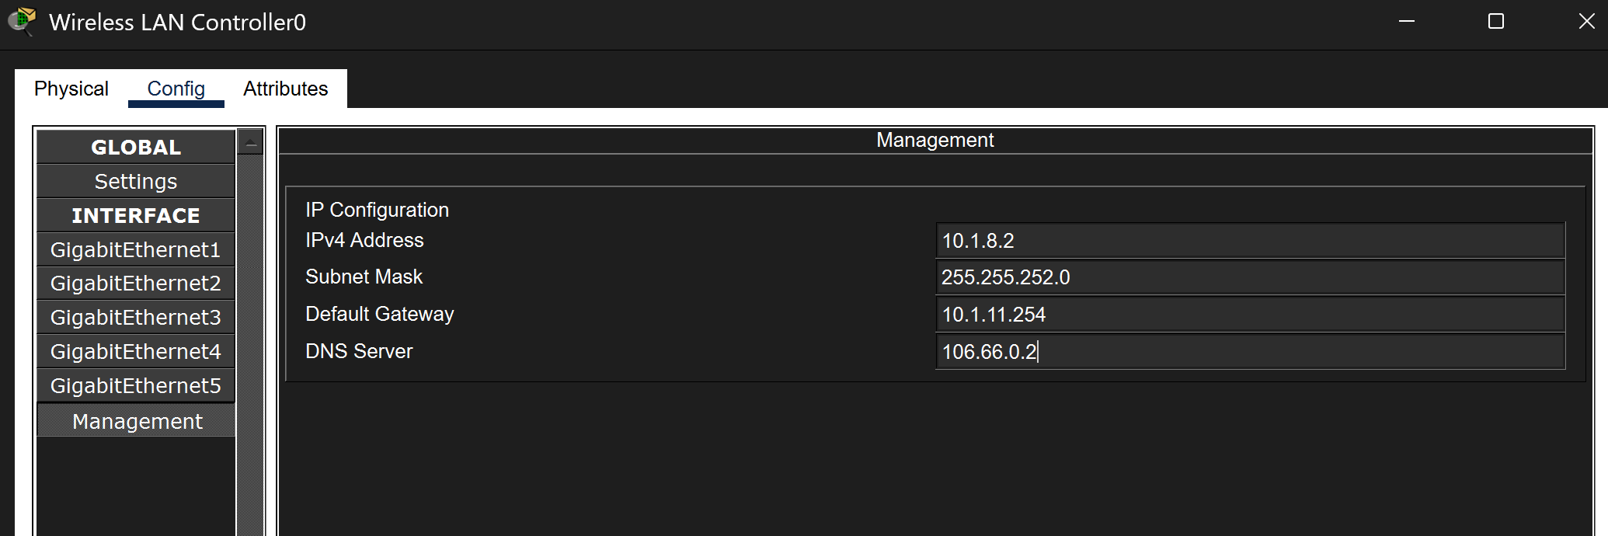Figure 5.4.1. WLC management interface configured in the Warden network.

A management VLAN ID of 0 means that the WLC sends its management traffic untagged. Switch3 associates that untagged traffic with native VLAN 800.

5.4.1 Management Connectivity Verification
The WLC management address was tested from the Hostel Student/Warden server:
ping 10.1.8.2
The initial requests may time out while address resolution takes place. Subsequent replies confirmed that the server could reach the WLC management interface.
Hostel Student/Warden
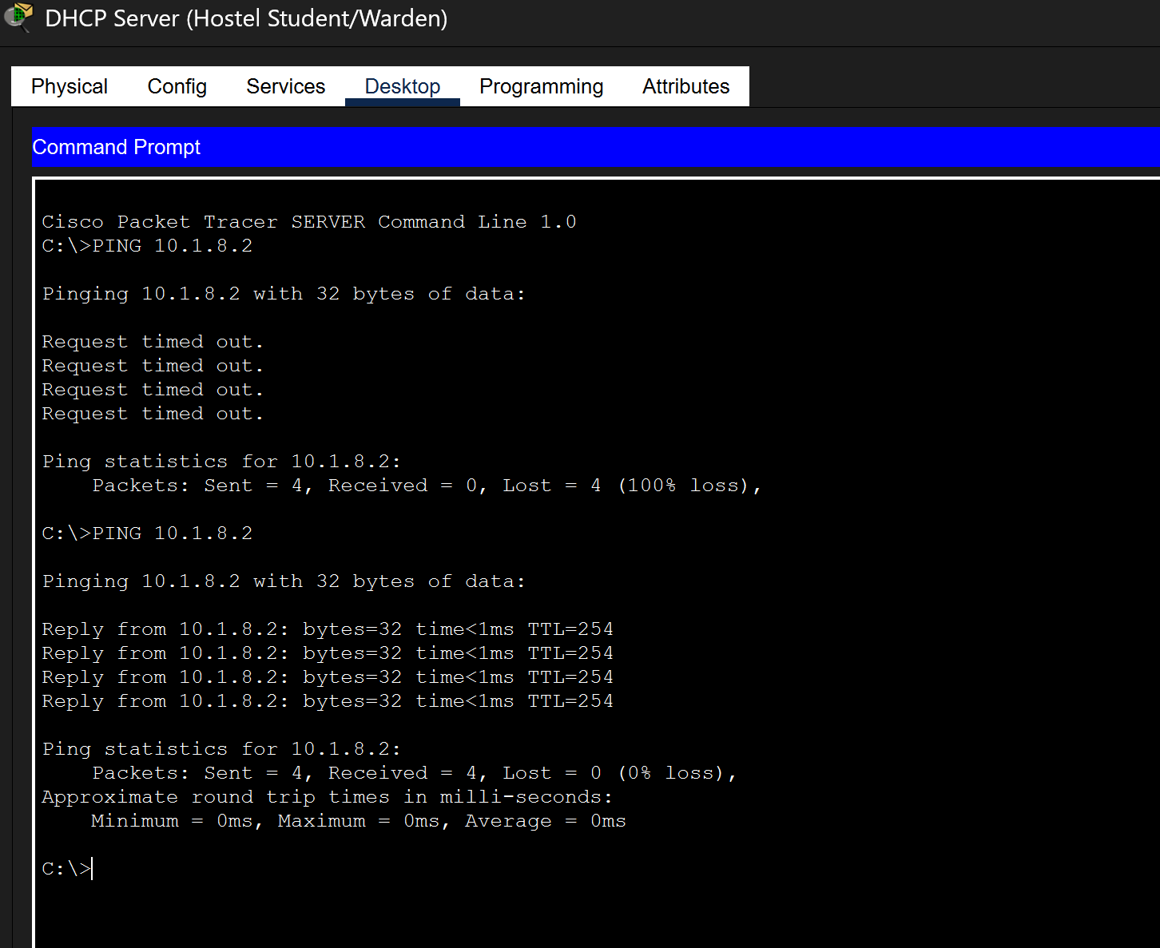
Figure 5.4.2. Successful connectivity from the Hostel Student/Warden server to the WLC management interface.

5.5 Initial WLC Setup

The WLC web interface was accessed using:
https://10.1.8.2
An administrative username and secure password were created during the initial setup.
The Wireless LAN Controller was assigned the management address 10.1.8.2/22 in Warden VLAN 800. Switch port Fa0/24 was configured as an 802.1Q trunk carrying VLANs 800 and 900. VLAN 800 was selected as the native VLAN to transport the WLC’s untagged management traffic.

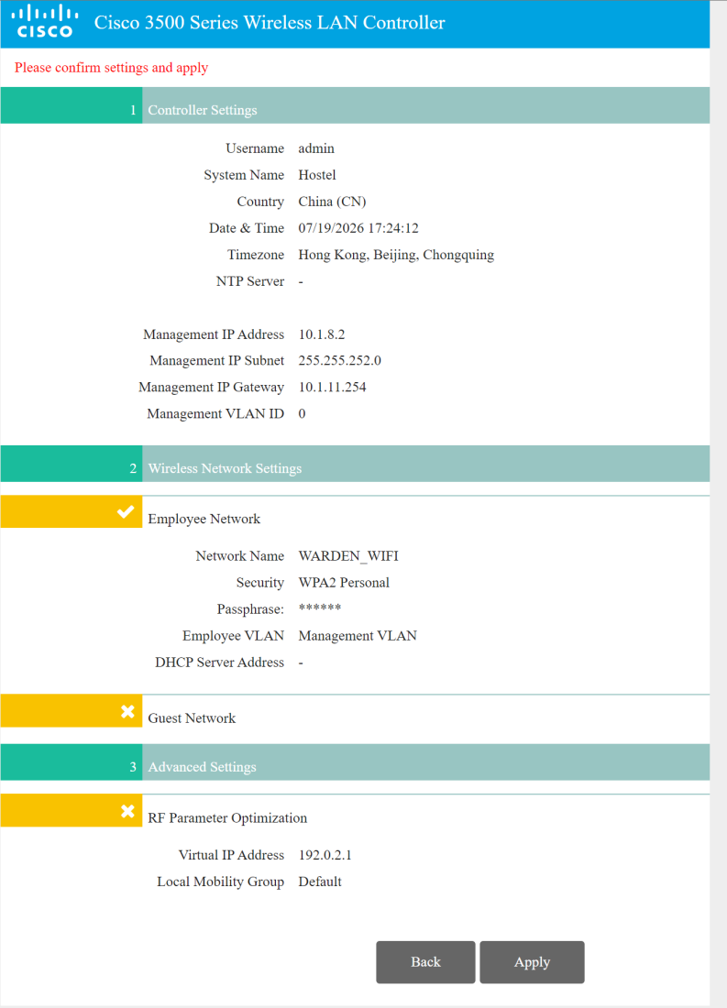
Figure 5.5.1. Completed WLC initial configuration showing the management network and initial Warden WLAN

WLC setup summary showing the management network and initial WPA2-protected WARDEN_WIFI network.

The Wireless LAN Controller setup wizard showing the management address and the initial WPA2-protected Warden wireless network.

5.6 Warden Wireless Network
The Warden WLAN was created during the initial WLC setup and mapped to the management interface.
Because the WLC management interface uses the native VLAN, Warden wireless traffic is placed into VLAN 800.
The wireless key should be configured on the WLC and wireless clients but concealed in the report.
Set Warden DHCP Server
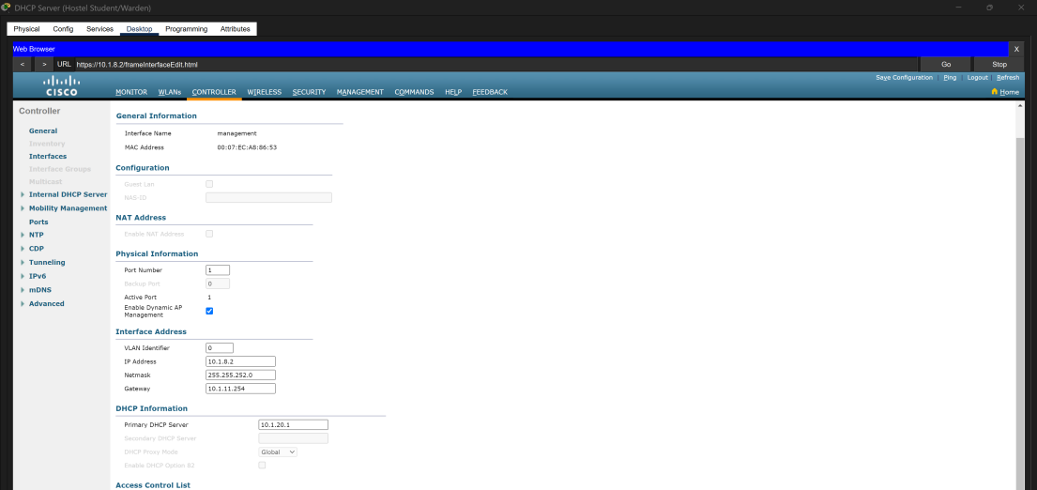
Figure 5.6.1. WARDEN_WIFI enabled and mapped to the WLC management interface.

5.7 Student VLAN Dynamic Interface

A separate WLC dynamic interface was created to transport Student WLAN traffic through VLAN 900.
The Student DHCP pool begins at 10.1.26.130 because 10.1.26.129 is reserved for the WLC dynamic interface. This prevents the WLC address from being assigned to a wireless client.
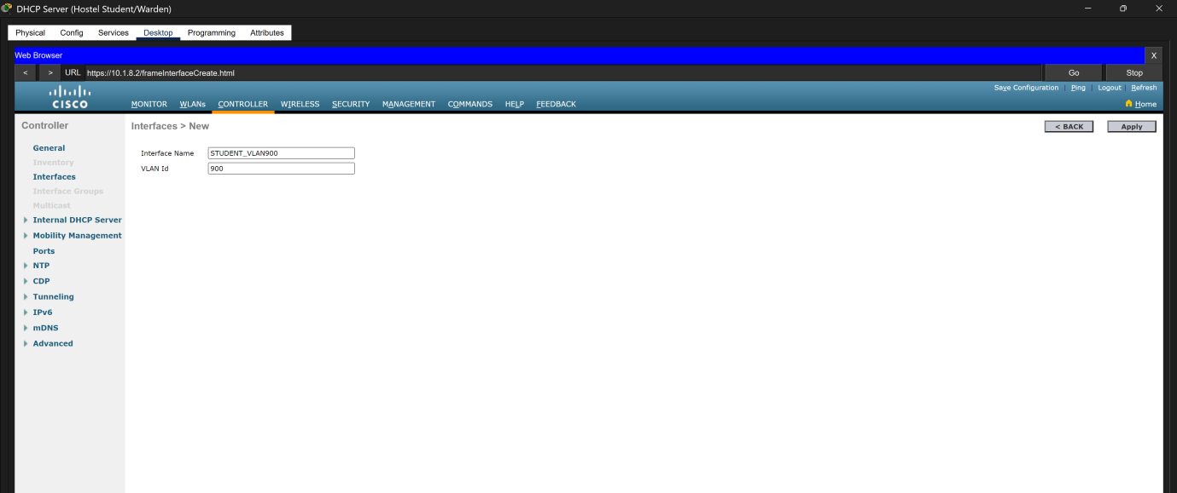
Figure 5.7.1. STUDENT_VLAN900 dynamic interface configured with VLAN identifier 900.
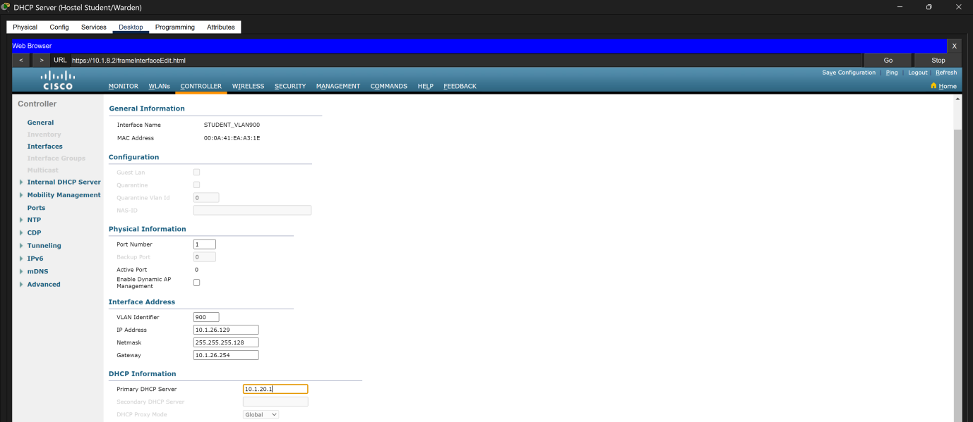
STUDENT_VLAN900 interface configured with address 10.1.26.129/25, gateway 10.1.26.254 and DHCP server 10.1.20.1.

5.8 Student Wireless Network
A second WLAN profile was created for Student users and mapped to the VLAN 900 dynamic interface.
The WLAN was enabled after its interface mapping and security settings were configured.

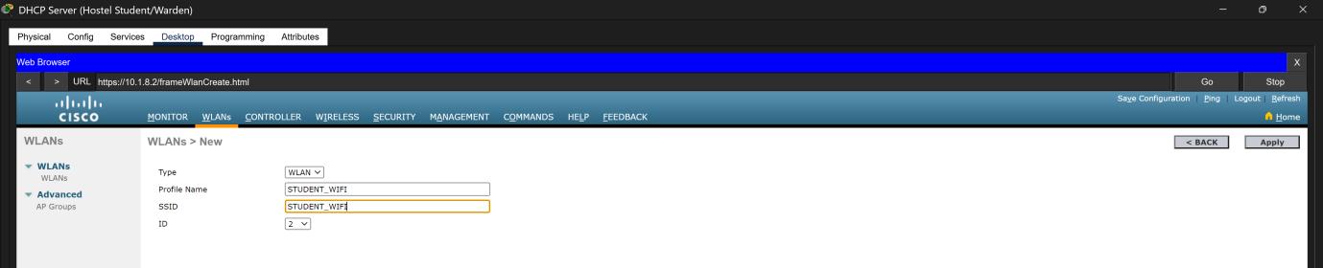Figure 5.8.1. STUDENT_WIFI enabled and mapped to the STUDENT_VLAN900 dynamic interface.

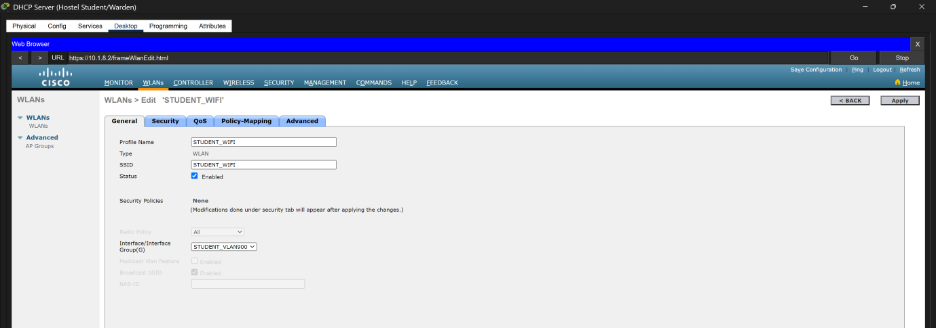
STUDENT_WIFI enabled and mapped to the STUDENT_VLAN900 dynamic interface.

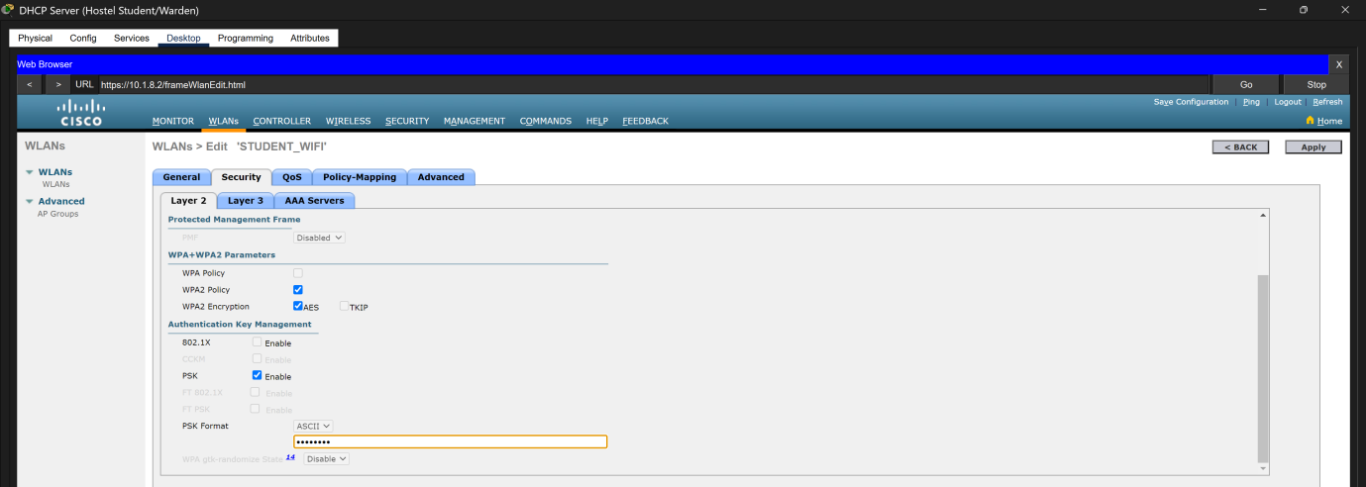
WPA2-Personal and AES security configuration for the STUDENT_WIFI WLAN.

5.9 Lightweight Access Point Configuration

Six lightweight access points were connected to Hostel-Wireless-Switch. The access points were divided between the two wireless-user groups:
Switch port | Access point | Access VLAN | User group
FastEthernet0/2 | AP0 | 800 | Warden
FastEthernet0/3 | AP2 | 800 | Warden
FastEthernet0/4 | AP4 | 800 | Warden
FastEthernet0/17 | AP1 | 900 | Student
FastEthernet0/18 | AP3 | 900 | Student
FastEthernet0/19 | AP5 | 900 | Student
The switch access-port configuration was documented in Part 2 and is not repeated here.
Each access point was configured to obtain its IPv4 settings automatically. The WLC address supplied to the access points was:
10.1.8.2
This address should appear as the primary controller on each lightweight access point.

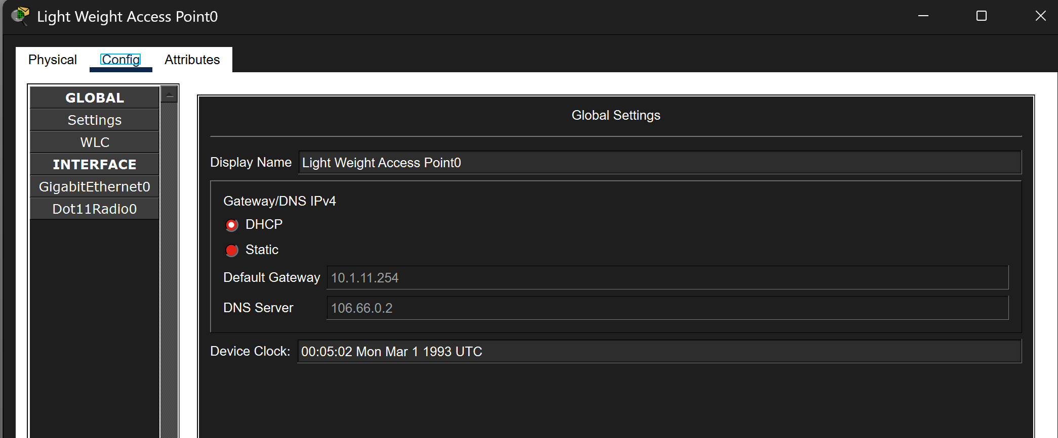
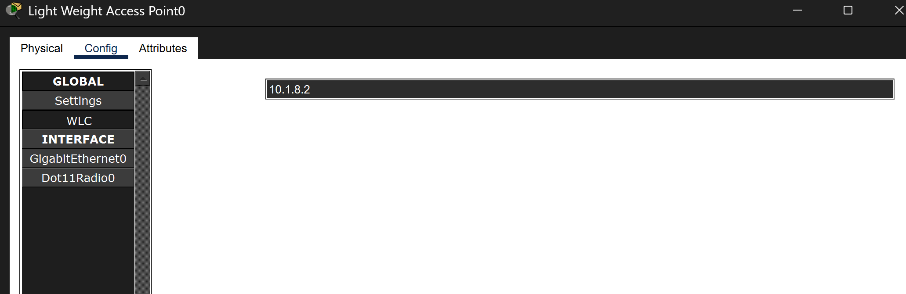Figure 5.9.1. Representative lightweight access point using DHCP and controller address 10.1.8.2.

5.10 Access Point Registration
The WLC monitoring page was used to verify that all six lightweight access points registered with the controller.
Access points | Expected status | Access points
AP0, AP2 and AP4 | Registered for Warden wireless coverage | AP0, AP2 and AP4
AP1, AP3 and AP5 | Registered for Student wireless coverage | AP1, AP3 and AP5

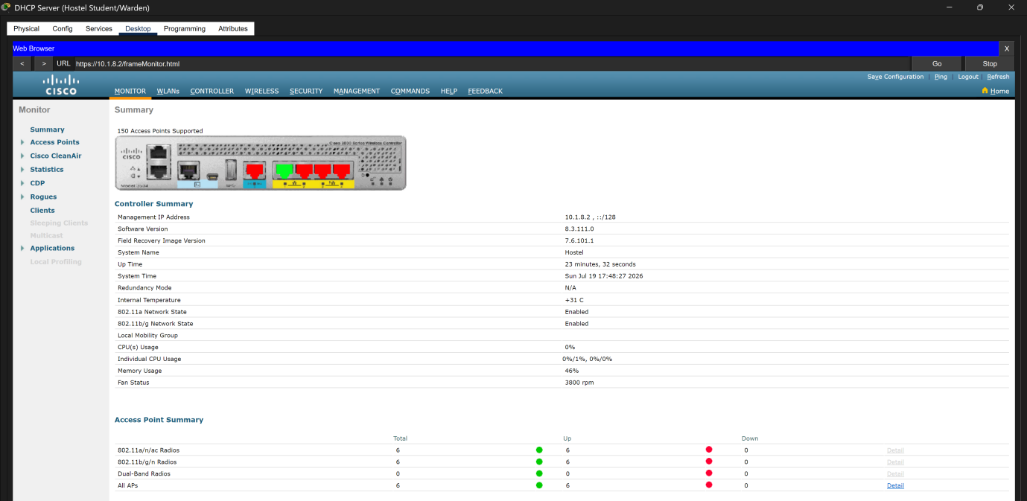
Figure 5.10.1. Six lightweight access points registered with the Wireless LAN Controller.
Successful AP registration confirms that the access points obtained valid management information and communicated with the WLC. It does not, by itself, confirm successful wireless-client DHCP or end-to-end connectivity.

5.11 Access Point Groups
Two AP groups were created so that each set of access points advertised the appropriate WLAN.

AP group | Access points | WLAN
WARDEN_GROUP | AP0, AP2 and AP4 | WARDEN_WIFI
STUDENT_GROUP | AP1, AP3 and AP5 | STUDENT_WIFI

The Warden access points were added to WARDEN_GROUP and mapped to WARDEN_WIFI. The Student access points were added to STUDENT_GROUP and mapped to STUDENT_WIFI.
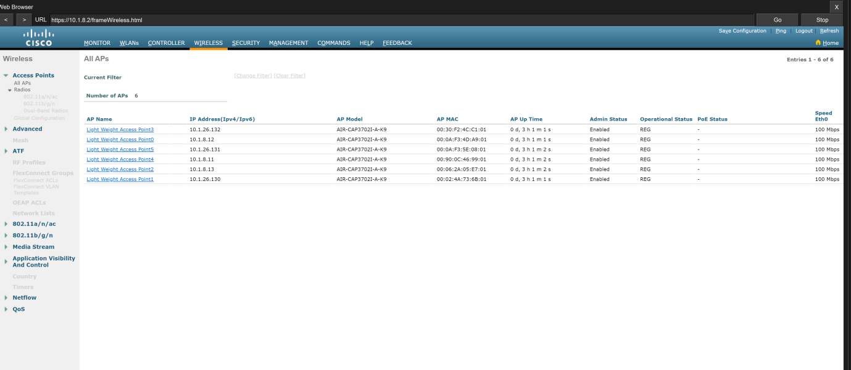
Figure 5.11.1. Warden and Student AP groups with their assigned access points and WLANs.

5.12 FlexConnect
FlexConnect Local Switching allows wireless-user traffic to be switched locally through the access point rather than requiring all client traffic to be returned through the WLC. FlexConnect Local Authentication permits the access point to process the required local WLAN authentication operation.
These settings were enabled for both WARDEN_WIFI and STUDENT_WIFI.
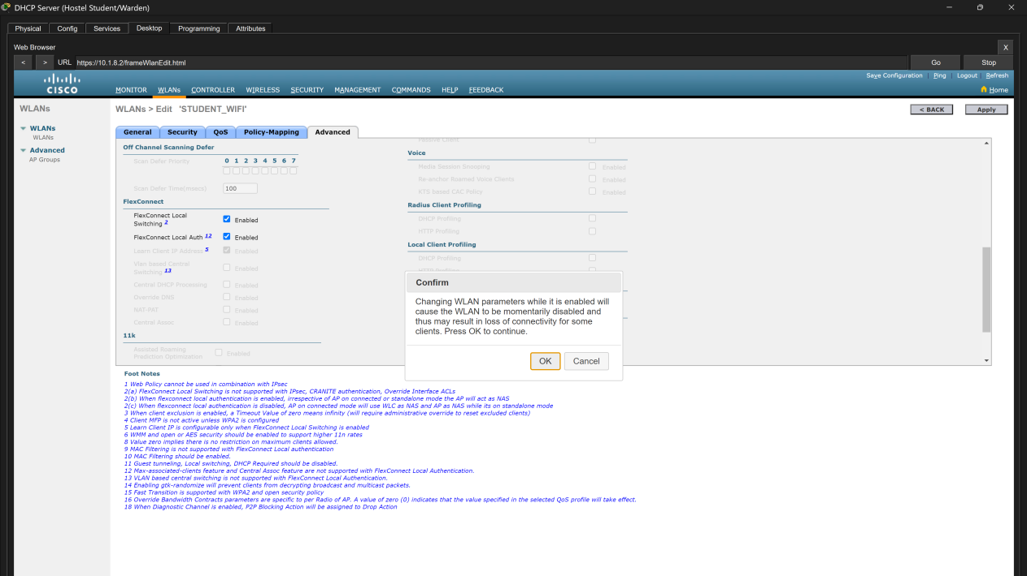
Figure 5.12.1. FlexConnect Local Switching and Local Authentication enabled for the representative WLAN.

5.13 Wireless Client Configuration & Verification

Wireless verification was performed separately for a Warden client and a Student client.

5.13.1 Warden Client
The expected Warden client settings are:
Setting | Expected value | Setting
Connected SSID | WARDEN_WIFI | Connected SSID
IPv4 network | 10.1.8.0/22 | IPv4 network
Default gateway | 10.1.11.254 | Default gateway
DHCP server | 10.1.20.1 | DHCP server
DNS server | 106.66.0.2 | DNS server

The Warden client associated with WARDEN_WIFI, obtained an address from the VLAN 800 DHCP pool and successfully reached its default gateway at 10.1.11.254.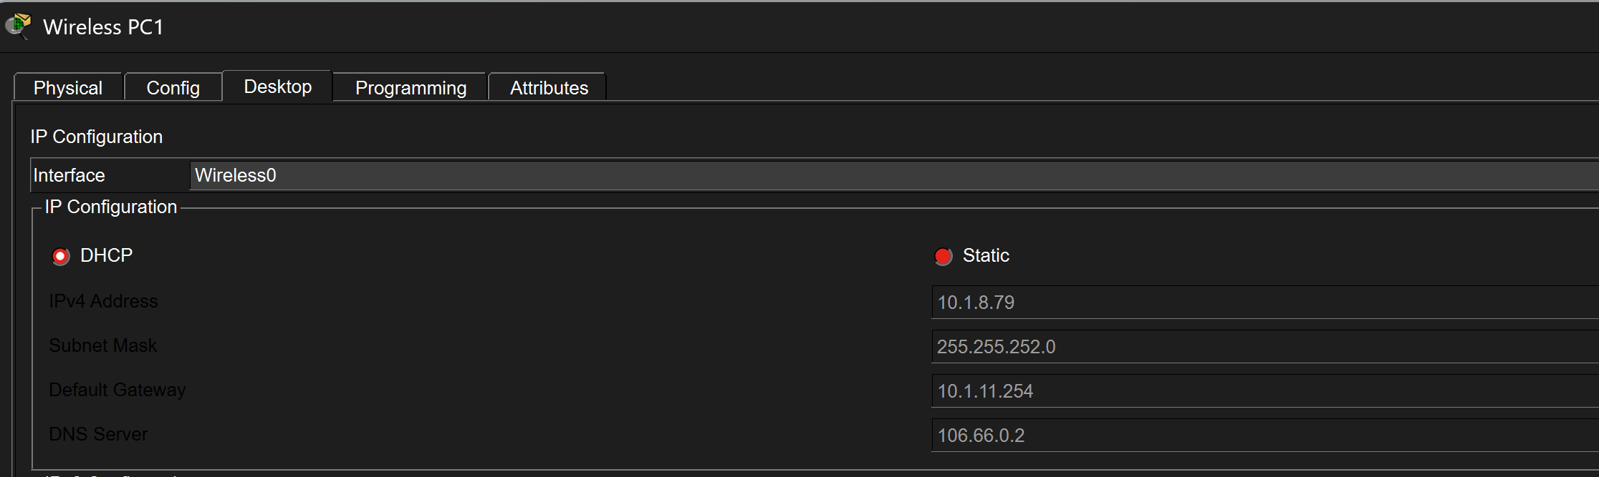
Figure 5.13.2. DHCP addressing received by the Warden wireless client.
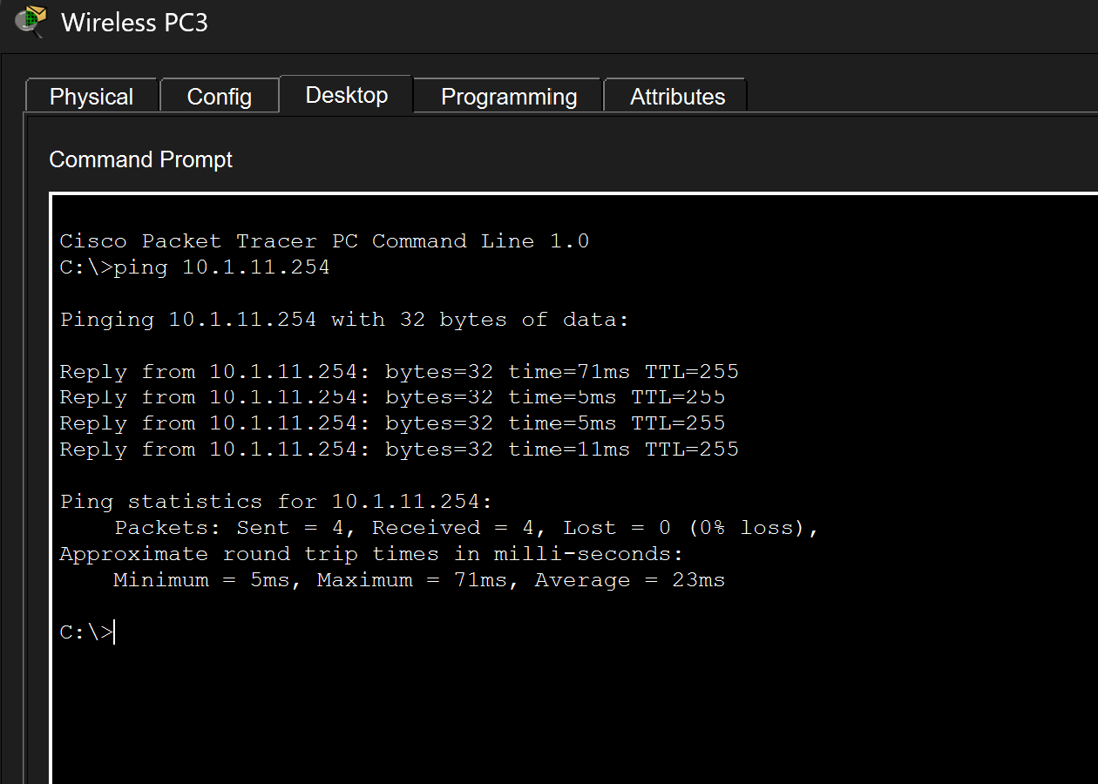
Figure 5.13.3. Successful communication between the Warden client and VLAN 800 gateway.

5.13.2 Student Client
The expected Student client settings are:
Setting | Expected value | Setting
Connected SSID | STUDENT_WIFI | Connected SSID
IPv4 network | 10.1.26.128/25 | IPv4 network
Default gateway | 10.1.26.254 | Default gateway
DHCP server | 10.1.20.1 | DHCP server
DNS server | 106.66.0.2 | DNS server

The Student client associated with STUDENT_WIFI, obtained an address from the VLAN 900 DHCP pool and successfully reached its default gateway at 10.1.26.254.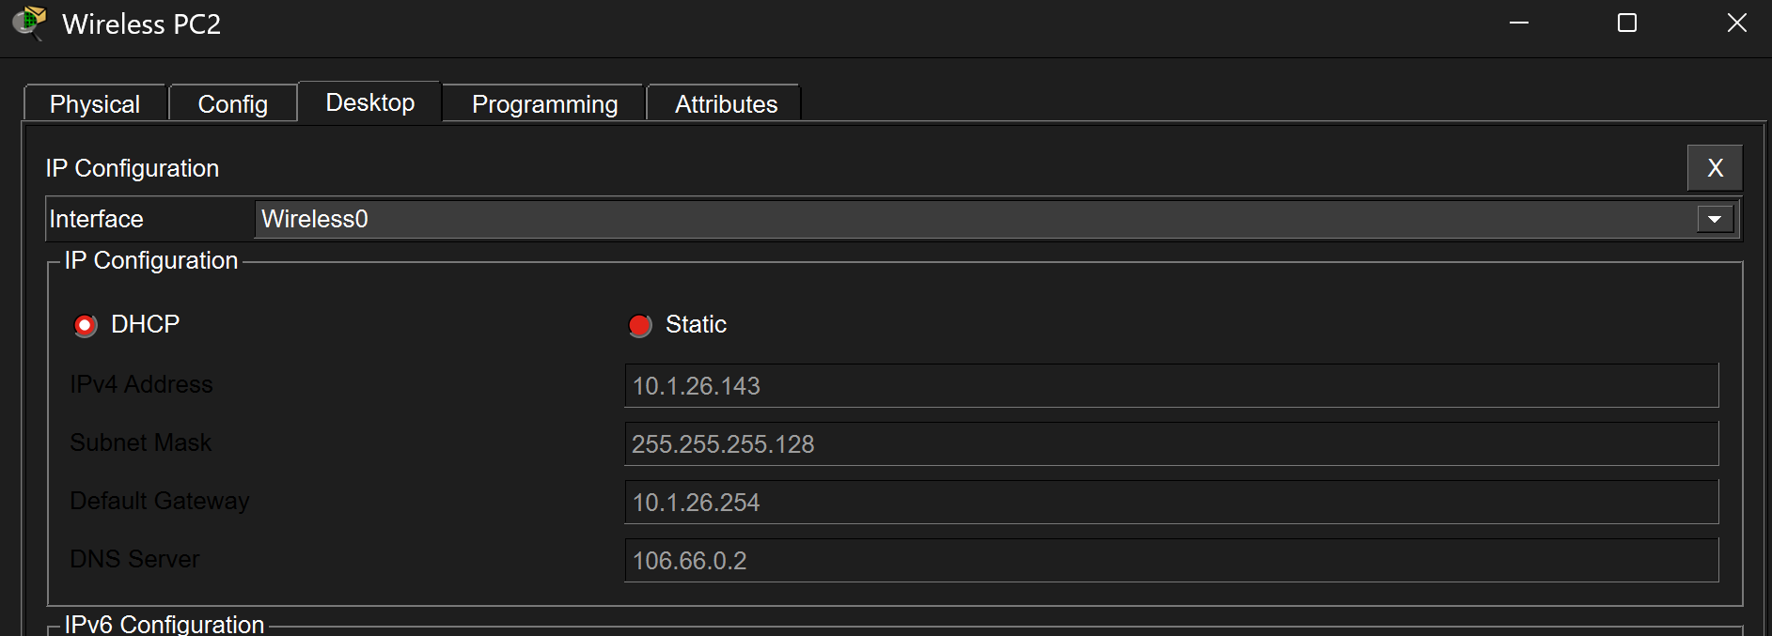
Figure 5.13.5. DHCP addressing received by the Student wireless client.
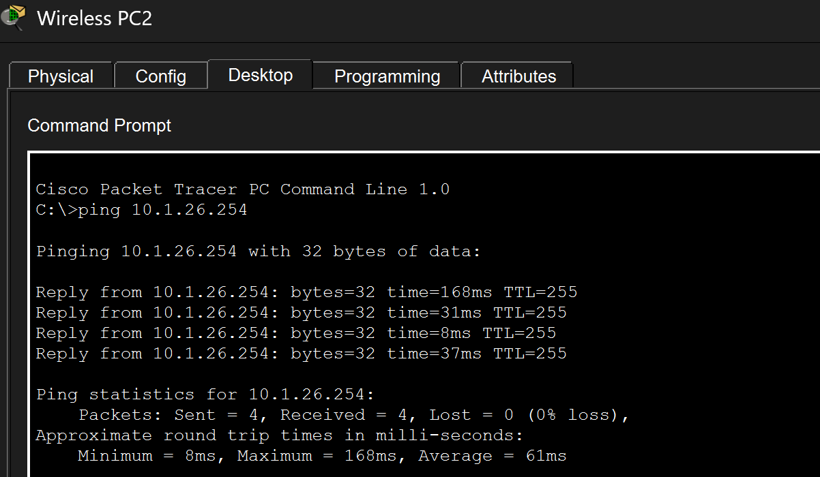
Figure 5.13.6. Successful communication between the Student client and VLAN 900 gateway.

5.13.3 End-to-End Wireless Verification

5.13 Section Conclusion
The Wireless LAN Controller was configured with management address 10.1.8.2/22 in Warden VLAN 800. A separate dynamic interface was created for Student VLAN 900 using address 10.1.26.129/25.
The WARDEN_WIFI and STUDENT_WIFI WLAN profiles were configured with WPA2-Personal and AES security. Six lightweight access points registered successfully with the WLC and were divided between Warden and Student AP groups.
Network L DHCP was successfully verified through Router11. The Network L client received address 10.1.24.10/25, gateway 10.1.24.126 and DNS server 106.66.0.2. Wireless DHCP was also verified when the Warden client received 10.1.8.79/22 and the Student client received 10.1.26.143/25 from the Hostel Student/Warden DHCP server.

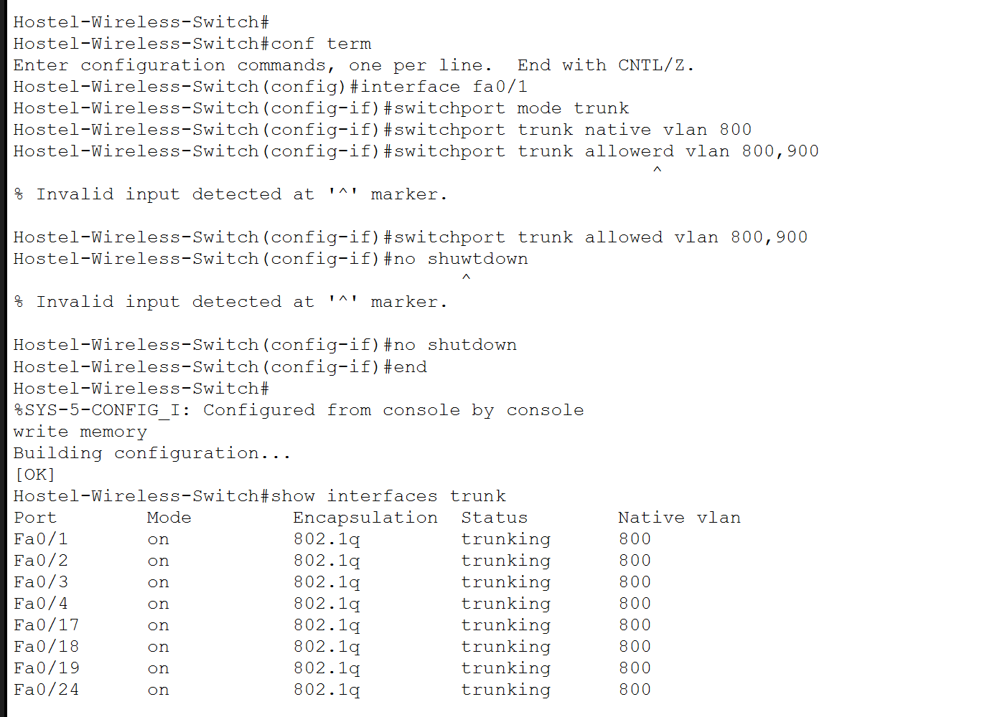

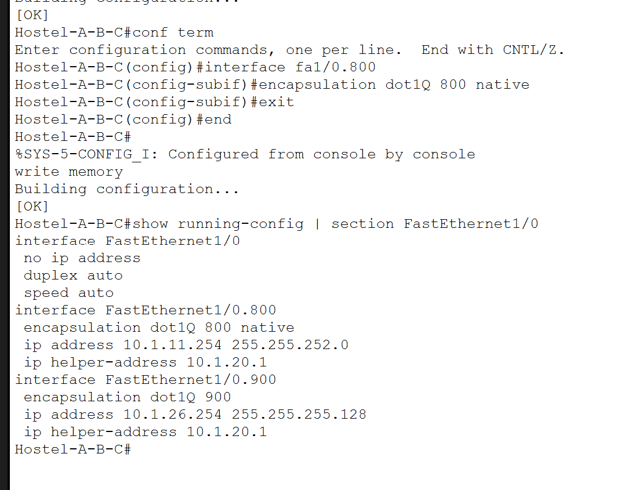

NAT/PAT Configuration

6.1 Objective
The objective of this stage was to configure dynamic Port Address Translation on the two enterprise exit routers. PAT allows multiple internal devices using private IPv4 addresses to communicate with external networks using a limited range of public addresses.
Net-Admin provides the primary Internet exit, while Router7 provides the backup Internet exit. A separate public address pool was allocated to each router so that translated traffic could be identified according to the exit path used.
6.2 NAT/PAT Design
Exit router | Public NAT network | Usable NAT pool | Outside interface
Net-Admin | 111.111.111.0/29 | 111.111.111.1–111.111.111.6 | Serial3/0
Router7 | 111.111.111.8/29 | 111.111.111.9–111.111.111.14 | Serial2/0
The subnet mask for both public NAT pools is:
255.255.255.248
The private enterprise networks use addresses beginning with 10. A standard access list was therefore used to identify the internal traffic eligible for translation:
access-list 1 permit 10.0.0.0 0.255.255.255
The wildcard mask 0.255.255.255 matches the complete private 10.0.0.0/8 address range.

6.3 Representative Primary PAT Configuration - Net-Admin
Net-Admin was selected as the representative configuration because it provides the normal Internet path for the enterprise network.
Traffic entering through FastEthernet0/0 or Serial2/0 is internal traffic. Serial3/0 connects to the ISP and is therefore the outside NAT interface.

6.3.1 Access List & Public Address Pool
The standard access list and public NAT pool were configured as follows:
access-list 1 permit 10.0.0.0 0.255.255.255

ip nat pool NETADMIN_POOL 111.111.111.1 111.111.111.6 netmask 255.255.255.248

ip nat inside source list 1 pool NETADMIN_POOL overload

The access list identifies internal private traffic. The NAT pool defines the public addresses available to Net-Admin.
The overload keyword enables PAT, allowing multiple internal sessions to share addresses from the public pool by using unique transport-layer port numbers.
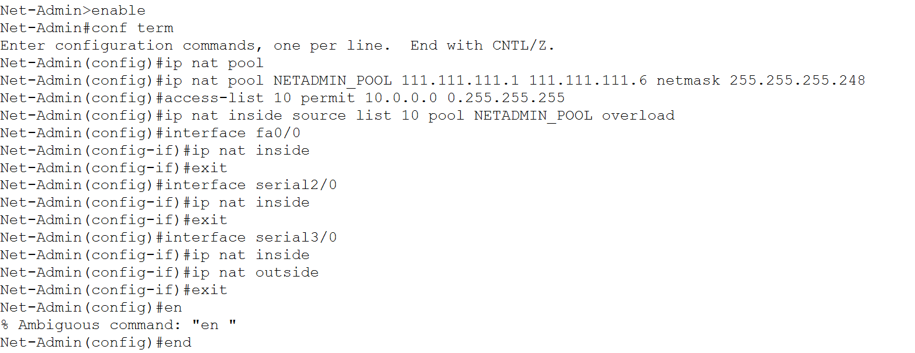
Figure 6.3.1. Net-Admin access list and public PAT pool configuration.

6.3.2 Inside & Outside Interfaces
The Net-Admin interfaces were assigned the following NAT roles:

Figure 6.3.2. Net-Admin inside and outside NAT interface configuration.
FastEthernet0/0 receives traffic from the Net-Admin LAN. Serial2/0 receives traffic from the remaining internal enterprise networks through Reception. Serial3/0 forwards translated traffic towards the ISP.
6.4 Backup PAT Configuration - Router7
Router7 provides the backup external path. It uses a separate public NAT pool:
Router7 FastEthernet0/0 connects to the internal campus transit network and is configured as an inside NAT interface. The Engineering VLAN subinterfaces also receive private client traffic and must be configured as inside interfaces. Serial2/0 connects to the ISP and is configured as the outside interface.
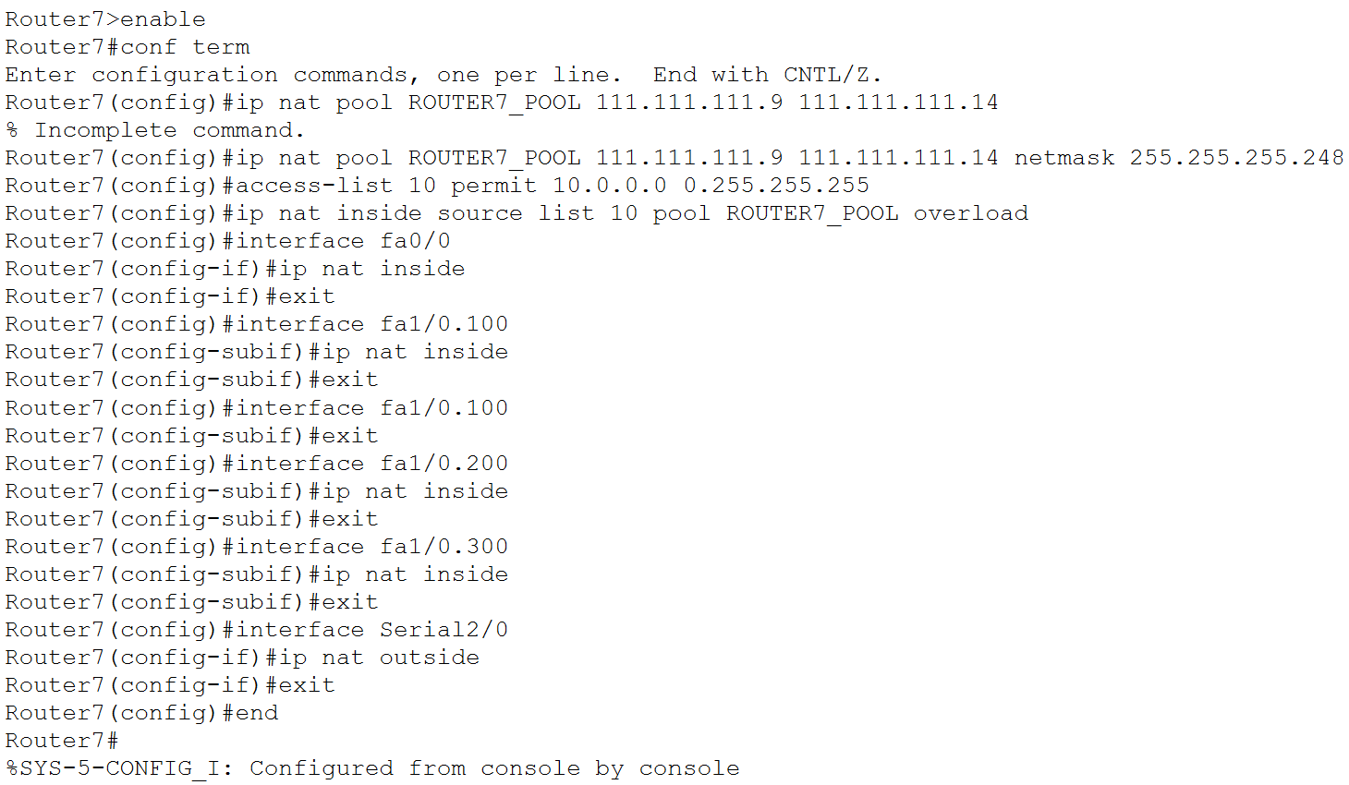


Figure 6.4.1. Router7 backup PAT configuration using ROUTER7_POOL.
The physical FastEthernet1/0 interface remains without an IPv4 address because it operates as an IEEE 802.1Q trunk. NAT is applied to the Layer 3 subinterfaces that receive routed traffic from VLANs 100, 200 and 300.

6.5 NAT/PAT Verification
6.5.1 Configuration Verification
The following commands were used to inspect the NAT/PAT configuration:
show ip nat statistics
show ip nat translations
show access-lists
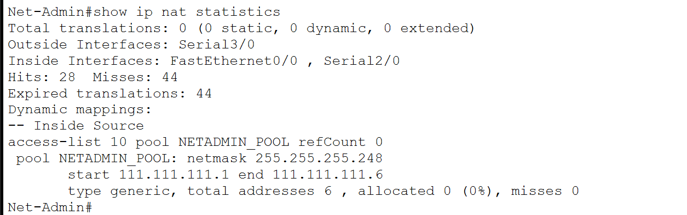
Figure 6.5.1. Net-Admin NAT statistics showing NETADMIN_POOL and the inside/outside interfaces.
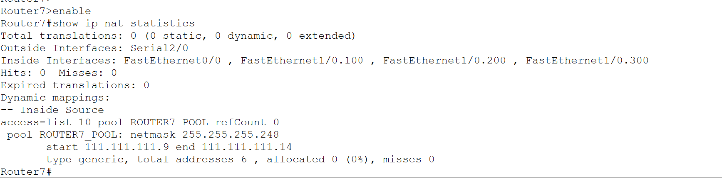Figure 6.5.2. Router7 NAT statistics showing ROUTER7_POOL and the inside/outside interfaces.

6.5.2 Generating Translated Traffic
An internal client generated external traffic by pinging an external server:
ping 106.66.0.2
The translation table was then checked immediately using:
show ip nat translations

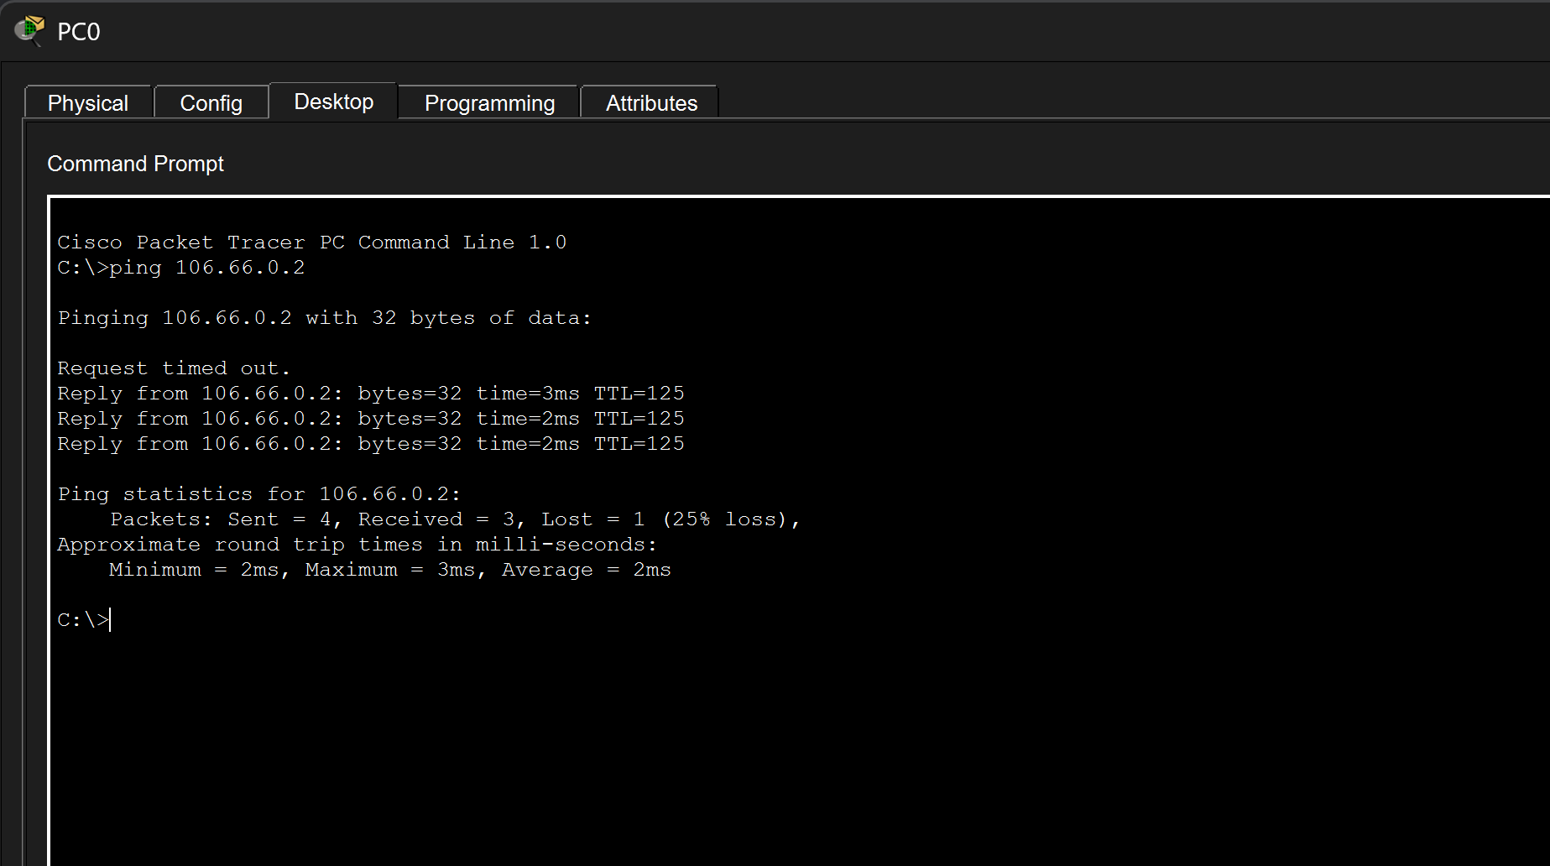
Figure 6.5.3. Successful external connectivity from an internal client through PAT.
6.5.3 Translating Verification
During primary-path operation, the inside-global address should come from:
111.111.111.1–111.111.111.6
An entry from this range confirms that Net-Admin translated the internal private address using NETADMIN_POOL.
During backup-path operation, the inside-global address should come from:
111.111.111.9–111.111.111.14
An entry from this range confirms that Router7 translated the internal private address using ROUTER7_POOL.
The backup translation test is documented together with the primary-link failure test in Part 7.
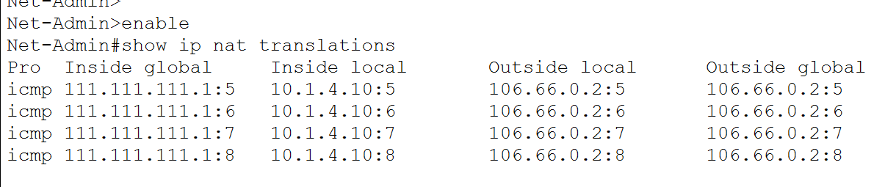
Figure 6.5.4. Active Net-Admin PAT translation showing an internal private address translated to NETADMIN_POOL.
6.6 Section Conclusion
Dynamic PAT was configured on the two enterprise exit routers. Net-Admin uses public pool 111.111.111.1–111.111.111.6 for the primary Internet path, while Router7 uses pool 111.111.111.9–111.111.111.14 for the backup path.
A standard access list identifies internal 10.0.0.0/8 traffic, and the overload option allows multiple private sessions to use the available public addresses. Appropriate interfaces were assigned as NAT inside or NAT outside according to their roles.
The configuration was verified using NAT statistics, access-list matches, external connectivity and active translation entries. Primary and backup path selection is verified in the following static-routing section.

Primary and Backup Static Routing
  - Objective
The objective of this stage was to provide reliable external connectivity through primary and backup WAN paths.
Net-Admin was configured as the primary enterprise exit router through WAN network 100.100.100.20/30. Router7 was configured as the backup exit router through WAN network 100.100.100.24/30.
A normal static default route was installed on Net-Admin, while a floating static default route with a higher administrative distance was installed on Router7. The active default route was advertised into OSPF so that the remaining internal routers could direct external traffic towards the appropriate exit.
Static return routes were also configured on the ISP router for both public NAT pools and the external-server network.

  - Static Routing Design

Device | Route purpose | Next hop | Administrative distance
Net-Admin | Primary default route | 100.100.100.21 | 1
Router7 | Backup floating default route | 100.100.100.25 | 120
ISP Router | Net-Admin NAT pool return route | 100.100.100.22 | 1
ISP Router | Router7 NAT pool return route | 100.100.100.26 | 1
ISP Router | External server network | 100.100.100.18 | 1
Router13 | Default route towards ISP | 100.100.100.17 | 1
The primary Net-Admin default route uses the default static-route administrative distance of 1.
The Router7 floating static route uses administrative distance 120. This is higher than OSPF’s administrative distance of 110, so Router7 normally prefers the OSPF default route learned through the internal network. If the primary default route is withdrawn, the floating static route becomes active.

  - Net-Admin Primary Default Route
Net-Admin connects to the ISP through Serial3/0. The ISP next-hop address on this connection is 100.100.100.21.
The primary default route was configured using:
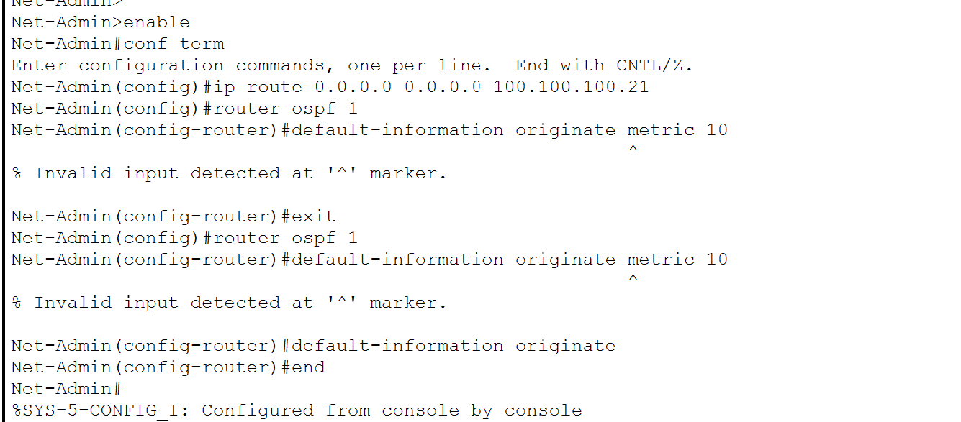
Figure 7.3.1. Primary static default route configured on Net-Admin and advertised into OSPF.

The static default route forwards destinations not present in the routing table to the ISP.
The default-information originate command advertises the default route into OSPF. This allows other internal routers to use Net-Admin as their normal external exit without requiring a separate static default route on every internal router.

The static default route forwards destinations not found in the routing table to the ISP. The default-information originate command advertises this route into OSPF so that internal routers can use Net-Admin as the primary exit.

  - Router7 Floating Static Default Route
Router7 connects to the ISP through Serial2/0. The ISP next-hop address on this connection is 100.100.100.25.
The backup route was configured with administrative distance 120:
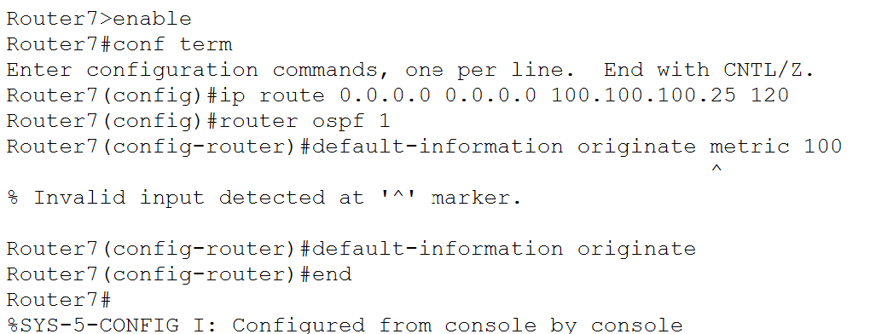
Figure 7.4.1. Router7 floating static default route through 100.100.100.25 with administrative distance 120.

The administrative distance causes the Router7 static route to remain inactive while an OSPF default route from Net-Admin is available.
If the primary path becomes unavailable, the OSPF default route learned from Net-Admin is withdrawn. Router7 then installs its floating static route and advertises the available backup default route into OSPF.

7.5 ISP Return Routes

Outbound enterprise traffic is translated by either Net-Admin or Router7 before reaching the ISP. The ISP therefore requires return routes to both public NAT networks.
Without these routes, the ISP could receive translated packets but would not know which enterprise router should receive the returning traffic.
The ISP also requires a route to the external-server network behind Router13.

7.5.1 ISP Static Route Summary

Destination | Nex Hop | Purpose
106.66.0.0/16 | 100.100.100.18 | External server network through Router13
111.111.111.0/29 | 100.100.100.22 | Net-Admin NAT pool
111.111.111.8/29 | 100.100.100.26 | Router7 NAT pool

7.5.2 ISP Route Configuration
The routes were configured on the ISP router:

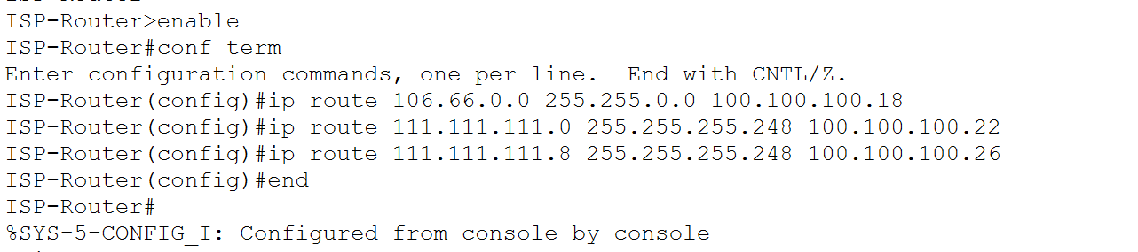
Figure 7.5.1. ISP static routes for the external-server network and both enterprise NAT pools.
The external ISP network uses only static routing. No internal OSPF network information is advertised to the ISP.

7.6 Router13 Default Route

Router13 provides the default gateway for the external servers in network 106.66.0.0/16. It connects to the ISP through network 100.100.100.16/30.
Router13 was configured with a default route towards ISP next hop 100.100.100.17:
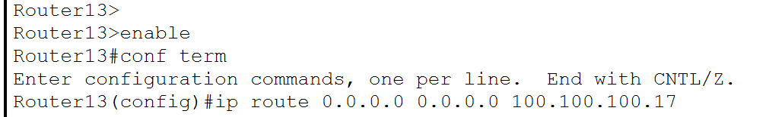
Figure 7.6.1. Router13 default route forwarding non-local traffic to 100.100.100.17.
This route allows the external DNS, HTTP, email and DHCP servers to return traffic towards the ISP and the enterprise NAT pools.

7.7 Primary Path Verification

7.7.1 External Connectivity
During normal operation, an internal client tested communication with the external DNS and HTTP servers:
ping 106.66.0.2
ping 106.66.0.3
The tests received successful replies after the initial address-resolution timeout.

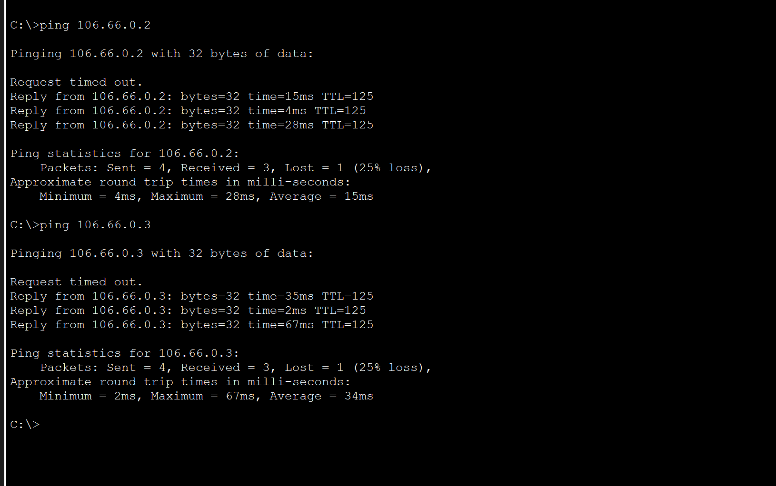
Figure 7.7.1. Successful connectivity to the external DNS and HTTP servers through the primary path.

The first request timing out does not indicate routing failure. It normally occurs while Packet Tracer performs ARP resolution before sending the remaining ICMP requests.

7.7.2 Primary NAT Translation
The Net-Admin translation table was checked using:
show ip nat translations
show ip nat statistics
The inside-local address 10.1.4.10 was translated to addresses from the Net-Admin public pool beginning with 111.111.111.1.

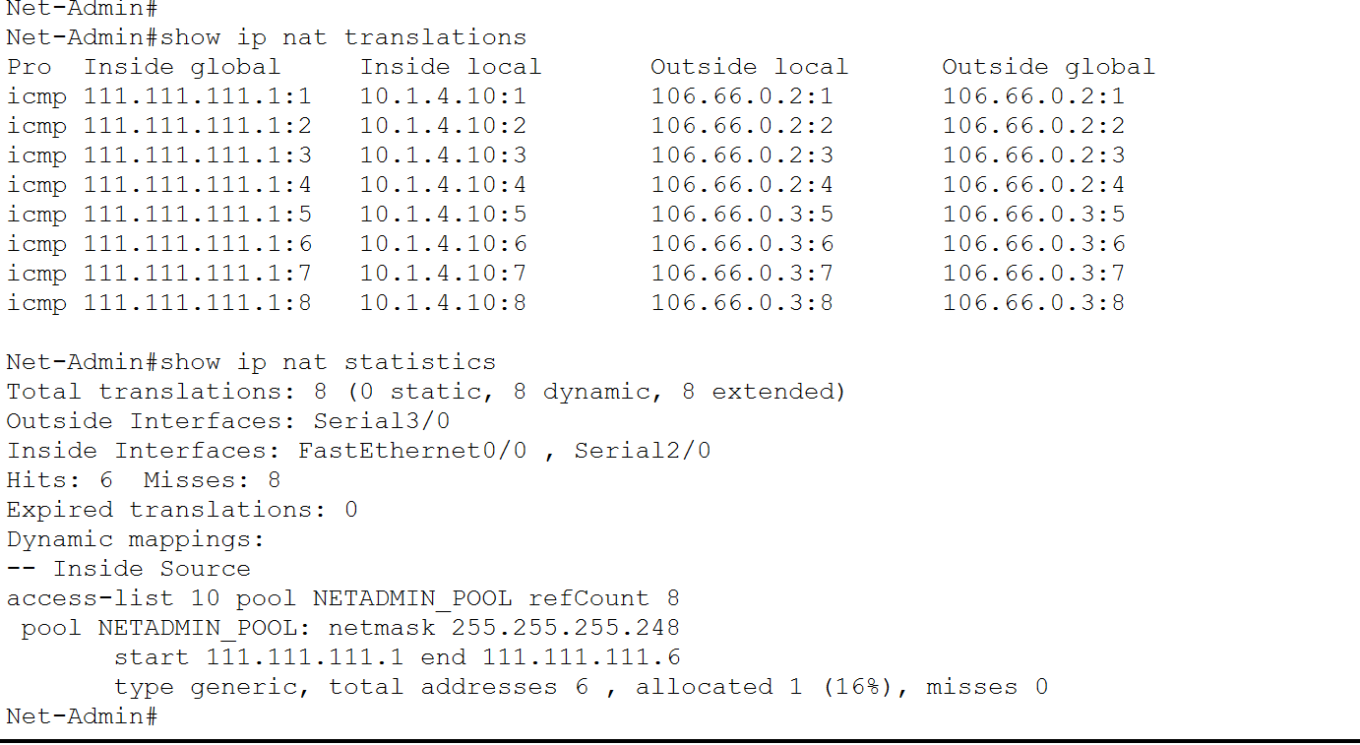
Figure 7.7.2. Net-Admin PAT translations created during primary-path external testing.
This confirms that traffic followed the primary path and was translated through NETADMIN_POOL.

7.8 Backup Path Testing

7.8.1 Simulating Primary-Link Failure
The primary ISP connection on Net-Admin was temporarily disabled to simulate a WAN-link failure:
configure terminal
interface serial3/0
shutdown
end

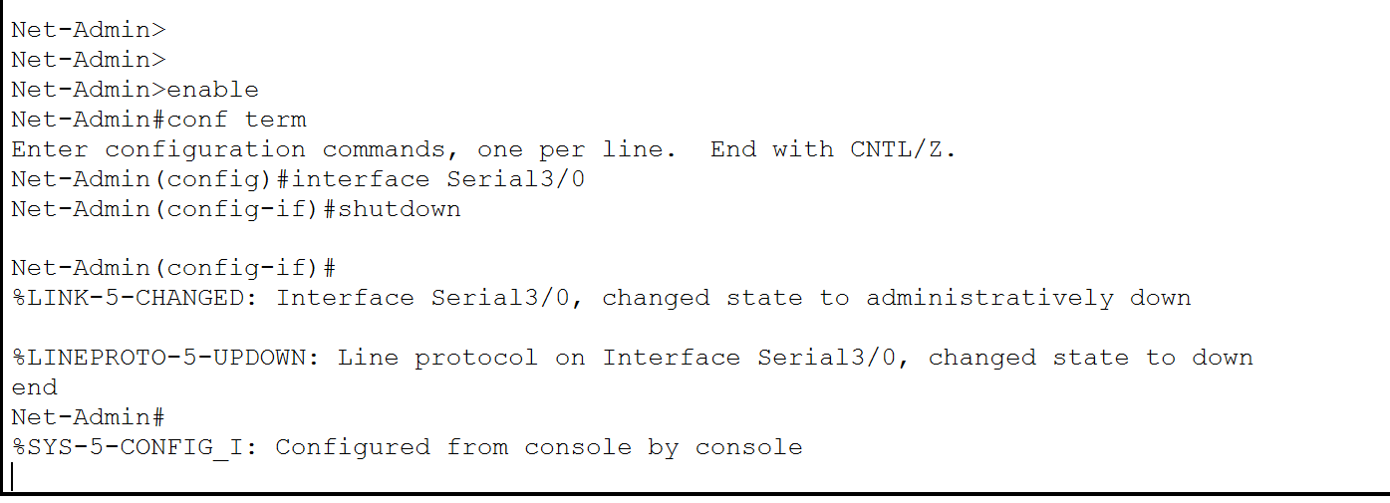
Figure 7.8.1. Net-Admin Serial3/0 disabled to simulate failure of the primary ISP path.
When Serial3/0 became unavailable, the primary static route through 100.100.100.21 was removed from Net-Admin’s routing table. Net-Admin therefore stopped advertising the primary default route into OSPF.

7.8.2 Router7 Floating Route Activation
After OSPF convergence, Router7 installed its floating static route:
S* 0.0.0.0/0 [120/0] via 100.100.100.25

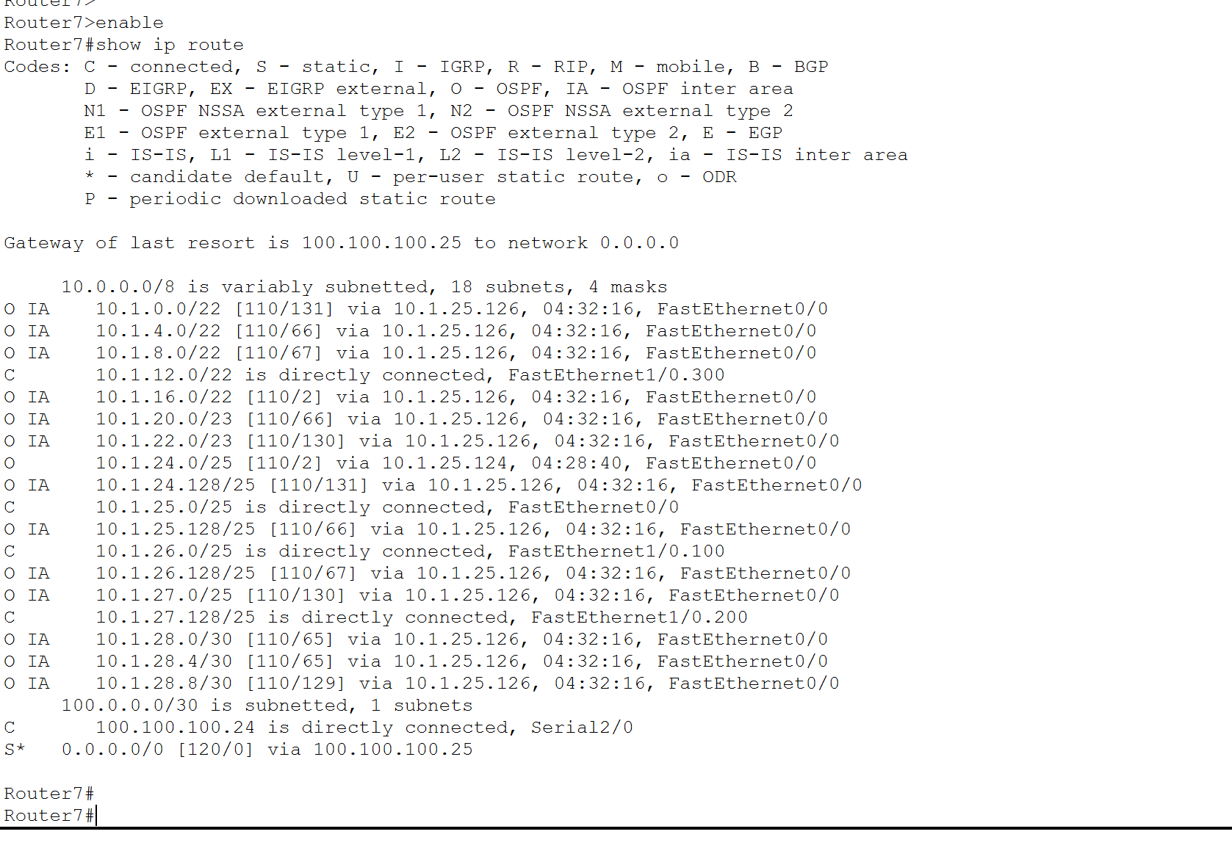
Figure 7.8.2. Router7 floating static default route active through 100.100.100.25.
This proves that the backup route remained inactive during normal operation and was installed only after the primary default route became unavailable.

7.8.3 OSPF Default-Route Change
The Reception routing table was inspected after convergence.
It displayed an OSPF external default route through:
10.1.25.125
This address belongs to Router7 FastEthernet0/0.

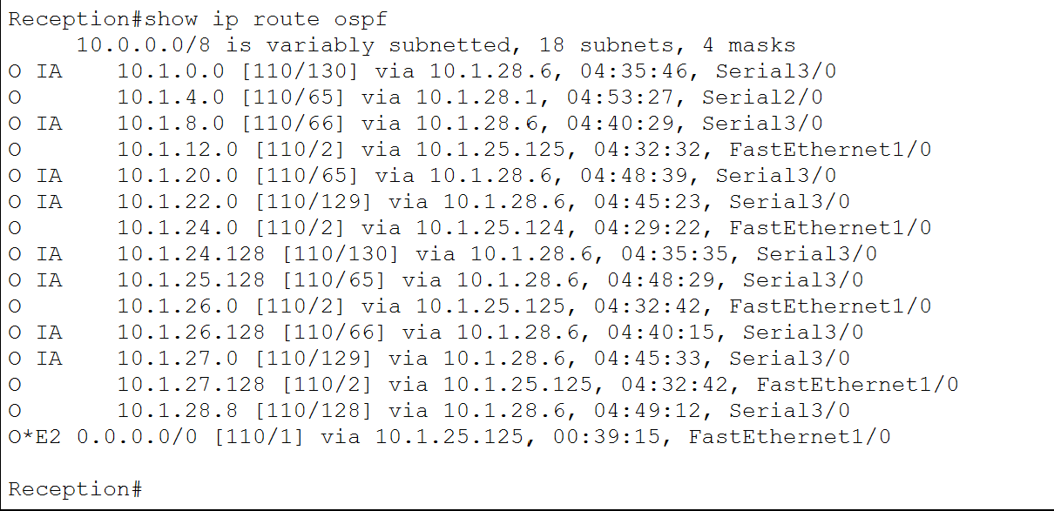
Figure 7.8.3. Reception using Router7 at 10.1.25.125 as its OSPF default route during backup operation.
This result confirms that Router7 advertised the backup default route and that the internal routers changed their external exit automatically
7.8.4 Backup External Connectivity
A Reception client tested the external DNS and HTTP servers while the primary Net-Admin connection remained disabled:
ping 106.66.0.2
ping 106.66.0.3
Both external addresses responded successfully.

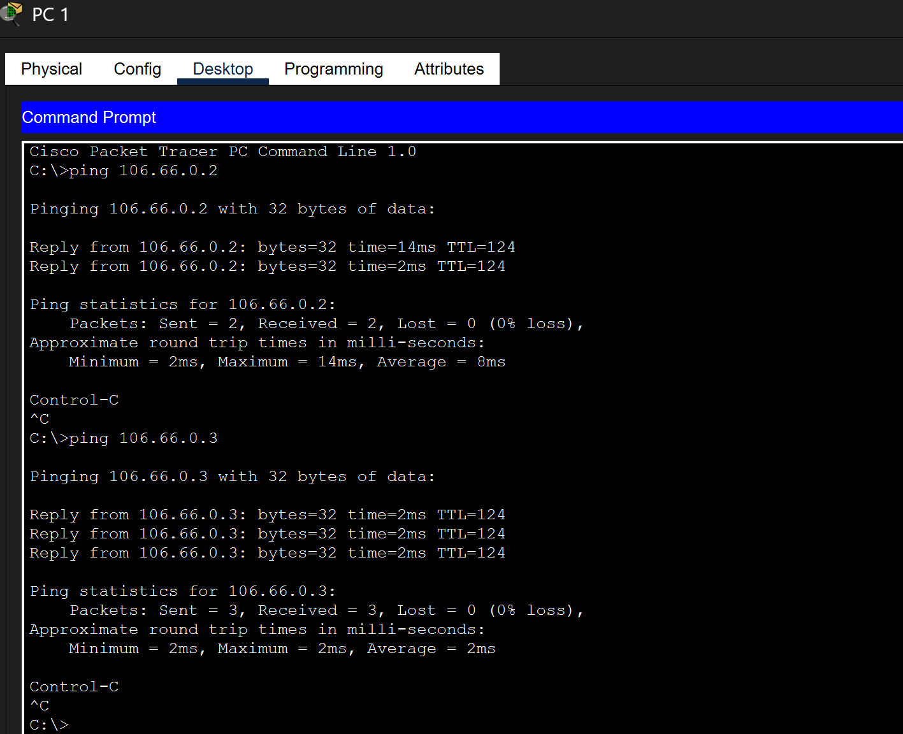
Figure 7.8.4. Successful external communication from Reception through the Router7 backup path.
This test confirms that internal traffic continued to reach the external network after failure of the primary WAN connection.

7.8.5 Backup NAT Translation
The Router7 NAT translation table was checked immediately after generating external traffic:
show ip nat translations
show ip nat statistics
The Reception client was translated to an address from ROUTER7_POOL. The screenshot shows inside-global addresses beginning with:
111.111.111.9

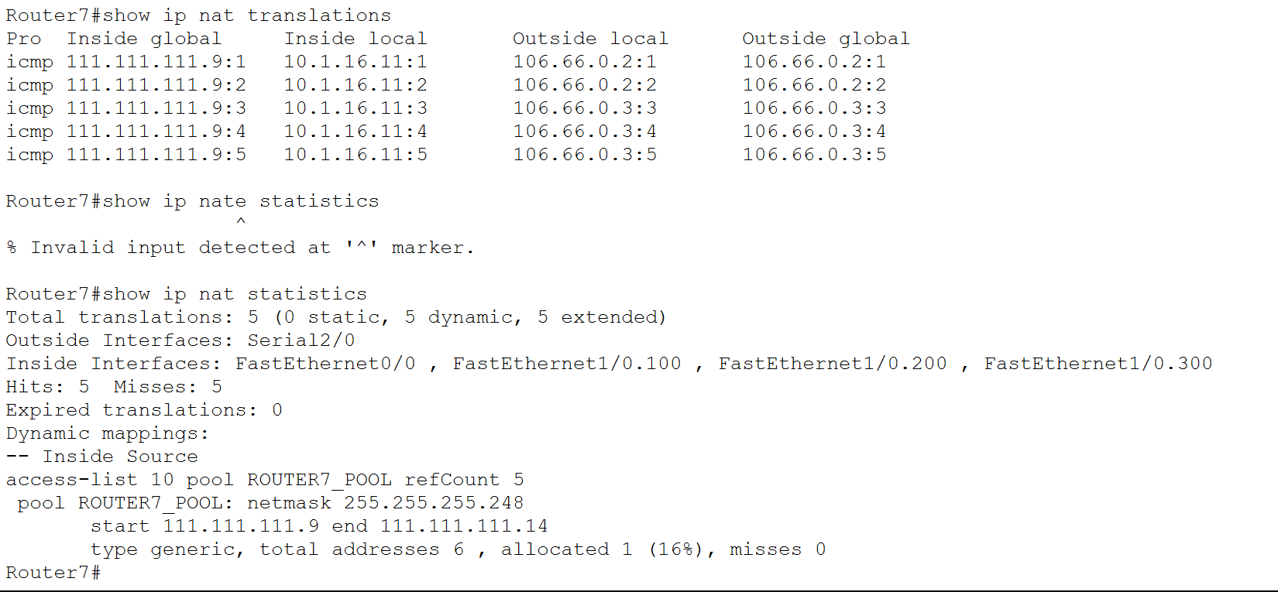
Figure 7.8.5. Router7 PAT translations generated during backup-path operation.
The inside-global address belongs to the Router7 public NAT pool, proving that both backup routing and backup PAT were operational.
An invalid command attempt is visible because show ip nat statistics was initially entered from the wrong command mode. The command was subsequently entered from privileged EXEC mode and produced the correct output.

7.9 Restoring the Primary Path
After the backup test, Net-Admin Serial3/0 was restored:
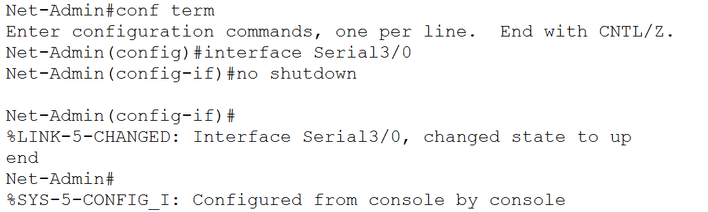
Figure 7.9.1. Net-Admin Serial3/0 restored after completion of the backup-path test.

7.10 Section Conclusion
Primary and backup external routing was successfully implemented using static default routes, OSPF default-route advertisement and dynamic PAT.
Net-Admin normally provides the enterprise Internet exit through WAN network 100.100.100.20/30. Router7 provides the backup exit through WAN network 100.100.100.24/30 using a floating static route with administrative distance 120.
When the primary link was disabled, Router7 installed its floating route and advertised the new default path into OSPF. Reception changed its default next hop to Router7, external connectivity remained operational, and client traffic was translated using ROUTER7_POOL.
After Net-Admin Serial3/0 was restored, the enterprise network reconverged to the preferred primary exit. These results verify successful primary-path operation, automatic failover, backup PAT and primary-path recovery

External Server Services
  - Objective
The objective of this stage was to configure and verify externally hosted DNS, HTTP and email services. The external servers are located in network 106.66.0.0/16 behind Router13.
Internal enterprise clients access these services through the primary or backup external path configured in Part 7. DNS translates domain names into IPv4 addresses, HTTP provides access to the public webpage, and the email server provides SMTP and POP3 services.
8.2 External Server Addressing
Server | IP address | Subnet mask | Default gateway | Service
Email | 106.66.0.1 | 255.255.0.0 | 106.66.255.254 | SMTP and POP3
DNS | 106.66.0.2 | 255.255.0.0 | 106.66.255.254 | DNS
HTTP | 106.66.0.3 | 255.255.0.0 | 106.66.255.254 | HTTP
External DHCP | 106.66.0.4 | 255.255.0.0 | 106.66.255.254 | DHCP

Router13 FastEthernet0/0 at 106.66.255.254/16 provides the default gateway for the external-server network.
All internal DHCP pools distribute 106.66.0.2 as the DNS server. Therefore, enterprise clients can resolve the external server names without manually configuring a DNS address.
The physical addressing of these servers was documented in Part 1 and is not repeated here.
8.3 DNS Server Configuration
The DNS service was enabled on the server at 106.66.0.2. Address records were created to associate the external server names with their corresponding IPv4 addresses.
Domain name | Record type | Address | Purpose
dhcp.com | A | 106.66.0.4 | External DHCP server
dns.com | A | 106.66.0.2 | DNS server
mail.com | A | 106.66.0.1 | Email server
site.com | A | 106.66.0.3 | HTTP server
www.public.com | A | 106.66.0.3 | Public website
These records provide name translation for all four external servers. Both site.com and www.public.com identify the HTTP server at 106.66.0.3.
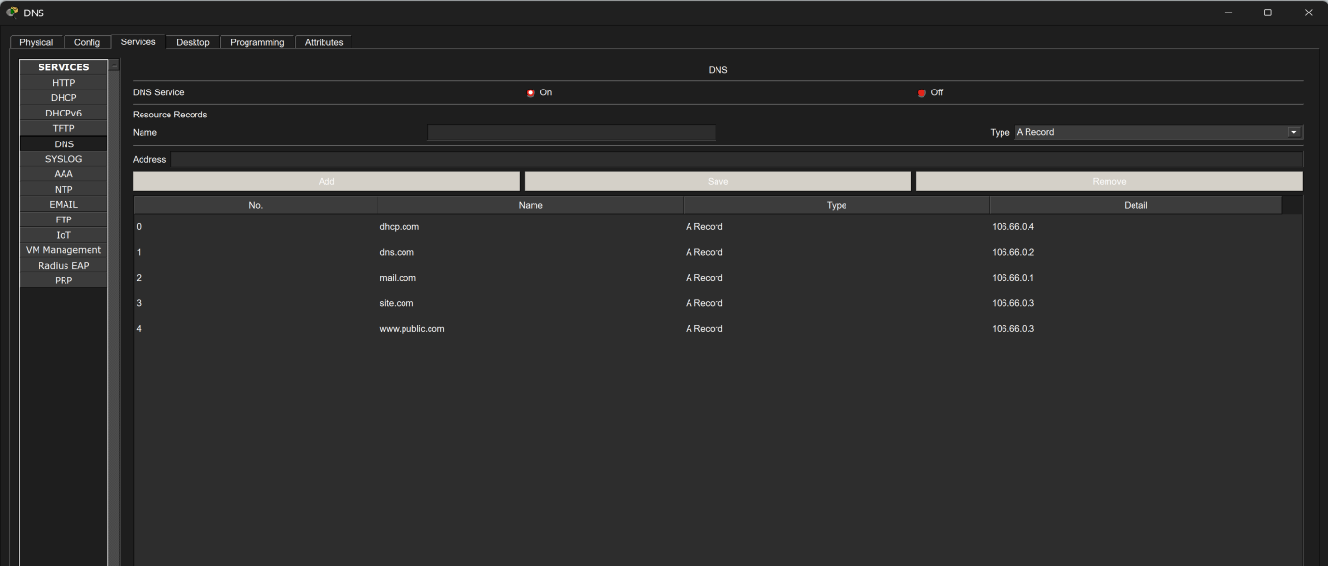
Figure 8.3.1. DNS server configuration showing address records for the external email, DNS, HTTP and DHCP servers.
8.3.1 DNS Verification

DNS resolution was tested from an internal enterprise client using:
nslookup mail.com

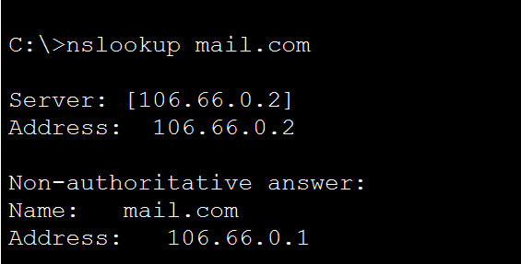
Figure 8.3.2. Successful resolution of mail.com to 106.66.0.1 from an internal enterprise client.
The public website name was also tested from an internal client:
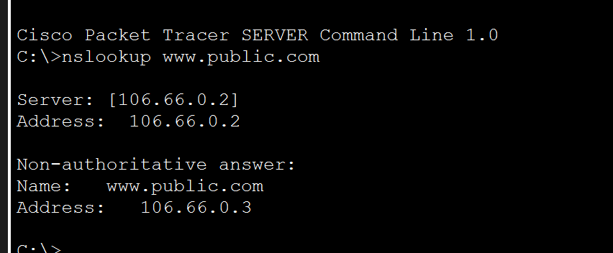
Figure 8.3.3. Successful resolution of www.public.com to the external HTTP server.

This result confirms that the client could reach the external DNS server through NAT and static routing. It also confirms that the DNS server returned the correct A record.

8.4 HTTP Service Configuration

The HTTP service was enabled on the external web server at 106.66.0.3.
The server’s index.html file was modified to provide a customised public webpage accessible through:
http://www.public.com
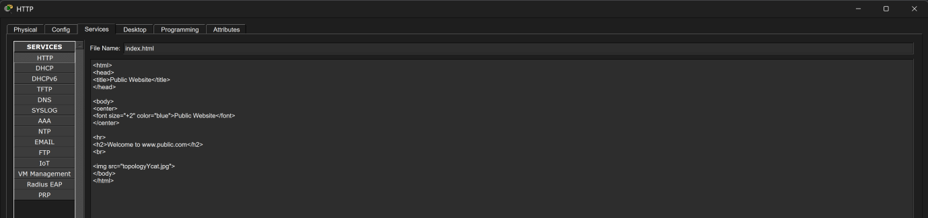
Customised index page configured on the external HTTP server at 106.66.0.3.

8.4.2 HTTP Verification

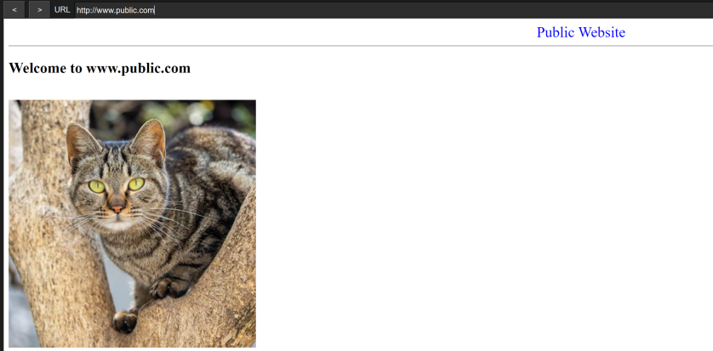
Figure 8.4.1. Customised index page configured on the external HTTP server.

Successful access to the external public website using www.public.com from an internal enterprise client.

The public webpage was successfully opened using www.public.com. This confirmed that the client resolved the hostname through DNS, reached the external server through NAT and static routing, and received the webpage through HTTP.

8.5 Email Server Configuration
The external email server was assigned address 106.66.0.1/16. SMTP and POP3 services were enabled using the domain:
mail.com
SMTP is used to send messages, while POP3 allows client devices to retrieve messages from their mailboxes.

8.5.1 Required Email Accounts
User group | Username | Email address | Password
Student | studentEmail | studentEmail@mail.com | Cisco123
Warden | wardenEmail | wardenEmail@mail.com | Cisco123
Library | librarianEmail | librarianEmail@mail.com | Cisco123
Guest | guestEmail | guestEmail@mail.com | Cisco123
Engineering | engineerEmail | engineerEmail@mail.com | Cisco123

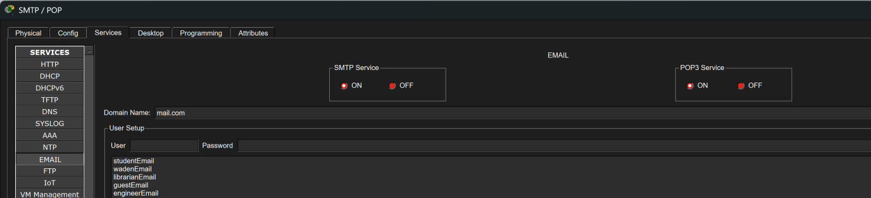
Figure 8.5.1. External email server configured with the mail.com domain and five required Topology Y accounts
8.6 Email Client Configuration
One client in each corresponding network must be configured with its assigned account.
Account | Suitable client location
studentEmail@mail.com | Student wireless VLAN 900
wardenEmail@mail.com | Warden wireless VLAN 800
libarianEmail@mail.com | Library Network J
guestEmail@mail.com | Guest Network K
engineerEmail@mail.com | Engineering VLAN 100, 200 or 300

8.6.1 Common Client Configuration
Field | Value
Email address | <username>@mail.com
Incoming mail server | mail.com
Outgoing mail server | mail.com
Username | Corresponding account username
Password | Cisco123
Because mail.com resolves to 106.66.0.1, the clients can use the domain name instead of entering the server address manually.
8.6.2 Student Email Client
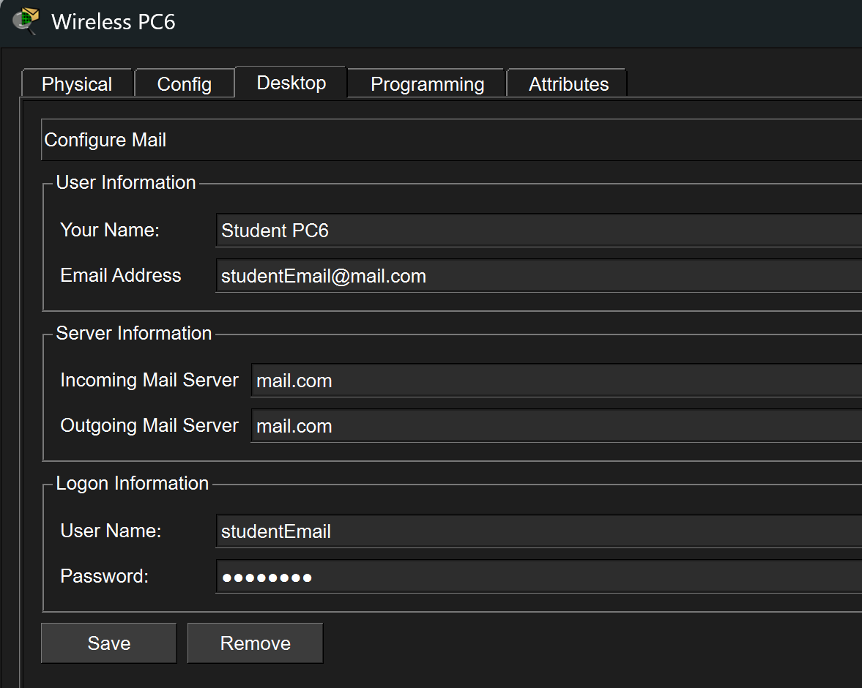
Figure 8.6.1. Student email client configured for studentEmail@mail.com.
8.6.3 Warden Email Client
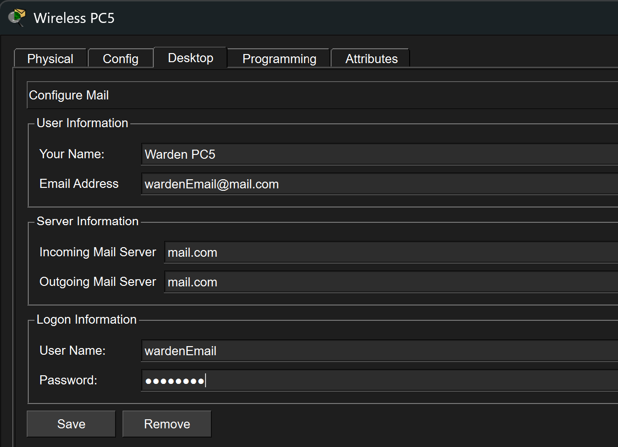
Figure 8.6.2. Warden email client configured for wardenEmail@mail.com.

8.6.4 Library Email Client
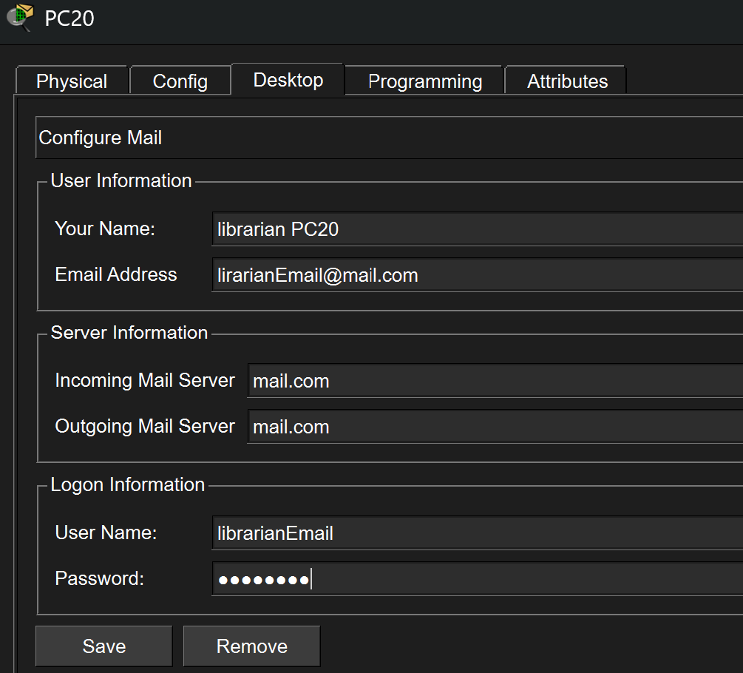
Figure 8.6.3. Library email client configured for libarianEmail@mail.com.
8.6.5 Engineering Email Client
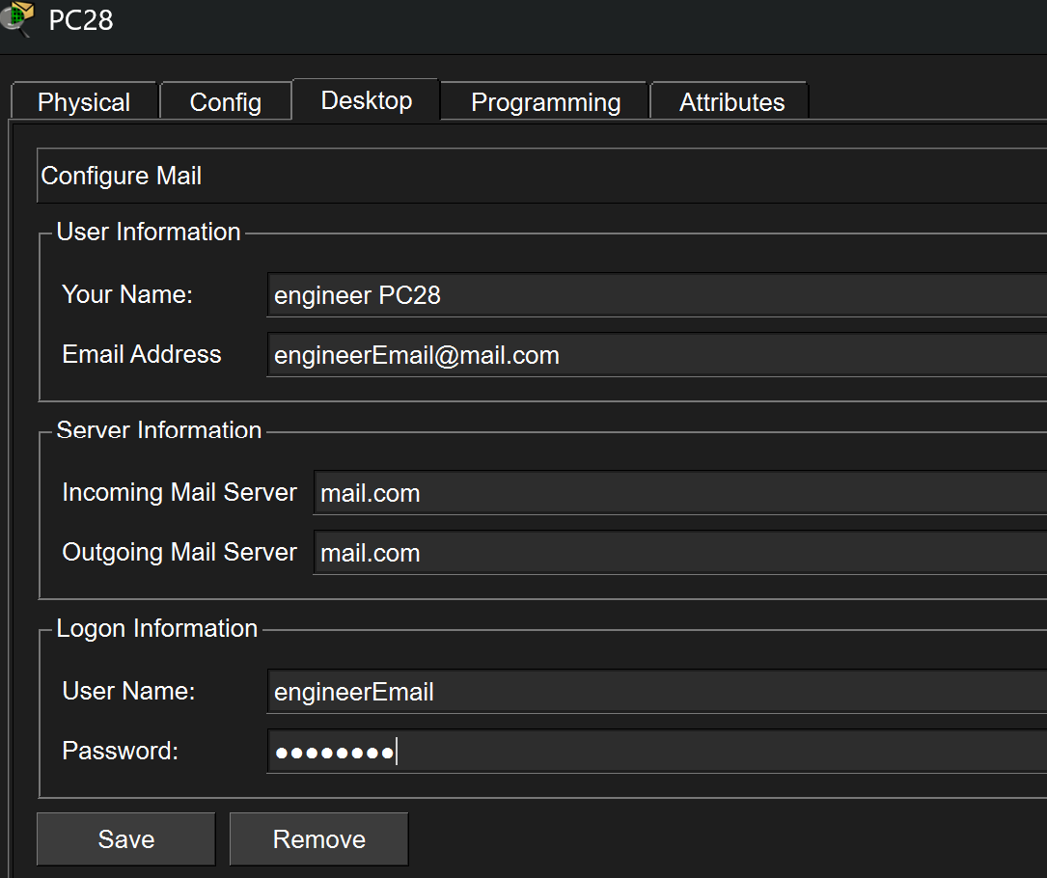
Figure 8.6.5. Engineering email client configured for engineerEmail@mail.com.
8.6.6 Guest Email Client
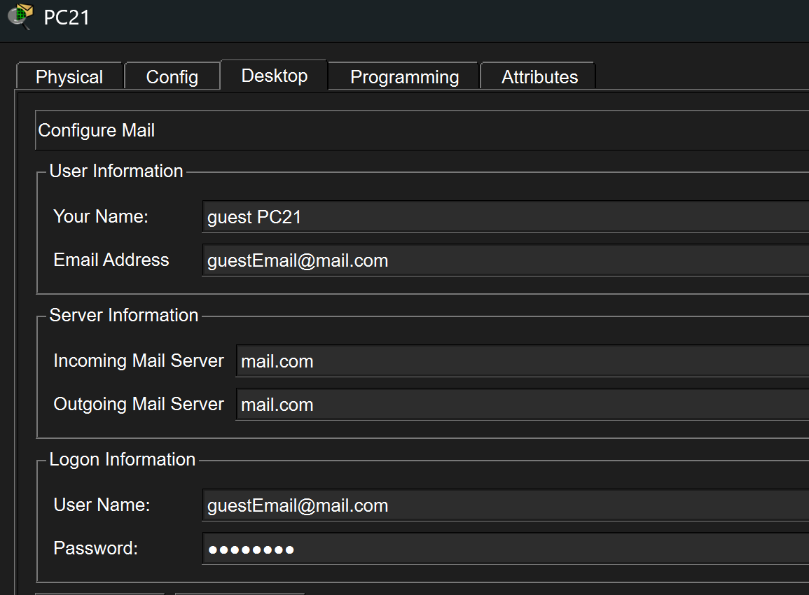
Figure 8.6.6. Guest email client configured for guestEmail@mail.com.

8.7 Email Service Verification
A test email with the subject Testing was sent from engineerEmail@mail.com to studentEmail@mail.com
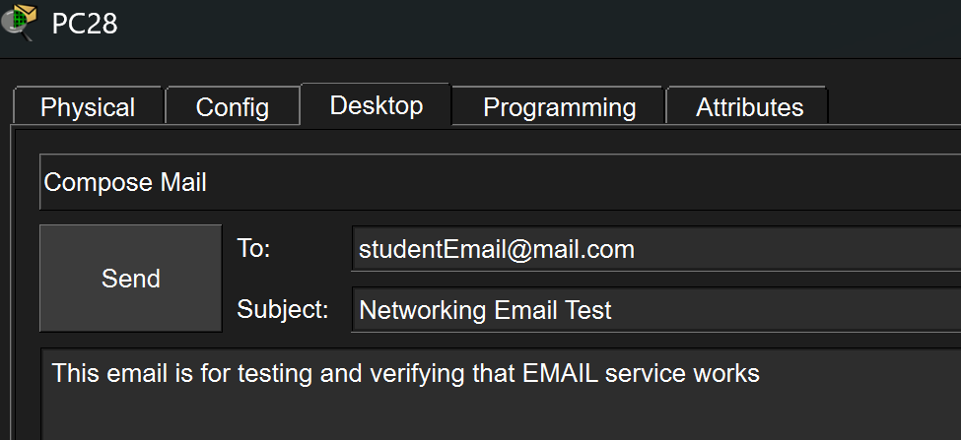
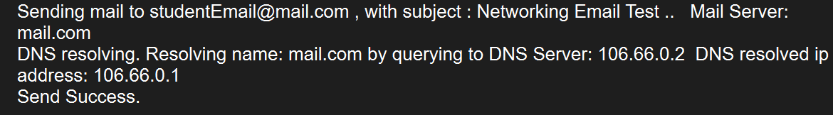
Figure 8.7.1. Test email sent from the Engineering account to Student account.

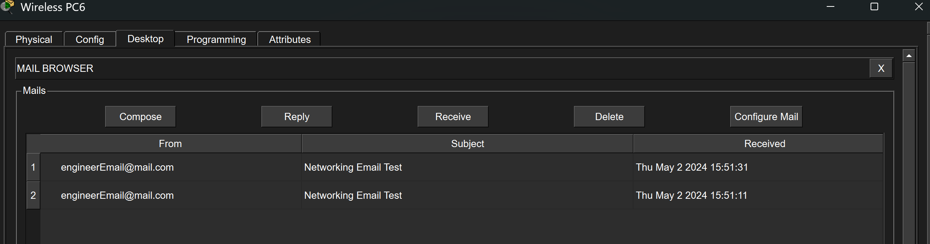
Figure 8.7.2. Student inbox showing the message received from engineerEmail@mail.com.

The message was subsequently opened on the Student PC. Its contents confirmed that it had been sent from the engineerEmail account to the Student account.

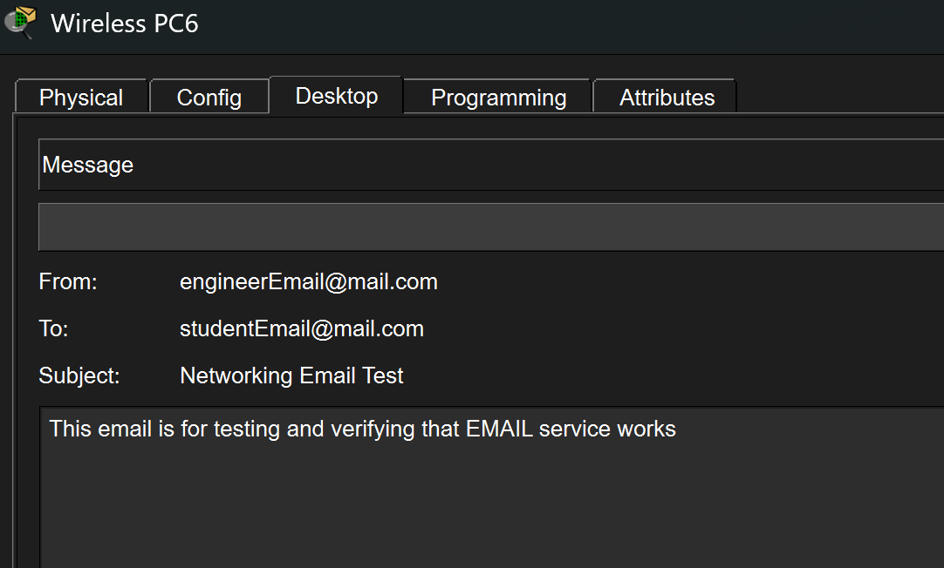
Figure 8.7.3. Opened message confirming successful email delivery between the Engineering and Student networks.

8.8 External-to-Internal Security Verification
An external server should attempt to ping a private internal client.
The test should fail because the internal private address is not directly advertised to the external network and no inbound static translation exists.
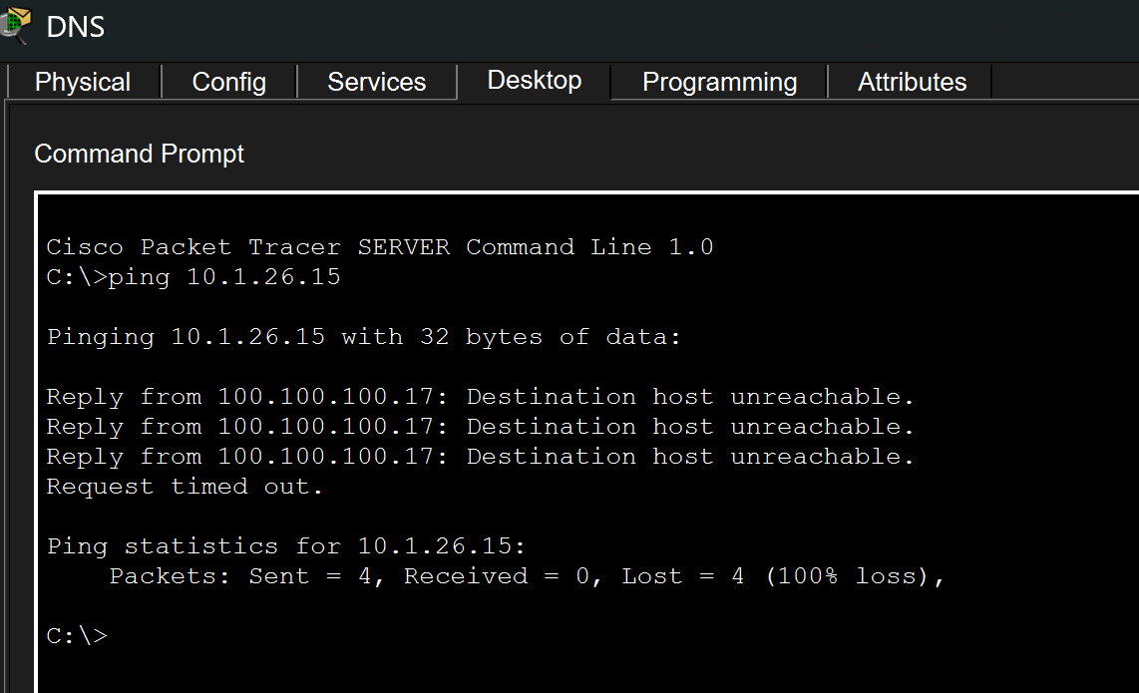
Figure 8.8.1. External server unable to initiate communication directly to an internal private client.
A failed unsolicited external ping is the expected result. It demonstrates separation between the external and internal networks; it should not be described as a fault.
The external server may still reply to communication initiated by an internal client because NAT creates a temporary translation for the returning traffic.

8.9 Section Conclusion
The external DNS, HTTP and email services were successfully configured and tested. The DNS server at 106.66.0.2 provides hostname resolution for the external servers, including www.public.com and mail.com. Successful access to www.public.com from an internal client confirmed that DNS resolution, routing, dynamic PAT and HTTP communication were operating correctly.
The external HTTP server at 106.66.0.3 displayed the required customised webpage and image. The external email server at 106.66.0.1 was configured with SMTP and POP3 services using the mail.com domain. The five required Topology Y accounts—studentEmail, wardenEmail, libarianEmail, guestEmail and engineerEmail—were created and assigned to clients in their respective networks. Successful email transmission and retrieval confirmed that the email service was operating correctly.
Internal clients were able to initiate communication with external services. An external device was unable to initiate an unsolicited ping to an internal private device, which is the expected result and confirms that the internal addressing information is not directly exposed to the external network.

- Research Findings

  - Introduction
This section proposes two improvements for the completed Topology Y enterprise network: Latency Reduction and Zero Trust Security. These improvements build on the existing VLAN, OSPF, DHCP, wireless, NAT/PAT and primary-and-backup routing design. They are research proposals only and do not need to be implemented in Packet Tracer, as stated in the project requirements.
  - Research Attribute 1 - Latency Reduction

    - Definition
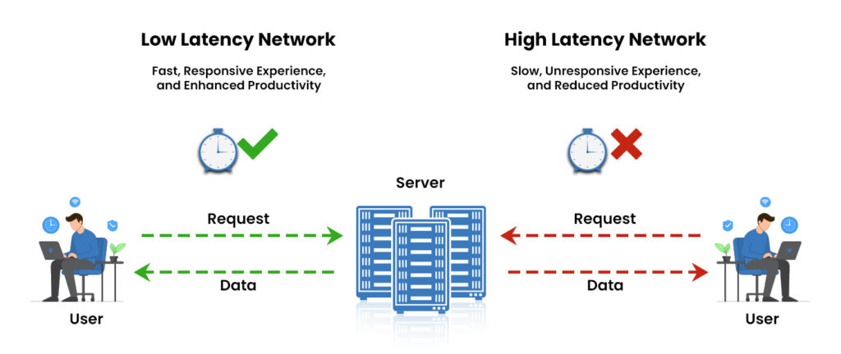
Figure 9.2.1. Factors contributing to network latency. Adapted from Pynet Labs (n.d.).
Network latency is the amount of time taken for data to travel from one device to another. In simple terms, it is the delay experienced when a user opens a website, accesses a server, sends an email or connects to a router through SSH. Lower latency provides a faster response, while high latency causes noticeable waiting or lag.
Latency can increase when links are slow, heavily used or congested. It can also increase when packets travel through an unnecessarily long route. This topology contains several serial links and two external WAN paths, so delays may occur when many devices are using the network at the same time.

    - Proposed Improvement
The first proposed improvement is to introduce Quality of Service, or QoS, on the primary and backup external WAN links. QoS does not increase the physical bandwidth of a connection. Instead, it classifies traffic and controls which packets are transmitted first when an interface becomes congested.
In Topology Y, higher priority could be assigned to small and time-sensitive traffic such as DNS requests and authorised SSH management sessions from Network A. HTTP, email and ordinary user traffic would continue using the remaining bandwidth, while large non-urgent transfers could receive lower priority. This would reduce the time that important packets spend waiting in the transmission queue when the WAN link is busy.
QoS should first be applied in the outbound direction on Net-Admin Serial3/0 and Router7 Serial2/0. Net-Admin Serial3/0 is the normal external exit, while Router7 Serial2/0 becomes the external exit when the backup path is active. Applying similar policies to both interfaces ensures that priority treatment continues during failover. Internal serial links should receive QoS policies only if monitoring shows repeated congestion or packet drops.

    - OSPF Path Optimization

OSPF selects routes using interface cost, and the route with the lowest total cost is preferred. Interface cost is influenced by the bandwidth value known to OSPF. If the configured bandwidth does not accurately represent the actual link speed, OSPF may treat a slower link as being equal to or better than a faster alternative.
For Topology Y, OSPF bandwidth and cost values should be reviewed only on internal links where more than one route to a destination exists. Faster or preferred internal links should be assigned lower costs, while slower alternative links should use higher costs and remain available when required. Changing a cost has no benefit when only one possible path exists.
This proposal concerns internal OSPF path selection. The choice between the primary and backup external WAN links should continue to be controlled by the primary default route through Net-Admin and Router7’s floating static route. OSPF costs should not be used to replace the existing primary-and-backup routing mechanism.

    - Application to Topology Y

Net-Admin is the primary exit to the external network through Serial3/0, while Router7 provides the backup exit through Serial2/0. QoS should therefore be applied to both outbound WAN interfaces so that important traffic continues receiving priority regardless of which external route is active.
The network should first be monitored using ping response times, packet loss, interface utilisation and queue-drop statistics. If congestion is confirmed, DNS requests and authorised SSH management traffic could receive higher priority because delays in these services affect name resolution and network administration. Normal HTTP, email and general user traffic would continue using the remaining bandwidth.
The distributed DHCP design may also reduce unnecessary relay traffic because different parts of the enterprise use DHCP servers located near their respective networks. However, DHCP occurs mainly when clients obtain or renew addresses, so this design does not reduce the delay of all normal application traffic.
Where alternative internal OSPF paths exist, interface bandwidth and cost values could be reviewed so that faster paths are preferred. Slower paths should remain available as alternatives rather than being removed.

9.2.5 Benefits & Limitations
The main benefit of QoS is more predictable performance during congestion. Important traffic can be transmitted before less urgent traffic, reducing the delay experienced by users and administrators.
However, QoS cannot increase the physical capacity of a link or remove delay caused by distance. Incorrect traffic classification may also prioritise unnecessary applications. Assigning too much bandwidth to one class could reduce the performance of other services.
OSPF path optimisation also has limitations. Incorrect costs may cause traffic to follow an inefficient route, so routing changes must be tested before deployment.

9.2.6 Recommendation
QoS should first be introduced on the primary and backup external WAN interfaces. Network performance should be measured before and after implementation using ping response times, packet loss and interface queue statistics.
OSPF bandwidth and cost values should also be reviewed where multiple routes exist. This proposal improves performance without requiring changes to the current IP addressing plan, VLAN design, OSPF areas, NAT pools or primary-and-backup routing arrangement.

  - Research Attribute 2 - Zero Trust

    - Definition
Zero Trust is a security approach in which users and devices are not automatically trusted simply because they are connected to the internal network. Every access request should be verified, and users should only receive access to the systems and services required for their roles.
Topology Y already separates departments and user groups using different networks and VLANs. These include Network Administration, Guest, Engineering, Warden VLAN 800 and Student VLAN 900. However, VLAN separation alone does not prevent communication once inter-VLAN routing is enabled. Additional security rules are required to control which networks may communicate.
Without these controls, a compromised Student or Guest device could attempt to reach Staff, Engineering or Network Administration resources.

    - Proposed Improvement

The proposed Zero Trust improvement is to apply least-privilege access control. Least privilege means that each user group is permitted to access only the systems and services required for its role. A device should not automatically receive broad access merely because it is connected to an internal VLAN.
In Topology Y, Student users require access to services such as DNS, email, HTTP and approved learning resources, but they do not require direct access to Network A or sensitive Staff networks. Guest users may require access to approved public services but should not be able to initiate communication with internal administrative or departmental networks.
Extended access control lists should be positioned close to the source networks so that unauthorised traffic is blocked before it travels across the enterprise. The intention is not to block all communication. Required services should first be explicitly permitted, followed by rules that deny access to protected internal networks.
This keeps the same meaning as your current paragraph but makes the traffic-policy logic clearer. Your report already correctly introduces least privilege and source-based filtering

    - Application to Toplogy Y
The first control should be an extended ACL applied inbound on the Hostel-A-B-C router subinterface serving Student VLAN 900. Applying the ACL inbound allows the router to examine Student traffic as it enters the routed network. Student devices could be permitted to access the external DNS server at 106.66.0.2, the email server at 106.66.0.1, the HTTP server at 106.66.0.3 and other approved learning services. Access to Network A and sensitive Staff or administrative networks should be denied unless specifically required.
A second extended ACL should be applied inbound on Student-Warden FastEthernet1/0, which receives traffic from Guest Network K. Guest users could be allowed to access approved public services while being denied access to Network Administration, Staff, Engineering and other private departmental networks.
SSH management should be protected separately by applying a standard ACL to the VTY lines of all routers and switches. The ACL should permit management connections only from authorised addresses in Network A. This is more precise than relying only on SSH encryption because SSH protects the session but does not determine which internal networks are allowed to initiate it.
ACL entries are processed from top to bottom and stop at the first match. Required DNS, HTTP, email and management traffic must therefore be permitted before applying broader deny statements. Every ACL also has an implicit deny at the end, so the policy must be tested carefully before deployment.

    - Benefits and Limitations
Zero Trust reduces unnecessary communication and limits an attacker’s ability to move from one compromised device into other departments. It provides stronger protection for Network Administration, Staff and Engineering resources and gives better control over Student and Guest users.
However, Zero Trust introduces additional configuration and management complexity. Incorrect ACL rules could block legitimate services, and central authentication systems would become important dependencies. The policies must therefore be introduced gradually and tested carefully.
    - Recommendation
Zero Trust should be introduced in phases. The first phase should apply inbound extended ACLs to Student VLAN 900 and Guest Network K while preserving access to the required external DNS, HTTP and email services. The policies should initially be tested using temporary logging and connectivity checks to confirm that legitimate traffic is not blocked.
The second phase should restrict SSH management on every router and switch so that only authorised devices from Network A can initiate administrative sessions. This should be implemented using an access-class on the VTY lines in addition to the existing SSH-only configuration.
A future production deployment could then introduce centralised AAA, 802.1X, enterprise wireless authentication, multi-factor authentication and central security monitoring. This staged approach changes the network from broad internal trust to controlled, least-privilege access without attempting to introduce all security controls at once.

- Conclusion
The Topology Y enterprise network was configured using the approved addressing plan and the requirements provided in Appendix A. The implementation included meaningful device hostnames, secured SSH access, VLANs and trunk links, router-on-a-stick inter-VLAN routing, multi-area OSPF, distributed DHCP services, wireless access for Warden VLAN 800 and Student VLAN 900, dynamic PAT, primary and backup external routes, and externally hosted DNS, HTTP and email services.
Representative configurations and verification outputs were used to avoid repeating similar commands for every device. The tests demonstrated internal routing, DHCP address assignment, wireless connectivity, external service access, NAT/PAT operation and backup-route activation. The proposed latency-reduction and Zero Trust improvements could further improve the network by prioritising important traffic, selecting more efficient paths and limiting unnecessary communication between user groups.
Overall, the completed topology provides the required connectivity, service availability and security foundation. Future improvements should be introduced gradually and tested to ensure that they improve performance and protection without disrupting legitimate network services.

- References

Cisco configuration references
Cisco. (n.d.). Configure inter-VLAN routing with the use of an external router.
https://www.cisco.com/c/en/us/support/docs/lan-switching/inter-vlan-routing/14976-50.html
Cisco. (n.d.). Configure network address translation.
https://www.cisco.com/c/en/us/support/docs/ip/network-address-translation-nat/13772-12.html
Cisco. (n.d.). Configure SSH on routers.
https://www.cisco.com/c/en/us/support/docs/security-vpn/secure-shell-ssh/4145-ssh.html

Cisco. (2017, August 11). Configuring the Cisco IOS XE DHCP relay agent.
https://www.cisco.com/c/en/us/td/docs/ios-xml/ios/ipaddr_dhcp/configuration/xe-16-6/dhcp-xe-16-6-book/dhcp-relay-agent-xe.html

Cisco. (2022, March 4). Cisco Wireless Controller configuration guide, Release 8.10: FlexConnect.
https://www.cisco.com/c/en/us/td/docs/wireless/controller/8-10/config-guide/b_cg810/flexconnect.html

Cisco. (2025, September 15). OSPF configuration guide—Cisco IOS XE 17.
https://www.cisco.com/c/en/us/td/docs/switches/lan/c9000/lyr3-fwd/ospf/ospf-configuration-guide/ospf.html

Cisco. (2026, April 22). NAT configuration guide—Network address translation.
https://www.cisco.com/c/en/us/td/docs/switches/lan/c9000/lyr3-fwd/nat/nat-configuration-guide/nat.html

Cisco. (n.d.). Review OSPF frequently asked questions.
https://www.cisco.com/c/en/us/support/docs/ip/open-shortest-path-first-ospf/9237-9.html

Cisco. (2019, August 13). Low latency queueing with priority percentage support.
https://www.cisco.com/c/en/us/td/docs/ios-xml/ios/qos_conmgt/configuration/xe-16-12/qos-conmgt-xe-16-12-book/qos-conmgt-llq-pps.html

Cybersecurity and Infrastructure Security Agency. (2023, April 11). Zero Trust maturity model.
https://www.cisa.gov/resources-tools/resources/zero-trust-maturity-model

NetSecProf. (2024, January 12). PacketTracer—Configuring a router on a stick [Video]. YouTube. https://www.youtube.com/watch?v=bqsR83SlnQY

National Institute of Standards and Technology. (2020). Zero trust architecture (NIST Special Publication 800-207). https://doi.org/10.6028/NIST.SP.800-207

