TEMASEK POLYTECHNIC
SCHOOL OF INFORMATICS & IT
DIPLOMA IN CYBERSECURTY & DIGITAL FORENSICS

AY 2026 APRIL SEMESTER
FORENSICS IN DIGITAL SECURITY (CCD2C04)
CASE STUDY REPORT

SUBJECT LEVEL: 2

INSTRUCTIONS TO CANDIDATES

- This Case Study Report consists of 3 pages (including the cover page).
- This document describes the Case Study that should be submitted for Forensics in Digital Security.
- This case study contributes 30% of the subject.
- Please complete this case study in groups of 3-4 members.
- Please read the requirements of the case study and complete ALL parts of the requirements.
- Please follow the submission instructions carefully.
- Please refer to Appendix A for the cover page of your case study report submission.
- Please refer to the Teaching Plan for milestones and submission timeline.
Computer Evidence Investigation

Case Study Report (30%)
You are a new digital forensic investigator in the special technology branch, before you embarked on any investigation, you are to level up your knowledge and skill in the domain of Digital Forensics. As such, you are required to complete the following tasks.

LinkedIn Learn Certification (5%)
Please note that the LinkedIn Learning Video must be accessed via TP Library Portal, otherwise you will not get the full video access or must pay for it. Follow the link: https://tp.libguides.com/linkedinlearning/loggingin

- Complete and attain the certification for the following modules.
- Linked the certs to your LinkedIn profile.

1.1) Computer Hacking Forensics Investigator (CHFI) Cert Prep
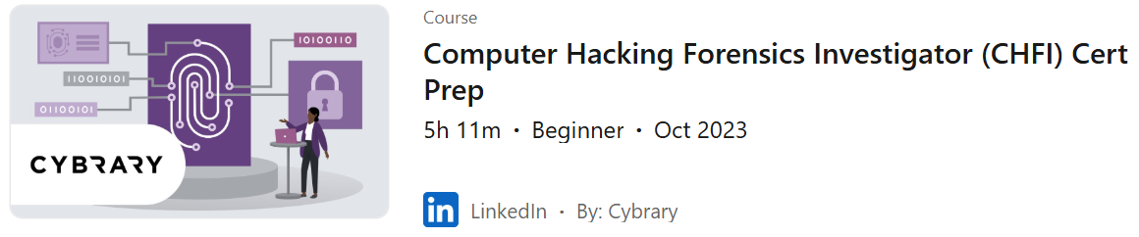
https://www.linkedin.com/learning/computer-hacking-forensics-investigator-chfi-cert-prep/course-introduction?resume=false&u=76881922

1.2) Learning Autopsy for Digital Forensics (Optional)


https://www.linkedin.com/learning/learning-autopsy-for-digital-forensics/hey-where-s-the-data?autoplay=true&u=76881922

Individual Research Reflection (Group Submission) (5%)
Base on the Computer Hacking Forensics Investigator (CHFI) Cert Prep LinkedIn Learn module; each group member is required to select one unique topic from the list provided below. No two member within the same group may choose the same topic.

2.1) Task Requirements
For your selected topic, you are to write a personal reflection that includes:

  - Key insights gained from the LinkedIn course.
  - Your evaluation of the forensic value of this topic in the field of digital forensics.

2.2) Topics List
- Filesystems Forensics
- Data Acquisition
- Anti-Forensics Techniques
- OS Forensics
- Network Forensics
- Web Attack Forensics
- Database Forensics
- Cloud Forensics
- Malware Forensics
- Email Forensics
- Mobile Forensics

3) Submission Guidelines
- Each student’s reflection report is limited to a maximum of 2 pages, font size 12.
- All individual reflections must be compiled into a single group report.
- Ensure that each section clearly indicates the name of the student and their selected topic.

Appendix

Each student must do the following:
- Provide a link to your LinkedIn Profile showing that you have updated it with the completed certifications.
- Provide screen shots of the completed certifications.

4) Computer Forensics Quiz (20%)
Complete a close book Digital Forensics Quiz to ascertain your digital forensics knowledge acquired. It will cover content from Week 1-3 including the CHFI LinkedIn module. The Quiz will be held in Week 6.

END

