Digital Forensics Case Defence Analysis Report
Case Number: P0xG0x

<Date>
Prepared by:
No. | Matric Number | Name | Contribution

Table of Contents
Table of Contents 2
1. Executive Summary 3
2. Methodology 3
3. Timeline 4
4. Relationship Diagram 4
5. Analysis 5
5.1. Analysis of Disk Image 5
5.1.1. Emails 5
5.1.2. Documents 5
5.1.3. Graphics Files 6
5.1.4. HTML Files 6
5.1.5. Analysis of File Slack 6
5.1.6. Miscellaneous 7
6. Conclusion 7
7. Tools Used 8
8. References 8
9. Appendix 8

Executive Summary
Brief non-technical overview. States the scope of the examination, key findings, and the main conclusion in plain language. Written last — after all findings are complete.
Nunc sagittis quis lacus id iaculis. Duis rhoncus dui id dapibus feugiat. Sed vel nisi convallis, elementum nisl quis, egestas sem. Vestibulum scelerisque magna commodo ligula egestas feugiat. Proin ac elit mi. Aenean blandit, ligula vel efficitur faucibus, mauris felis eleifend dui, eu ullamcorper orci augue quis orci. Curabitur hendrerit varius scelerisque. Donec at convallis justo, non condimentum ex.
Nunc pharetra nibh non posuere varius. Praesent quis lacinia velit, ac consequat lectus. Aenean ex dui, finibus vitae nunc vitae, porttitor consectetur quam. Mauris vel neque ante. Nulla ullamcorper ipsum ut tellus consectetur mattis. Aliquam pellentesque tristique neque vel porttitor. Mauris quis justo sagittis, interdum massa et, tincidunt nibh. Etiam et pulvinar dolor, eget dictum metus.

Methodology
Describe the setup of your team computer forensics investigation environment and the forensically sound process and procedure, which was used to analyse the acquired image. State all process and procedure used from the time you received the acquired image to demonstrate forensic soundness.
Case reference number, date evidence received, and chain of custody.
Tools used (name, version, SHA-256 hash of the tool binary), acquisition method, hash verification records, and the examination environment (hardware specs, OS version, tool settings). Must be detailed enough for another examiner to replicate exactly.
Nunc sagittis quis lacus id iaculis. Duis rhoncus dui id dapibus feugiat. Sed vel nisi convallis, elementum nisl quis, egestas sem. Vestibulum scelerisque magna commodo ligula egestas feugiat. Proin ac elit mi. Aenean blandit, ligula vel efficitur faucibus, mauris felis eleifend dui, eu ullamcorper orci augue quis orci. Curabitur hendrerit varius scelerisque. Donec at convallis justo, non condimentum ex.
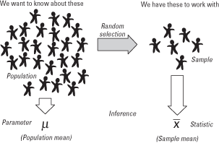
Figure 1

Timeline
- Provide a visual infographic on the case timeline. e.g.
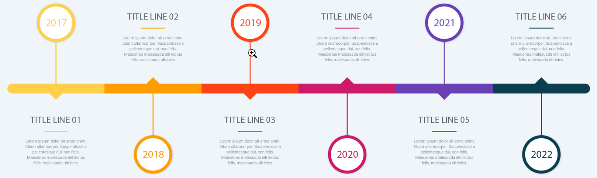
Figure 2
- Put these evidences into a timeline, in ascending order. You may use the template below:
S/No | Date | Time | Artefact Description
1
2

Table 1
Nunc sagittis quis lacus id iaculis. Duis rhoncus dui id dapibus feugiat. Sed vel nisi convallis, elementum nisl quis, egestas sem. Vestibulum scelerisque magna commodo ligula egestas feugiat. Proin ac elit mi. Aenean blandit, ligula vel efficitur faucibus, mauris felis eleifend dui, eu ullamcorper orci augue quis orci. Curabitur hendrerit varius scelerisque. Donec at convallis justo, non condimentum ex.

Relationship Diagram
Depict all the related persons involved in a relationship diagram. e.g.
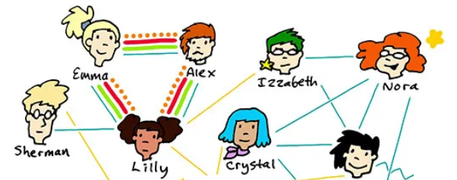

Analysis

Analysis of Disk Image
Describe the forensic tools used to analyse the acquired image. Use alternative tools e.g. Autopsy and FTK to verify the findings found in the investigation. Using the acquired image given, show the possible digital evidences that your team found that would be useful to the case.
Lorem ipsum dolor sit amet, consectetur adipiscing elit. Ut nulla magna, molestie sit amet luctus quis, tincidunt ac mi. Sed convallis purus ac metus efficitur facilisis. In molestie sit amet tellus at blandit. Integer tempus at eros sit amet iaculis. Donec imperdiet luctus quam.

Emails
- Lorem ipsum dolor sit amet, consectetur adipiscing elit. Ut nulla magna, molestie sit amet luctus quis, tincidunt ac mi. Sed convallis purus ac metus efficitur facilisis. In molestie sit amet tellus at blandit. Integer tempus at eros sit amet iaculis. Donec imperdiet luctus quam. Vestibulum sed nisl eros. Donec laoreet est ut justo imperdiet, quis ultrices lectus mollis. Nunc suscipit vulputate magna, ac facilisis metus scelerisque vel. Sed scelerisque posuere massa, eu eleifend urna egestas at. Fusce id tempor nisi. Vestibulum aliquam euismod sollicitudin. Nunc in semper nunc, ut hendrerit nulla.

- 
Figure 3

Documents
- Lorem ipsum dolor sit amet, consectetur adipiscing elit. Ut nulla magna, molestie sit amet luctus quis, tincidunt ac mi. Sed convallis purus ac metus efficitur facilisis. In molestie sit amet tellus at blandit. Integer tempus at eros sit amet iaculis. Donec imperdiet luctus quam. Vestibulum sed nisl eros. Donec laoreet est ut justo imperdiet, quis ultrices lectus

Graphics Files
- Lorem ipsum dolor sit amet, consectetur adipiscing elit. Ut nulla magna, molestie sit amet luctus quis, tincidunt ac mi. Sed convallis purus ac metus efficitur facilisis. In molestie sit amet tellus at blandit. Integer tempus at eros sit amet iaculis. Donec imperdiet luctus quam. Vestibulum sed nisl eros. Donec laoreet est ut justo imperdiet, quis ultrices lectus mollis. Nunc suscipit vulputate magna, ac facilisis metus scelerisque vel. Sed scelerisque posuere massa, eu eleifend urna egestas at. Fusce id tempor nisi. Vestibulum aliquam euismod sollicitudin. Nunc in semper nunc, ut hendrerit nulla.

Figure 4

HTML Files
- Phasellus sit amet orci mattis, suscipit tellus sit amet, interdum enim. Sed congue sodales leo, ut faucibus elit scelerisque sit amet. Pellentesque porttitor risus eu nisi rhoncus sodales. Etiam mollis sollicitudin dui, at pellentesque nulla dignissim ac. Praesent malesuada nisl at mi tincidunt, id feugiat mauris laoreet. Etiam non egestas elit. Aliquam molestie neque at blandit sodales.

Analysis of File Slack
- Phasellus sit amet orci mattis, suscipit tellus sit amet, interdum enim. Sed congue sodales leo, ut faucibus elit scelerisque sit amet. Pellentesque porttitor risus eu nisi rhoncus sodales. Etiam mollis sollicitudin dui, at pellentesque nulla dignissim ac. Praesent malesuada nisl at mi tincidunt, id feugiat mauris laoreet.

Figure 5

Miscellaneous
- Phasellus sit amet orci mattis, suscipit tellus sit amet, interdum enim. Sed congue sodales leo, ut faucibus elit scelerisque sit amet. Pellentesque porttitor risus eu nisi rhoncus sodales. Etiam mollis sollicitudin dui, at pellentesque nulla dignissim ac. Praesent malesuada nisl at mi tincidunt, id feugiat mauris laoreet. Etiam non egestas elit. Aliquam molestie neque at blandit sodales.

Conclusion
From the analysis of the evidence collected, draw the possible conclusion to the case. It should be objective based on the evidences and not based on assumptions and opinions.
Interpretation of the findings. Maps evidence to the 5WH framework. States explicitly what CAN and CANNOT be concluded from the evidence. Distinguishes confirmed facts (e.g. 'The file was accessed') from inferences ('This is consistent with user jsmith being present'). Crucial for court credibility.
Nunc sagittis quis lacus id iaculis. Duis rhoncus dui id dapibus feugiat. Sed vel nisi convallis, elementum nisl quis, egestas sem. Vestibulum scelerisque magna commodo ligula egestas feugiat. Proin ac elit mi. Aenean blandit, ligula vel efficitur faucibus, mauris felis eleifend dui, eu ullamcorper orci augue quis orci. Curabitur hendrerit varius scelerisque. Donec at convallis justo, non condimentum ex.

Tools Used
- A
- B
- C
- D
- E
- F

References
- SSSSSSSSSSSSSSSSSSSSSSSSSSSSSSSSSSSSSSSSSSSSSSSSSSSSSSSSSSSSSSSSSSSSSSSSSSSSSSSSSSSSSSSSSSSSSSSSSSSSSSSSSSSSSSSSSSSSSSSSSSSSSSSSSSSSSS

Appendix
- Chain of custody form, hash verification logs, tool output screenshots, raw data extracts, and all supporting documentation. Every exhibit must be numbered, indexed, and cross-referenced in the main body of the report. The appendices are what the opposing expert will scrutinize first.
- MAPS (Message, Audience, Purpose, Strategy) oral presentation framework.

- Individual TESSy Subject Survey must be completed with screenshots of completion

