
DIPLOMA IN CYBERSECURITY &
DIGITAL FORENSICS (LEVEL 2)

FORENSICS IN DIGITAL SECURITY (CCD2C04)

Practical 2
Forensic Toolkit

The objective of this lab is to explore how FTK and HxD software is used in analysing files and file system. The concept of slack space will also be discussed.

- Part 1 Setting Up

- Start the Virtualbox Windows 10 VM.

- The HxD should have been installed in the VM, else follow the subsequent steps to install.

- Find the HxD installer in C:\Software\Labs\P2\HxD of your guest machine. The file name is HxDSetup.exe.

- Start the Virtualbox Windows 10 VM.

- Install HxD then shut down the VM. Allow installer to remove older version and select typical installation.

- Find the image of a blank, formatted floppy disk in C:\FDS of your host machine. The file name is floppy.img.

- Add a Floppy Controller to the Virtualbox Windows 10 VM. You may do so via Virtualbox Manager > Settings > Storage > Add Floppy Controller
[Note: Make sure your Virtualbox Windows 10 VM is powered off.]
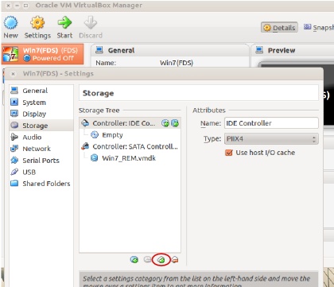

- Add the blank floppy image (floppy.img) to the Virtualbox image.
[Note: The folder where floppy.img is stored is mentioned previously.]

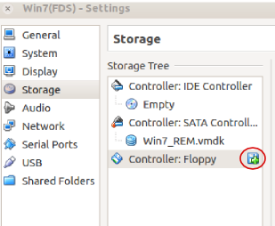

- Start your Virtualbox Windows 10 VM and login as “user”.

- Sdelete64 should have been installed with a shortcut on the desktop, else go to C:\Software\tools\sysinternalssuite\sdelete64.exe.

- Format the floppy disk via Windows Explorer > Computer > Right Click on Floppy Disk Drive > Format. Uncheck the “Quick Format” of the Format Dialog.
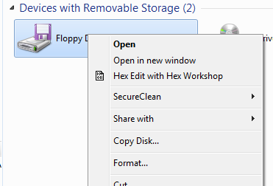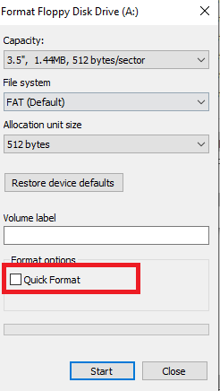
- You may also use the Sdelete64 to wipe Drive A:
Clean and zero all free space in Drive A: Sdelete64 -c -z a:
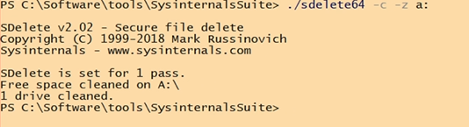

- Use WordPad program to create a file with a sentence “This is to test deleting files and then wiping them”. Name the file TestFileP2.rtf.

- Save TestFileP2.rtf into the floppy disk, and verify it is there.

- Now delete the file.

- Start FTK and start a new case with case number “1” and case name “Part1”.
[Note: If you encounter problems with access rights when starting FTK, then use
“Run as Administrator” option when starting.]

- In Add Evidence dialog box, what type of evidence should you add?

- What is the time zone you should select in Local Evidence Time Zone drop down box under Evidence Information? Why?

- Locate the file that you have just deleted from the floppy. Describe where you can find this file and state its contents.

- Close all open windows in your VM.

- Part 2 Secure Wiping Data

- Use “Windows Explorer” to perform a format or Sdelete64 to wipe floppy disk.


- After Sdelete64 finishes cleaning the floppy disk, close the program.

- Start FTK and start a new case with case number “2” and case name “Part2”. Add in the floppy as evidence.

- What did you see from FTK’s Evidence Information box?

- In the Slack/Free space area, what does the FAT1 & FAT2 show? What does it mean or indicate?

- Part 3 Manipulating File Slack

- Use the same floppy disk, in Sdelete64 to wipe clean the floppy disk.


- Create a text file with the following words, “This is a normal text”, save as file.txt into the floppy disk.

- Start HxD using “Run as Administrator” option.

Exploring with HxD

- In HxD, Click on Tools > Open Disk, select the floppy disk (A: drive). Then Uncheck the option “Open as Read Only” and click OK.
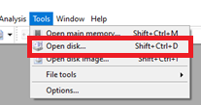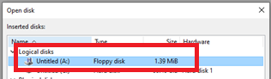

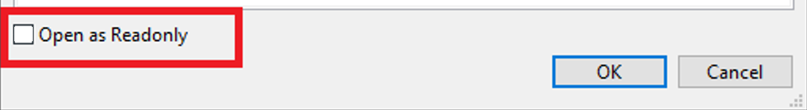

- Then click on Search > Find and look for text string that you input into the text file that you created in the previous step.
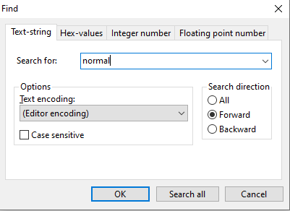

- Note the sector number in decimal as shown at the sector of HxD.
[Note: The sector number is shown on the right to the message.]

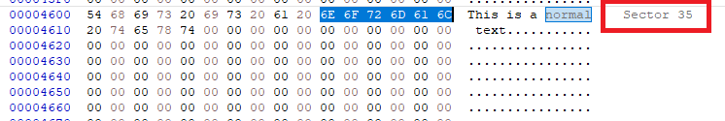

- Scroll to the bottom of the Sector. Type in a special phrase “Hidden Secret” and click the Save button on the Toolbar.
[Note: Did you select “Run as Administrator” option.]

- Now open the same text file by going to File > Open.

- Can you find the string “Hidden Secret”? Why?

Using FTK to search file and disk slack space.

- Start FTK and in Add in Evidence, select Drive A from the Local Drive option button.

- Use “3” as the case number and “Part3” as the case name.

- Now use FTK to search for the special text “Hidden Secret”. Indicate below where you can find these texts ie note down the sector and offset of the data.

- Clue: Click the Search tab. Click Tools > Analysis Tools > Full Text Indexing check box, if necessary, and then click OK.

- In Search tab, enter “Secret” in Search Term text box, type your search string and click Add. Enter as many as you like, but please note the AND, OR.
- You may need to use Live Search if necessary. Can you find the text? What is the difference in using Live Search?

- How can you verify the results between FTK and HxD?

- What is slack space? What is the main issue of slack space as a forensic investigator?

- Part 4 Create Secret Message in Slack Space

Wipe clean the floppy disk and plant a secret message into the slack space. Get your peer to look for the secret message.

