
DIPLOMA IN CYBERSECURITY &
DIGITAL FORENSICS (LEVEL 2)

FORENSICS IN DIGITAL SECURITY (CCD2C04)

Practical 3
Storage Investigation

- Introduction
This lab involves the use of HxD (Hexadecimal Editor) to conduct investigation of the floppy disk (floppyP3.img) provided in LMS and how data can be hidden inside the slack space.

- Overview of FAT File System

- Use HxD to view the boot sector (sector 0)
  - Attach the floppy disk (floppyP3.img) to your VM.
  - Open HxD, under “Tools> Open Disk”, an “Open Disk” dialog will appear.
  - Select Logical Disk “Floppy A:” in the “Open Disk” dialog.
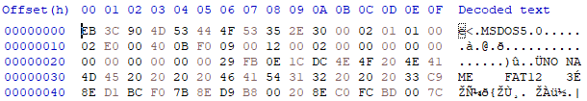

Byte Range | Offset  Dec (Hex) | Values, | Sector
Bytes per sector | 11–12 (0x0B-0x0C) | 0x0200, 512
Sector per cluster | 13 (0x0D) | 0x01, 1 | 1 sector per cluster
Reserved | 14-15 (0x0E-0x0F) | 0x01, 1 | 1
No. of FAT | 16 (0x10) | 0x02, 2
Number of root directory entries | 17–18 (0x11-0x12) | 0x00E0, 224
Total number of sectors | 19–20 (0x13-0x14) | 0x0B40, 2880
Media descriptor type | 21 (0x15) | 0xF0 (1.44 MB)
Number of sectors per FAT | 22-23 (0x16-0x17) | 0x0009, 9
FAT 0 | 512 (0x200-0x13FF) |  | Sector 1 –9
FAT 1 | 5120 (0x1400-0x25FF) |  | Sector 10 - 18
Root Directory | 9728  (0x2600-0x41FF) | (number of root entries * 32) / (bytes per sector)  (224 * 32)/512  14 sectors | Sector 19-32
Data Area | 16896  (0x4200 onwards) |  | Sector 33-2879

- Use HxD to view FAT 0 at Sector 1 and FAT 1 at Sector 10.
  - FAT 0 at Sector 1
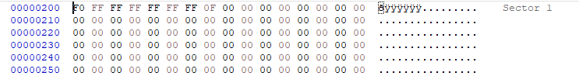

  - FAT 1 at Sector 10

- Use HxD to review the root directory entries at Sector 19
  - Refer to the lecture slides and read the details of the Long File Name Directory Entries.

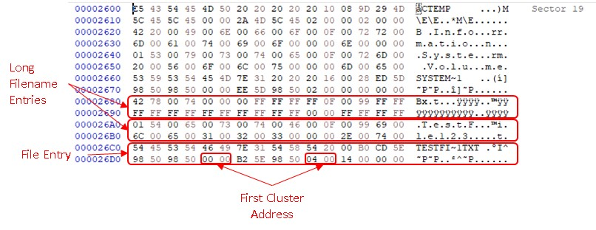
- Use HxD to locate first cluster of the file TestFile123.txt
  - 00 00 04 00 => 0x 0000 0004 > Cluster 4
  - (Cluster No. - 2) x (Sectors/cluster) + (sector of cluster 2)
  - (4-2)x(1) + 33 = sector 35
  - Use HxD to view sector 35 (as shown in Figure D3)

- Use HxD to locate data cluster of the file TestFile123.txt

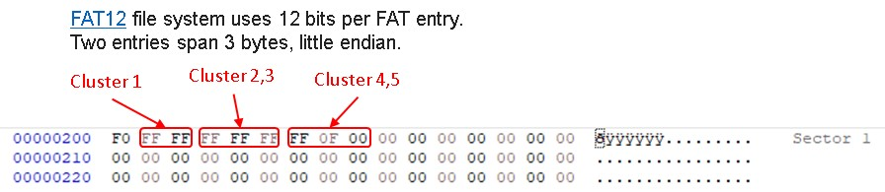
  - Cluster 4,5=>FF 0F 00
  - Cluster 4 value = 0xFFF, Cluster 5 value = 0x000
  - Cluster 4 is the end of chain indictor while Cluster 5 is empty cluster.

- Try adding content to the file to increase the size to more than 512 bytes
- Use HxD to locate next cluster for TestFile123.txt
  - Cluster 4,5=> 05 F0 FF
  - Cluster 4 value = 0x005, Cluster 5 value = 0xFFF
  - Cluster 4 is chained to Cluster 5, Cluster 5 is the end of chain indicator.

- Explore Another File Entry with HxD
Identify file entry for “Welcome.txt” located inside the floppy disk and answer the following question.
- Which are the file entries for “Welcome.txt”?

- At which cluster is the data of file “Welcome.txt” located?

- What is the created date for the file “Welcome.txt”, in hexadecimal?

- Explore Deleted File Entry with HxD
Explore the data located in the floppy disk to identify delete file entries.

- What is the value used to flag a file entry as deleted?

- What is the file name of the deleted file located inside the disk?

- What is the created date of the deleted file, in hexadecimal?

- Explore Slack Space
You will hide evidence in three areas on a test disk and your partner will need to search for the hidden messages in the slack space.

- Before you start think of a three word message and each word must have more than one letter. Write this down:

- Part A. Preparing your floppy disk

- Before you power on your Virtualbox Windows 10 VM, rename the floppy image that you have used in Practical 2 with the last 5 digits of your Matric number.

- Then, attach the floppy disk to your VM. If you are not sure how to do so, please refer to Practical 2.

- Start your Windows 10 VM and login as “user”.

- Format your floppy disk and use sdelete64 to wipe the floppy disk.
[Note: Refer to Practical 2 on how to wipe the floppy disk.]

Part B. Planting the secret message

- Use WordPad to create 3 files to be saved into the floppy disk.

- Create the first file with the text string “Welcome to Singapore”. Save this file as LabP3-1.rtf in the floppy disk.

- Create the second file with the text string “Welcome to Malaysia”. Save this file as LabP3-2.rtf in the floppy disk.

- Create the third file with the text string “Welcome to Indonesia”. Save this file as LabP3-3.rtf in the floppy disk.

- Now start the HxD.

- Use the HxD to document the filename and sector number in Table A below. If not sure please refer to Practical 2 on how to fill the details.

Filename & Data Item Sector & Offset
Table A

- Now plant the message that you have prepared using the following method.

- Plant the 3 words in different location of the disk sector. Click Disk > Next Sector to proceed to another sector. Skip a few sectors if necessary; find an empty sector, which shows only zeros in the middle column of the window. Type your message word and record the sector in the Table B. Repeat until all the 3 words has been planted.

Message Word Sector & Offset
Table B

You must let your lecturer verify the above before proceeding.

- Part C. Search the Message Using FTK
Name: __________________
Adm No: __________________
Class: __________________

- The lecturer will give you a floppy disk image created from Part B.

- Note the Floppy Disk number and write it below.
Investigation Floppy No._______________

- Create a new case name “Reveal message” and use “43” as the case number.

- Now use FTK to investigate the disc you just obtained. Search for the planted message from the disc and write down the details of the location of the message in the table C below.

Message Word Sector & Offset
Table C
- Explain what is slack space?

- Is the slack space dependent on the Operating System? Why (Clue: compare Windows & Unix filesystems)?

- What is the advantage and disadvantage of using slack space to store hidden messages?

- Part D (E Learning)

- Hide Secret Files in Plain Sight
http://www.youtube.com/watch?v=bnHVSXbXdnQ

- Hide Secret Messages in Audio
https://www.youtube.com/watch?v=4LP6nDRbDOA

