
DIPLOMA IN CYBERSECURITY &
DIGITAL FORENSICS (LEVEL 2)

FORENSICS IN DIGITAL SECURITY (CCD2C04)

Practical 6
Data Hiding

You will use open source tools to discover hidden text in images and plant messages in images.

- Part 1. Preparing Messages

  - Start Windows 10 VirtualBox VM.

  - Create a folder C:\P6.

  - Copy the folder C:\Software\Labs\P6\ImagesFiles into C:\P6.
[Note: You should copy the entire folder and not the contents of the folder.]

  - Use Notepad to create a file. The file should contain a simple sentence that you want to hide.

  - Save the files in C:\P6.

- Part 2. Insert the Message

- Using the Multihasher hashing program found in C:\Software\Labs\P5\Hash Tool to calculate the hash value of the image file you intend to hide the file in.
[Note: The images may be found in C:\P6\Images files.]

MD5 Value: Image filename:

- Start the S-Tool program in C:\Software\Labs\P6\S-Tools4.

- Drag and drop a bmp image into the S-Tools Window. Then drag and drop the previously created secret text file into the bmp image. Observed the output from the Action window. Note, only bmp, gif and wav file can be used in this program.
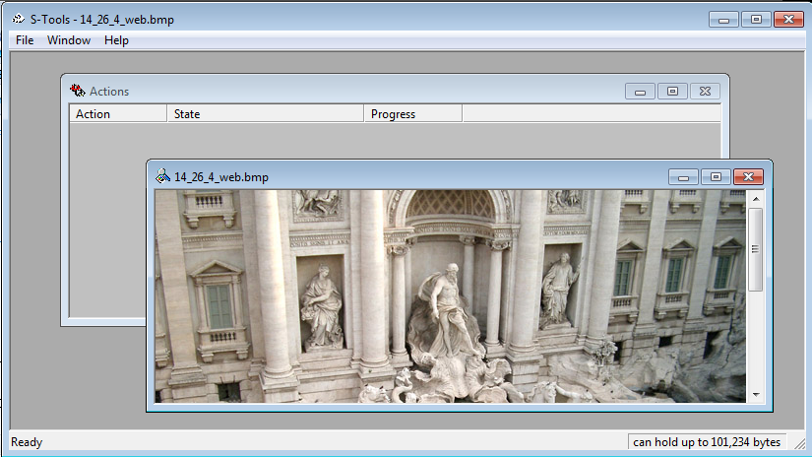

- Right-click on the new image and save it as a different name.

- Open the two images side by side, do you observe any difference?
no

- Now use the Hash program to calculate the new image hash value. Is there a difference in the hash value compared to the original image?

MD5 Value: Image filename:

- Use the same hidden image file and reveal the secret text file content.

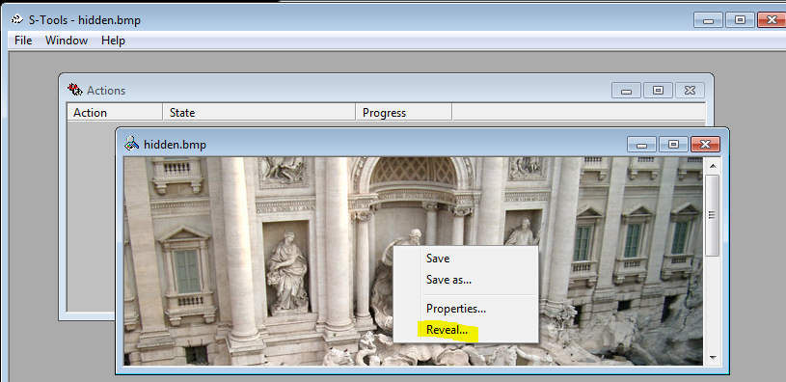

Part 3. Using More Stenographic and Password Breaking Tool

- Go to the folder C:\Software\Labs\P6\JPHide and Seek, locate the program Jpshwin.exe.

- Use Notepad to create a message and save it to the current directory.

- Activate the Jpshwin.exe.

- Click on the Help menu to note how to hide a message file in the picture.

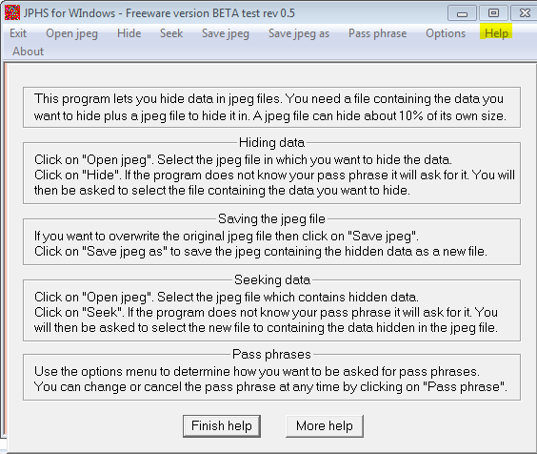

- Open jpeg -> select a jpg image file

- Note the max Capacity and recommended limit. Why is there a limit to the size of message that can be hidden in a picture?

- Select the Hide option, use a simple word as the passphrase and select the file to hide. Use Save jpeg as option to save image to another file name to C:\Software\Labs\P6\StegDetect

- Now you will use StegDetect to break the passphrase that you have placed inside the image. First, copy the image file into the C:\Software\Labs\P6\StegDetect.

- Use Shift + right click on C:\Software\Labs\P6\StegDetect to open the command prompt to run the Stegbreak program.

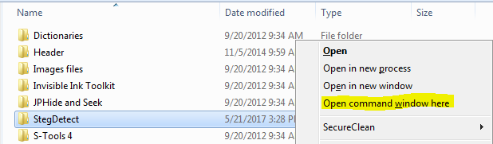

- Use the following command to run Stegbreak program.
stegbreak -r rules.ini –f dictionaryfile imagefile
You need to input the dictionaryfile and imagefile
E.g.
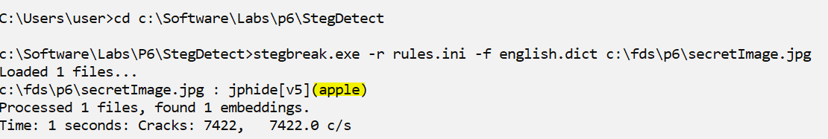

- Using the obtain password, use the Jpshwin.exe to extract out the message.
Open jpeg -> select the hidden image, Seek -> enter the passphrase -> save the extracted file

- Find a big image and try hiding another smaller image within the big image. Is it possible?

- You should also try using steghide and stegseek as well, which can be installed via Kali Linux.
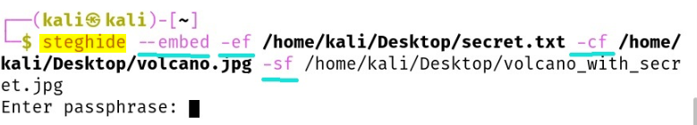

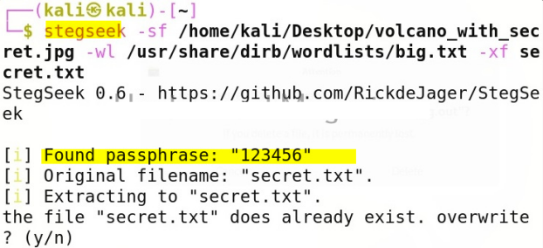

- Part 4. Rebuilding File Headers

- Use any image view to view the image file that is in the folder C:\Software\Labs\P6\Header.
- Can you view the picture image.bak?
NO

- Start the HxD. Open the image.bak file.

- Write down the value of the first 10 bytes in Hexadecimal format starting at the first byte position below.

- Now leave the image.bak file open, using the HxD open another jpeg file, and observed the hexadecimal value of its first byte position.

- What should be the correct value for the image.bak headers in order to restore the file?

- Now change image.bak with the correct values and save it. Then add a file extension “.jpg” to the file. Now see if you can view it.

- Part 5. Challenge

- Your lecturer will now ask you to download a special image file.
Clue: “The person who created the image loves the Oktober Fest”

- With the clue provided, try to obtain the secret message in the image.

- Write down the secret message from the special image using all the techniques that you have learned.

- Part 6. E-learning

- Steganography
https://www.lynda.com/IT-Infrastructure-tutorials/Steganography/476620/511453-4.html

- Forensic Network Analysis with Wireshark and Network miner
https://www.youtube.com/watch?v=6wxcQXVZ5L4

