Thermal Tool

Catalog

**Arguments** 2

**Excel Format** 2

1. Tools for PTU, sensor, and HDD 2

2. Tools for CPU_pid and GPU_pid 4

**How to Use?** 5

**Revision History** 6

1. 2021.01.21 Debug --ptu2 6

2. 2021.02.20 Upgrade –gpulog --cpulog 7

# **Arguments**

* --output thermal.xlsx
* --hdd HDDtemp.txt
* --bmc BMCtemp.txt/BMCtempswitch.txt
* --bmc2 sdr.txt
* --ptu PTUtemp_old.txt
* --ptu2 PTUtemp_new.txt
* --cpulog CPU_PID.log/CPU_PID.txt
* --gpulog GPU_pid.txt
* --draw enable/disable (optional, the default value is 'enable', set it to 'disable' if you don't plan to draw)

# **Excel Format**

## Tools for PTU, sensor, and HDD

All the sheets can be classified into the following three types: common sheet, log sheet, and summary sheet.



* **Common sheet**

PTU, sensor, and HDD are all common sheets, which are used as the guidelines to generate the log sheet and summary sheet.

In the common sheet, you **must** fill in the data you want to grasp from a given log file, starts from the **first** column and the **second** row, for example:

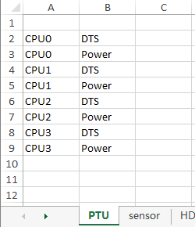

Figure PTU example

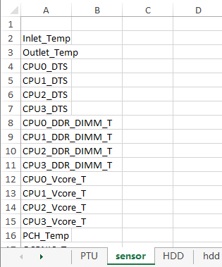

Figure sensor example

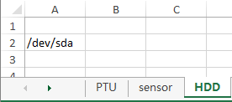

Figure HDD example

* **Log sheet**

PTU log, sensor log, and hdd log are all log sheets, which used to represent the data.

When use the tool, you don’t need to delete them or create a new sheet manually because the tool will automatically clear the previous data or create a log sheet if it does’t exist.

* **Summary sheet**

PTU summary, sensor summary, and hdd summary are all log sheets, which used to summarize the data in the log sheet.

Similarly, the summary sheets are also automatically updated or created, there is no need to clear them or create new ones manually.

## Tools for CPU_pid and GPU_pid

Same as the first tool, all the sheets can be classified into the following three types: common sheet, log sheet, and summary sheet.



In the common sheet, you **must** fill in the data you want to grasp from a given log file, starts from the **first** column and the **second** row

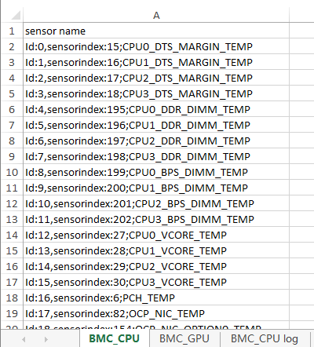

Figure 4 BMC_CPU example

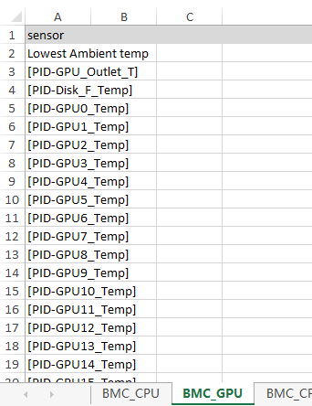

Figure 5 BMC_GPU example

# **How to Use?**

To use the tool, you have to execute the following command:

[tool name] --output [excel name] --[operations] [log name]

**Examples**

* .\thermal.exe --output .\thermal.xlsx --bmc .\BMCtemp.txt --hdd .\HDDtemp.txt --ptu .\PTUtemp_old.txt
* thermal.exe --output thermal.xlsx --bmc BMCtemp.txt --hdd HDDtemp.txt --ptu PTUtemp_old.txt --draw disable
* thermal.exe --output thermal.xlsx --bmc2 sdr.txt --hdd HDDtemp.txt --ptu2 PTUtemp_new.txt
* .\thermal.exe --output thermal.xlsx --bmc2 .\sdr.txt --hdd .\HDDtemp.txt --ptu2 .\PTUtemp_new.txt --draw diable
* .\thermal.exe --output thermal.xlsx --ptu .\PTUtemp_old.txt --draw disable
* .\thermal.exe --output thermal.xlsx --ptu2 .\PTUtemp_new.txt
* .\thermal.exe --output thermal.xlsx --bmc .\BMCtemp.txt
* thermal.exe --output thermal.xlsx --bmc2 .\PTUtemp_old.txt
* thermal.exe --output .\log.xlsx --cpulog .\CPU_PID.txt --gpulog .\GPU_pid.txt
* thermal.exe --output log.xlsx --cpulog CPU_PID.txt
* thermal2.exe --output log.xlsx --cpulog CPU_PID.txt --gpulog GPU_pid.txt --draw disable

# **Revision History**

## 2021.01.21 Debug --ptu2

* **Issue**

In the summary sheet, CPU0 has data whereas CPU1 is empty.

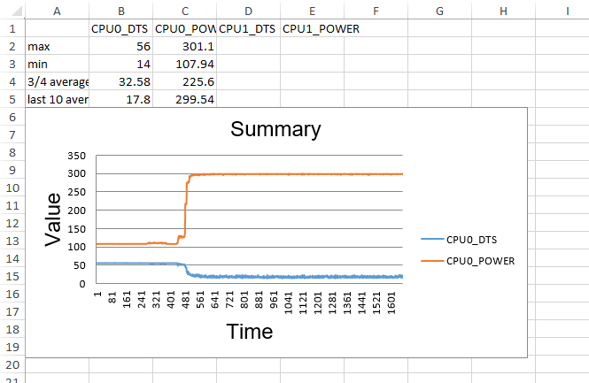

* **Reason**

In the ptu.txt, data is incomplete. The 1668th datais incomplete for it only contains CPU0 while CPU1 is missing.

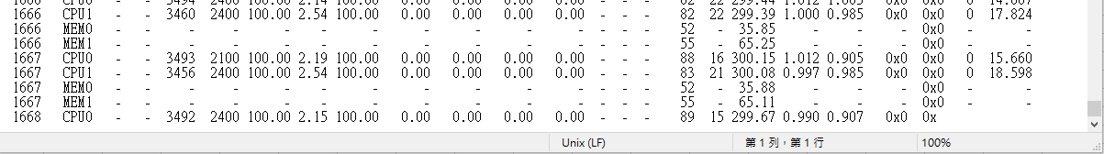

This missing data then leads to an incomple log sheet.

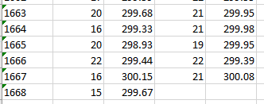

Therefore, the summary sheet only contains CPU0.

* **Solution**

Either delete the incomplete data (line 1668) or supplement the incomplete data will help.

* **Improvement in the code**

To figure out this problem, we add some tips in the code to help users realize the missing data.

Whenever there exists incomplete data, some warning information will pop up on the screen:

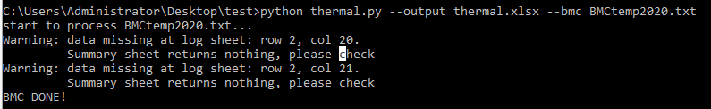

## 2021.02.20 Upgrade –gpulog --cpulog

* **Add a nickname column**

In the requirement sheet, some names are too long and are hard to read in the chart. Therefore, we add a column for short name in the second column. In the meantime, names in the chart of the summary sheet also change.

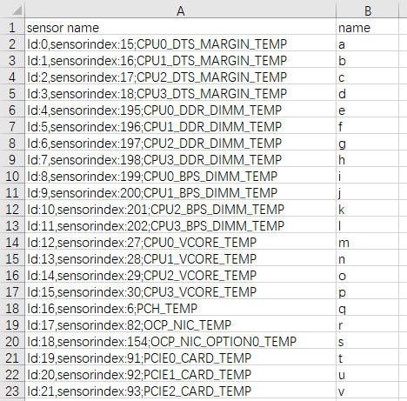

Figure add a 2nd column for short name

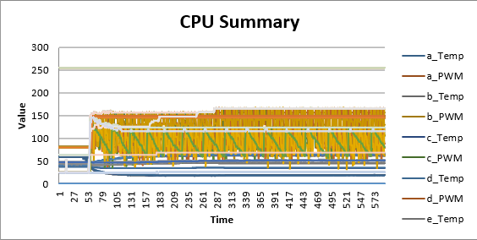

Figure names in the chart also change

* **Add support for the [Final Domain Output Duty] in GPU log**

This version is able to retrieve the [Final Domain Output Duty] and add them to the last five columns.

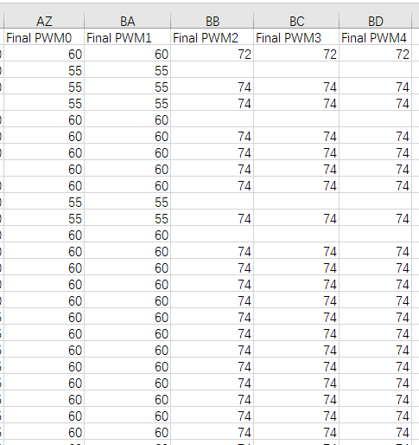

Figure [Final Domain Output Duty] is shown in the last 5 columns