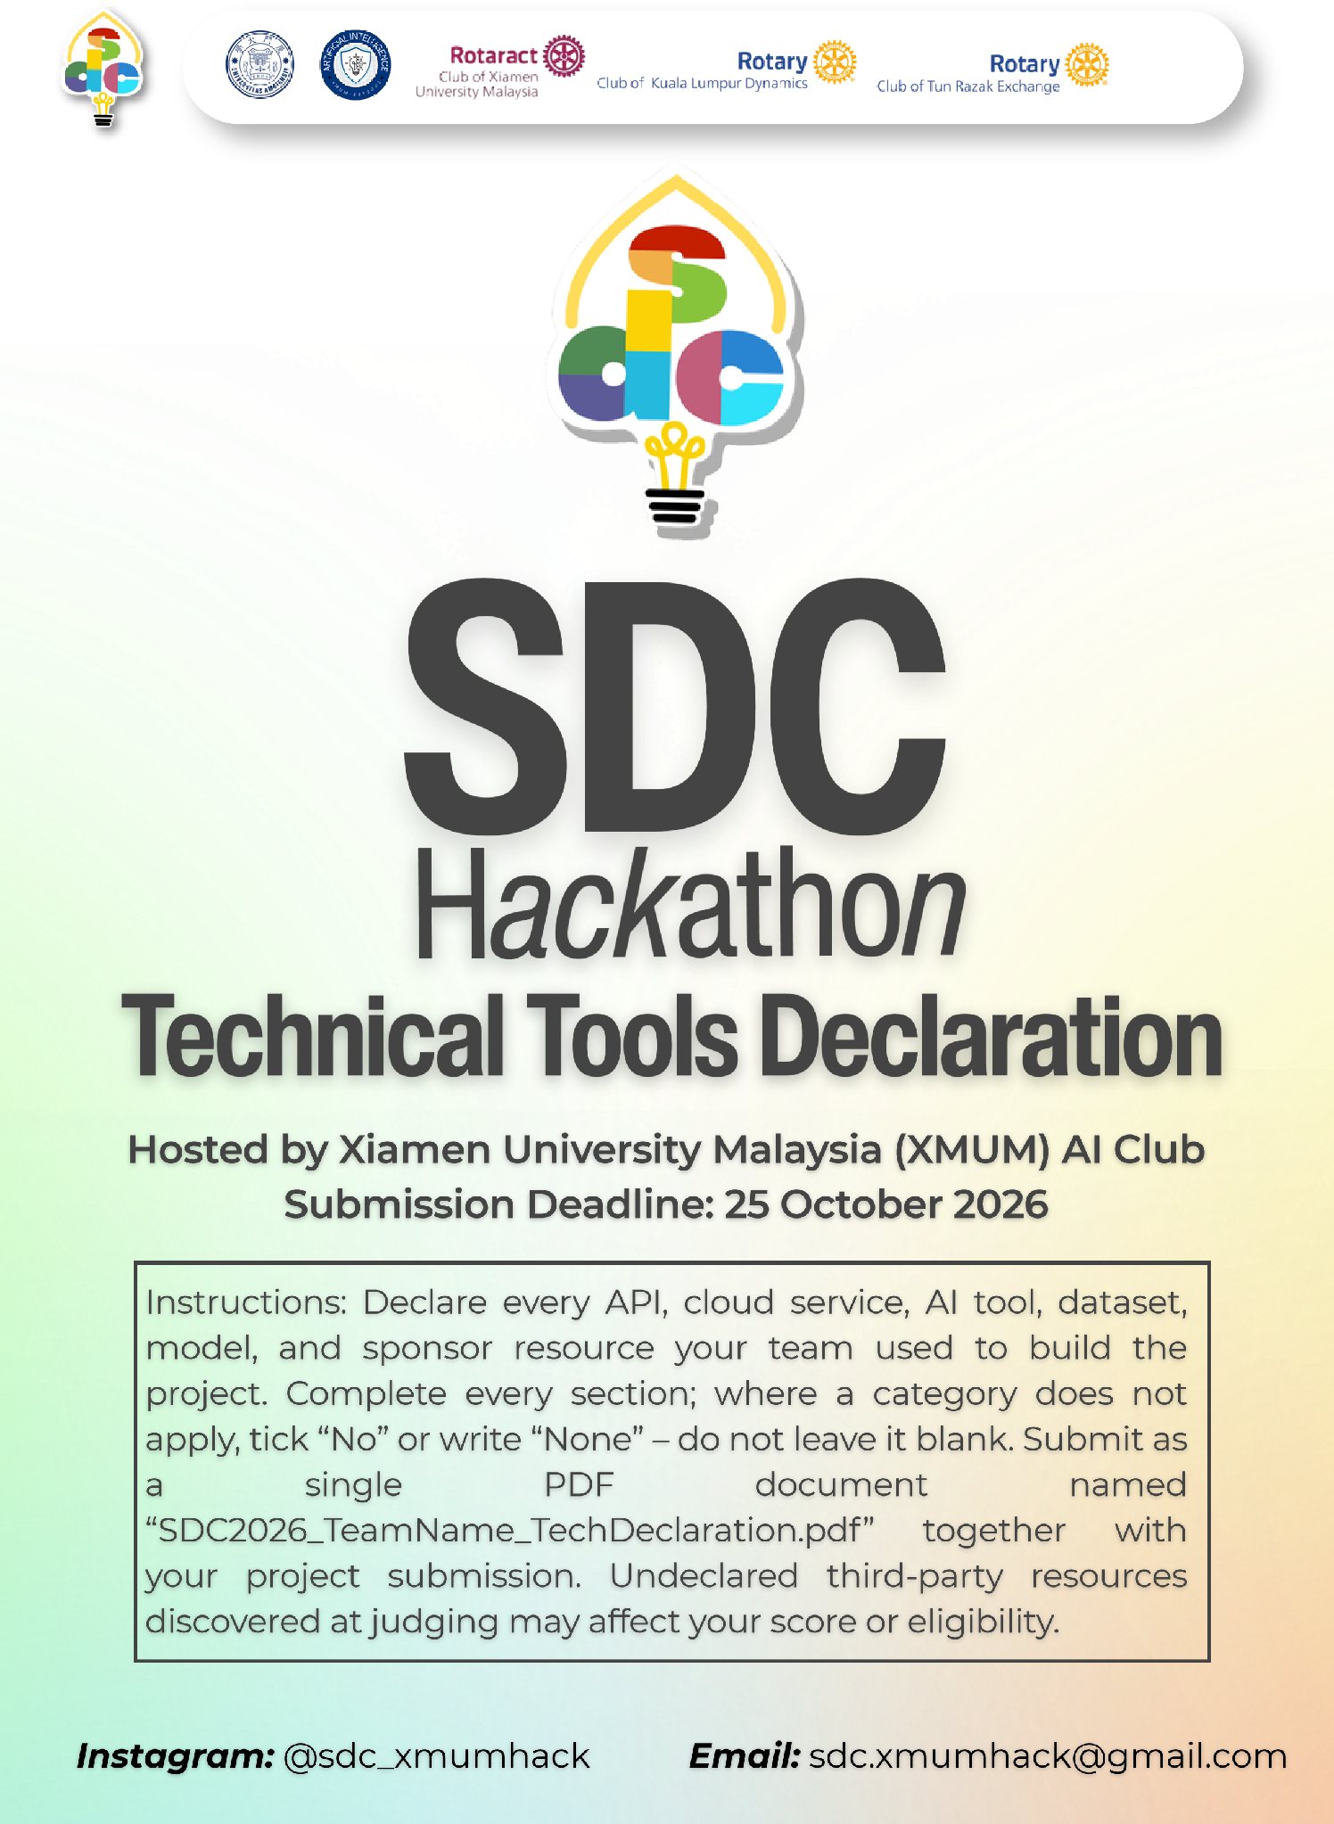
SDC HACKATHON 2026
Technical & Tools Declaration
Hosted by Xiamen University Malaysia (XMUM) AI Club
Submission Deadline: Not stated in the provided materials; team to confirm
Instructions: Declare every API, cloud service, AI tool, dataset, model, and sponsor resource your team used to build the project. Complete every section; where a category does not apply, tick “No” or write “None” – do not leave it blank. Submit as a single PDF document named “SDC2026_TeamName_TechDeclaration.pdf” together with your project submission. Undeclared third-party resources discovered at judging may affect your score or eligibility.

1. Team & Project Overview
Team Name | Taygood
Project / Solution Name | Kutip
Name (Leader) | YapHongSan
Email & Phone (Leader) | YapHongSan@gmail.com · Phone: [team leader to add]
University Affiliation(s) | Taylor’s University
Live Prototype URL | Not yet deployed; local demo available from the repository
Code Repository URL (public / access granted to judges) | https://github.com/YapHongSanHansen/Xmum

2. Architecture & Technology Stack

2.1 System Architecture Overview
Describe how the components declared in this document connect end-to-end (e.g., user interface → backend → AI model/API → database → cloud hosting). Attach a system block diagram as an appendix if available.
[Maximum 200 words]
Users open a Next.js 16 and React 19 web app presented inside a simulated Orbyte hub. Zustand persists demo state in browser localStorage. User actions and the frozen demo clock pass into a pure TypeScript rules engine, which calculates cash warnings, credit holds, chase ranking, approvals and the append-only activity log. For Bukti, the browser calls a Next.js /api/extract server route. The route sends synthetic message text and, when present, a synthetic payment-slip image to Anthropic's Claude Opus 5.5 through the official SDK. Zod validates the structured response; failures or a missing key use reviewed cached results. AI only extracts evidence. Deterministic rules compare claims with seeded bank-statement lines, and a human must approve consequential actions before records change. The current prototype has no database, authentication or live Orbyte, WhatsApp or bank integration. It runs locally; Vercel is the planned deployment target.

2.2 Languages, Frameworks & Libraries
List the main programming languages, frameworks, and third-party libraries that your team did not create. Open-source use is permitted provided it is declared and properly licensed/attributed.
Name & Version | Purpose in Project | License
TypeScript 5; Node.js 20+ | Application code and server runtime | Apache-2.0; MIT
Next.js 16.4.3; React/React DOM 19.3.0 | Web app, UI and server route | MIT
Tailwind CSS 4; Lucide React 1.61.0 | Styling and interface icons | MIT; ISC
Zustand 5.0.16; Zod 4.6.7 | Persisted client state; AI-output validation | MIT
@anthropic-ai/sdk 1.3.0 | Server-side Claude API client | Apache-2.0
Vitest 5.0.5; ESLint 9 | Rules/demo tests and linting | MIT

3. APIs & Cloud Services

3.1 External APIs
List every external API your solution calls (GenAI, maps, payments, messaging, data feeds, etc.). Do not include API keys or secrets in this document.
API & Provider | Purpose in Project | Access Tier (free / paid / sponsor-provided)
Anthropic Messages API | Optional live Bukti extraction of synthetic message text and slip images; cached fallback if unavailable | Paid API; no sponsor access
WhatsApp wa.me links (Meta) | Opens a prefilled reminder for a person to send; no WhatsApp Business API | Free public link
None | No payment, bank, maps or accounting API is called | N/A
None | N/A | N/A
None | N/A | N/A

3.2 Cloud Platforms & Deployment
List every cloud service used for hosting, storage, databases, authentication, or compute, and indicate how the prototype is deployed.
Service & Provider | Purpose in Project | Plan / Region
Orbyte (Alpha Red Solutions) | Sponsor workspace record for a synthetic client/project; simulated hub context only, with no runtime API integration | Sponsor account; region not stated
Vercel (planned) | Planned Next.js hosting; not yet deployed at time of declaration | Plan and region not yet selected
Browser localStorage | Local demo state and activity log; no cloud database | User browser only
Local Node.js runtime | Current working prototype and API route | Developer machine
None | No database, authentication, object storage or bank feed | N/A

4. AI Tools, Models & Datasets

4.1 AI Models Used in the Solution
List every AI model embedded in or called by your application, including pre-trained, fine-tuned, and self-trained models.
Model & Version | Source / Provider | Usage (pre-trained / fine-tuned / self-trained) | License / Terms
Claude Opus 5.5 (claude-opus-5-5) | Anthropic | Pre-trained; optional live extraction. Tested demo can use reviewed cached output. | Anthropic commercial/API terms
None | No other model | No fine-tuned or self-trained models | N/A
None | N/A | N/A | N/A
None | N/A | N/A | N/A
None | N/A | N/A | N/A

4.2 Datasets
List all datasets used for training, fine-tuning, evaluation, or in the running application. State clearly if a dataset contains personal or sensitive data.
Dataset Name | Source / URL | Type (public / private / self-collected / synthetic) | License | Personal Data? (Y/N)
Kutip synthetic demo dataset | Team-created repository fixtures | Synthetic runtime and evaluation data | Team-created; repository license not specified | N
Synthetic payment-slip image and bank CSV | Team-created demo assets and fixtures | Synthetic | Team-created; repository license not specified | N
Seeded AI extraction outputs | Team-reviewed cached results in source code | Synthetic cached runtime fallback | Team-created; provider terms apply to generation | N
No training or fine-tuning dataset | None | N/A | N/A | N
No real customer or bank data | None | N/A | N/A | N

4.3 AI-Assisted Development Tools
Tools used to help write code, design, content, or documentation (e.g., chat assistants, code completion tools, image generators). Declaring these tools does not reduce your score; undeclared use may.
Did your team use any generative-AI tool to help create code, design, text, or other project material?
☒ Yes ☐ No
If yes, list them below:
Tool & Version | Used For | Extent of Use (minor / moderate / major)
Claude Code (version not recorded) | Research, PRD, documentation, code generation and iteration | Major
OpenAI Codex desktop (25 Oct 2026) | Repository review and drafting/completing this declaration | Minor
None | N/A | N/A
None | N/A | N/A
None | N/A | N/A

Briefly describe how your team reviewed, tested, and took responsibility for AI-generated output:
[Maximum 100 words]
AI-assisted drafts and code were reviewed by the team. Deterministic business logic is covered by Vitest tests, including the seeded end-to-end demo script. Generated suggestions were checked against the PRD and source code and adapted before use. Claude's runtime extraction is Zod-validated, must quote source text, falls back to reviewed cached results on failure, and never marks an invoice paid: a matching bank-statement line and human approval are required. The team remains responsible for all submitted content and code.

5. Sponsor-Provided Resources
Declare any official SDC sponsor-provided GenAI API, cloud credits, tools, mentoring, or data that your team used.
Did your project use any official SDC sponsor-provided resource?
☒ Yes ☐ No
If yes, list them below:
Sponsor | Resource (API / credits / platform / data) | How It Was Used in the Project
Alpha Red Solutions Sdn Bhd | Orbyte platform account and Domain 2 challenge materials | Configured a synthetic Taygood/Kutip client-project record and used Orbyte's hub approach to shape the simulated module, roles, approvals and audit trail.
None | No sponsor AI API, cloud credits or dataset used | N/A
None | N/A | N/A
None | N/A | N/A

Was the sponsor resource essential to the core functionality of the prototype, or could it be replaced? Explain briefly:
[Maximum 100 words]
Orbyte is important to the target product and demo context, but the current core prototype does not depend on live Orbyte APIs. The team configured only a synthetic client/project record and simulated the hub, roles, approvals, audit trail and Connect inputs. The core workflow could run independently or on another SME platform; a real Orbyte integration requires a supported API and authentication surface. No sponsor AI API, cloud credits or dataset were used.

6. Security, Privacy & Responsible Use

6.1 Data Handling & Privacy
What user or personal data does your application collect, store, or send to third-party services (including AI APIs)? How is it protected, and how long is it kept? State “No user data is collected” if applicable.
[Maximum 150 words]
The prototype uses only synthetic demo data. State is stored in browser localStorage until the user resets the demo or clears site data; there is no application database. If ANTHROPIC_API_KEY is configured, only the selected synthetic message text and attached synthetic slip image are sent server-side to Anthropic for extraction. The key is never returned to the browser. Without a key, reviewed cached results are used and no AI request is made. The demo opens prefilled WhatsApp wa.me links; it does not use the WhatsApp Business API or send messages automatically. Orbyte contains only a synthetic client/project record, not invoice or bank data. Provider retention is governed by the connected Anthropic API account terms and must be confirmed before production. A real deployment requires authentication, role enforcement, encryption, retention rules, consent notices and PDPA controls.

6.2 Known Limitations & Risks
Identify the main technical limitations of your AI components (e.g., hallucination, bias, rate limits, dependency on a single provider) and any mitigation you have implemented.
[Maximum 150 words]
The current prototype relies on synthetic data and localStorage; it has no production authentication, database, multi-tenant isolation, Orbyte API integration or live bank/WhatsApp feed. The Claude live path has not been exercised on the build machine; reviewed cached extractions are the tested fallback. AI may misread mixed-language messages or slips, hallucinate fields, or face timeouts, rate limits and provider outages. Mitigations include Zod validation, quoted source evidence, confidence indicators, deterministic cross-checks, a required bank-line match before PAID, human approval and cached fallback. Current rules also omit courtesy D-3 reminders; an unverified paid claim has no expiry; and a verified but unapproved receipt is excluded from the forecast. Vercel deployment and the production region are not yet confirmed.

7. Compliance & Readiness Checklist
Tick all boxes that apply before submitting.
☒ | All APIs, cloud services, AI tools, models, and datasets used in the project are declared in this document.
☒ | All third-party code, datasets, and models are used in accordance with their licenses, and attribution is provided where required.
☒ | No API keys, passwords, or other credentials are exposed in the code repository, prototype, or this document.
☒ | Any use of generative-AI tools for development has been disclosed and reviewed by the team.
☒ | Any use of official SDC sponsor resources has been declared in Section 5.
☐ | The prototype described here is accessible to judges through the links provided in Section 1.
☐ | All fields in this template have been completed within the word limits stated.

8. Declaration
By submitting this document, the team leader confirms that the information provided is complete and accurate to the best of the team’s knowledge, and that every API, cloud service, AI tool, dataset, model, and sponsor resource used in the project has been declared.
Signature: [team leader to sign]
Date: [team leader to complete]

