GENAI PROJECT PROPOSAL
Job Listing Scraper AI
RAG + LangChain for Job Q&A, Resume Matching and New-Listing Notifications

Document type | Technical Project Proposal
Project stage | MVP / proof of concept
Primary source | LinkedIn-first connector; future multi-source expansion
Core technologies | Python, LangChain, RAG, embeddings, vector database, scheduler, notification service

1. Executive Summary
This proposal describes a generative AI job-discovery assistant that collects job listings, stores them in a searchable knowledge base, answers natural-language questions using Retrieval-Augmented Generation (RAG), compares new jobs against one or more resumes, and sends notifications when a newly discovered role is likely to be a strong match. The first MVP focuses on a LinkedIn-first source connector, while the architecture keeps job-source logic separate so Indeed, Hiredly, JobStreet or other sources can be added later without redesigning the core RAG and matching layers.
The main design principle is to avoid placing the full resume into every prompt. Instead, the resume is parsed once into structured fields such as skills, experience, education, preferred roles and locations. The original resume text can also be embedded into a vector store. When a job is evaluated or a question is asked, only the most relevant candidate evidence and job evidence are retrieved and passed to the LLM. This keeps prompts smaller, improves traceability and supports multiple resumes or resume versions.
Capability | What the system does | MVP priority
Job ingestion | Collects new job records, normalizes fields, removes duplicates and stores raw/cleaned text. | High
RAG Q&A | Answers questions over saved jobs and candidate data using retrieved evidence. | High
Resume matching | Ranks jobs against candidate profile, hard constraints and semantic similarity. | High
Notifications | Alerts the user only for unseen jobs above configured thresholds. | High
Feedback learning | Stores relevant/not-relevant/applied feedback to improve later ranking. | Medium
Multi-source expansion | Adds job-board adapters behind a common source interface. | Later

2. Problem Statement and Motivation
Job seekers often repeat the same manual workflow: search multiple job boards, open many listings, compare each role against their background, remember which jobs were already seen, and revisit the search later for new postings. Keyword search alone can miss semantically relevant opportunities, while broad alerts can create too much noise.
The proposed system solves this by maintaining a private job knowledge base and candidate profile. It combines deterministic filtering, semantic retrieval and LLM-generated explanations. The user can ask questions such as “Which new machine-learning jobs fit my current resume?”, “Show remote entry-level roles posted this week”, or “Why is this role a poor match for me?” and receive grounded answers linked back to stored job records.

3. Project Objectives
- Build a modular job-ingestion pipeline that begins with a LinkedIn-first connector and can later support additional job boards.
- Normalize job listings into one consistent schema regardless of source.
- Create a RAG knowledge base for natural-language Q&A over job listings and candidate/resume data.
- Parse resumes into structured candidate profiles and vector representations instead of blindly injecting the full resume into every prompt.
- Rank new jobs using hard filters, semantic similarity, structured skill overlap and optional LLM reasoning.
- Notify the user when a newly discovered, previously unseen job passes configurable relevance criteria.
- Preserve source links and supporting evidence so recommendations are explainable and auditable.

4. Scope

4.1 In Scope for MVP
- One-user or small private deployment.
- One or more uploaded resumes.
- LinkedIn-first job source adapter, isolated behind a common connector interface.
- Scheduled job discovery and duplicate detection.
- Storage of normalized job metadata and full descriptions.
- Embeddings and vector retrieval.
- LangChain-based RAG Q&A.
- Job-to-resume scoring and explainable match reasons.
- Notifications by one initial channel such as email or Telegram.
- Basic user feedback: relevant, not relevant, applied, ignored.

4.2 Out of Scope for Initial MVP
- Automatic job applications or form submission.
- Automated messaging to recruiters.
- Guaranteeing platform access where the platform does not permit automated collection.
- Enterprise-scale multi-tenant identity and billing.
- Fine-tuning a custom foundation model.
- Perfect prediction of hiring outcomes.

5. Proposed System Architecture
The architecture separates source collection, storage, retrieval, ranking and notification. This separation is important because job-source availability may change, while the candidate profile, RAG service and matching engine should remain reusable.
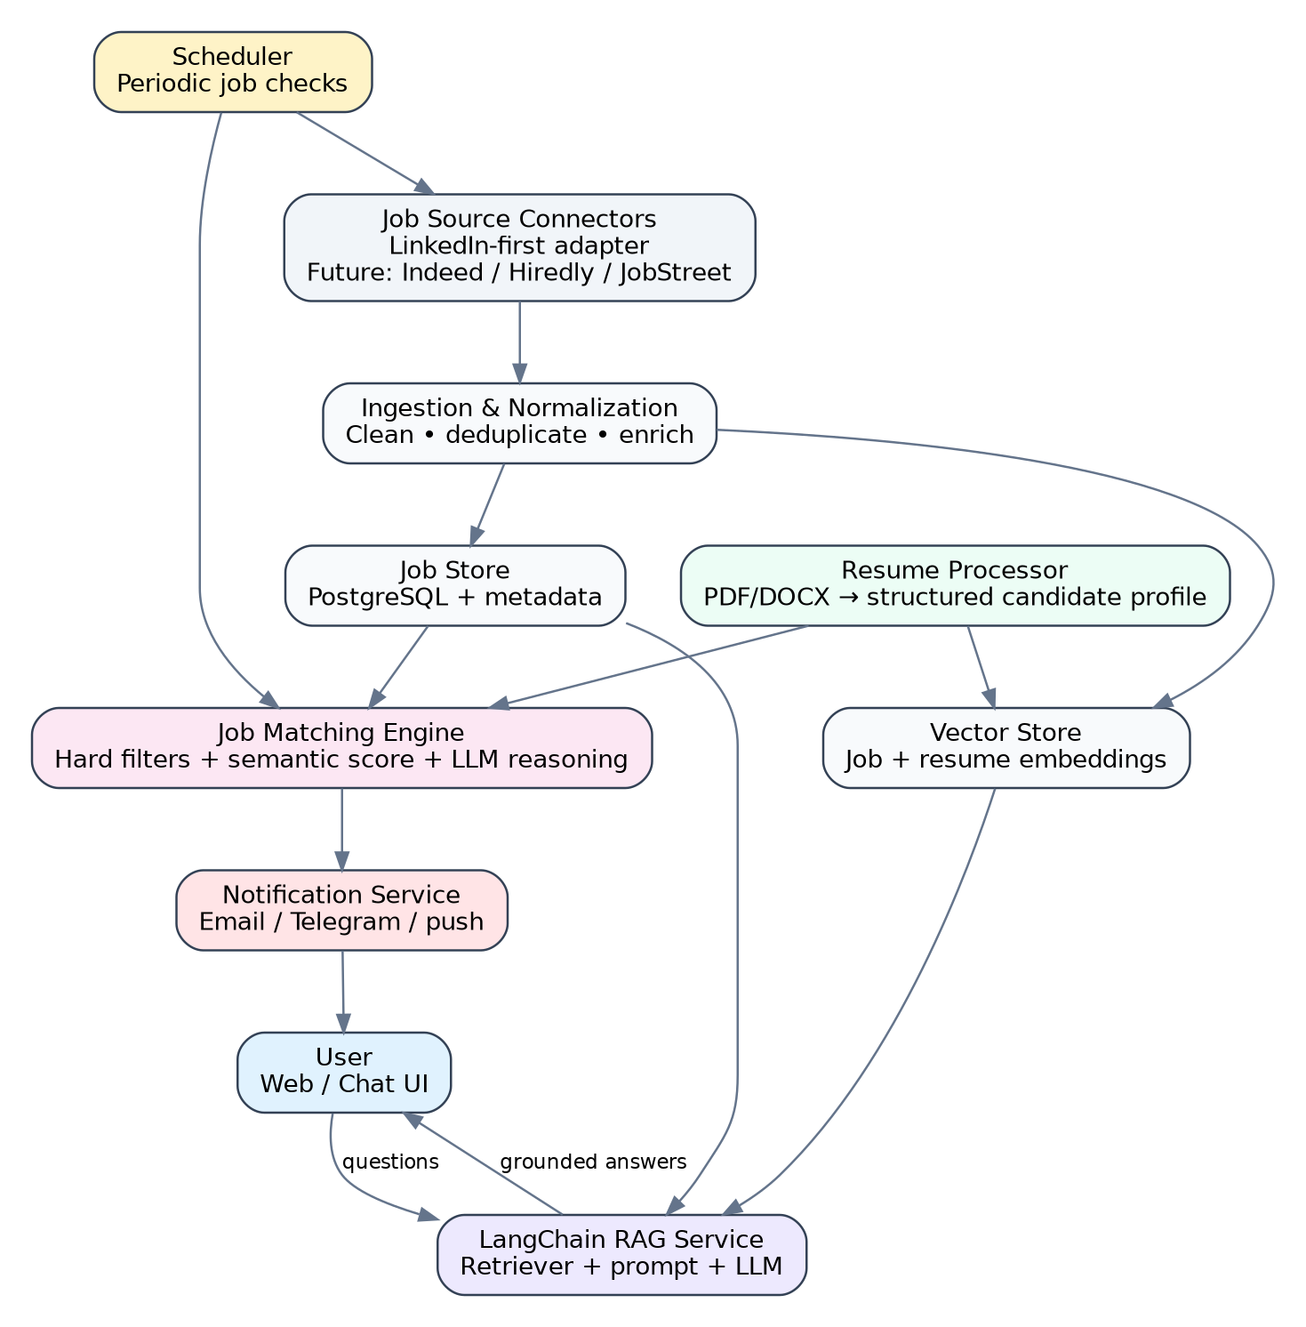
Figure 1. Overall architecture of the proposed job-discovery assistant.
Layer | Responsibilities | Suggested technologies
Source connectors | Fetch or import listings from a source and return a common raw job object. | Python connector interface; compliant APIs/feeds/exports where available
Ingestion pipeline | Parsing, cleanup, normalization, deduplication, enrichment and embedding. | Python, Pydantic, BeautifulSoup where permitted, scheduler/worker
Operational store | Canonical jobs, source IDs, status, scores, notification history. | PostgreSQL or SQLite for smallest MVP
Vector store | Semantic search across job descriptions and resume/candidate content. | pgvector, Chroma, FAISS or another LangChain-compatible store
RAG service | Retriever, context construction, prompt template, model call and answer formatting. | LangChain
Matching engine | Hard constraints, semantic score, skill overlap, optional LLM explanation. | Python + embeddings + optional LLM chain
Notification service | Sends only unseen, above-threshold matches and records delivery state. | Email, Telegram bot, push or webhook
API/UI | Chat interface, filters, job details, resume management and feedback. | FastAPI + Streamlit/React/Next.js

6. Job Data Pipeline: LinkedIn-First
The ingestion layer should use a source-adapter pattern. A connector returns raw listings in a common interface; the rest of the pipeline does not care whether the listing came from LinkedIn, Indeed, Hiredly, JobStreet, a partner API, a feed, a user export or another approved mechanism.
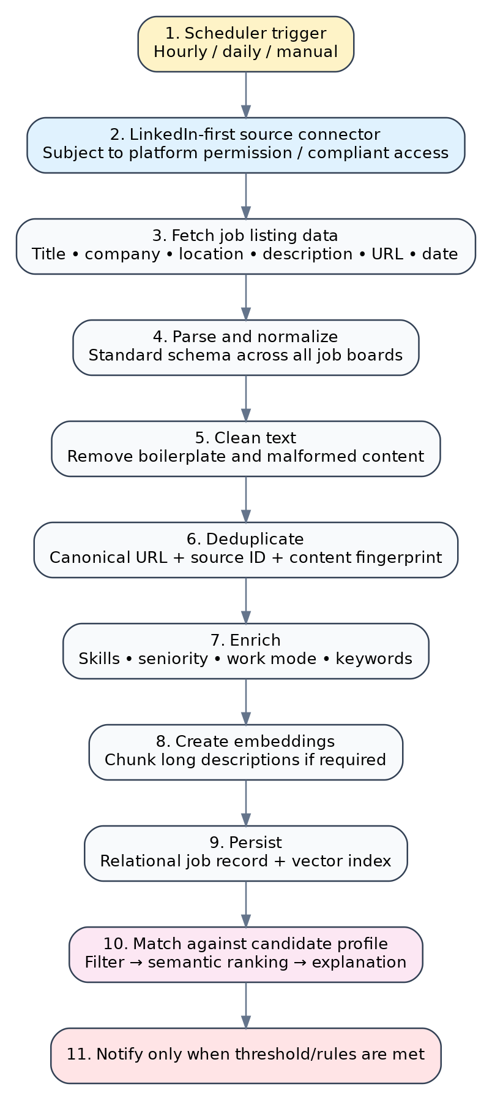
Figure 2. LinkedIn-first ingestion, normalization, embedding and matching pipeline.

6.1 Recommended Job Record Schema
Field | Description
job_id | Internal UUID.
source | linkedin, indeed, hiredly, jobstreet, etc.
source_job_id | Source-specific identifier when available.
canonical_url | Normalized URL used for navigation and duplicate control.
title | Job title.
company | Company name.
location | Human-readable location.
country | Normalized country code or name.
work_mode | On-site, hybrid, remote or unknown.
employment_type | Full-time, part-time, contract, internship, etc.
seniority | Intern, entry, junior, mid, senior, lead or unknown.
posted_at | Posting date when available.
discovered_at | First time the system discovered the record.
description_raw | Original collected job description.
description_clean | Clean text used for retrieval.
skills_required | Extracted or inferred skill list.
embedding_ref | Vector-store reference.
content_hash | Fingerprint for duplicate detection.
is_active | Whether the job still appears active when rechecked.
last_seen_at | Most recent successful observation.
match_score | Latest score for the active candidate profile.
notification_status | not_sent, sent, suppressed, failed.
Platform access note. LinkedIn states that it does not permit third-party crawlers, bots, browser extensions or other software that scrapes or automates activity on the service. Therefore, the proposal intentionally isolates LinkedIn access as a connector and recommends using only permitted methods, official products/APIs where access is granted, user-provided exports, feeds, or alternative job sources. This is an architectural and compliance risk, not a limitation of RAG itself.

7. LangChain and RAG Design
RAG retrieves relevant external knowledge and supplies it to the language model before generation. LangChain documentation describes both two-step RAG, where retrieval happens before generation, and agentic RAG, where an agent can decide when retrieval is needed. For this project, two-step RAG is the recommended MVP because job-search questions are predictable, easier to test and cheaper to operate. Agentic behavior can be added later for more complex multi-step research.
Figure 3. Recommended LangChain RAG flow for job and resume question answering.

7.1 Suggested RAG Components
Component | Purpose | Implementation note
Document loader | Loads job descriptions and resumes. | Use file-specific loaders for PDF/DOCX and a custom JobDocument converter.
Text splitter | Splits long descriptions/resumes into retrievable chunks. | Prefer semantic sections or moderate chunk size with overlap.
Embedding model | Converts text into vectors. | Use one embedding model consistently per index version.
Vector store | Stores and searches vectors. | Attach metadata such as job_id, date, source, location and company.
Retriever | Returns relevant job/resume chunks. | Combine semantic similarity with metadata filters.
Reranker (optional) | Improves ordering of retrieved chunks. | Useful when corpus grows or top-k retrieval is noisy.
Prompt template | Constrains the LLM to supplied evidence. | Require explicit uncertainty and source links.
LLM | Generates answer or match explanation. | Keep provider swappable behind configuration.
Output parser | Returns structured answer, job IDs, reasons and caveats. | Prefer JSON/Pydantic for API responses.

7.2 Example Query Flow
- User asks: “What are the best new data-science jobs for me in Kuala Lumpur or remote?”
- The system detects intent = job_search and extracts metadata filters such as location, remote preference and freshness window.
- Retriever searches job vectors using the query, while applying metadata filters where possible.
- Candidate-profile evidence is retrieved only for relevant skills, education and experience.
- Top job evidence and candidate evidence are assembled into a compact context.
- The prompt asks the LLM to compare evidence, avoid unsupported claims and return ranked jobs with reasons and gaps.
- The UI shows job title, company, match score, evidence-backed explanation and source link.

8. Resume and Candidate Profile Design
The resume should not simply be copied into a static prompt template for every request. The recommended approach has two representations: a structured candidate profile for deterministic filtering and scoring, plus the original resume content as retrievable chunks for nuanced evidence.
Candidate profile field | Examples
profile_id | candidate_main, candidate_data_science, candidate_software
target_roles | Data Scientist, ML Engineer, Data Analyst
skills | Python, SQL, pandas, scikit-learn, LangChain
years_experience | Overall and optionally per skill/domain
education | Degree, major, institution, graduation date
projects | Project title, technologies, measurable outcomes
work_experience | Role, company, dates, responsibilities, achievements
preferred_locations | Kuala Lumpur, Selangor, remote
work_mode_preferences | Remote / hybrid / on-site
salary_preferences | Optional minimum or range
blocked_terms | Senior-only, commission-only, relocation required, etc.
resume_version | Hash/version for reproducibility

8.1 Prompt Strategy
Recommended: retrieve only the candidate evidence needed for the current job or question, then insert that evidence into the prompt alongside the relevant job evidence.
Avoid by default: sending every page of every resume in every request. This increases token usage, can dilute important evidence and makes multiple-resume support harder.

8.2 Example Matching Prompt Template
SYSTEM ROLE:
You are a job-fit evaluator. Use only the supplied job evidence and candidate evidence.
Do not invent skills, experience, salary, location, or requirements.
CANDIDATE EVIDENCE:
{candidate_context}
JOB EVIDENCE:
{job_context}
TASK:
1. Give a match score from 0 to 100.
2. List the strongest matching reasons.
3. List important missing or uncertain requirements.
4. Classify the role as strong match, possible match, stretch, or poor match.
5. Explain the result briefly and cite the job_id/evidence sections used.

9. Job Matching and Notification Logic
A hybrid ranker is recommended. Pure LLM scoring can be expensive and inconsistent; pure keyword scoring misses semantic similarity. The MVP should combine deterministic constraints, embeddings, structured overlap and optional LLM reasoning.
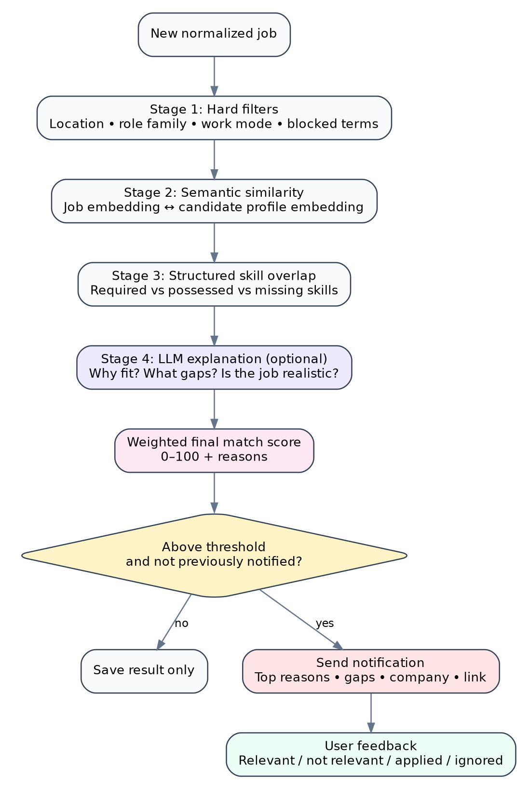
Figure 4. Hybrid job matching and notification decision flow.

9.1 Example Weighted Score
A starting formula can be tuned with feedback:
Final Match Score = 35% Semantic Similarity + 30% Skill Overlap + 15% Role/Level Fit + 10% Location/Work-Mode Fit + 10% Freshness/Preference Bonuses
Hard disqualifiers should be applied before or after scoring as explicit penalties or filters. Examples include an unacceptable location, mandatory citizenship/work authorization mismatch, required seniority far above the candidate profile, or a previously rejected company.
Notification rule | Purpose
score >= user threshold | Avoid low-quality alerts.
not previously notified | Prevent repeated alerts for the same job.
job is still active or recently observed | Reduce stale notifications.
passes hard filters | Respect explicit user constraints.
cooldown / digest policy | Avoid alert fatigue by batching when appropriate.
record notification event | Supports auditability and prevents duplicates.

10. Functional Requirements
ID | Requirement
FR-01 | The system shall support one or more candidate resumes.
FR-02 | The system shall parse each resume into structured candidate fields.
FR-03 | The system shall store resume text or chunks for semantic retrieval.
FR-04 | The system shall ingest job listings through a common source-connector interface.
FR-05 | The first MVP connector shall target a LinkedIn-first workflow subject to permitted access methods.
FR-06 | The system shall normalize listings into a common job schema.
FR-07 | The system shall detect and suppress duplicate jobs.
FR-08 | The system shall create embeddings for searchable job and resume content.
FR-09 | The system shall answer natural-language questions over stored jobs and candidate data.
FR-10 | The system shall preserve links or identifiers to the evidence used in answers.
FR-11 | The system shall calculate a job-match score using configurable components.
FR-12 | The system shall record explanation reasons and missing requirements.
FR-13 | The system shall periodically evaluate newly discovered jobs.
FR-14 | The system shall notify the user when notification conditions are satisfied.
FR-15 | The system shall prevent duplicate notifications for the same job and candidate profile.
FR-16 | The system shall accept relevance feedback for future tuning.
FR-17 | The architecture shall support adding other job boards without changing the core RAG interface.

11. Non-Functional Requirements
Category | Requirement
Accuracy | Answers and recommendations should be grounded in retrieved job/resume evidence and clearly mark uncertainty.
Performance | Typical interactive Q&A should return within an acceptable conversational latency target; background ingestion can be asynchronous.
Privacy | Resume files and extracted personal data should remain private, encrypted where appropriate and excluded from logs unless necessary.
Maintainability | Source-specific scraping/import code must remain isolated from normalization, RAG and matching layers.
Observability | Log pipeline runs, failed fetches, retrieval traces, model calls, scores and notification deliveries without exposing sensitive content unnecessarily.
Testability | Each connector, parser, deduplicator, retriever and scorer should have deterministic unit tests where possible.
Scalability | The MVP can begin with SQLite/Chroma but should allow migration to PostgreSQL/pgvector and worker queues as data grows.
Compliance | Automated collection must follow the applicable platform terms, permissions, robots/access restrictions and laws.

12. Proposed Data Model
Entity | Key fields | Purpose
CandidateProfile | profile_id, target_roles, skills, preferences, active_resume_id | Structured candidate data used for filters and ranking.
Resume | resume_id, profile_id, file_name, version_hash, parsed_text, created_at | Original and parsed resume version.
ResumeChunk | chunk_id, resume_id, text, embedding_ref, metadata | Semantic retrieval over resume evidence.
Job | job_id, source, source_job_id, title, company, location, url, description, posted_at | Canonical normalized listing.
JobChunk | chunk_id, job_id, text, embedding_ref, metadata | Semantic retrieval over long job descriptions.
MatchResult | match_id, job_id, profile_id, score, component_scores, reasons, gaps | Stores reproducible match evaluation.
Notification | notification_id, job_id, profile_id, channel, status, sent_at | Prevents duplicate notifications and tracks delivery.
Feedback | feedback_id, job_id, profile_id, label, note, created_at | Relevant/not relevant/applied/ignored feedback.
PipelineRun | run_id, source, started_at, ended_at, status, counters, error_summary | Operational monitoring and debugging.

13. Suggested API Surface
Method | Endpoint | Purpose
POST | /resumes | Upload and parse a resume.
GET | /profiles/{id} | Read structured candidate profile.
PATCH | /profiles/{id} | Update preferences, target roles or filters.
POST | /ingestion/run | Trigger a manual source-ingestion run.
GET | /jobs | Search/filter normalized jobs.
GET | /jobs/{id} | Read job details and latest match explanation.
POST | /rag/query | Ask a natural-language question over jobs/resumes.
POST | /matches/recompute | Recompute scores after profile or scoring changes.
GET | /matches | List ranked candidate-job matches.
POST | /feedback | Store relevance/application feedback.
GET | /notifications | Review notification history.

14. Recommended Technology Stack
Area | MVP recommendation | Reason
Language | Python | Strong ecosystem for scraping/import, NLP, LangChain and APIs.
API | FastAPI | Simple typed APIs and async support.
RAG orchestration | LangChain | Retrievers, prompt composition, model adapters and vector-store integrations.
Optional agent orchestration | LangGraph later | Useful for stateful or multi-step agent workflows; not necessary for first two-step RAG MVP.
Relational database | PostgreSQL; SQLite for tiny local prototype | Reliable metadata, history, deduplication and filtering.
Vector database | pgvector, Chroma or FAISS | LangChain-compatible semantic retrieval.
Validation | Pydantic | Typed job, resume and response schemas.
Scheduler | APScheduler / cron for MVP; Celery/RQ later | Periodic source checks and background matching.
UI | Streamlit for prototype or React/Next.js for product UI | Fast initial chat/search interface or production flexibility.
Notifications | Email or Telegram first | Low-complexity delivery channel.
Observability | Structured logs; optionally LangSmith for RAG traces/evaluation | Helps inspect retrieval and answer quality.

15. Suggested Project Structure
job-listing-rag-ai/
├── app/
│ ├── api/ # FastAPI routes
│ ├── connectors/ # linkedin.py, indeed.py, hiredly.py, jobstreet.py
│ ├── ingestion/ # normalize, clean, deduplicate, enrich
│ ├── resumes/ # loaders, parsers, candidate profile builder
│ ├── rag/ # loaders, splitters, retriever, chains, prompts
│ ├── matching/ # filters, scoring, explanations
│ ├── notifications/ # email / Telegram / webhook
│ ├── db/ # ORM models and repositories
│ ├── scheduler/ # recurring jobs
│ └── core/ # config, logging, security
├── prompts/
│ ├── rag_qa.txt
│ └── job_match.txt
├── tests/
│ ├── test_connectors.py
│ ├── test_deduplication.py
│ ├── test_retrieval.py
│ └── test_matching.py
├── scripts/
├── migrations/
├── .env.example
├── pyproject.toml
└── README.md

16. Implementation Plan and Milestones
Phase | Main deliverables | Exit criteria
1. Foundation | Repository, config, schema, database, sample jobs and one sample resume. | Can create/read normalized jobs and profiles.
2. Resume processing | PDF/DOCX loading, structured profile extraction, resume chunks and embeddings. | Candidate profile is reviewable and searchable.
3. Source ingestion | Common connector interface, LinkedIn-first adapter approach, normalization and deduplication. | New job records enter the canonical store without duplicates.
4. RAG Q&A | Job/resume vector index, retriever, prompt and structured answer output. | User can ask grounded questions and receive job IDs/links.
5. Matching engine | Hard filters, semantic score, skill overlap and explanation. | Jobs receive reproducible 0–100 scores with reasons/gaps.
6. Notification engine | Scheduler, threshold rules, delivery channel and notification history. | New qualifying jobs trigger one notification only.
7. Evaluation and tuning | Retrieval test set, scoring feedback, failure analysis and threshold tuning. | Quality metrics and known failure cases are documented.
8. Expansion | Additional job-board adapters and production hardening. | New source can be added without modifying RAG core.

17. Testing and Evaluation Strategy

17.1 Ingestion Tests
- Schema validation for required/optional job fields.
- Duplicate detection across URL variants and repeated runs.
- Date/location/work-mode normalization.
- Failure handling and retry behavior.
- Connector-specific parsing fixtures so HTML/API changes are detected quickly.

17.2 RAG Tests
- Retrieval recall: whether known relevant job chunks appear in top-k results.
- Groundedness: whether the answer stays within retrieved evidence.
- Citation/link accuracy: whether returned job IDs and URLs match the evidence.
- Filter correctness for date, location, work mode and source.
- Adversarial questions where the correct response should admit insufficient evidence.

17.3 Matching Tests
- Golden set of job/resume pairs manually labeled strong, possible, stretch or poor.
- Score stability when irrelevant wording changes.
- Penalty correctness for hard disqualifiers.
- Feedback-driven threshold tuning.
- Separate evaluation of retrieval quality and final generation quality.

18. Risks and Mitigations
Risk | Impact | Mitigation
LinkedIn scraping/access restrictions | Connector may be blocked or violate platform terms. | Keep source access isolated; use permitted APIs/exports/feeds or alternative sources; never couple core RAG to one scraper.
HTML/page changes | Parser breaks silently. | Fixtures, validation, field completeness monitoring and connector versioning.
Duplicate/stale jobs | Poor alerts and repeated recommendations. | Canonical URLs, source IDs, content hashes, last_seen_at and active status.
LLM hallucination | Misleading fit explanations. | Retrieve evidence first, constrain prompts, return uncertainty, preserve source links and use structured outputs.
Resume privacy | Sensitive personal data exposure. | Private storage, minimal logging, access control, encryption and configurable deletion.
High notification noise | User ignores alerts. | Hard filters, adjustable threshold, digest mode, feedback and duplicate suppression.
Embedding/model changes | Index incompatibility or ranking drift. | Version embedding model and index; re-embed intentionally with migration records.
Overreliance on semantic score | Relevant jobs may be missed or false positives ranked high. | Hybrid scoring with explicit filters, structured skills and human feedback.

19. MVP Acceptance Criteria
- A resume can be uploaded and converted into both a structured candidate profile and searchable resume chunks.
- At least one source connector can ingest job listings into the common schema.
- Repeated ingestion does not create duplicate records for the same job under normal conditions.
- The user can ask natural-language questions and receive answers grounded in stored job/resume evidence.
- Every recommended job includes a source URL or stable source identifier.
- Each new job receives a reproducible score with component scores or reasons.
- The system sends one notification for an unseen qualifying job and records the delivery event.
- The user can mark a job relevant or not relevant and the feedback is stored.
- A second job source can be added through the connector interface without modifying the RAG chain.

20. Future Enhancements
- Indeed, Hiredly, JobStreet and company-career-site connectors.
- Job salary normalization and currency handling.
- Company research RAG using official company pages and trusted sources.
- Application tracker with stages, interview notes and reminders.
- Resume-to-job tailoring suggestions that preserve truthfulness.
- Cover-letter drafting grounded in the selected resume and job description.
- Personalized reranking learned from relevant/not-relevant/applied feedback.
- Multiple candidate profiles for different career directions.
- LangGraph agent for multi-step questions such as compare role, company, commute and skill gaps.
- Daily or weekly digest with top jobs, newly trending skills and repeated skill gaps.

21. Recommended MVP Build Order
The most practical sequence is to make the core useful before adding more sources:
- Start with a small set of sample jobs and one resume; define the job schema and candidate profile.
- Build resume parsing and the RAG Q&A flow first so the system can already answer job/resume questions.
- Add the source connector and ingestion pipeline behind a strict adapter interface.
- Add hybrid match scoring and explanations.
- Add scheduled checks and one notification channel.
- Collect feedback and evaluate retrieval/matching quality before expanding to more job boards.
Recommended architectural decision: treat the resume as a first-class knowledge source and candidate profile, not merely a giant prompt variable. Treat each job board as a replaceable connector, not as the center of the application. The long-lived value of the project is the normalized job corpus, the RAG layer, the matching logic and the feedback loop.

22. References
1. LinkedIn User Agreement. https://www.linkedin.com/legal/user-agreement. Accessed July 2026. Defines contractual restrictions and platform-use terms.
2. LinkedIn Help: Prohibited software and extensions. https://www.linkedin.com/help/linkedin/answer/a1341387. States that LinkedIn does not permit third-party crawlers, bots, browser plug-ins or extensions that scrape or automate activity.
3. LangChain Documentation: Retrieval. https://docs.langchain.com/oss/python/langchain/retrieval. Describes retrieval building blocks and two-step vs agentic RAG patterns.
4. LangChain Documentation: Build a RAG agent with LangChain. https://docs.langchain.com/oss/python/langchain/rag. Official tutorial for retrieval followed by generation.
5. LangChain Documentation: Semantic search engine. https://docs.langchain.com/oss/python/langchain/knowledge-base. Official guide covering indexing and semantic retrieval for RAG-style applications.
6. LangChain Documentation: Short-term memory. https://docs.langchain.com/oss/python/langchain/short-term-memory. Relevant if multi-turn conversational memory is added.
7. LangGraph Documentation: Overview. https://docs.langchain.com/oss/python/langgraph/overview. Optional future orchestration for stateful and multi-step agent workflows.
8. LangSmith Documentation: Evaluate a RAG application. https://docs.langchain.com/langsmith/evaluate-rag-tutorial. Official guidance for creating datasets and evaluating RAG systems.

Appendix A. Example Structured Match Output
{
"job_id": "job_123",
"profile_id": "candidate_main",
"match_score": 84,
"classification": "strong_match",
"component_scores": {
"semantic_similarity": 89,
"skill_overlap": 82,
"role_level_fit": 90,
"location_fit": 100
},
"strong_reasons": [
"Python and SQL are directly supported by candidate evidence.",
"The role is entry-level and matches the target role family.",
"Location/work mode satisfies current preferences."
],
"gaps": [
"Docker is requested but not clearly supported by the retrieved resume evidence."
],
"source_url": "https://example.com/job/123",
"should_notify": true
}

