Title:
Authors:

Abstract:
Background objective
Methods
Results
Conclusions

Introduction

Method
Maybe we could rename all 16 scenarios, based on the number of covariates, and correlation. This way, the trend of the curve may represent something meaningful.

Results
- Correlation structure of covariate spaces:
High correlation between BW, BMI, CRCL; By design to test the SCM under difficult tasks
Figure 1. Correlation structure of covariates in the simulated virtual cohorts (Need update for n=100 or n=250)
- Refit the model via nlmixr2 runscm lincmt and ode
TBD
- Comparison of the operating characteristics of three automated covariate selection methods.
- Model stability
- Focei-based SCM and VAE in nlmixr2 have similar convergence status, both have higher rate of successful convergence and condition number <1000, compared to Focei-based SCM in NONMEM.
- This is expected since Vae itself goes annealing thorough EM phase and then estimation like saem. The focei is used to evaluate convergence status. [Needs to factcheck]
- Model parameterization impact model stability: lincmt> ode;
- Complex model with correlated covariate structure has lower convergence rate
- Small sample size impacts the condition number of correlation matrix -> especially for NONMEM
Is the convergence definition and condition number of correlation the same/comparable between nlmixr2 and NONMEM.
- Power
Power = proportion of correct recovery/overall fit.
- FOCEI-SCM in xlmixr2 ~ FOCEI-SCM in NONMEM ~>? VAE
- Lincmt ~ ode
- Sample size and model complexity/covariate correlation maters!
Do we need to do some sort of paired statistical analysis?
- Covariate selection pattern
False selection happens to (1) same covariate-PK variable in different shapes,
(2) then happens between covariates of high correlation, e.g., BW-BMI
Lincmt ~ ode: similar selection pattern
FP and FN from highest to the lowest: N40>n80>n300
- Estimation Accuracy

Discussion

Conclusion

Figures
Figure 1. Correlation structure of covariates in the simulated virtual cohorts (Need update for n=100 or n=250)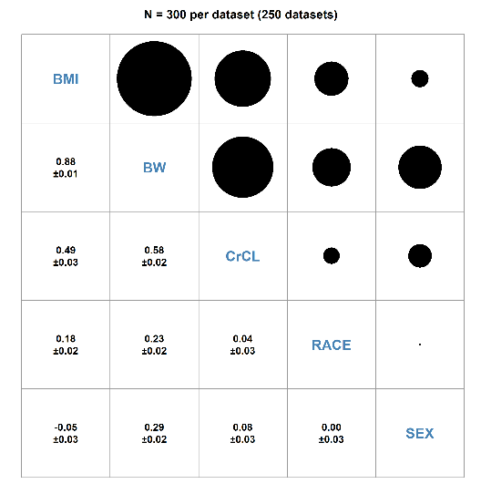
Figure 2.
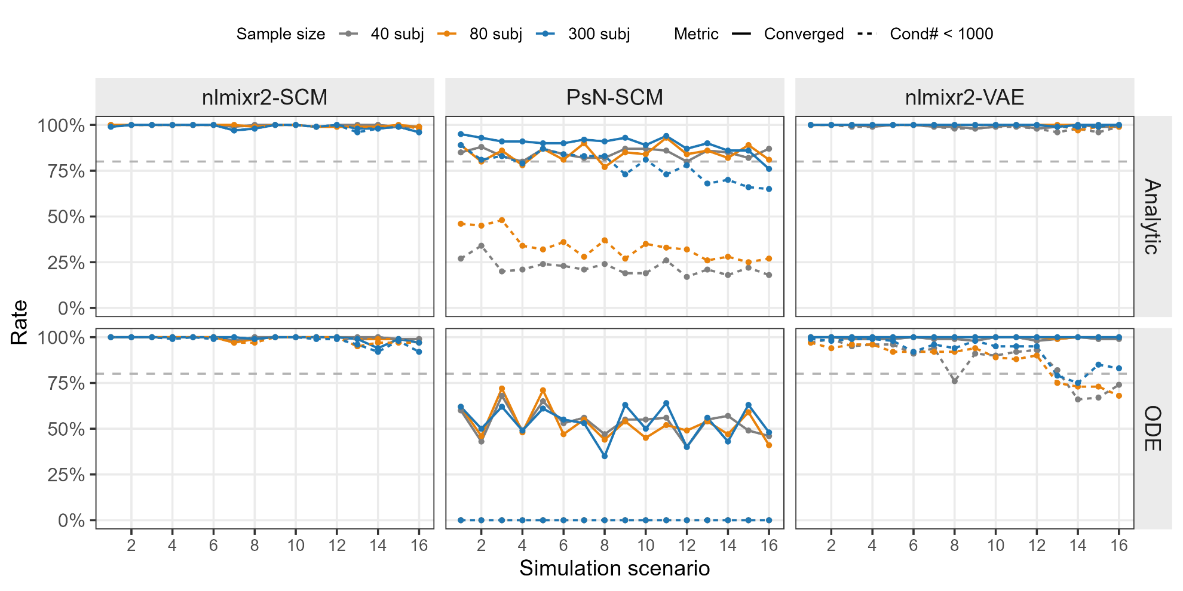

Figure3
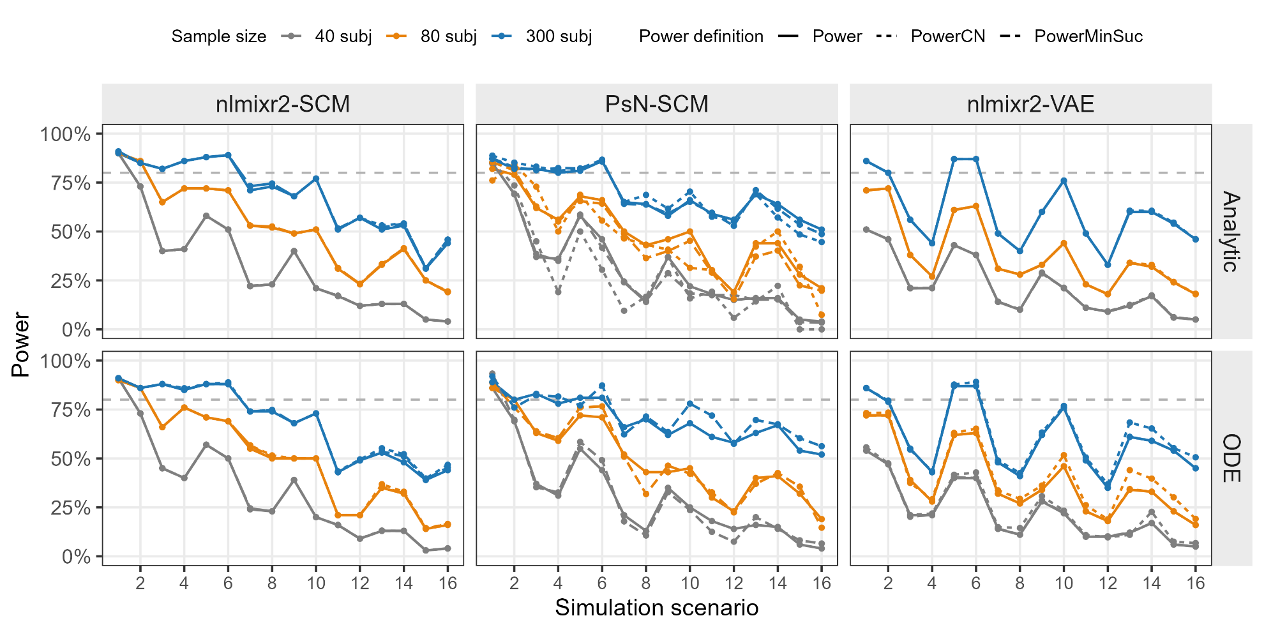

Figure 4
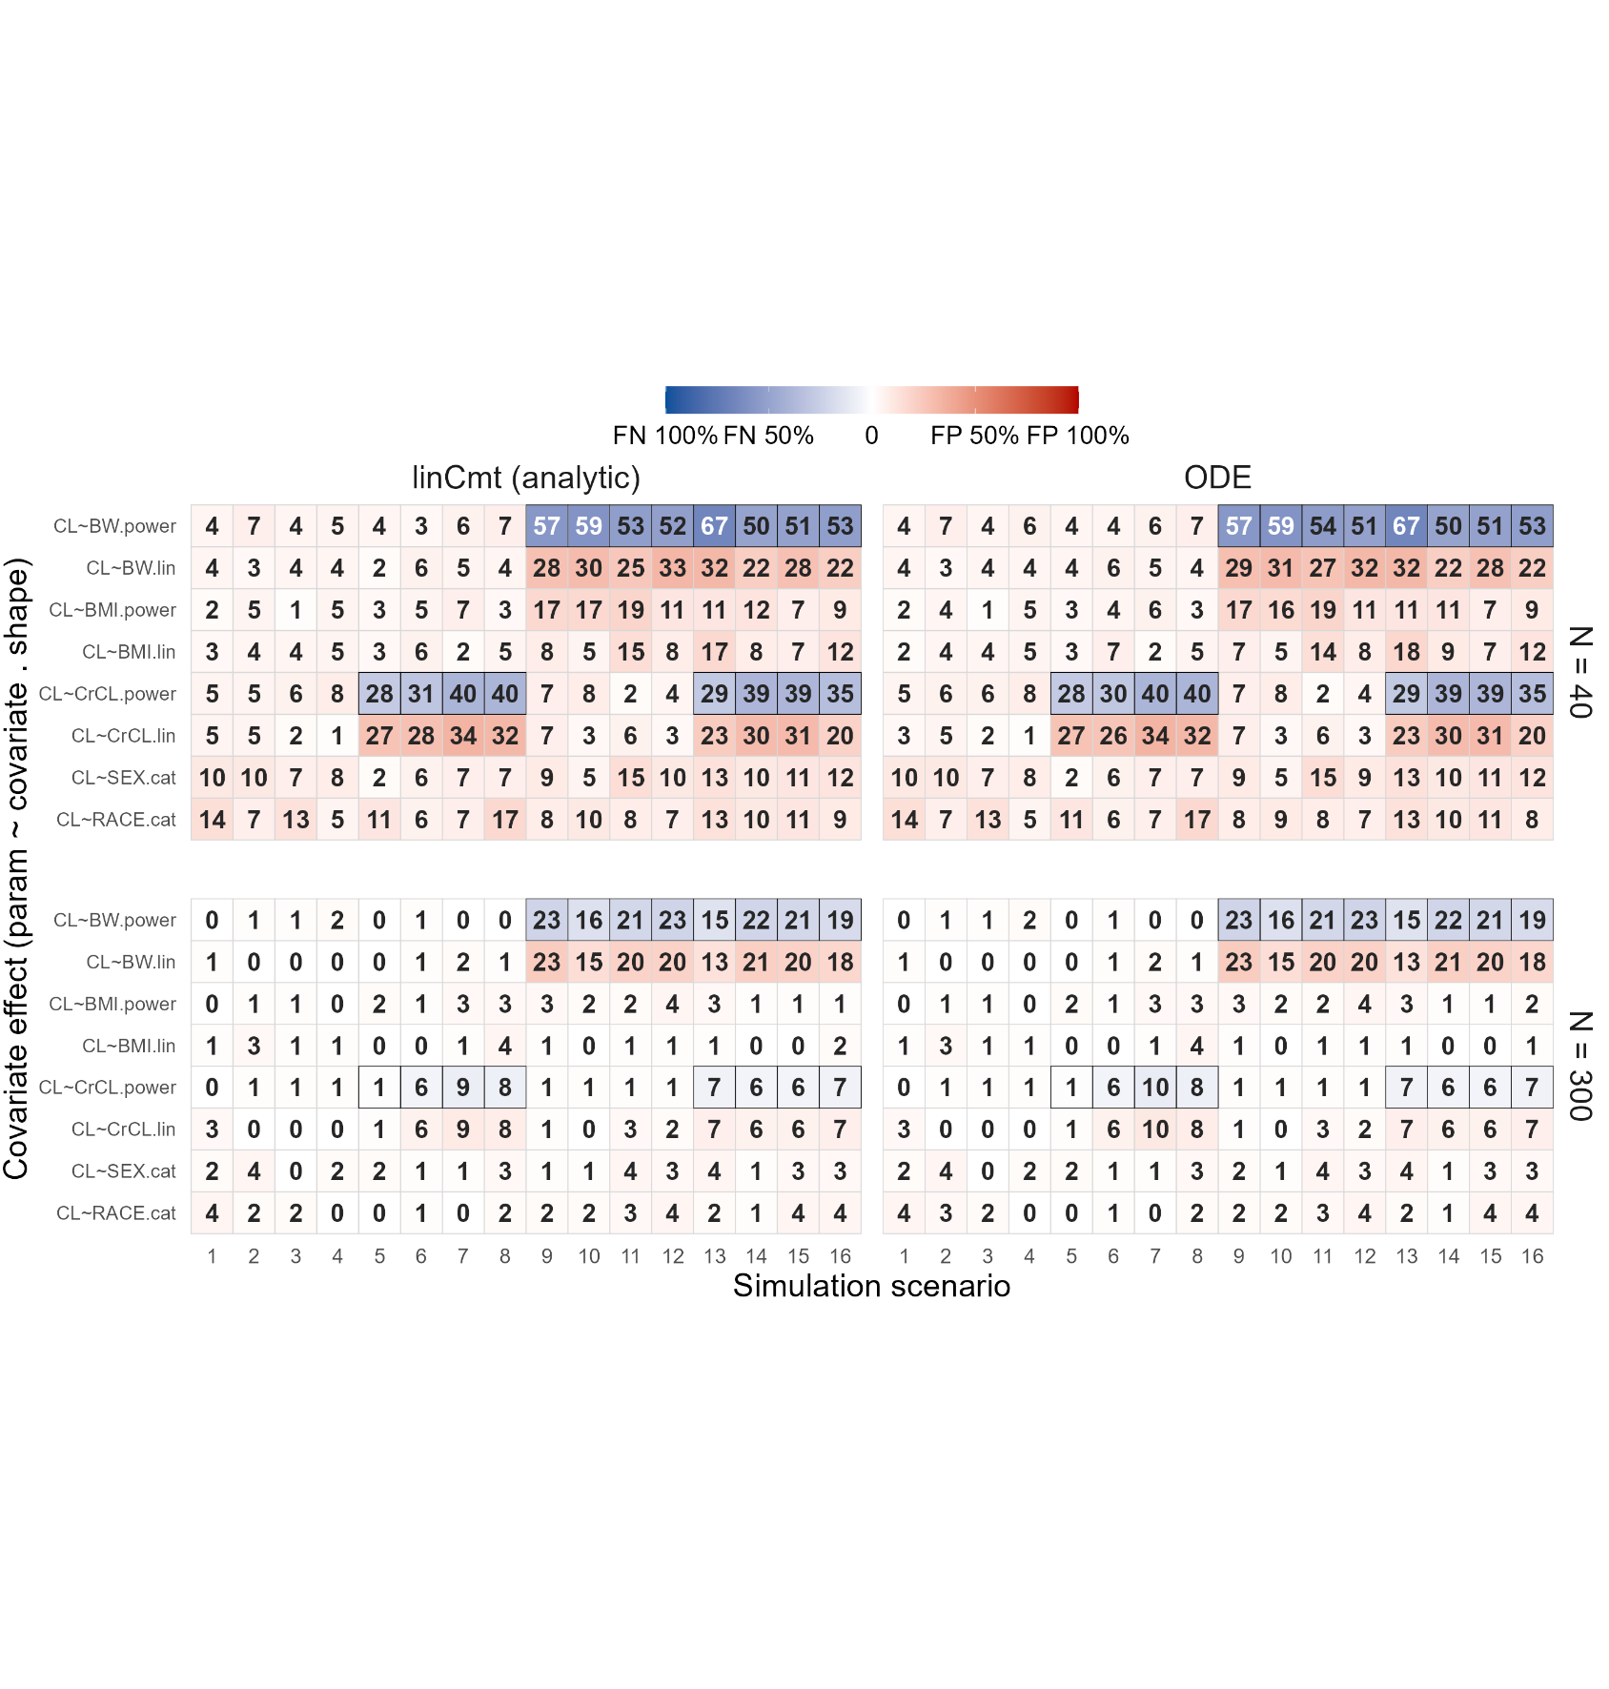

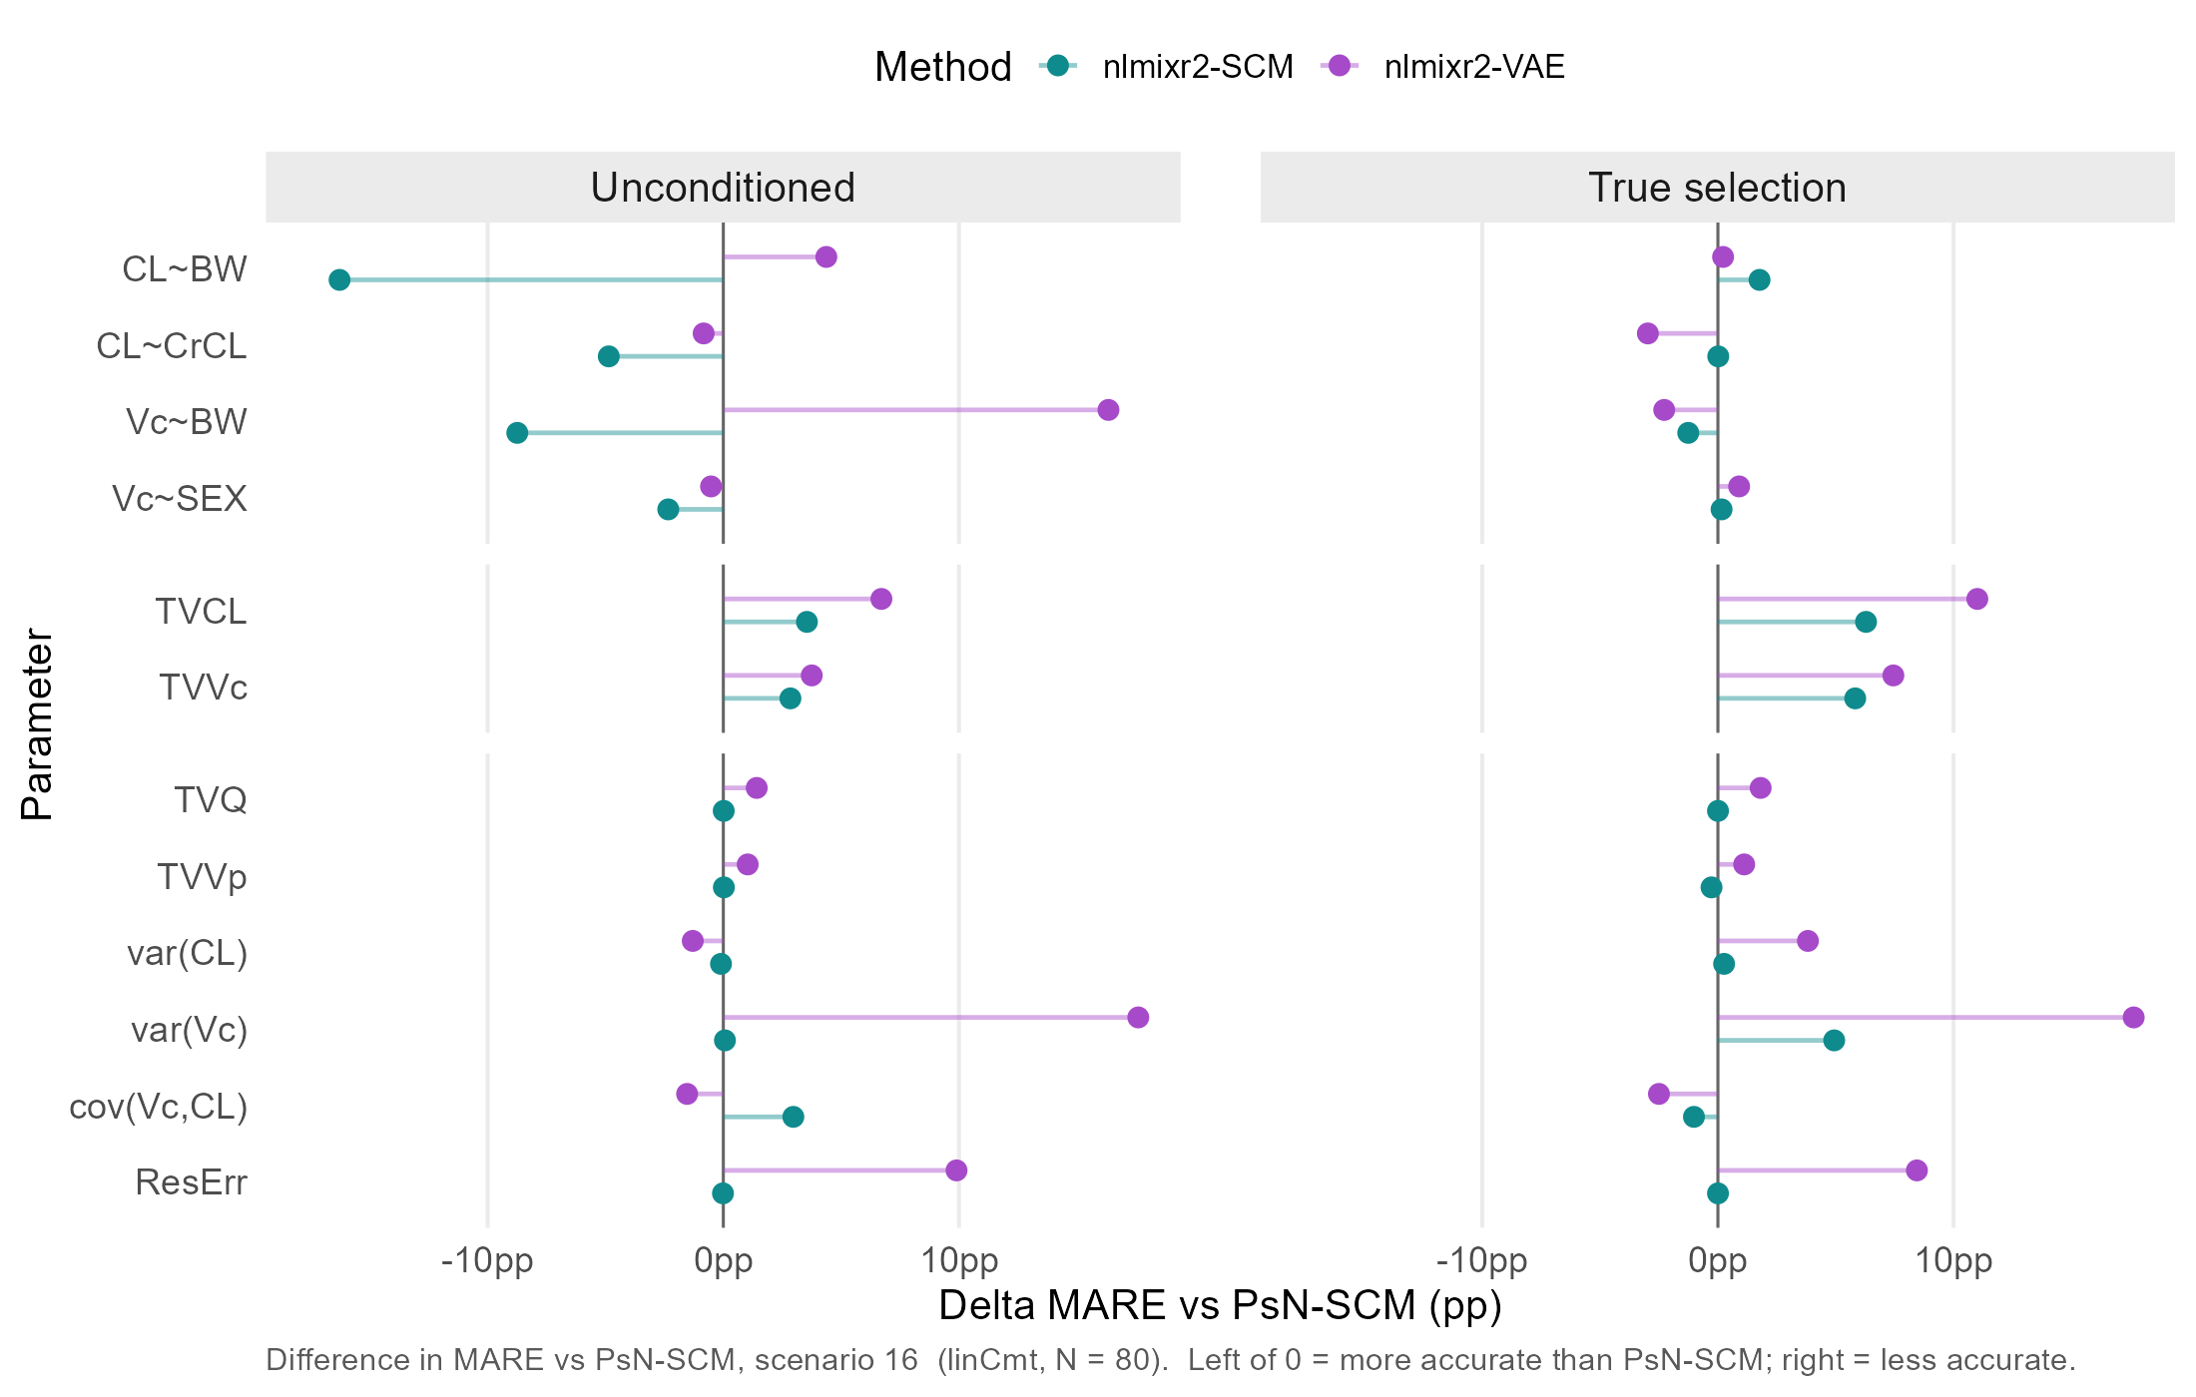

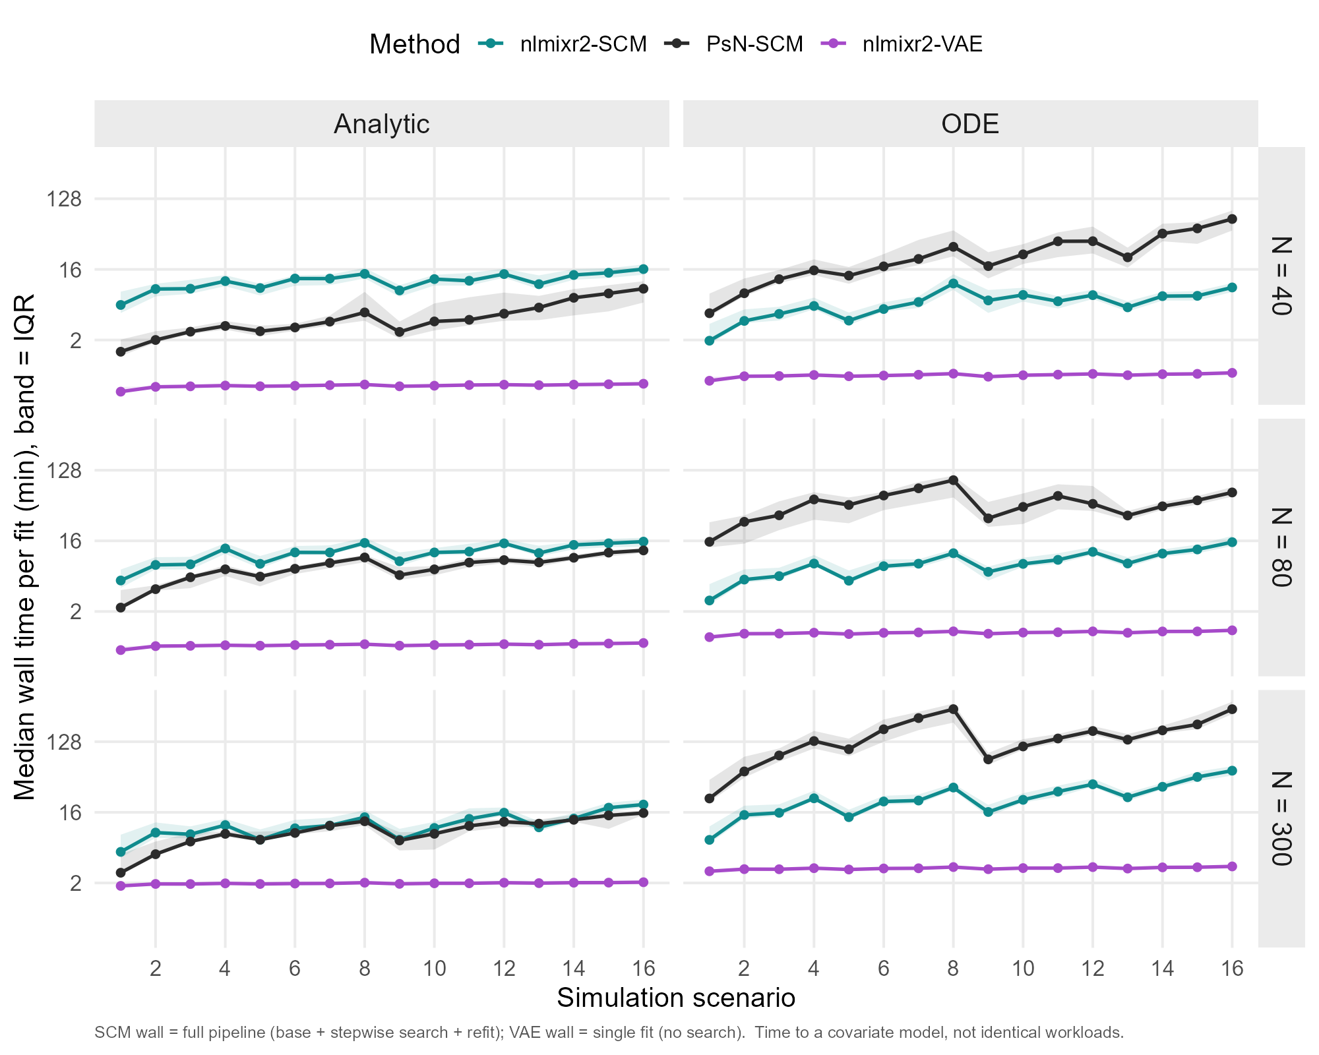

Tables
Table 1. The true covariate effects used for simulation

Supplemental Figures

Nlmixr2SCM
Figure 3a. The convergence status of focei-based SCM in nlmixr2
"C:\Users\LIUYA8J\OneDrive - Novartis Pharma AG\Internship\GithubRepo\nlmixr2scm\output\figures\nlmixr2_scm_0730\fig_diag_rates_all_Converged-CNBelowCutoff_focei_bobyqa.png"
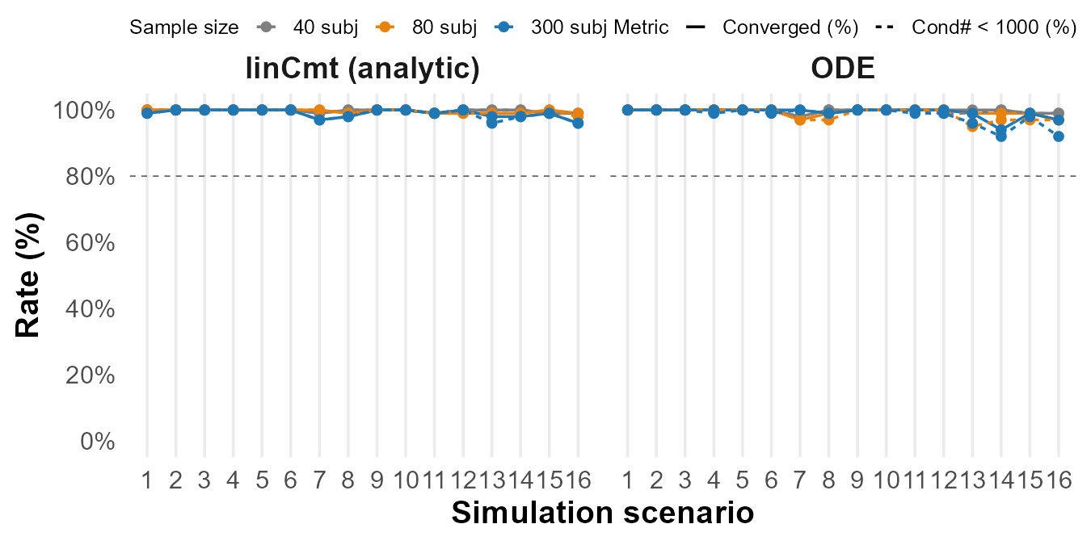

Figure 3b. The Power of focei-based SCM in nlmixr2 [Cropped legend]
GithubRepo\nlmixr2scm\output\figures\nlmixr2_scm_0730\fig_power_focei_bobyqa_multi.png"
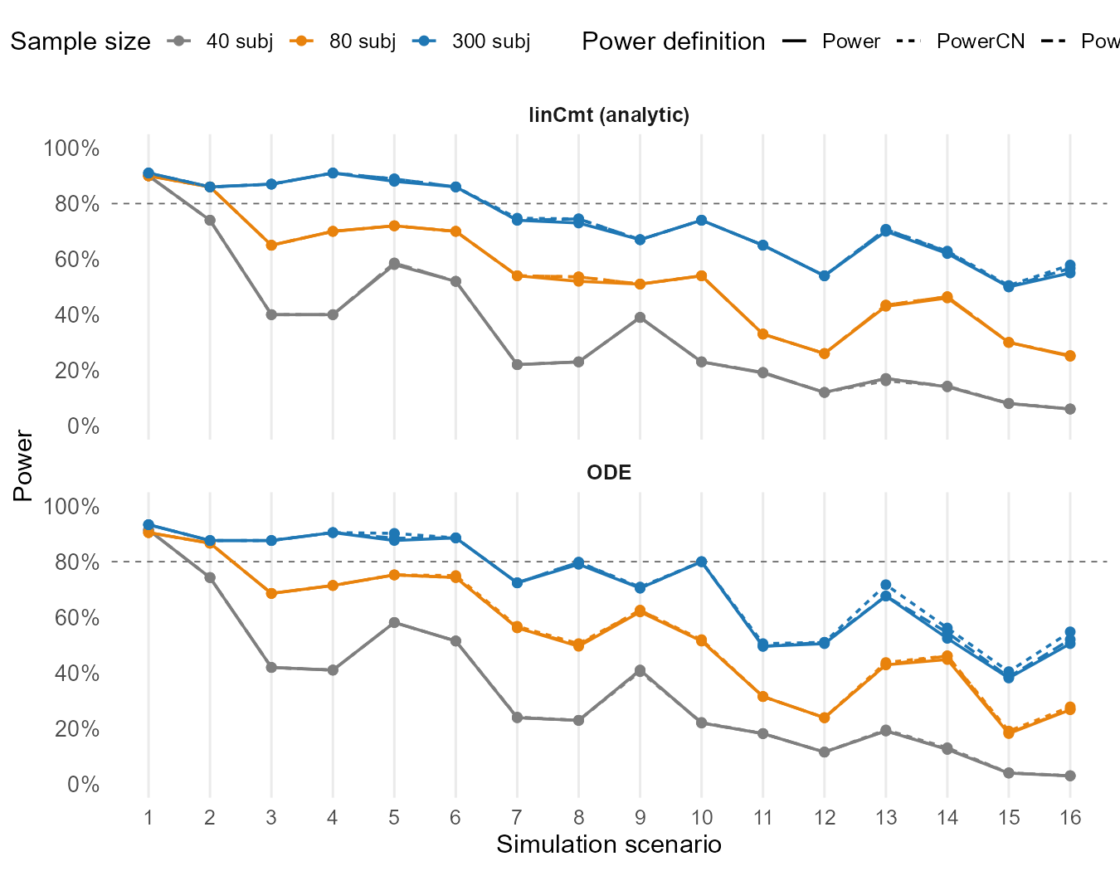

Figure 3c. The covariate selection pattern of focei-based SCM in nlmixr2
"C:\Users\LIUYA8J\OneDrive - Novartis Pharma AG\Internship\GithubRepo\nlmixr2scm\output\figures\nlmixr2_scm_0730\fig_covsel_heatmap_scm_focei_bobyqa_allN_both.png"
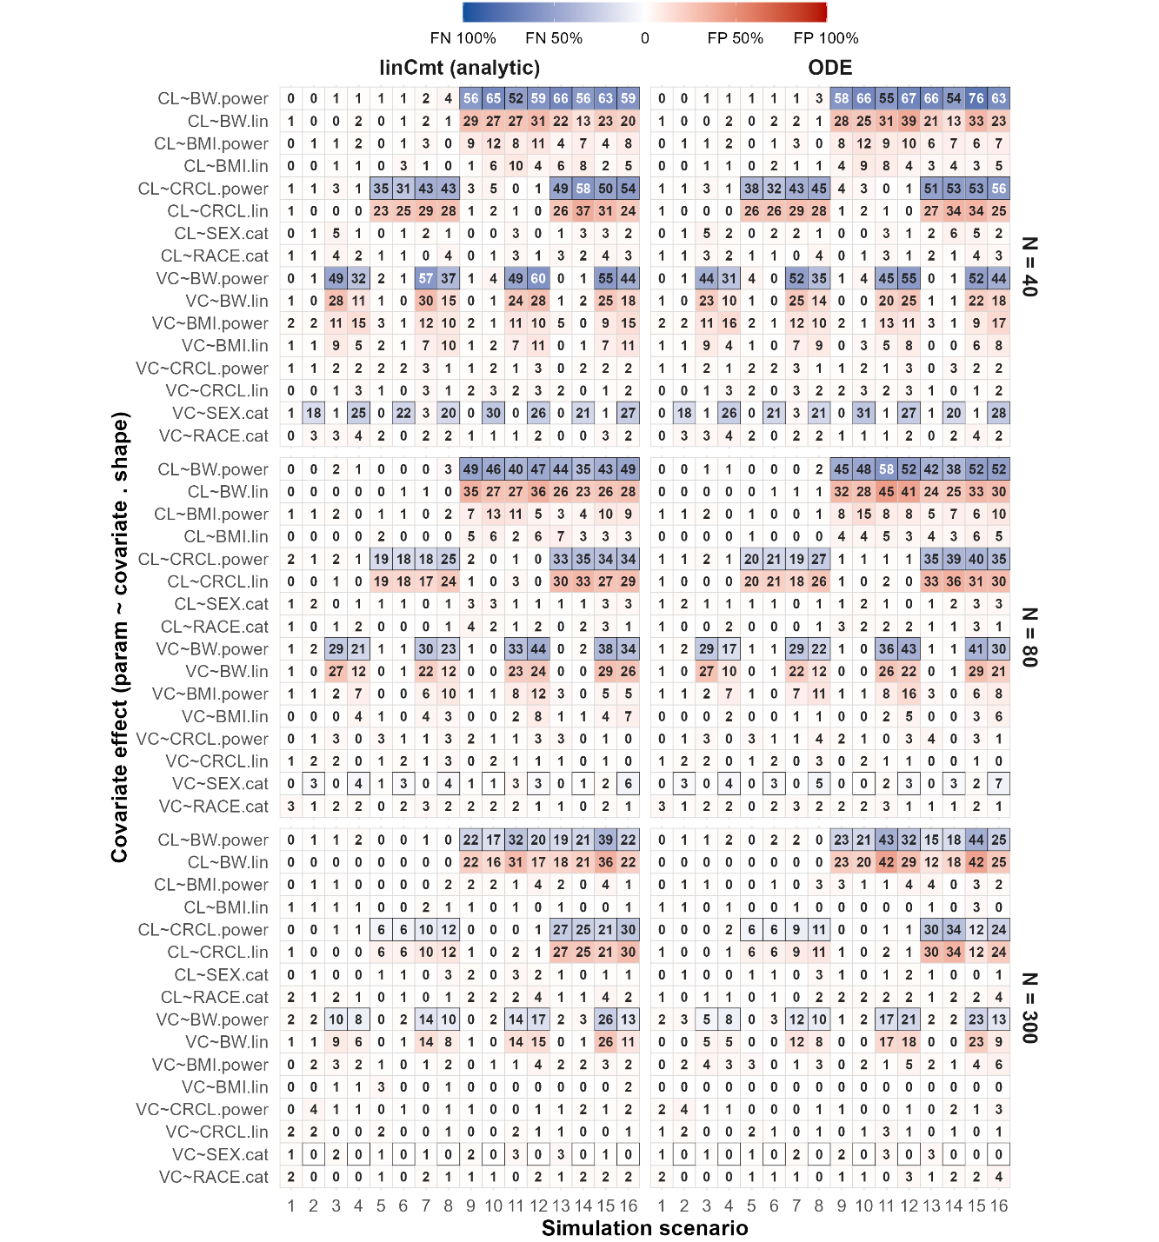
Figure 3d. The parameter estimation accuracy of focei-based SCM in nlmixr2
"C:\Users\LIUYA8J\OneDrive - Novartis Pharma AG\Internship\GithubRepo\nlmixr2scm\output\figures\nlmixr2_scm_0730\fig_error_metrics_scn16_allN_allStruct_RMRSE-MARE_focei_bobyqa.png"
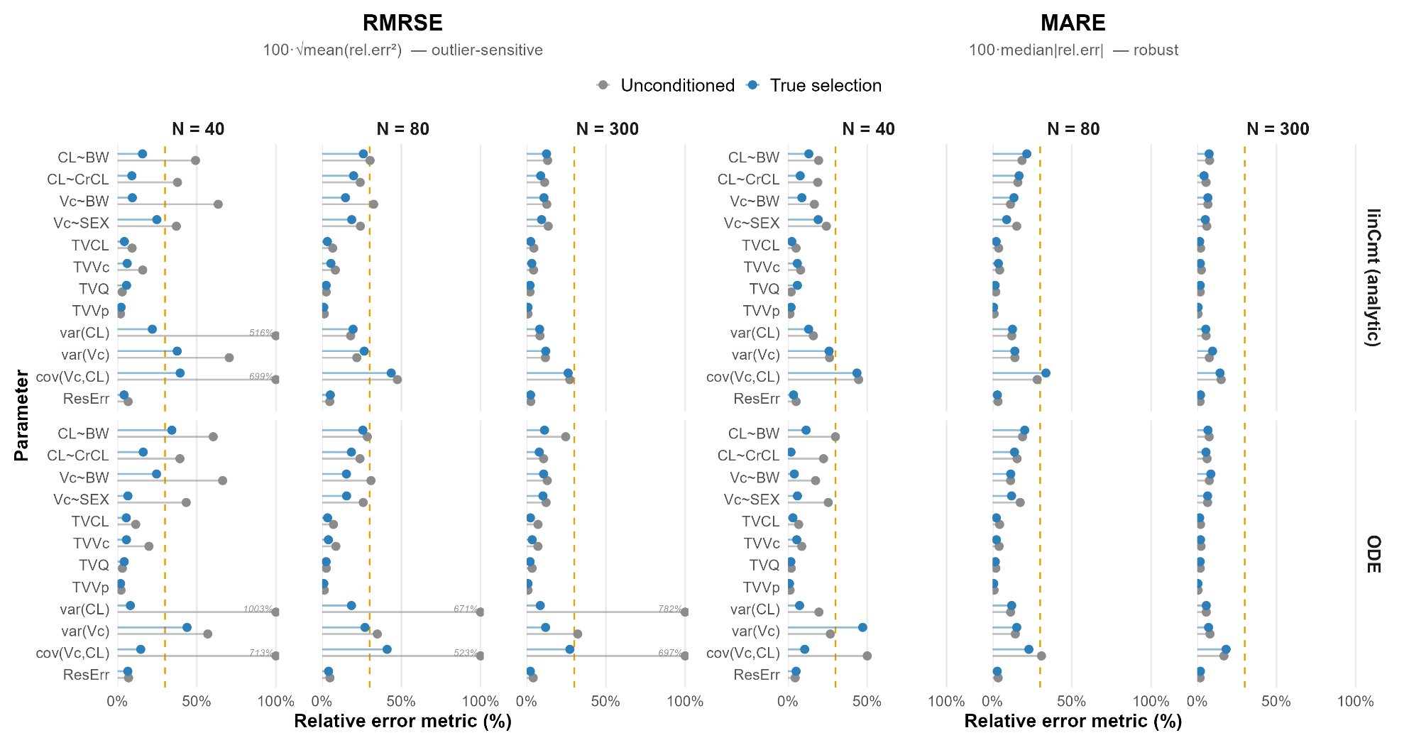

PsN-SCM
Figure 4a. The convergence status of focei-based SCM in NONMEM
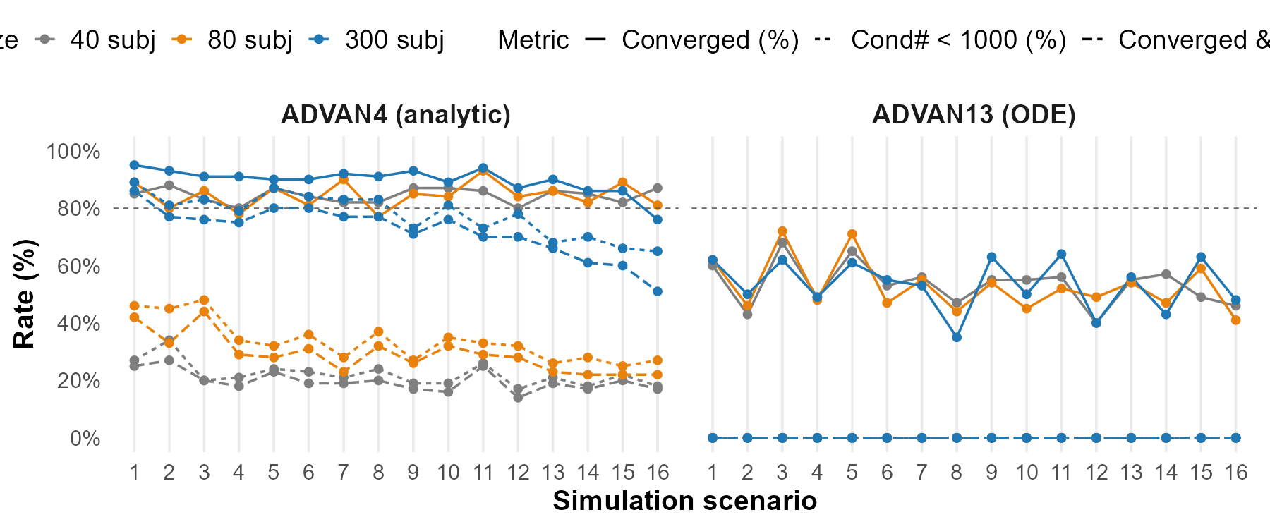
Figure 4b. The Power of focei-based SCM in NONMEM
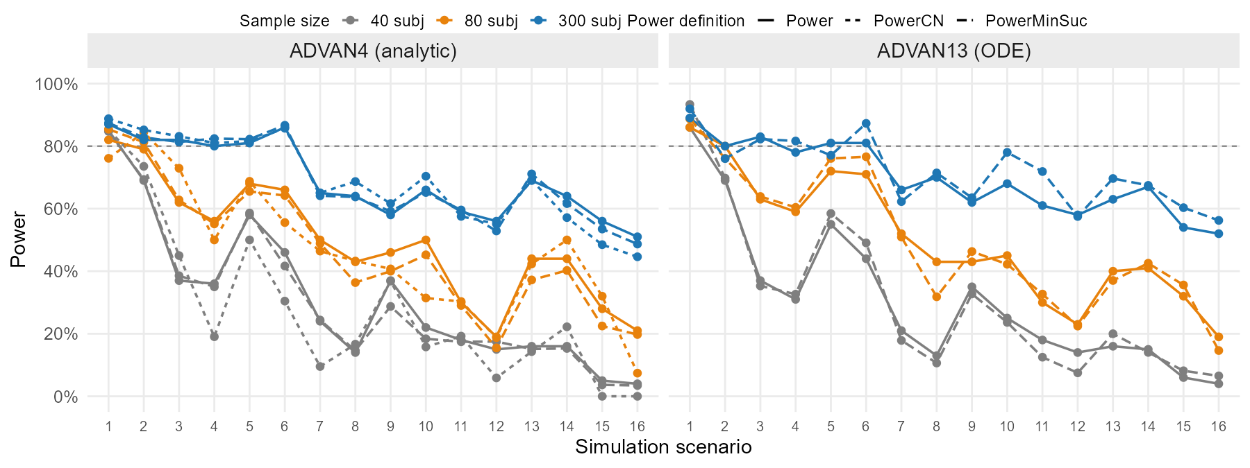
Figure 4c. The covariate selection pattern of focei-based SCM in NONMEM
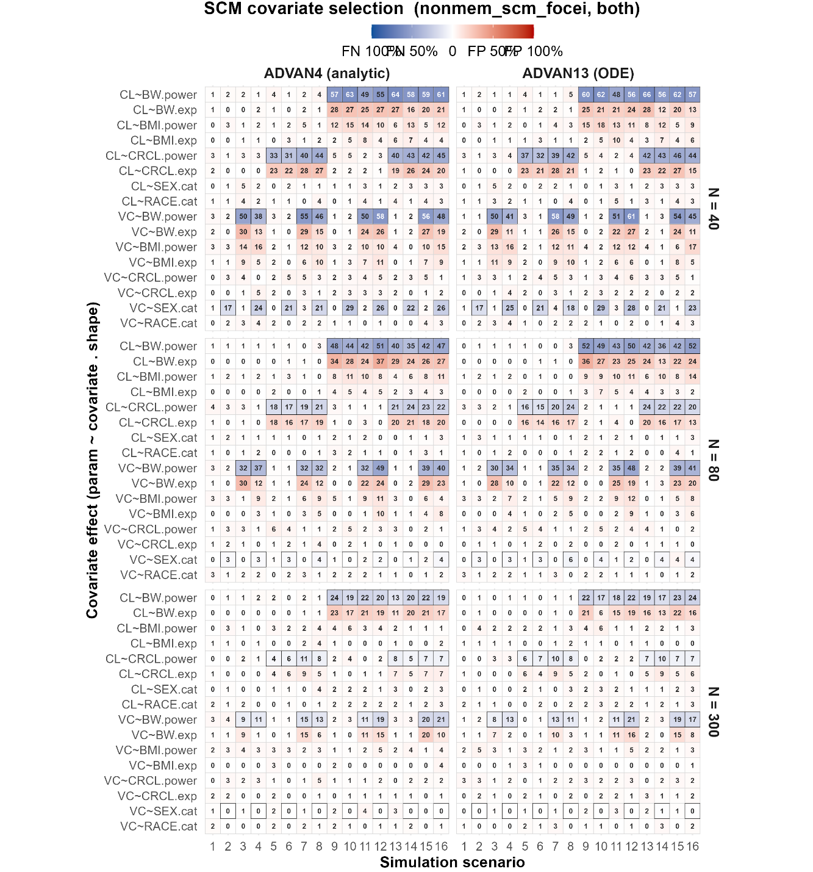
Figure 4d. The parameter estimation accuracy of focei-based SCM in NONMEM
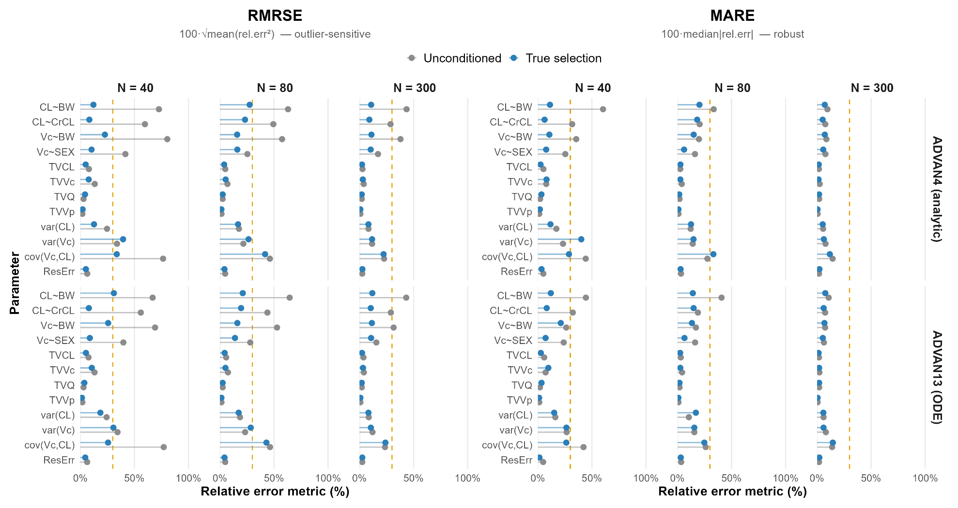

VAE
Figure 5a. The convergence status of vae-based covariate selection in nlmixr2
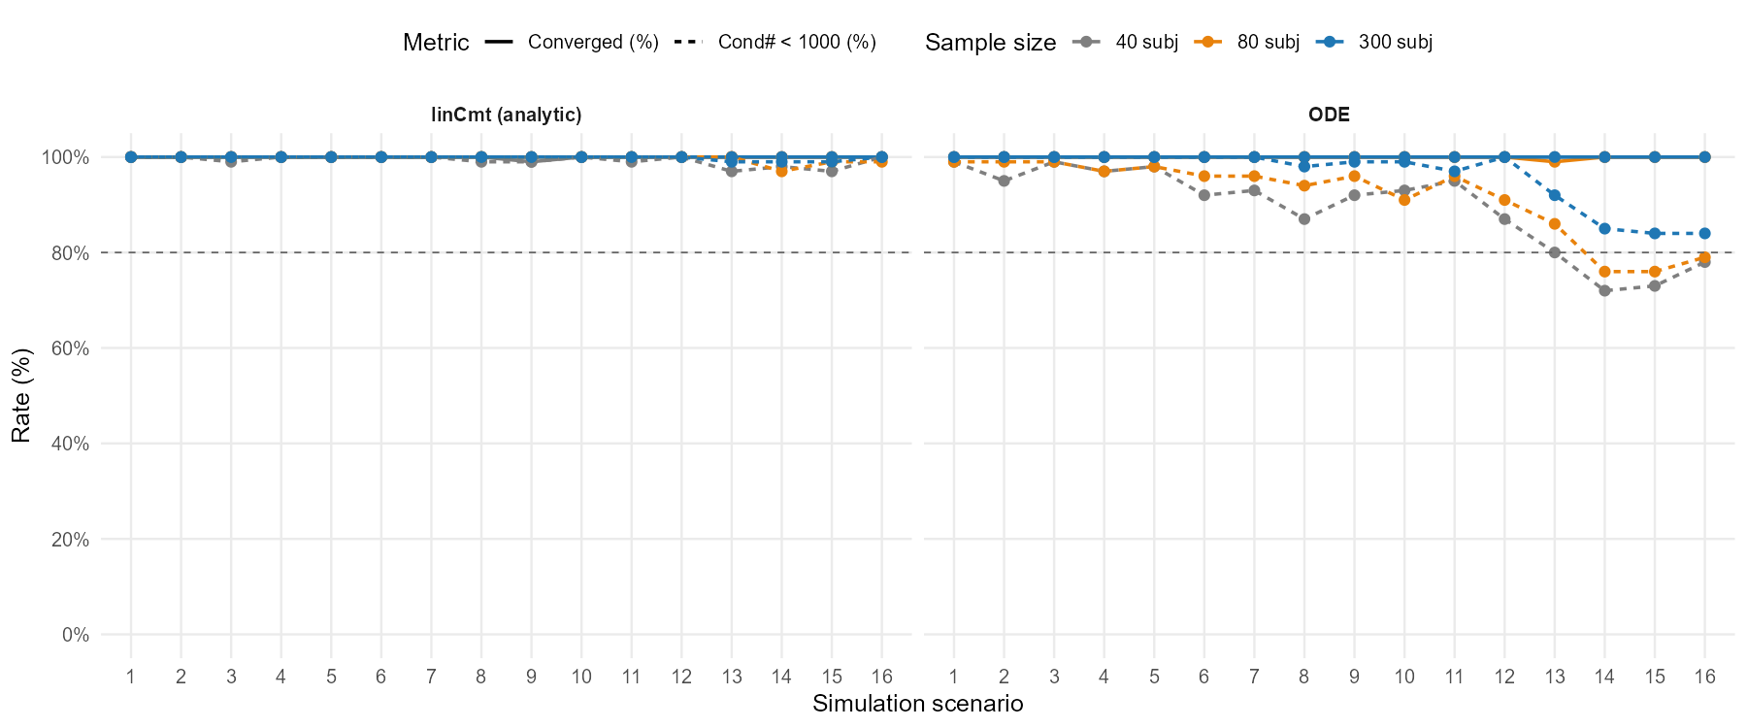

Figure 5b. The Power of vae-based covariate selection in nlmixr2
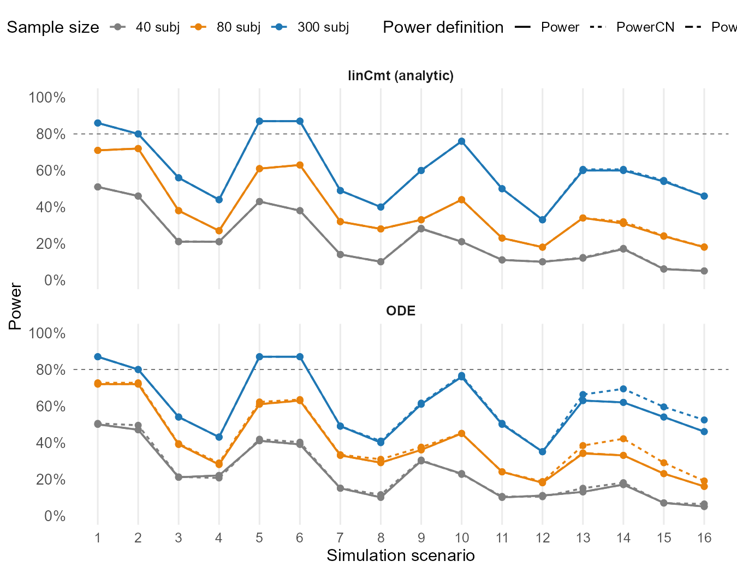
Figure 5c. The covariate selection pattern of vae-based covariate selection in nlmixr2
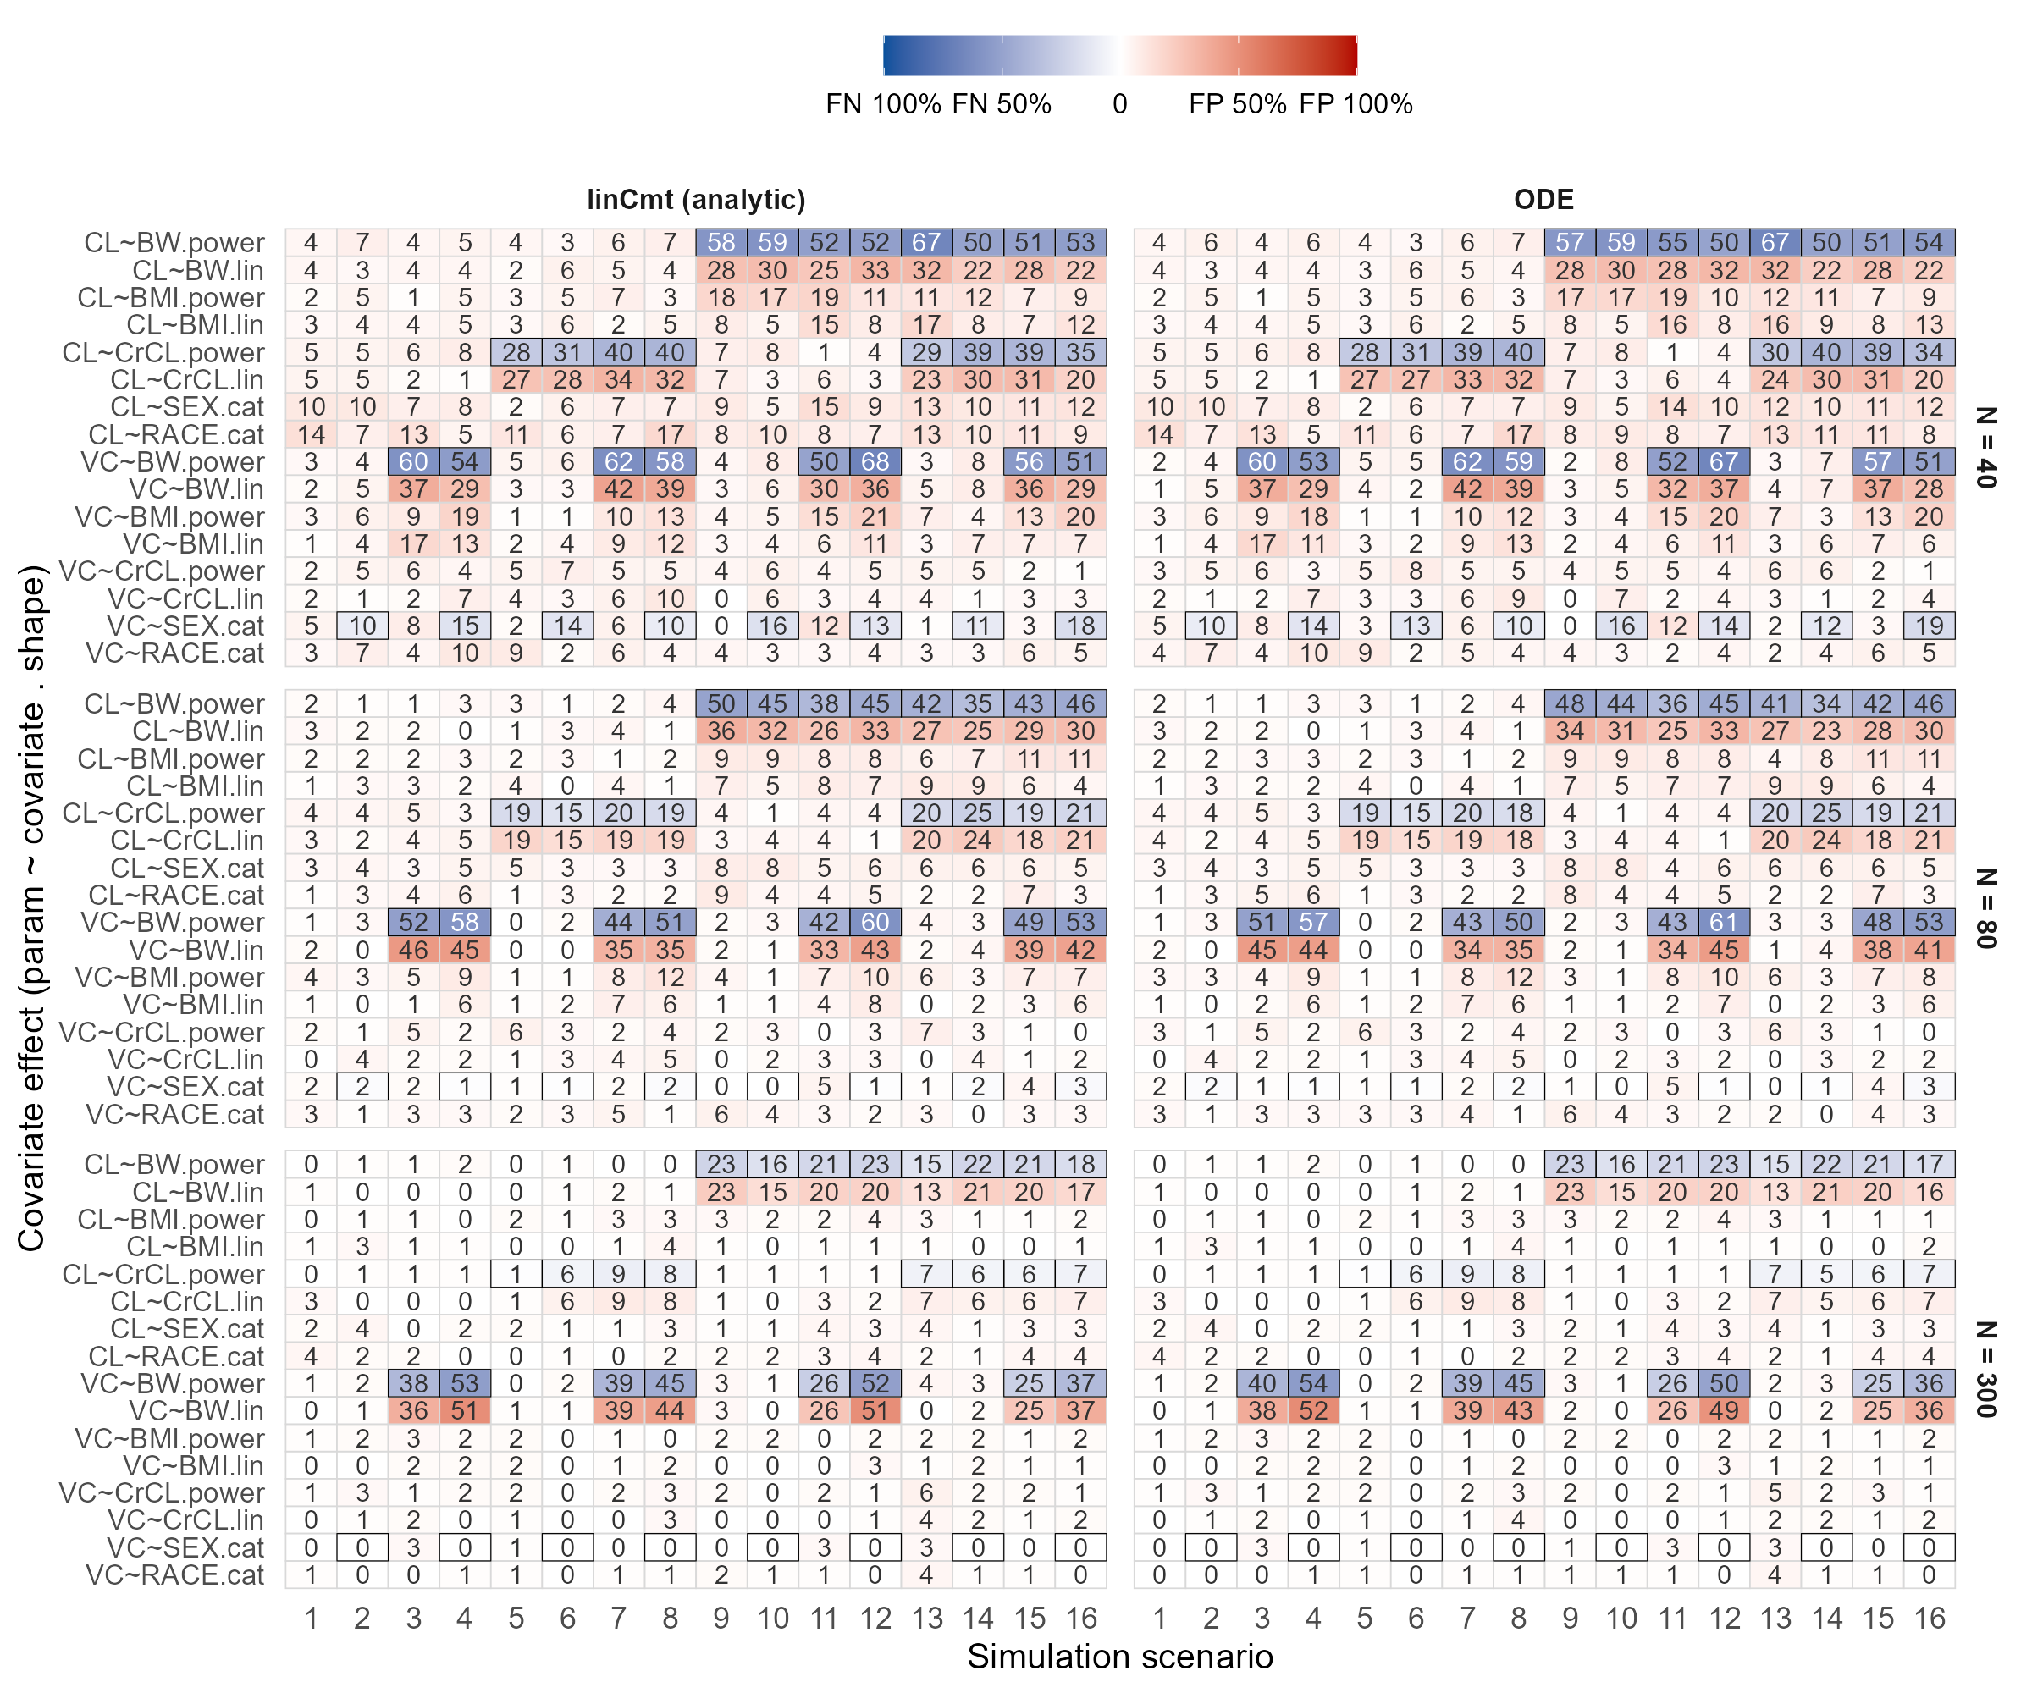
Figure 5d. The parameter estimation accuracy of vae-based covariate selection in nlmixr2
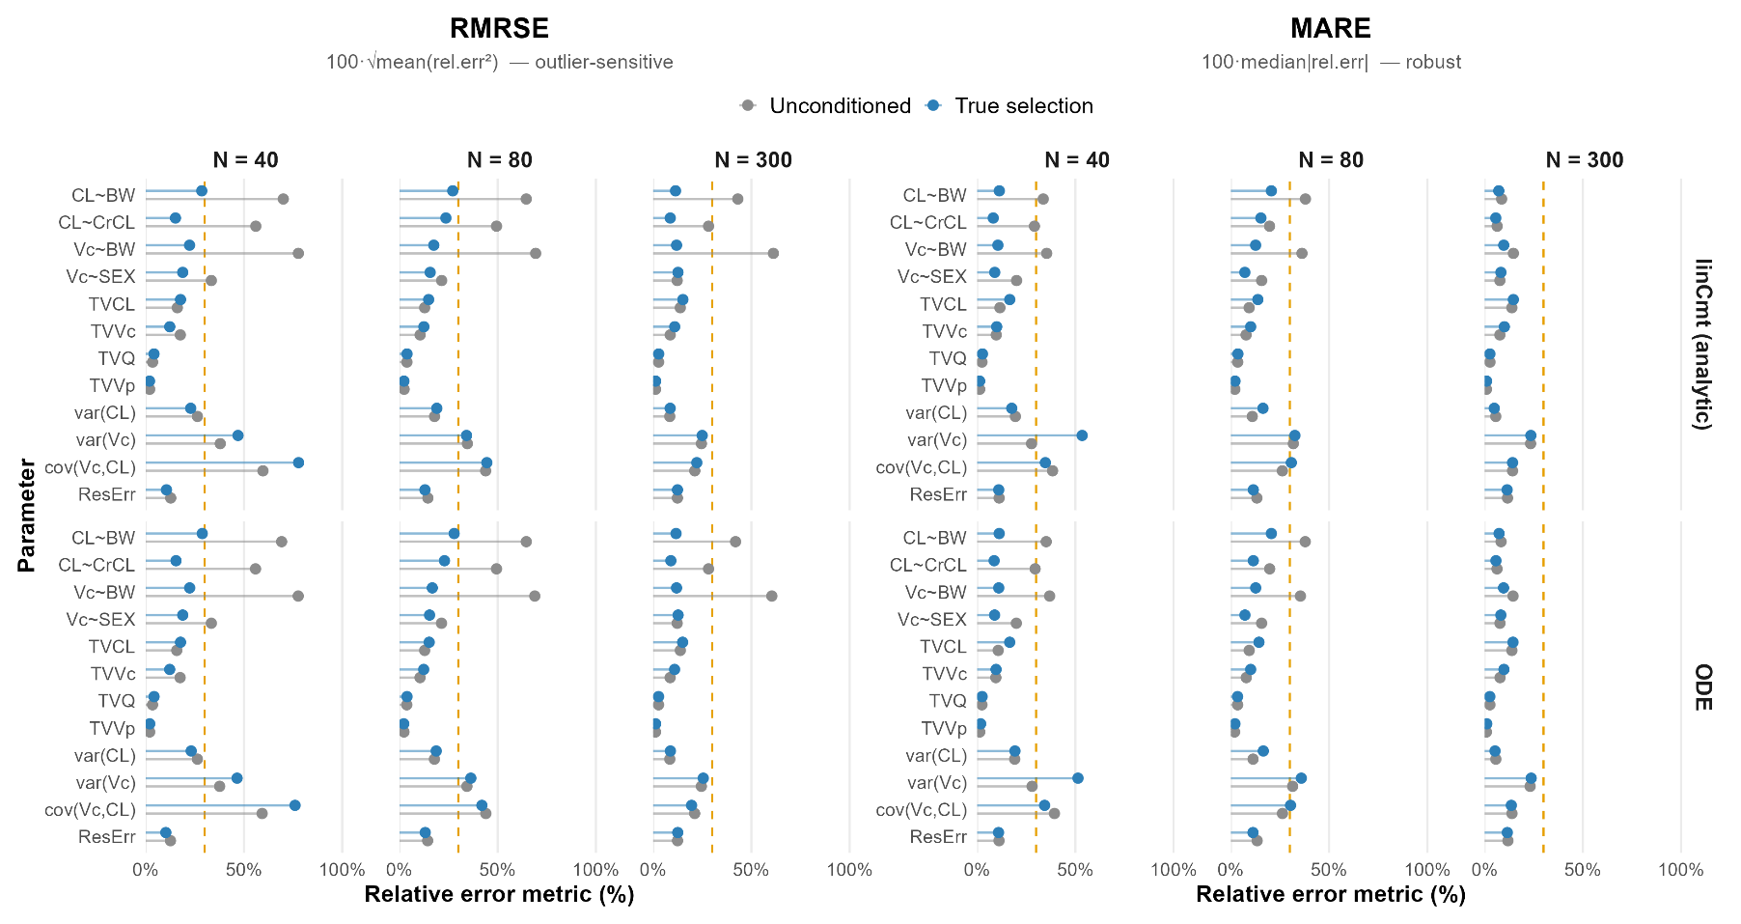

Supplemental Tables
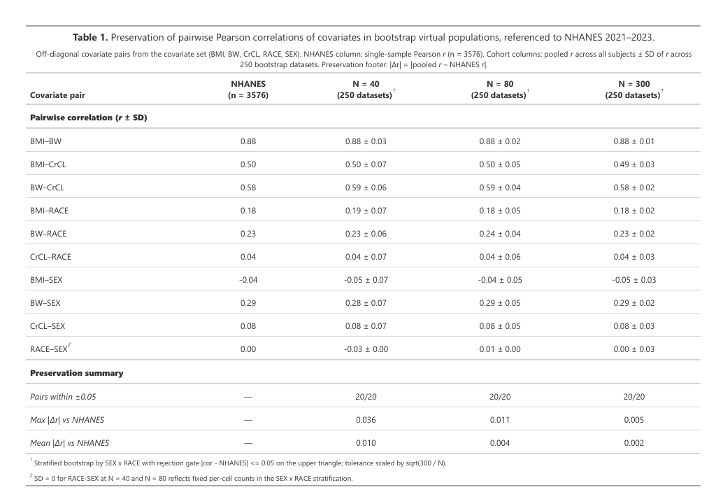

How different methods in the nlmixr2 ecosystem select covariates for popPK models.
Methods status:

