Description of the data

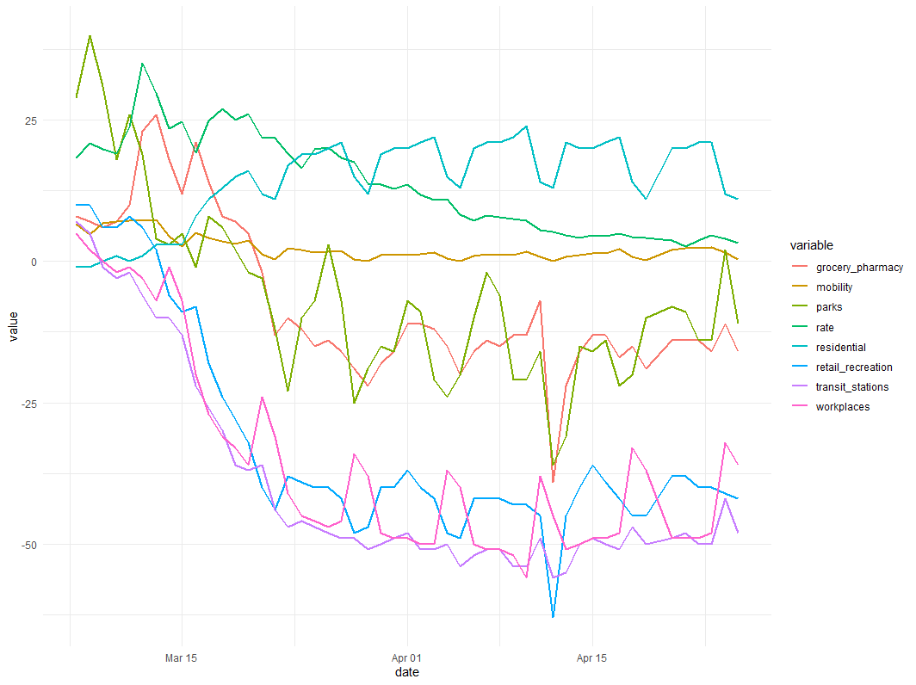

Figure 1 the data changes across time for the united state.

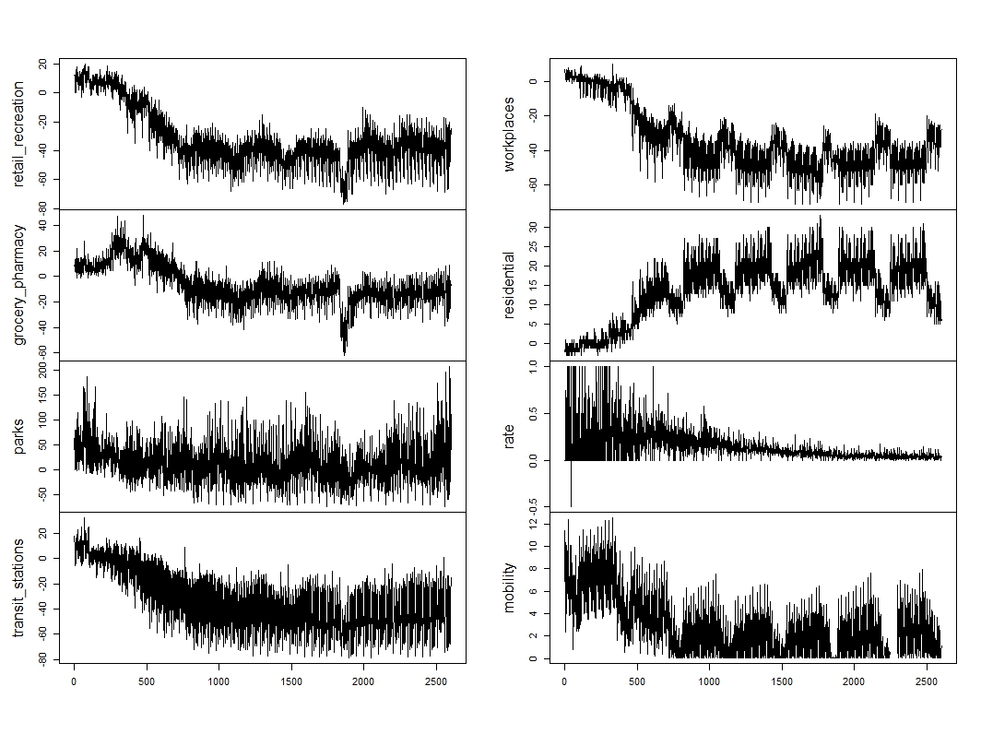

Figure 2 tendency of the variable across 50 states

We found that the value has a dramatic change after the end of March when the state government start to have a self-quarantine and closed the restaurant, theater, etc. And at that point, the increase rate starts to decrease. The plot indicates that the social distance, isolation policy is beneficial to hinder the transmission of coronavirus. And the figure 2 from 50 states showed a similar trend.

Next, I tried to fit a unified SEM model to explore the causal effect of the variables and exam whether every state showed the same pattern by using the GIMME method. If the effect from the visit rate or distance unrelated to the increase rate, it will provide some support for reopening. And If 50 states showed the different pattern of the effects, some states who have a weaker relationship would start to reopen their state