## **Name : Mohd Yaqoob**

## **ID: BIT-23F-013**

## **Section: IT“3A”**

## **Lab: 08**

## **Subject: Artificial Intelligence**

## **Program: BS-IT**

**Task1**.

Write a Python class named Car that represents a car. The class should have the following attributes:

• make: the car's make (e.g., "Toyota")

• model: the car's model (e.g., "Corolla")

• year: the car's manufacturing year (e.g., 2020)

• mileage: the number of miles driven by the car.

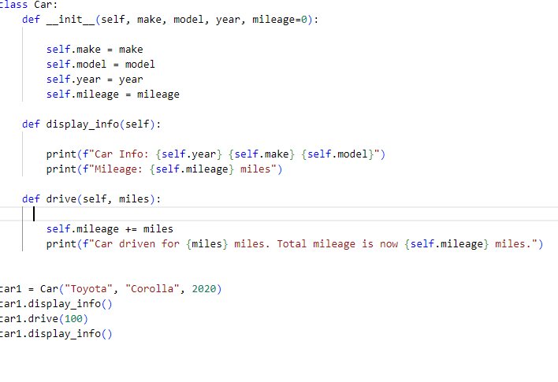

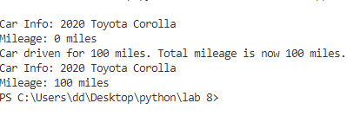

**Task2.**

rite a Python class named Student that represents a student. The class should have the following attributes:

• name: the student's name.

• age: the student's age.

• marks: a list of the student's marks.

The class should have the following methods:

• _init_(self): Constructor to initialize the student's attributes.

• add marks(self, marks): Adds a list of marks to the student's marks list.

• average marks(self): Calculates and returns the average of the student's marks.

• display info(self): Displays the student's information (name, age, average marks).

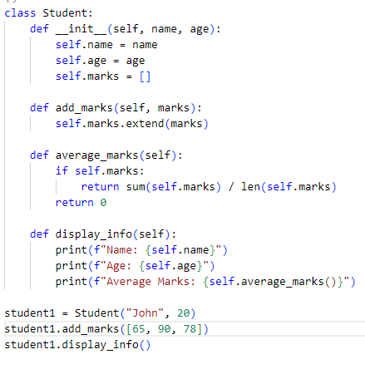

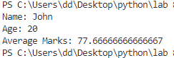

**Task3.**

Write a Python class named Bank Account that represents a bank account. The class should have the following attributes:

• accountholder: the name of the account holder.

• balance: the balance of the account.

The class should have the following methods:

• _init_(self): Constructor to initialize the account holder's name and balance.

• deposit (self, amount): Deposits an amount into the account.

• withdraw (self, amount): Withdraws an amount from the account if there are sufficient funds.

• display balance(self): Displays the current balance of the account.

