## **Name : Mohd Yaqoob**

## **ID: BIT-23F-013**

## **Section: IT“3A”**

## **Lab: 06**

## **Subject: Artificial Intelligence**

## **Program: BS-IT**

**TASK-01** :

Write a Python function that takes a number as input and returns the sum of its digits.

## Program:

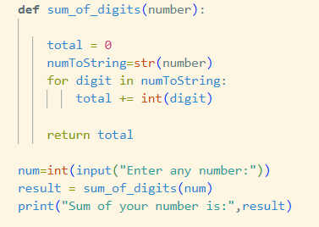

## Output:



**TASK-02 :**

Write a Python function that takes a sentence as input and returns the number of words in it.

## **Program:**

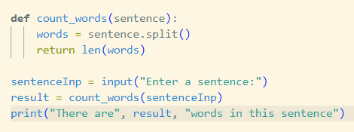

## **Output:**



TASK-03 : Write a Python function that takes an integer and returns whether the number is even or odd.

## Program:

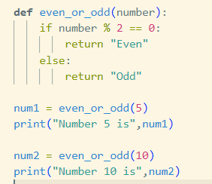

## Output:

