## **Name : Mohd Yaqoob**

## **ID: BIT-23F-013**

## **Section: IT“3A”**

## **Lab: 07**

## **Subject: Artificial Intelligence**

## **Program: BS-IT**

**TASK 1**

Write a Python function that draws a square using asterisks (*). The side length of the square should be provided by the user.

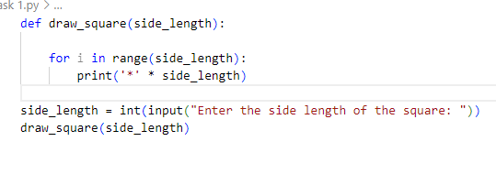

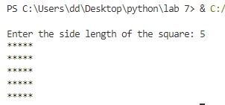**TASK 2**

Write a Python function that takes a list of numbers as input and returns the sum of only the even numbers.

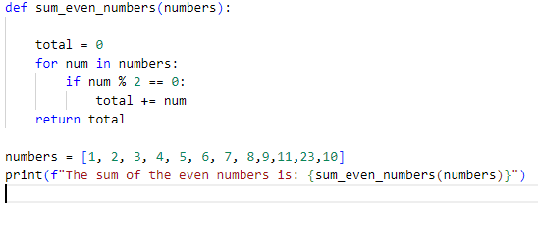

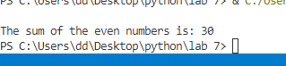

**TASK 3**

Write a Python function that takes a number as input and counts down to zero, printing each number.

