Distributed and Operating Systems

Lab 1: Bazar.com: A Multi-tier Online Book Store

Raghad Sabri 11924224

Yaqout Salameh 11924020

In this project, we did everything together but we made Zoom and pushed the project to GitHub from one device most of the time.

Here is the result of the project we covered all the possible scenarios we can get, as you can see in these images:

Enter an unavailable value or wrong data type (unaccepted)

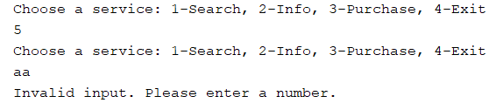

To search for specific book topics (case insensitive) (enter an unavailable value or wrong data type (unaccepted))

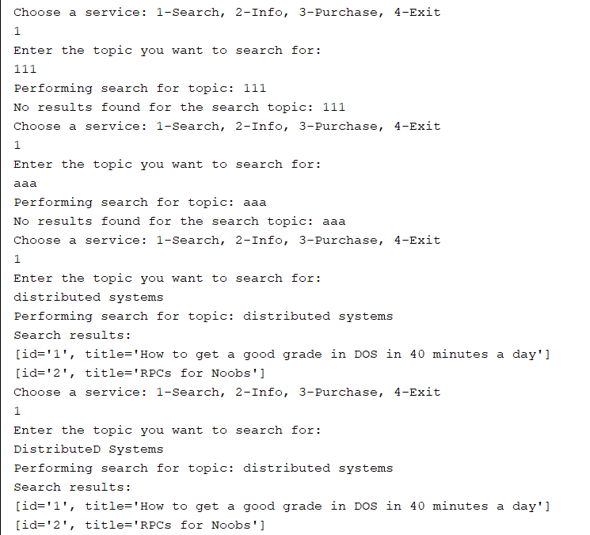

Info to get specific book ID information(enter an unavailable value or wrong data type (unaccepted))

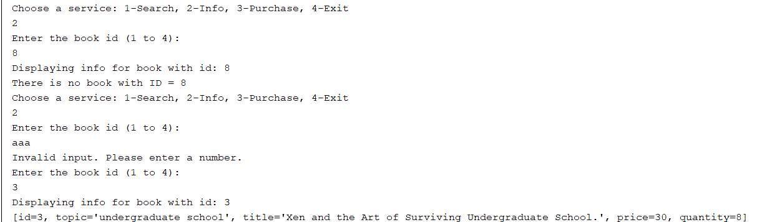

Purchase to order by specifying book ID (enter an unavailable value or wrong data type (unaccepted))

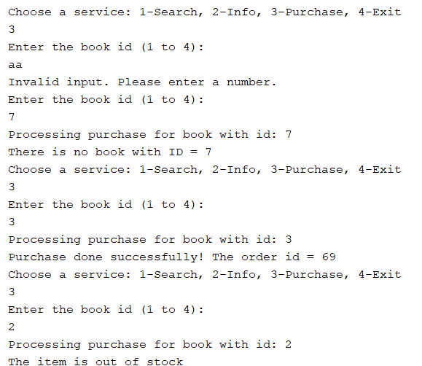

To exit the program

