**YouTube Video Links für Splace Gruppe Spielräume**

**Apokalypse**

The Apocalypse, Albrecht Dürer: <https://www.youtube.com/watch?v=-YbFZg-vcDs> (LINKS)

Darksiders: <https://www.youtube.com/watch?v=5cDSLhBk2nQ> (RECHTS)



**Das Spiel in der Kultur**

MOMA NY: <https://www.youtube.com/watch?v=dfvlLwYXUcU> (LINKS)

Video Game Culture: <https://www.youtube.com/watch?v=K-qT4KTEDmk> (RECHTS)



**Diesseits Jenseits**

The Plan: <https://www.youtube.com/watch?v=8EFGmvDb1KU> (LINKS)

Hieronymus Bosch: <http://www.youtube.com/watch?v=zXt2S5nWrA0> (RECHTS)



**Dystopische Städte**

~~Bioshock:~~ [~~https://www.youtube.com/watch?v=dfCLxECJw5o~~](https://www.youtube.com/watch?v=dfCLxECJw5o)

~~Blade Runner: https://www.youtube.com/watch?v=bamCY0GHQhw~~

Metropolis: <https://www.youtube.com/watch?v=h0AlrH_K7Ko> (LINKS)

ANNO 2070: <https://www.youtube.com/watch?v=6ONqSVh_EfM> (RECHTS)



**Emotionen**

Fifa: <https://www.youtube.com/watch?v=-4ycZ509Wxk> (LINKS)

You'll Never Walk Alone: <https://www.youtube.com/watch?v=gteDQCFG9Po> (RECHTS)



**Fabelwesen**

Guild Wars 2 Concept Art: <https://www.youtube.com/watch?v=IUuxw0tGkVE> (LINKS)

Schwarze Romantik: <https://www.youtube.com/watch?v=_aQU81VX7lw> (RECHTS)



**Gender in Games**

Beyond Two Souls: <https://www.youtube.com/watch?v=TnUltxjNaDo> (LINKS)

Excuse Me Princess: <https://www.youtube.com/watch?v=hPYcASQL_IA> (RECHTS)

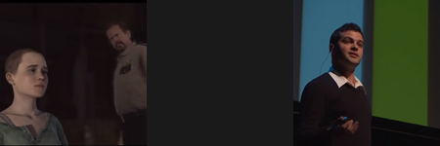

**Geschicklichkeit**

Mirror's Edge: <http://www.youtube.com/watch?v=2N1TJP1cxmo> (LINKS)

Parkour and Free Running: <http://www.youtube.com/watch?v=8DKQJceXQio> (RECHTS)

~~Super Mario Bros: http://www.youtube.com/watch?v=kcmKPmj9yeE~~



**Individualisierung_Avatare**

Carnival Rio de Janeiro: <http://www.youtube.com/watch?v=kTc3pv7d5vY> (LINKS)

Cosplay: <https://www.youtube.com/watch?v=9aFMKxhdpzc> (RECHTS)

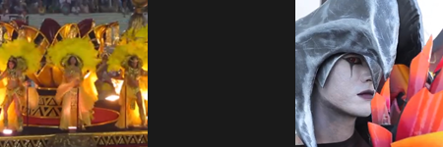

**Massenphenomen**

League Of Legends: <https://www.youtube.com/watch?v=NFQPUCu3reg> (LINKS)

~~Woodstock: http://www.youtube.com/watch?v=T9VMZwKmO4A~~

Colour Festival: <http://www.youtube.com/watch?v=Hh-o5g4tLVE> (RECHTS)



**Mensch Maschine**

Deus Ex: Human Revolution Serif Industries: <https://www.youtube.com/watch?v=UG_oThcYsn0> (LINKS)

Real Humans Trailer: <https://www.youtube.com/watch?v=iwh3xxozlZs> (RECHTS)



**Mythen**

~~Slender: The Arrival: https://www.youtube.com/watch?v=312tpSXMyeQ~~

Year Walk: <https://www.youtube.com/watch?v=LVz_MhMsAvs(> LINKS)

Bioshock Infinite: <https://www.youtube.com/watch?v=LUXT0axtAPc> (RECHTS)

~~CAVE! CAVE! DEUS VIDET:~~ [~~https://www.youtube.com/watch?v=Zlr22mRY5h~~](https://www.youtube.com/watch?v=Zlr22mRY5h) > link geht nicht.



**Narration**

Heavy Rain: <http://www.youtube.com/watch?v=fMK6sTnMxBI> (LINKS)

Umberto Eco: <http://vimeo.com/31923147> (RECHTS)

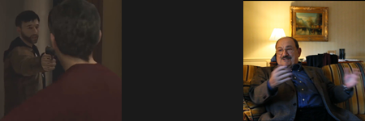

**Spielräume**

Gone Home: <https://www.youtube.com/watch?v=x5KJzLsyfBI> (LINKS)

Skyrim VR: <https://www.youtube.com/watch?v=k7n5kRRHDpw> (RECHTS)

~~Portal:~~ [~~https://www.youtube.com/watch?v=TluRVBhmf8w~~](https://www.youtube.com/watch?v=TluRVBhmf8w)

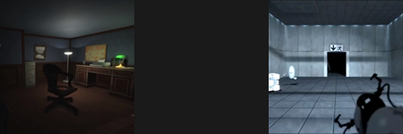

**The Great Game**

Battlefield 3 Simulator: <https://www.youtube.com/watch?v=TQ0gjNOofaQ> (LINKS)

POK, the game of life and death: <https://www.youtube.com/watch?v=OY7Wbew-3UU> (RECHTS)



**Urängste**

Goya's Caprichos - The sleep produces monsters:

<https://www.youtube.com/watch?v=StCDWenKKFw> (LINKS)

LIMBO: <https://www.youtube.com/watch?v=cHjt8LNaUT8> (RECHTS)

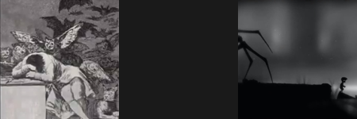

**Weltall**

2001: Space Odyssey: <http://www.youtube.com/watch?v=E8TABIFAN4o> (LINKS)

Broken Age: <https://www.youtube.com/watch?v=rCP30fPc4J8> (RECHTS)

