cover


Pharmacy Management System

College of Information Technology
Course : Database Programming

Students:
Yara Emad Ghannam :202110467
Lana Ssmer Kayyali :202310914

Supervisor:
Dr. Alaa Abuthawabeh

T a b l e o f C o n t e n t s
T a b l e o f C o n t e n t s
1 Problem Statement and Project Scope---------p.1
1.2 Project Plan and Schedule ----------------p.3
1.3 SDLC Model ---------------------------------p.4
2. System Analysis
2.1 Requirements Gathering
2.1.1 Functional Requirements ----------p.5
2.1.2 Non-Functional Requirements ----p.7
2.2 Use Case Diagram---------------------------p.9
3. System Design
3.1 Extended ER-Diagram --------------------p.10
3.2 Relational Schema --------------------------p.11
4. User Interface Design ---------------------------p.12

Problemstatment
1.1 Problem Statement and Project Scope
The scope of this project is to develop a comprehensive Pharmacy Management System (PMS). The system aims to automate the daily tasks of a pharmacy, such as managing medicine stocks, processing patient prescriptions, and recording sales transactions. By digitizing these operations, the system ensures higher accuracy, better data integrity, and a more streamlined workflow for pharmacists.
The Pharmacy Management System is designed to be a robust, user-friendly platform that bridges the gap between pharmacists and patients. The primary goal is to provide a centralized database that manages all pharmacy-related data efficiently.

Goles

1.2 Goals
The main objectives of this project are:
- Automation of Inventory: To maintain an up-to-date record of all medicines, including doses, prices, and stock levels.
- Accurate Prescription Processing: To enable pharmacists to link prescriptions directly to patient profiles, ensuring safety and history tracking.
- Financial Tracking: To record sales and support various payment methods (Cash and Cards) with precision.
- Data Security: To provide secure access to the system based on user roles (Pharmacist and Patient).

Schedule
1.3 Project Plan and Schedule
The Gantt chart shows the project plan for developing the Pharmacy Management System. It includes phases such as setup, requirements gathering, analysis, design, and UI development.
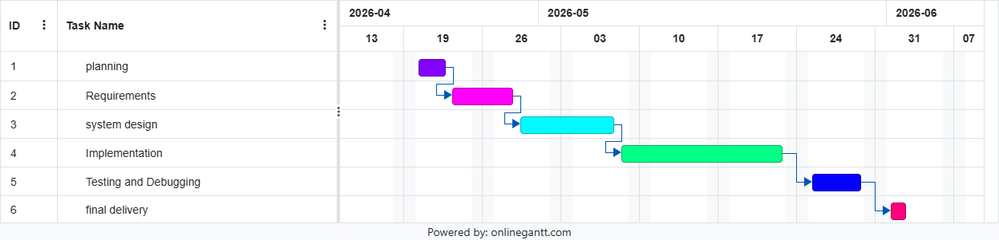

Figure 1: Gantt Chart of project

SDLC Model

2.3 SDLC Model using Agile
The Agile Model is used to develop the Pharmacy Management System. It divides the project into small iterations, where each part is developed and tested step by step.
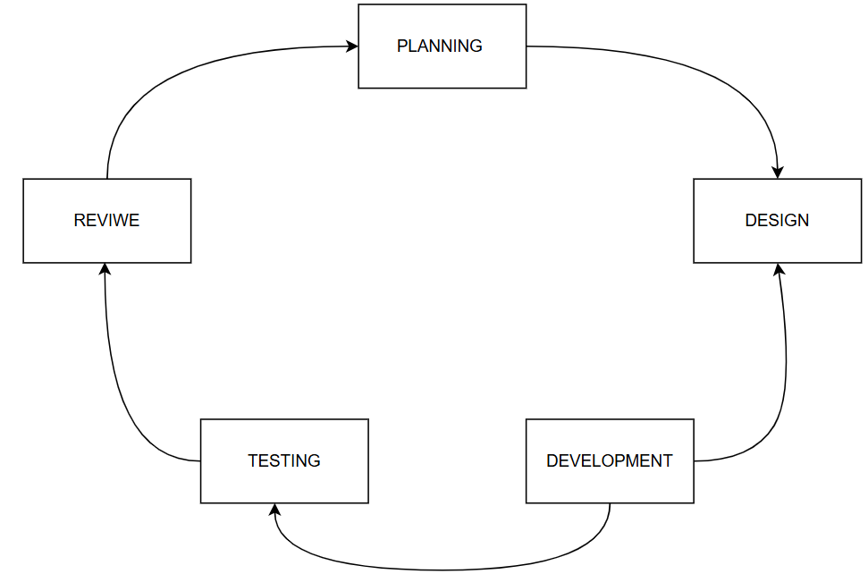
The system is built in cycles, allowing continuous improvement and flexibility throughout the development process.

Figure 2: SDLC Model (Agile)

Requirments gathring

1.4 2. Requirements Gathering
Functional Requirements

1. User Management & Security
- FR-1: The system shall allow users to register and login based on their roles (Pharmacist or Patient).
- FR-2: The system must allow the Pharmacist to manage their profile, including updating personal information (Name, Phone, DOB).
- FR-3: The system shall provide secure access control, ensuring patients can only view their own prescriptions and history.

2. Inventory & Medicine Management
- FR-4: The system shall enable the Pharmacist to add new medicines to the database, specifying Medicine ID, Name, Price, Dose, and Quantity.
- FR-5: The system must allow updating medicine stock levels and deleting records of discontinued medications.
- FR-6: The system shall maintain an inventory log that tracks the location and capacity of stored medicines.

FR

Functional Requirements

3. Prescription & Order Processing
- FR-7: The system shall allow Pharmacists to create and process medical orders (Prescriptions) for registered patients.
- FR-8: The system must link each order to a specific Patient ID and the Pharmacist ID responsible for the transaction.
- FR-9: The system shall validate medicine availability before finalizing any medical order.
- FR-10: The system shall allow Patients to search for available medicines and submit a request to purchase or order them.
- FR-11: The system shall notify the Pharmacist of new medicine requests to be processed

4. Sales & Billing
- FR-12: The system must calculate the total amount for each transaction including any applicable taxes.
- FR-13: The system shall support multiple payment methods, specifically Cash and Credit Cards.
- FR-14: For Card payments, the system must record transaction details such as Card Type and Issuer Bank.

5. Reporting & History
- FR-15: The system shall allow patients to view their complete prescription history and previous orders.
- FR-16: The system must allow Pharmacists to view their assigned shifts and branch information.

NF

2.1.2 Non-Functional Requirements
1. Security & Access Control
- NFR-1: The system shall implement role-based access control (RBAC) to ensure only authorized users (Pharmacists and Patients) can access sensitive data.
- NFR-2: All user passwords and personal information must be protected and encrypted within the database.
2. Data Integrity & Accuracy
- NFR-3: The system must maintain high data integrity, ensuring that medicine stock levels are accurately updated after every sale or prescription process.
- NFR-4: The database shall ensure that all transactions are atomic, preventing any data inconsistency during concurrent user access.
3. Performance & Speed
- NFR-5: The system shall be highly responsive, with a maximum response time of 2 seconds for medicine searches and invoice generation.
- NFR-6: The system must support multiple simultaneous users without any degradation in overall performance.

NFR2

2.1.2 Non-Functional Requirements
4. Availability & Reliability
- NFR-7: The system shall be operational 99.9% of the time during the pharmacy's working hours.
- NFR-8: The system must perform regular automated data backups to ensure recovery in case of hardware failure.
5. Usability & User Experience
- NFR-9: The interface shall be intuitive and user-friendly, requiring minimal training for staff to manage daily pharmacy operations.
- NFR-10: The system should provide clear error messages and validation alerts to help users navigate the features easily.

Use Case Diagram
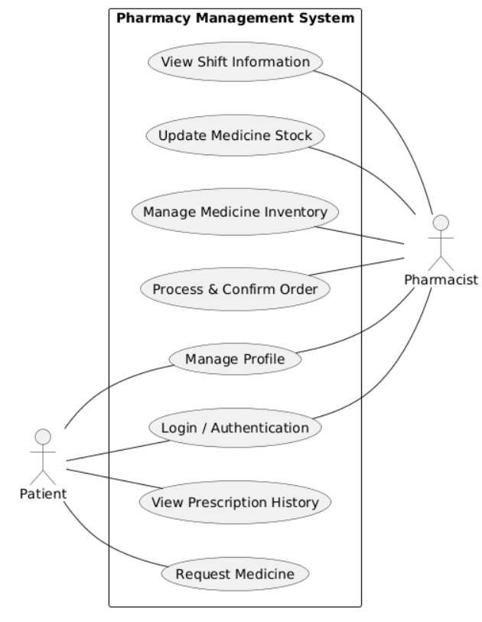
2.2 Use Case Diagram

Figure 3: Use Case diagram of system

ER
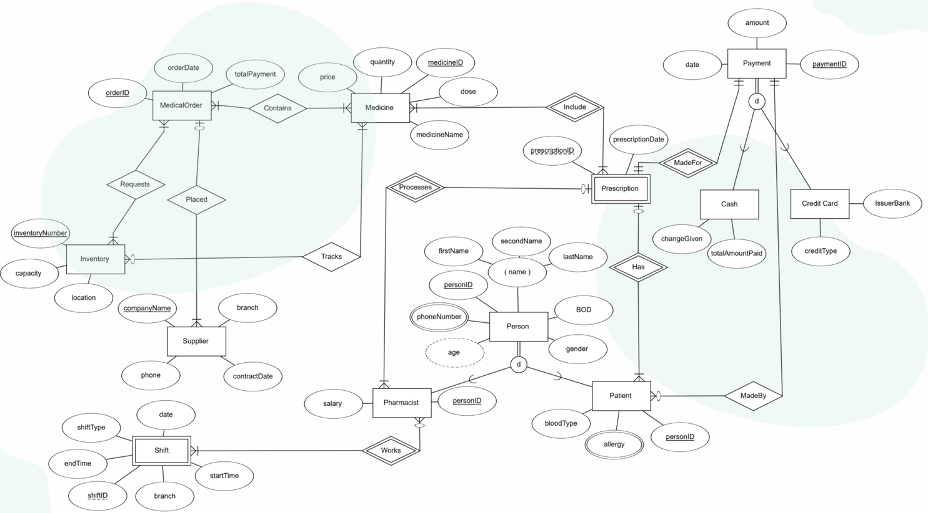
3.1 Extended ER-Diagram
Figure 4: ER Diagram

Schema
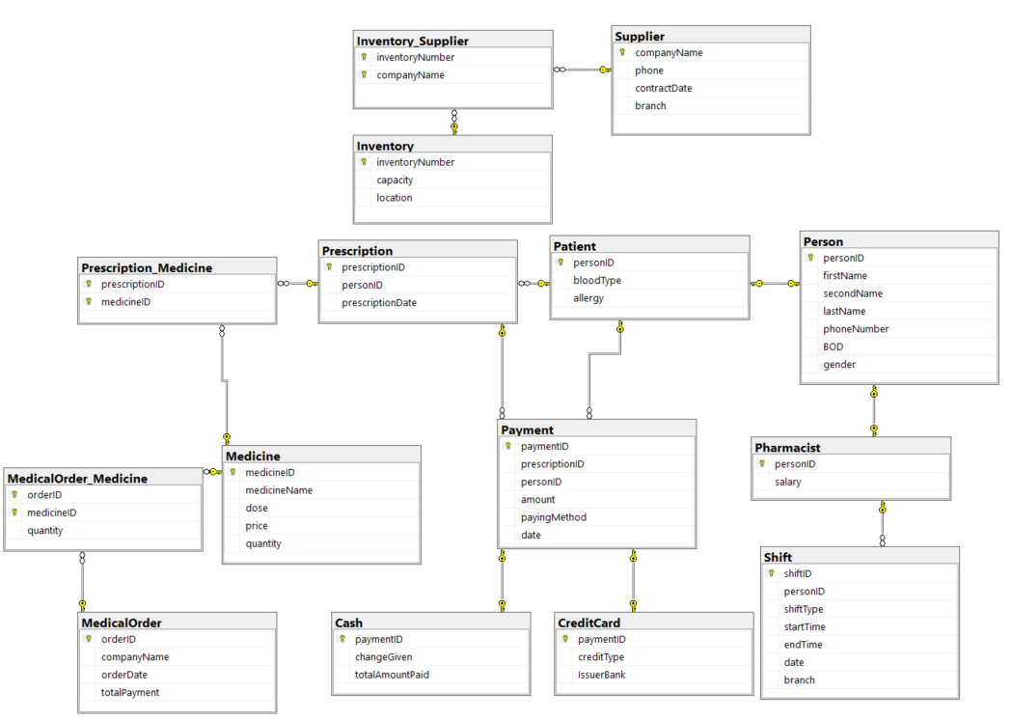
3.2 Relation Schema
Figure 5: Relation Schema

User Interface
4. User Interface Design
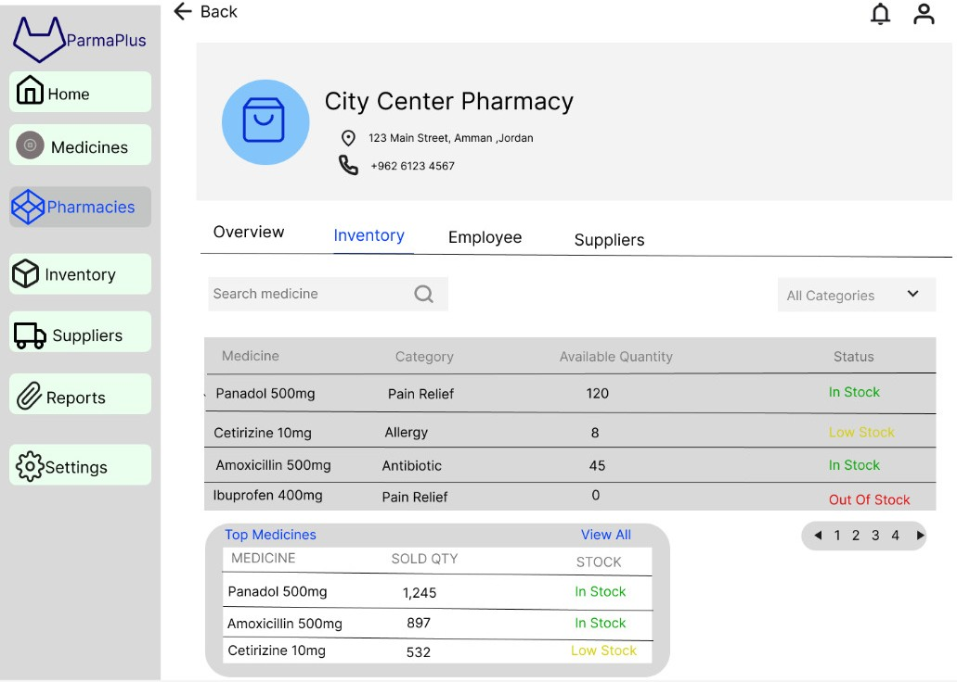
Figure 6: Interface

Copy of User Interface
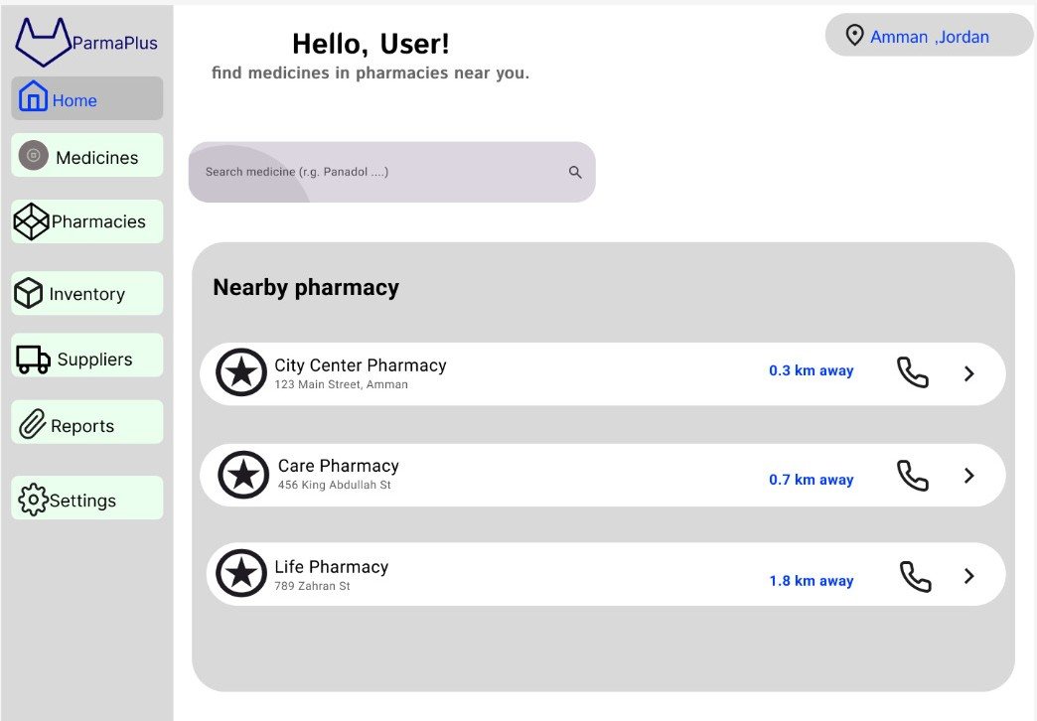
4. User Interface Design
Figure 7: Interface

