Day 2

Q2)
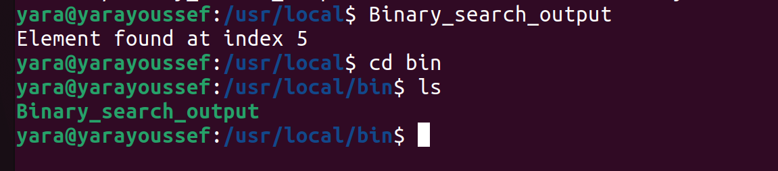

You can run files in the {/usr/local/bin} directory without having to specify the full path because it is typically included in the system's PATH environment variable.

